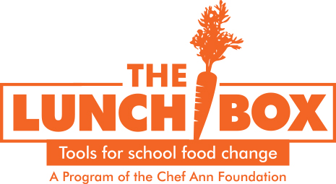 

**We’re Having a Fruit & Veggie Tasting Today!**

What did you taste today?

Did you like the sample? (color in one)

How does this produce grow?

(Under ground, above ground, or on a tree?)

Describe the taste and texture:

(Is it sweet, bitter, earthy, tart, crunchy, soft?)

**We’re Having a Fruit & Veggie Tasting Today!**

What did you taste today?

Did you like the sample? (color in one)

How does this produce grow?

(Under ground, above ground, or on a tree?)

Describe the taste and texture:

(Is it sweet, bitter, earthy, tart, crunchy, soft?)

**We’re Having a Fruit & Veggie Tasting Today!**

What did you taste today?

Did you like the sample? (color in one)

How does this produce grow?

(Under ground, above ground, or on a tree?)

Describe the taste and texture:

(Is it sweet, bitter, earthy, tart, crunchy, soft?)

**We’re Having a Fruit & Veggie Tasting Today!**

What did you taste today?

Did you like the sample? (color in one)

How does this produce grow?

(Under ground, above ground, or on a tree?)

Describe the taste and texture:

(Is it sweet, bitter, earthy, tart, crunchy, soft?)