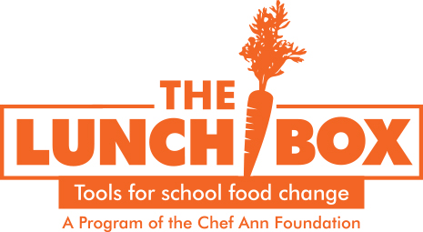

**We’re Having a Menu Item**

**Tasting Today!**

What did you taste today?

Did you like the sample? (color in one)

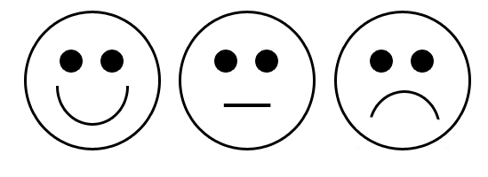

Why did you or didn’t you like it?

**We’re Having a Menu Item**

**Tasting Today!**

What did you taste today?

Did you like the sample? (color in one)



Why did you or didn’t you like it?

**We’re Having a Menu Item**

**Tasting Today!**

What did you taste today?

Did you like the sample? (color in one)



Why did you or didn’t you like it?

**We’re Having a Menu Item**

**Tasting Today!**

What did you taste today?

Did you like the sample? (color in one)



Why did you or didn’t you like it?

**We’re having a Menu Item**

**Tasting Today!**

What did you taste today?

Did you like the sample? (color in one)



Why did you or didn’t you like it?