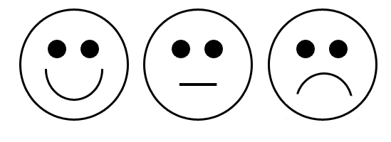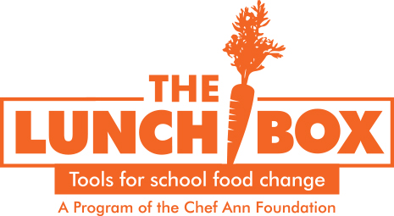

**We’re Having a Recipe Tasting Today!**

What did you taste today?

Did you like the sample? (color in one)

Should we put this on the menu next year?

* Yes
* No

Help us name our recipe! What should this dish be called

**We’re Having a Recipe Tasting Today!**

What did you taste today?

Did you like the sample? (color in one)

Should we put this on the menu next year?

* Yes
* No

Help us name our recipe! What should this dish be called

**We’re Having a Recipe Tasting Today!**

What did you taste today?

Did you like the sample? (color in one)

Should we put this on the menu next year?

* Yes
* No

Help us name our recipe! What should this dish be called?

**We’re having a Recipe Tasting Today!**

What did you taste today?

Did you like the sample? (color in one)



Should we put this on the menu next year?

* Yes
* No

Help us name our recipe! What should this dish be called?

**We’re Having a Recipe Tasting Today!**

What did you taste today?

Did you like the sample? (color in one)

Should we put this on the menu next year?

* Yes
* No

Help us name our recipe! What should this dish be called?

**We’re having a Recipe Tasting Today!**

What did you taste today?

Did you like the sample? (color in one)



Should we put this on the menu next year?

* Yes
* No

Help us name our recipe! What should this dish be called?