P1. Other Identifier: ____
*P2. Location: Not for Publication X Unrestricted
*a. County Marin and (P2c, P2e, and P2b or P2d. Attach a Location Map as necessary.)
*b. USGS 7.5' Quad San Rafael-Marin County, CA Date 1993 T ; R ; of of Sec ; B.M.
- Address 1714 Fourth Street City San Rafael, CA Zip 94901
- UTM: (Give more than one for large and/or linear resources) Zone , mE/ mN
e. Other Locational Data: APN 011-192-08

*P3a. Description: (Describe resource and its major elements. Include design, materials, condition, alterations, size, setting, and boundaries)
The one-story commercial building is rectangular in plan with its main façade immediately adjacent to the sidewalk. It has a simple stepped parapet and two storefronts with entrances left of display windows. Storefronts slant outward from recessed doors creating a zig-zag façade. The building has glass block bulkheads and metal window and door trim. Cladding is stucco. There is a small wood-clad volume at the rear of the main building with a shed roof.

*P3b. Resource Attributes: (List attributes and codes) HP6. 1-3 Story Commercial building.

*P4. Resources Present: Building Structure Object Site District Element of District Other (Isolates, etc.)
P5b. Description of Photo: (View, date,

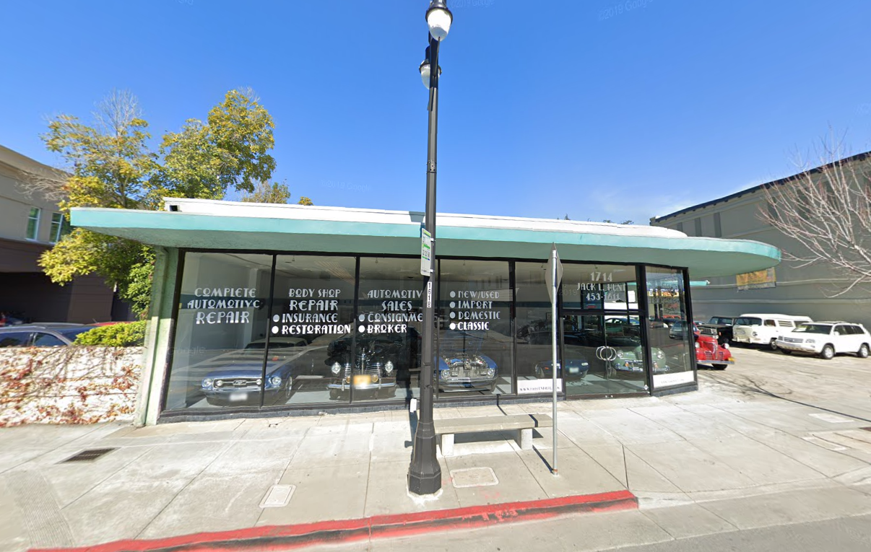

accession #) 1714 Fourth Street viewed from West side of A St, looking East.
Google, 2018.

*P6. Date Constructed/Age and Sources:
Historic Prehistoric Both
1951, (City Data)
*P7. Owner and Address:

*P8. Recorded by: (Name, affiliation, address)
Kai Morgan
Garavaglia Architecture, Inc.
582 Market Street, Suite 1800
San Francisco, CA 94104

*P9. Date Recorded: July 30, 2020
*P10. Survey Type: (Describe) Intensive.
*P11. Report Citation: (Cite survey report and other sources, or enter “none.”) None
*Attachments: NONE Location Map Sketch Map Continuation Sheet Building, Structure, and Object Record Archaeological Record District Record Linear Feature Record Milling Station Record Rock Art Record Artifact Record Photograph Record Other (list) ________________

B1. Historic Name:
B2. Common Name: 1714 Fourth Street
B3. Original Use: Service Station B4. Present Use: Service station
*B5. Architectural Style: Mid-century Modern
*B6. Construction History: (Construction date, alteration, and date of alterations)
Built 1951 (City Data).
*B7. Moved? No Yes Unknown Date: Original Location:
*B8. Related Features:
B9. Architect: Unknown b. Builder: Unknown
*B10. Significance: Theme Commercial Development Area San Rafael, Marin County
Period of Significance 1951 Property Type Retail Applicable Criteria C/3
(Discuss importance in terms of historical or architectural context as defined by theme, period, and geographic scope. Also address integrity.)
Continued on page 3
B11. Additional Resource Attributes: (List attributes and codes)
*B12. References:
Ancestry.com. U.S. City Directories, 1822-1995 [database on-line]. Provo, UT, USA: Ancestry.com Operations, Inc., 2011.
California Missions Foundation. (2017, September 03). San Rafael Arcángel. Accessed July 29, 2020.
California Missions Resource Center, San Rafael Arcángel Key Facts. (2019). Retrieved July 29, 2020, from https://missionscalifornia.com/san-rafael-arcangel-mission/key-facts
City and County of San Francisco Planning Department, Neighborhood Commercial Buildings: Historic Context Statement 1865-1965-Draft for Public
Review (February 17, 2016), 20.
City of San Rafael, Historic resources Inventory 1978, 918 Fifth St. Provided by City of San Rafael to Garavaglia Architecture.
County of Marin, Assessor-Recorder-County Clerk, Assessor record detail 011-221-08. Accessed online 7/20/2020
“History of Mission San Rafael Arcángel,” California Missions Foundation, website. Accessed April 24, 2019.
“History of San Rafael,” San Rafael Chamber, website. Accessed April 24, 2019
Jessica Sewell, “Sidewalks and Store Windows as Political Landscapes,” Perspectives in Vernacular Architecture, Volume 9, Constructing Image, Identity, and Place (2003)
Marin County History Museum, Images of America: Modern San Rafael: 1940-2000, (Charleston, SC: Arcadia Publishing, 2008)
Marin History Museum, Images of America: Early San Rafael (Charleston, SC: Arcadia Publishing, 2008.
B13. Remarks:

*B14. Evaluator: Kara Brunzell

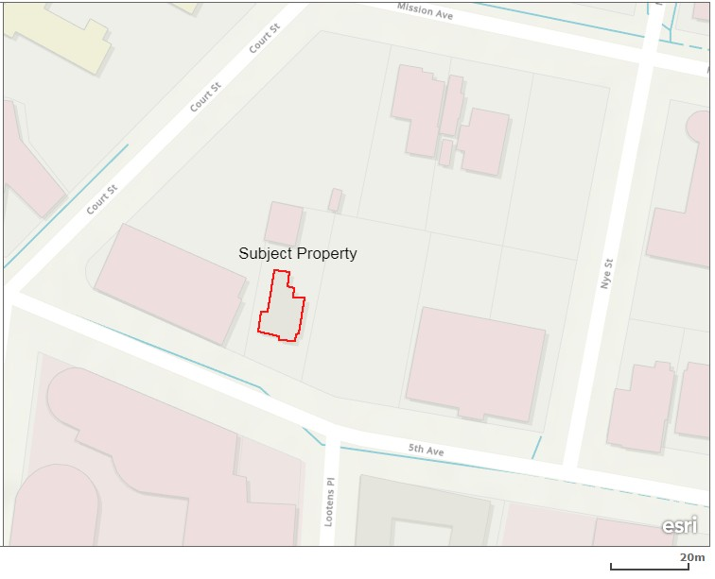
*Date of Evaluation: July 30, 2020

(This space reserved for official comment)
*P3a. Description: (continued)
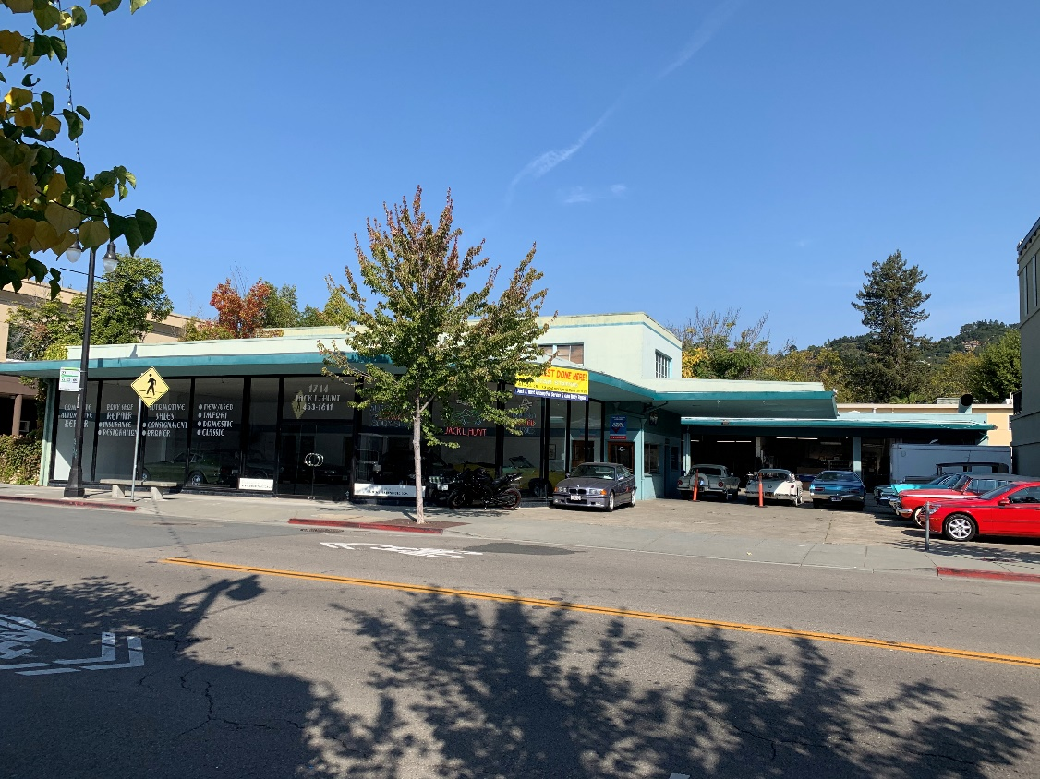
Photograph 2: View from the South side of Fourth Street, camera facing North, Google 2018.

Character Defining Features of 1714 Fourth Street:
- Flat roof with parapet.
- Second story with flat roof and industrial sash windows.
- Projecting porte cochere on East facade.
- Fully glazed curved corner on South end.
- Heavy awning bellow parapet curved on south end.
- L shaped wing on North end with open vehicle bays.

B10. Significance (continued):
Historic Context of San Rafael
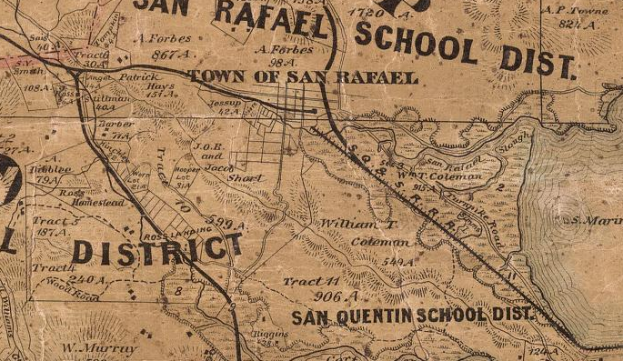
The area that is now the City of San Rafael was once the site of several Coast Miwok villages, including the village of Nanaguani along San Rafael Creek, inhabited by the Aguasto tribe. In 1817, Mission San Rafael Arcángel was founded as the 20th of 21 Spanish missions in the Spanish colonial province of Alta California. Originally planned as an asistencia (hospital) for Native Americans who became ill at Mission Dolores in present day San Francisco, San Rafael Arcángel gained full mission status in 1822. Mission San Rafael was noted for its abundant agricultural products including vineyards, orchards, grain, and thousands of sheep, cattle and horses. Following the secularization of the missions in 1834, the mission was placed under the control of administrators. In 1837, Timothy Murphy was appointed as administrator, and by 1844, was granted three contiguous parcels that were eventually divided into smaller tracts, shaping the boundaries of San Rafael. The Mission itself declined rapidly as an economic or political force in San Rafael and was largely abandoned by 1840. The ruins of the Mission were removed in 1870 and what stands on the site now are reconstructions from 1919 and 1949.
Figure 2: Official county map of Marin County. Produced by H. Austin, 1873.
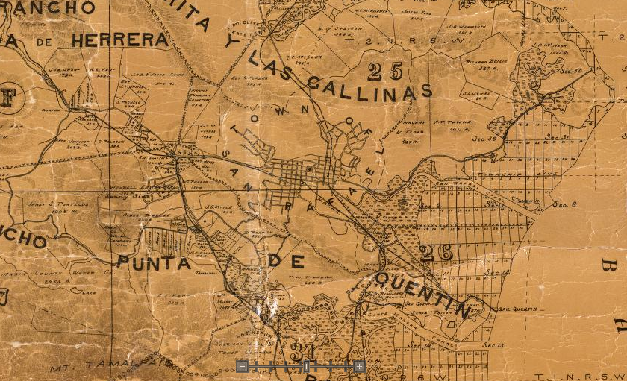
Figure 3: Official county map of Marin County. Produced by George M. Dodge, 1892.

1945-1970: Post War
During the post war years especially between 1953 and 1955, the construction of San Rafael’s housing stock continued to increase. The development of the Terra Linda and Marinwood neighborhoods on former ranch lands are just one example of San Rafael’s expansion at this time. Ferry strikes beginning in the late 1940s led to construction of another bridge and the demise of ferry service between San Rafael and Richmond. Completion of the Richmond-San Rafael Bridge in 1956 added another element of auto-oriented infrastructure to the region.

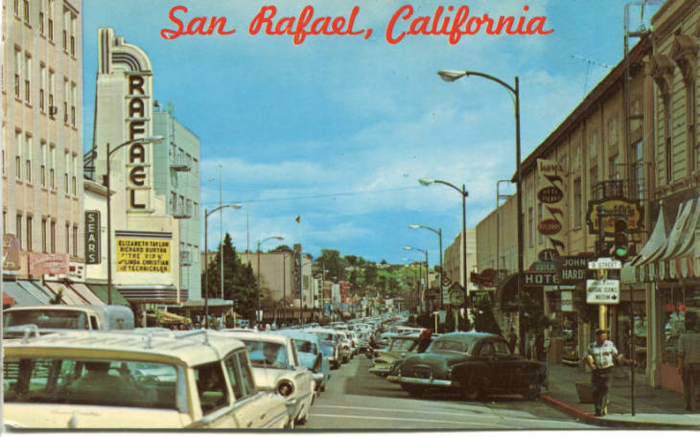
In the years immediately after the war, Fourth Street emerged as the commercial and cultural center of Marin County. San Rafael’s downtown continued to prosper, as department stores, restaurants, the County Courthouse, City Hall and even the first Kaiser Permanente clinic in town, combined with churches, nearby residences, and emerging postwar industries to define the modern city. The explosive growth occurring in San Rafael at the time can be seen in shifts of building materials, techniques and location during the post war period. Rapid construction of many inexpensive commercial buildings took place on recently drained lands that had been the marshy floor of the San Rafael Valley, expanding the town’s footprint into previously open space. Other notable examples of construction during this period can be found in the Eichler homes in the Terra Linda and Marinwood neighborhoods. The Period of Significance for the Proposed Downtown Commercial/Civil Historic Districts are bookended by the completion of a second Viaduct of Highway 101 over San Rafael creek in 1971, completing a transformation from Spanish frontier outpost to bustling American city.
Figure 4: View Looking west form Fourth and B Streets, 1963. Anne T. Kent California Room.

Development of large department stores anchored regional shopping centers at Northgate in Terra Linda and the Village in Corte Madera in the 1960s and 1970s and eroded Downtown San Rafael’s dominance as the county’s retail destination. From the mid-twentieth century to the present, San Rafael’s Downtown continues to be centered on its Fourth Street and B Street commercial corridors, which still display a great variety of period architecture from the 1860s through the mid-twentieth century, embodied in its stores, banks and restaurants. Initially centered on the Mission and maritime routes to San Francisco, San Rafael became, in turn, a Railroad depot, a regional wartime economic center, an auto-oriented county seat, and finally the commercial and cultural center of Marin County. The changing character of San Rafael is embodied in its varied architectural forms which continue to demonstrate the course of the town’s development.

Architecture:
1714 Fourth Street was constructed during a period of growth following the second world war, in a time when automobile centered construction was first being developed. The building is a classic example of Mid-Century modern architecture and demonstrates the clear shift towards auto oriented construction in San Rafael.

Evaluation
The NRHP and California Register of Historical Resources (CRHR) require that a significance criterion from A-D or 1-4 (respectively) be met for a resource to be eligible.
Criterion A/1: The property at 1714 Fourth Street is not associated with events that have made a significant contribution to the broad patterns of our history. It was developed within the general context of the residential development San Rafael and its growth during the last decades of the nineteenth century. However, research has not revealed any particularly important associations with that or any other historic context. Therefore, the property is recommended not eligible to the NRHP and CRHR under Criterion A/1.
Criterion B/2: The property is not associated with the life of persons important to our history. Therefore, the house is recommended to lack the associative significance required for eligibility to the NRHP or CRHR under Criterion B/2.
Criterion C/3: The property at 1714 Fourth Street is significant for its architecture. It is an excellent example of Mid-Century modern architecture displaying features characteristic of post war construction. For these reasons, the property is recommended eligible to the NRHP and CRHR under Criterion C/3.
Criterion D/4: In rare instances, buildings themselves can serve as sources of important information about historic construction materials or technologies and be significant under Criterion D/4. The building is an example of a well-understood type of construction and does not appear to be a principal source of important information in this regard. It is therefore recommended not eligible for the NRHP or the CRHR under Criterion D/4.
Historic integrity is defined as the authenticity of a property’s historic identity, evidenced by the survival of physical characteristics that existed during its historic period. There are seven aspects of integrity: location, design, setting, materials, workmanship, feeling, and association. Loss of integrity, if sufficiently great, would be more determinative than significance, rendering a property ineligible for historic listing.
The building has not been moved and therefore retains integrity of location. The composition of elements that constitute the form, plan, space, structure, and style of the building are unaltered; therefore, the building retains integrity of design. The immediate setting has been somewhat altered over decades with the intrusion of large-scale buildings, its integrity of setting has therefore been partially degraded. The building’s integrity of materials and workmanship is evident in the survival of exterior architectural features. The property therefore retains sufficient significant physical characteristics from its original construction to convey its historic qualities and therefore retains integrity of feeling. Its continued use as a residence allows it to retain integrity of association. Therefore, the building retains sufficient integrity convey its historic significance.
The property is recommended eligible for listing on the NRHP and CRHR and qualifies as a historical resource under CEQA.

Marin County History Museum, Images of America: Early San Rafael, (Charleston, SC: Arcadia Publishing, 2008), 9.
“History of San Rafael,” San Rafael Chamber, website. Accessed April 24, 2019. http://srchamber.com/history-of-san-rafael/.; and, “History of Mission San Rafael Arcangel,” California Missions Foundatin, website. Accessed April 24, 2019. http://californiamissionsfoundation.org/mission-san-rafael/.
California Missions Resource Center, San Rafael Arcángel Key Facts. (2019). Retrieved July 29, 2020, from https://missionscalifornia.com/san-rafael-arcangel-mission/key-facts
Images of America: Early San Rafael, 19.
California Missions Foundation. (2017, September 03). San Rafael Arcángel. Retrieved July 29, 2020, from http://californiamissionsfoundation.org/mission-san-rafael/

