P1. Other Identifier: ____
*P2. Location: Not for Publication X Unrestricted
*a. County Marin and (P2c, P2e, and P2b or P2d. Attach a Location Map as necessary.)
*b. USGS 7.5' Quad San Rafael-Marin County, CA Date 1993 T ; R ; of of Sec ; B.M.
- Address 1852 Fourth St. City San Rafael, CA Zip 94901
- UTM: (Give more than one for large and/or linear resources) Zone , mE/ mN
e. Other Locational Data: APN 010-291-57

*P3a. Description: (Describe resource and its major elements. Include design, materials, condition, alterations, size, setting, and boundaries)
The two-story storefront building has a rectangular plan and flat roof with clay tile parapet. It is clad in stucco with terracotta ornament including an elaborate frieze at the cornice, diminutive balconet at the center of the upper façade, and detailing between stories. Paired upper story windows are fitted with double hung multiple light wood sash. Transoms are also multiple light wood. Original glazed wood doors are at the center and west end of the building. Storefronts and bulkheads are contemporary.

*P3b. Resource Attributes: (List attributes and codes) HP6. 1-3 Story Commercial building.

*P4. Resources Present: Building Structure Object Site District Element of District Other (Isolates, etc.)
P5b. Description of Photo: (View, date,
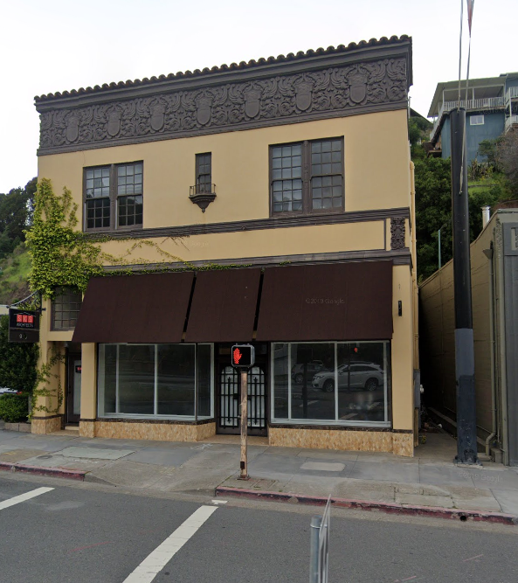

accession #) 1852 Fourth St viewed from the South side of Fourth Street, looking North. Google 2019.

*P6. Date Constructed/Age and Sources:
Historic Prehistoric Both
1922 (City Data)
*P7. Owner and Address:

*P8. Recorded by: (Name, affiliation, address)
Kai Morgan
Garavaglia Architecture, Inc.
582 Market Street, Suite 1800
San Francisco, CA 94104

*P9. Date Recorded: July 30, 2020
*P10. Survey Type: (Describe) Intensive.
*P11. Report Citation: (Cite survey report and other sources, or enter “none.”) None
*Attachments: NONE Location Map Sketch Map Continuation Sheet Building, Structure, and Object Record Archaeological Record District Record Linear Feature Record Milling Station Record Rock Art Record Artifact Record Photograph Record Other (list) ________________

B1. Historic Name:
B2. Common Name: 1852 Fourth St
B3. Original Use: Commercial B4. Present Use: Commercial
*B5. Architectural Style: Art Deco/Spanish Revival
*B6. Construction History: (Construction date, alteration, and date of alterations)
Built 1922 (City Data).
*B7. Moved? No Yes Unknown Date: Original Location:
*B8. Related Features:
B9. Architect: b. Builder:
*B10. Significance: Theme Commercial Development Area San Rafael, Marin County
Period of Significance 1922 Property Type Commercial Applicable Criteria C/3
(Discuss importance in terms of historical or architectural context as defined by theme, period, and geographic scope. Also address integrity.)
Continued on page 3
B11. Additional Resource Attributes: (List attributes and codes)
*B12. References:
Ancestry.com. U.S. City Directories, 1822-1995 [database on-line]. Provo, UT, USA: Ancestry.com Operations, Inc., 2011.
California Missions Foundation. (2017, September 03). San Rafael Arcángel. Accessed July 29, 2020.
California Missions Resource Center, San Rafael Arcángel Key Facts. (2019). Retrieved July 29, 2020, from https://missionscalifornia.com/san-rafael-arcangel-mission/key-facts
City and County of San Francisco Planning Department, Neighborhood Commercial Buildings: Historic Context Statement 1865-1965-Draft for Public
Review (February 17, 2016), 20.
City of San Rafael, Historic resources Inventory 1978, 918 Fifth St. Provided by City of San Rafael to Garavaglia Architecture.
County of Marin, Assessor-Recorder-County Clerk, Assessor record detail 011-221-08. Accessed online 7/20/2020
“History of Mission San Rafael Arcángel,” California Missions Foundation, website. Accessed April 24, 2019.
“History of San Rafael,” San Rafael Chamber, website. Accessed April 24, 2019
Jessica Sewell, “Sidewalks and Store Windows as Political Landscapes,” Perspectives in Vernacular Architecture, Volume 9, Constructing Image, Identity, and Place (2003)
Marin County History Museum, Images of America: Modern San Rafael: 1940-2000, (Charleston, SC: Arcadia Publishing, 2008)
Marin History Museum, Images of America: Early San Rafael (Charleston, SC: Arcadia Publishing, 2008.
B13. Remarks:

*B14. Evaluator: Kara Brunzell

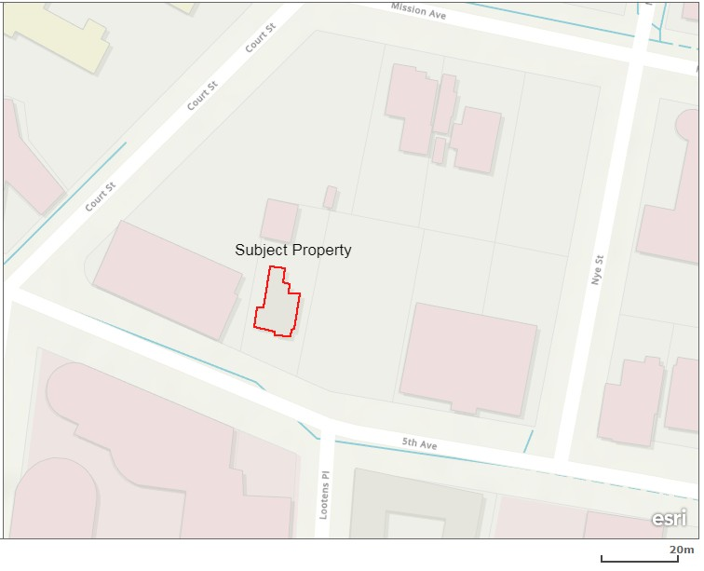
*Date of Evaluation: July 30, 2020

(This space reserved for official comment)
*P3a. Description: (continued)
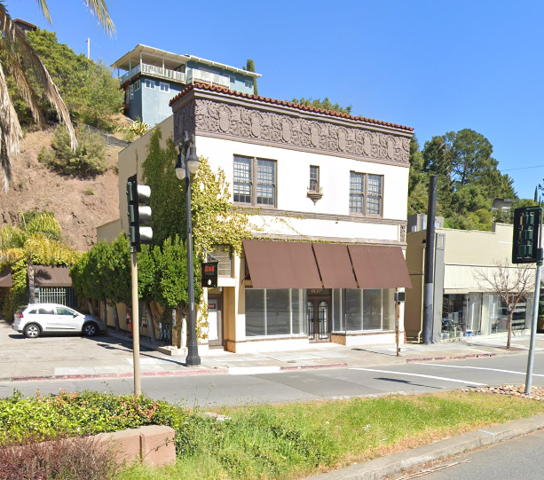
Photograph 2: View from the South-west side of Fourth Street, camera facing North-east, Google 2019.

Character Defining Features of 1852 Fourth St:
- Flat roof with clay tile parapet.
- Stucco and Terracotta ornamentation.
- Elaborate frieze at cornice.
- Balconet between upper and lower stories.
- Paired upper story windows are fitted with double hung multiple light wood sash.
- Multiple lite wood transoms.
- Original glazed wood doors.

B10. Significance (continued):
Historic Context of San Rafael
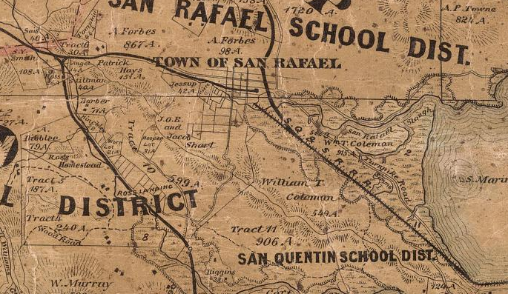
The area that is now the City of San Rafael was once the site of several Coast Miwok villages, including the village of Nanaguani along San Rafael Creek, inhabited by the Aguasto tribe. In 1817, Mission San Rafael Arcángel was founded as the 20th of 21 Spanish missions in the Spanish colonial province of Alta California. Originally planned as an asistencia (hospital) for Native Americans who became ill at Mission Dolores in present day San Francisco, San Rafael Arcángel gained full mission status in 1822. Mission San Rafael was noted for its abundant agricultural products including vineyards, orchards, grain, and thousands of sheep, cattle and horses. Following the secularization of the missions in 1834, the mission was placed under the control of administrators. In 1837, Timothy Murphy was appointed as administrator, and by 1844, was granted three contiguous parcels that were eventually divided into smaller tracts, shaping the boundaries of San Rafael. The Mission itself declined rapidly as an economic or political force in San Rafael and was largely abandoned by 1840. The ruins of the Mission were removed in 1870 and what stands on the site now are reconstructions from 1919 and 1949.
Figure 2: Official county map of Marin County. Produced by H. Austin, 1873.
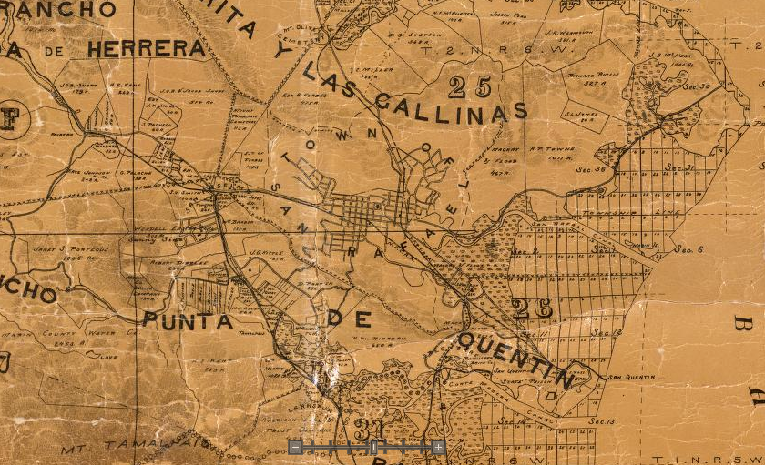
Figure 3: Official county map of Marin County. Produced by George M. Dodge, 1892.

1906-1937: Post Earthquake to the opening of the Golden Gate Bridge
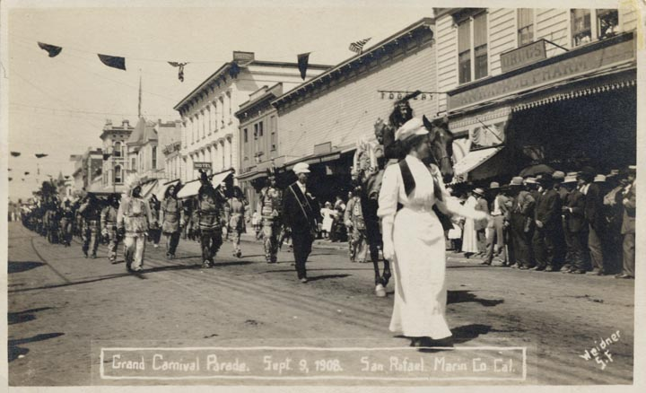
In the later years of the 19th century San Rafael had begun to be seen by some San Franciscans as a desirable escape from city life. Wealthy San Franciscans such as AP Hotaling, John H Reddington, William Tell Coleman, and Robert Dollar began to relocate to San Rafael, after regular ferry services became available travel between the two cities. There was an influx of new residents following the San Francisco earthquake and fire in 1906. The new population triggered new development including in the residential neighborhoods on the borders of the new downtown. The expansion of these neighborhoods created a foundation for the mixed residential/commercial areas in what is now the West End and neighborhoods north of downtown such as the Proposed Conservation District One. The early twentieth century saw a huge interest in the civic life of San Rafael, with the establishment of a Marin County Board of Supervisors, a local National Guard company, and construction of new civic buildings.
Figure 4: Grand Carnival Parade, Fourth Street San Rafael. September 9th, 1908.

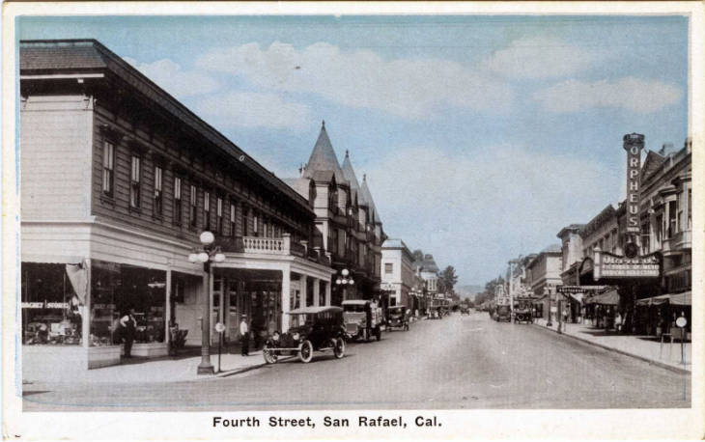
Examples of this period in San Rafael’s urban development can be seen in the Classical Revival San Rafael Improvement Club which was built for the 1915 Panama-Pacific exhibition and floated across the bay from San Francisco. The building became the staging area for mosquito eradication programs and other projects. The Public Library, which still stands at the corner of Fifth and E Streets, anchoring the northern end of the Proposed Downtown Commercial/Civil Historic District, is another prime example of civic architecture of the period.
Figure 5: Intersection of A and Fourth Streets looking west, c1920. Anne T. Kent California Room.

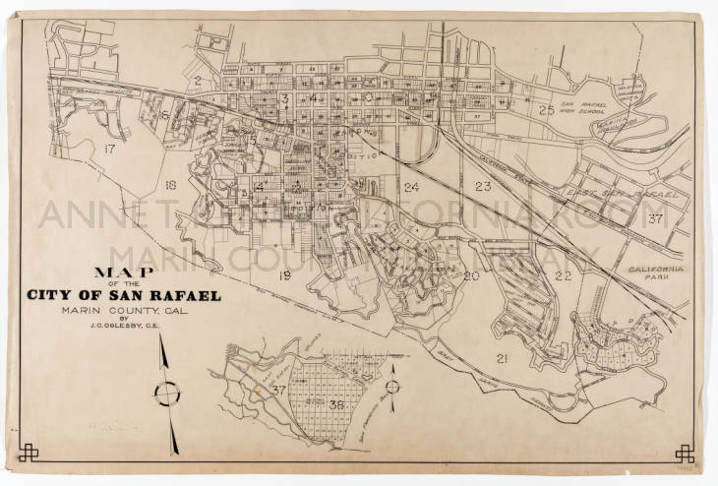
The growth of nearby military installations such as Hamilton Army Air Base would also result in considerable impacts on downtown growth and commerce and sets stage for post-war suburban growth though little of that growth occurred near Downtown.
Figure 6: Map of the City of San Rafael, 1929. J.C Oglesby collection in the Anne T. Kent California Room.

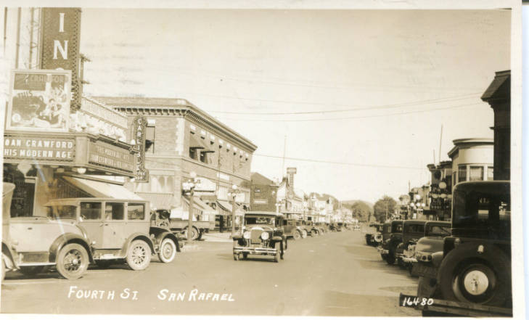
The early Twentieth Century saw a transformation of transportation infrastructure in San Rafael, beginning with the relocation of passenger ferry service from Tiburon to Sausalito and the construction of the Northwestern Pacific electric interurban railway system from the Sausalito ferry terminal. The interurban system was soon providing commuter service from southern Marin, the Ross Valley and San Rafael to San Francisco.
Figure 7: View of Fourth Street looking east, 1932. Anne T. Kent California Room.

As late as 1903, nearly two decades after their invention, automobiles were banned from many Marin County roads, prohibited from night use, and limited to a 15 mile-per-hour speed. In 1909, a winding series of roads leading from Sausalito through the other towns of Marin County was designated a California state highway, an early step in the transformation of California’s built environment around the personal automobile. Entering San Rafael from the west, the highway traveled along Fourth Street before turning north and leaving San Rafael via Lincoln Avenue. The federal government had authorized the construction of US 101 in 1925, and by 1929 its Marin County route was under development. By the mid-1930s, US 101 was handling 1.5 million cars annually. Population growth and ever-increasing reliance on automobile transportation created demand for additional infrastructure, and federal funding made available by the New Deal allowed construction on the Golden Gate Bridge to begin in 1933.

Architecture:
1852 Fourth St is an excellent example of Mission revival style architecture which incorporates elements of the contemporary Art Deco style into its design. The structure includes many features characteristic of this early to mid-20th century styles including a decorative frieze, balconet and terracotta detailing. California was the birthplace of the Mission style. The earliest examples were built in the 1890s, and the style spread westward in the 1900s. The style appears in house plan books such as those of Sears Roebuck and Co. that sold plans for Mission style called the Alhambra (1910).
Identifying features of the Mission style include: “Mission-shaped dormer or roof parapet; commonly red tile roof covering, widely overhanging eaves, usually open porch roofs supported by large, square piers, commonly arched above, wall surface usually smooth stucco.” Principal subtypes are distinguishable in the symmetrical and asymmetrical. Variants and details include shaped dormers and parapets mimicking those found on Spanish Colonial Mission buildings, prominent one-story porches, and arched roof supports to simulate the arcades of Hispanic buildings. Occasionally Mission-like bell towers occurred on some examples. Windows are usually double-hung and grouped together. Some examples have visor roofs that most commonly occur beneath the parapets of flat roofs.

Evaluation
The NRHP and California Register of Historical Resources (CRHR) require that a significance criterion from A-D or 1-4 (respectively) be met for a resource to be eligible.
Criterion A/1: The property at 1852 Fourth St is not associated with events that have made a significant contribution to the broad patterns of our history. It was developed within the general context of the residential development San Rafael and its growth during the last decades of the nineteenth century. However, research has not revealed any particularly important associations with that or any other historic context. Therefore, the property is recommended not eligible to the NRHP and CRHR under Criterion A/1.
Criterion B/2: The property is not associated with the life of persons important to our history. Therefore, the house is recommended to lack the associative significance required for eligibility to the NRHP or CRHR under Criterion B/2.
Criterion C/3: The property at 1852 Fourth St is significant for its architecture. It is an excellent example of Spanish revival architecture displaying features characteristic of this style. For these reasons, the property is recommended eligible to the NRHP and CRHR under Criterion C/3.
Criterion D/4: In rare instances, buildings themselves can serve as sources of important information about historic construction materials or technologies and be significant under Criterion D/4. The building is an example of a well-understood type of construction and does not appear to be a principal source of important information in this regard. It is therefore recommended not eligible for the NRHP or the CRHR under Criterion D/4.
Historic integrity is defined as the authenticity of a property’s historic identity, evidenced by the survival of physical characteristics that existed during its historic period. There are seven aspects of integrity: location, design, setting, materials, workmanship, feeling, and association. Loss of integrity, if sufficiently great, would be more determinative than significance, rendering a property ineligible for historic listing.
The house has not been moved and therefore retains integrity of location. The composition of elements that constitute the form, plan, space, structure, and style of the building are unaltered; therefore, the building retains integrity of design. The immediate setting has been somewhat altered over decades with the intrusion of large-scale buildings, its integrity of setting has therefore been partially degraded. The building’s integrity of materials and workmanship is evident in the survival of exterior architectural features. The property therefore retains sufficient significant physical characteristics from its original construction to convey its historic qualities and therefore retains integrity of feeling. Its continued use as a residence allows it to retain integrity of association. Therefore, the building retains sufficient integrity convey its historic significance.
The property is recommended eligible for listing on the NRHP and CRHR and qualifies as a historical resource under CEQA.

Marin County History Museum, Images of America: Early San Rafael, (Charleston, SC: Arcadia Publishing, 2008), 9.
“History of San Rafael,” San Rafael Chamber, website. Accessed April 24, 2019. http://srchamber.com/history-of-san-rafael/.; and, “History of Mission San Rafael Arcangel,” California Missions Foundatin, website. Accessed April 24, 2019. http://californiamissionsfoundation.org/mission-san-rafael/.
California Missions Resource Center, San Rafael Arcángel Key Facts. (2019). Retrieved July 29, 2020, from https://missionscalifornia.com/san-rafael-arcangel-mission/key-facts
Images of America: Early San Rafael, 19.
California Missions Foundation. (2017, September 03). San Rafael Arcángel. Retrieved July 29, 2020, from http://californiamissionsfoundation.org/mission-san-rafael/
Images of America: Early San Rafael, 37.
Ibid, 37.
Jim Wood, History of a Highway, Marin Magazine, April 17, 2009, https://marinmagazine.com/community/history/history-of-a-highway/, accessed July 20, 2020.
Viriginia Lee McAlester, A Field Guide to American Houses, (New York: Alfred A. Knopf, 2013), 510-518.
Ibid.

