Employee Self Service Setup
Sage Employee Self Service (ESS) is a web-based resource for SCAC employees to view and print pay stubs and W-2 tax forms, and to verify that your personal HR system data is updated and accurate.
To set up your ESS login, follow these steps:
- Open a web browser. Internet Explorer, Edge, Chrome, Chrome Canary, Firefox, Opera and Safari have all been tested and work with ESS.
- Type login.scacwv.org into the address bar. The address will show up as https://login.scacwv.org/selfservice - this is OK.
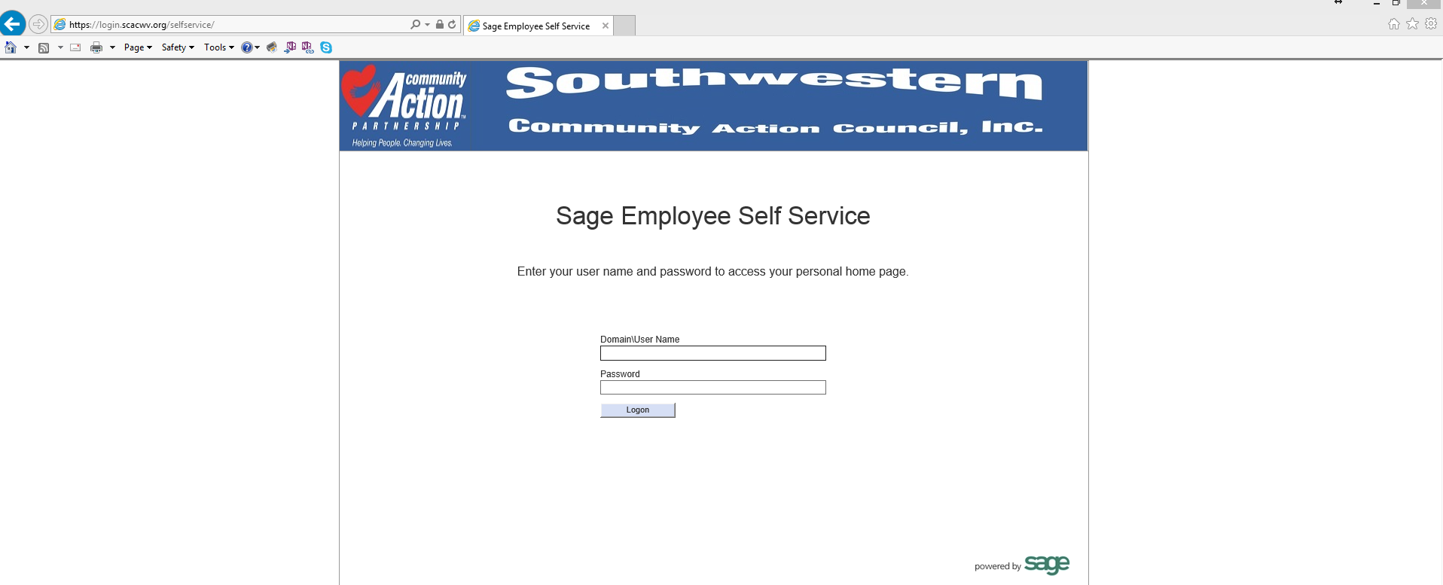

Once ESS is in use by the entire agency, a shortcut to access it will be added to the agency website.

- Logon Credentials:
In the box marked Domain\Username, type scacwv\yourfirstname.yourlast name .
Be sure to use the backslash key above the Enter key \ , not /

Use the password you use to log in to your computer. If you don’t know it or it doesn’t work, call Tim(304-781-0945), Jerry (304-390-0088), or Christy (304-781-0983) for help.

The first time you log in, you will be taken to a page which will ask for your first name, last name, social security number, and date of birth. This is a secure site and it’s safe to enter this info.
When entering your social security number, make sure to include the dashes. If you don’t, your login creation will fail. Use this format: 123-45-6789.
When entering your birthdate, use this format: 01/01/2016

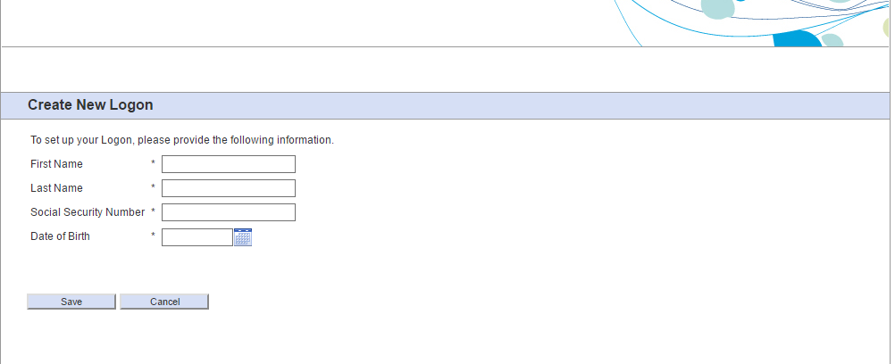

If you get the screen below, one of two things has happened.
- You forgot the dashes in your social.
- Something you entered doesn’t match your record in the HR software. You may have used a nickname or mistyped something. Go back and try again, and if it fails a second time, call HR to verify that your info is correct. If you have a check stub, check to make sure the name you’re using to sign in matches what’s on the stub.
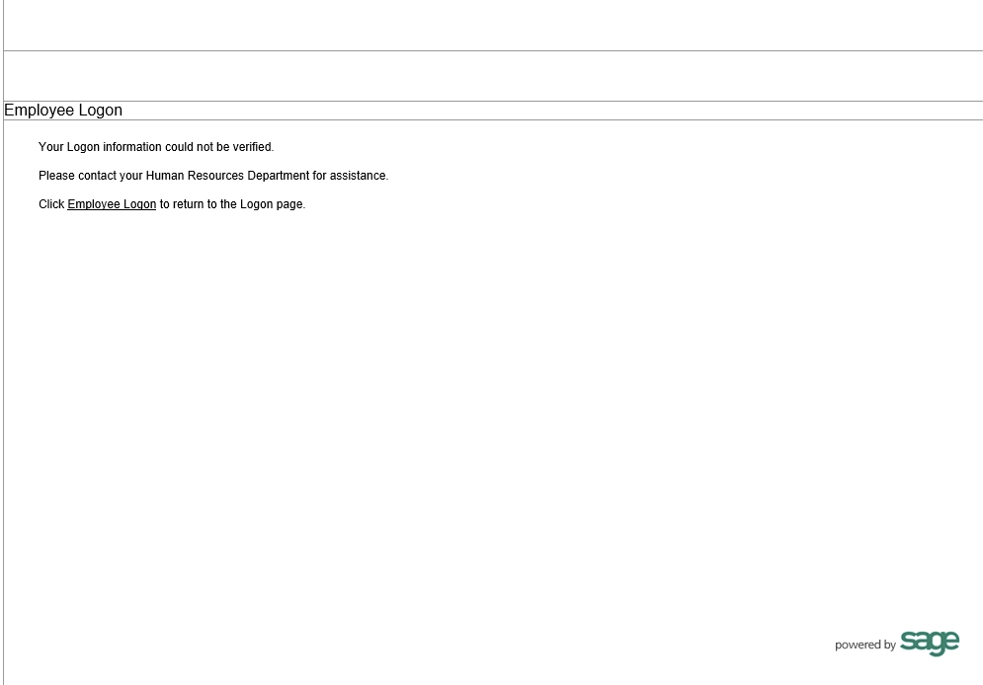

- Once you’ve successfully logged in, you will see your personalized home page with a summary of pay history, messages, and a list of your current benefits. To the left under the Employee menu, you will find links to review your personal data as reported by the agency HR/payroll system, a detailed pay history including check stubs for print or download, W-2 forms, and W-4 forms with your tax witholding information.

- Look at your data, please make note of anything that’s outdated and needs to be changed (such as address, phone number, life insurance beneficiary, new dependent to add, etc.) please contact HR for instructions on how to update your information.

