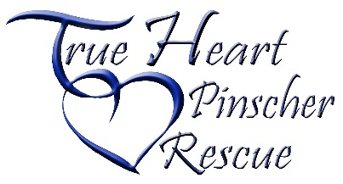
Volunteer Position:
Marketing Coordinator

Primary Objective:
Create, update, and maintain new and fresh content on social media and website, as well as timely release of newsletters and/or providing content for newsletters. Assist in gathering information on dogs currently in foster, those who have recently been adopted, etc.
Responsibilities:
- Communicate with all levels of the organization including foster homes in order to gather information on dogs to be highlighted and success stories to promote.
- Add and update content on the website often ensure accurate information
- Assist in the development of social media content
- Write articles for contribution to the quarterly newsletter.
- Take pictures or organize with another volunteer to have pictures taken at adoption events
- Work closely with the Foster Care Coordinator to ensure up-to-date information and images are available for dogs in foster care.
- Maintain a catalog of success stories and/or press releases for use with promotion of rescue or grant submittals.

Qualifications:
- Must be at least 18 years of age
- Must be reliable, responsible, a self-starter, and be able to work independently.
- Must have good written and oral communication skills.
- Must have excellent computer skills and/or experience in graphics, website design, journalistic or blog writing.

Location and Hours
- A few hours a month.
- Positions are available in each state True Heart serves. (Indiana, Kentucky, Ohio, North Carolina, and Pennsylvania)
Supervision:
- Report to Administrative Coordinator
Benefits:
- Save lives of dogs that may have otherwise been euthanized in a shelter
- Increase knowledge of dogs
- Improve socialization and training of animals and assist people in understanding dogs needs
- Build network of animal welfare individuals in your community.
- Improve social media and marketing skills
Requirements:
- Sign a Volunteer agreement and protocol

