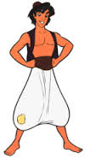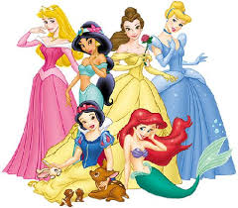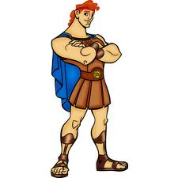
Presenting….
Disney Favorites
Oak Park High School Choir
FRIDAY, October 14, 2016

7 p.m. / OPHS Pavilion
Tickets on sale at the door:
$10 for adults / $5 for children/students

At this concert several of our students will be singing solos, duets, and ensembles of all of your favorite Disney songs AND the entire choir will be performing a spectacular rendition of The Nightmare Before Christmas!!

You won't want to miss this fun-filled evening!!!

