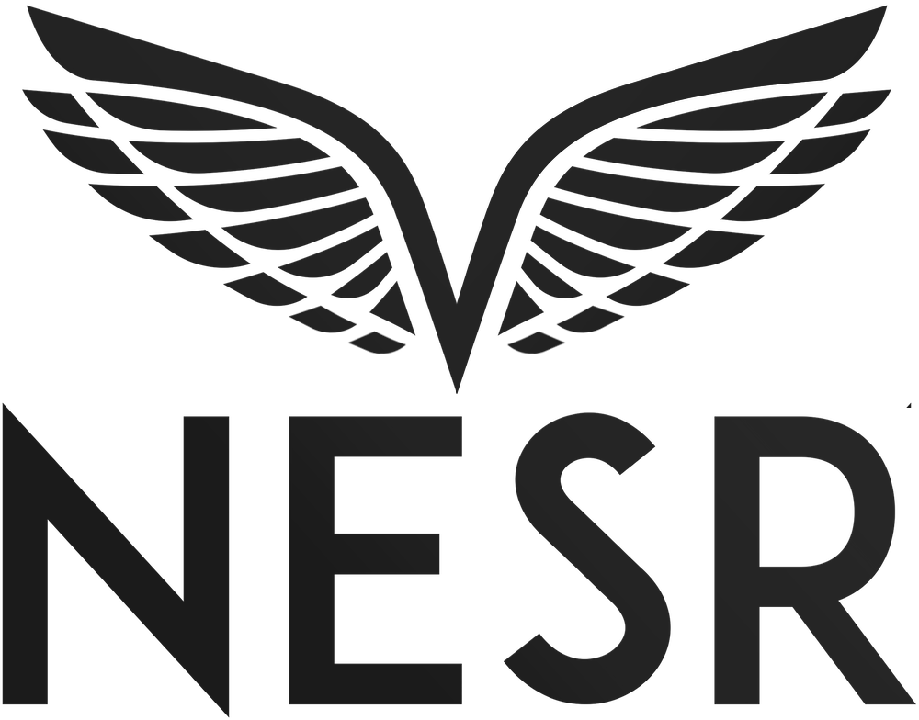
NESR Begins Construction of 180,000 m² Facility at King Salman Energy Park (SPARK)

The state-of-the-art facility will be a key asset in Saudi Arabia’s energy sector, offering advanced oilfield services and creating jobs opportunities
King Salman Energy Park, Saudi Arabia / ACCESSWIRE / April 21, 2025 / National Energy Services Reunited Corp. (“NESR” or the “Company”) (Nasdaq: NESR) (Nasdaq: NESRW) an international, industry-leading provider of integrated energy services in the Middle East and North Africa (“MENA”) region, proudly announces the start of construction on its cutting-edge industrial facility at King Salman Energy Park (“SPARK”), a leading energy industrial ecosystem strategically located at the heart of the global energy market.
The Company previously announced a groundbreaking event earlier this year in February, enabling a fast-paced approach to the building of its 180,000 m² state-of-the-art facility set to transform the region’s oilfield services landscape.
The groundbreaking ceremony, held at SPARK, brought together prominent industry leaders, including Saudi Aramco Upstream President and SPARK Chairman Nasir K. Al-Naimi, SPARK President and CEO Mishal I. Al Zughaibi, and NESR Chairman and CEO Sherif Foda. Their participation underscores a united vision to accelerate innovation, localization, and sustainability in the Kingdom’s energy sector.
Mishal I. Al Zughaibi said: “The groundbreaking of NESR’s facility marks a significant milestone in SPARK’s journey to becoming a global hub for energy, industry, and technology. This investment highlights the growing trust in SPARK’s ecosystem and reinforces our role in enabling strategic partnerships that drive localization, innovation, and job creation—core pillars of Saudi Arabia’s Vision 2030.”
Sherif Foda, Chairman & CEO of NESR remarked: “The facility will serve as a vital hub within NESR in the Kingdom and the region, driving local talent development, creating job opportunities, focusing on sustainability and embracing the highest LEED facility development standards in the world under Saudi Arabia’s ambitious plans for an energy-driven future.”
NESR’s new facility will be a key asset supporting Saudi Arabia’s energy sector, offering advanced oilfield services and creating jobs opportunities. Developed in four strategic phases, the NESR SPARK facility will introduce cutting-edge technologies for drilling optimization, well intervention, production enhancement, and sustainability solutions. In the first phase of development, NESR will transition its hydraulic fracturing operations to the new facility at SPARK, leveraging AI and machine learning to boost efficiency, enable predictive maintenance, and reduce non-productive time, positioning the facility as a pivotal hub for innovation in the regional oilfield services industry.
This investment aligns with Saudi Arabia’s Vision 2030 and SPARK’s mission, emphasizing localization, technological advancement, and the strengthening of domestic manufacturing and service capabilities within the energy sector. By establishing this advanced facility, NESR reaffirms its commitment to enhancing the MENA energy sector at large.
About NESR
Founded in 2017, NESR is one of the largest national oilfield services providers in the MENA and Asia Pacific regions. With over 6,000 employees, representing more than 60 nationalities in 16 countries, the Company helps its customers unlock the full potential of their reservoirs by providing Production Services such as Hydraulic Fracturing, Cementing, Coiled Tubing, Filtration, Completions, Stimulation, Pumping and Nitrogen Services. The Company also helps its customers to access their reservoirs in a smarter and faster manner by providing Drilling and Evaluation Services such as Drilling Downhole Tools, Directional Drilling, Fishing Tools, Testing Services, Wireline, Slickline, Drilling Fluids and Rig Services.
About SPARK
SPARK is a leading industrial ecosystem with sustainability at its core, connecting the world to opportunities in the Saudi energy sector and beyond. As a national megaproject proudly driving socio-economic impact locally and globally, SPARK is simultaneously catalyzing the Kingdom’s role in the global energy transition while offering a world-class ecosystem in the heart of the energy market for investors and tenants.
For media inquiries, please contact:
Lubna Hamdan
National Energy Services Reunited Corp.
971502670225
lubna@nesr.com
For inquiries regarding NESR, please contact:
Blake Gendron
National Energy Services Reunited Corp.
832-925-3777
investors@nesr.com

