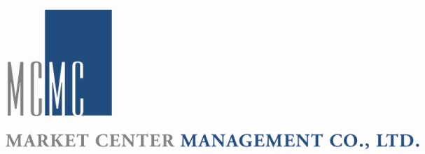
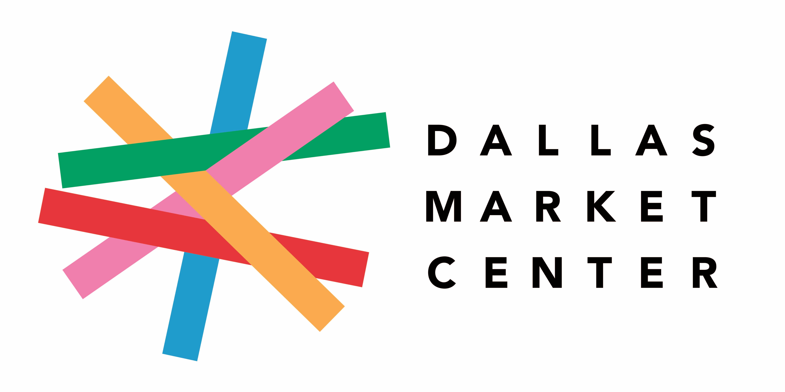
Dallas Market Center Selected For Development
and Management Agreement With
Dubai Global Connect Marketplace
—Strategic alliance includes multi-year support for the first permanent B2B marketplace in the Middle East—

Media Contact: Cole Daugherty, Dallas Market Center, cdaugherty@dallasmarketcenter.com, 214-760-2884

DALLAS – Sept. 21, 2020 – Dallas Market Center, the most complete lifestyle marketplace in North America, via its parent company, Market Center Management Company, announced a strategic alliance with Dubai Global Connect to support the development and management of the 10 million square foot wholesale marketplace in Dubai opening in 2023. The multi-year agreement was signed with the Dubai Global Connect ownership team consisting of the Investment Corporation of Dubai (ICD) in partnership with Dubai South.

Dubai Global Connect will be the first permanent B2B marketplace for consumer goods in the Middle East and will be open year-round to qualified retail buyers and designers, manufacturers and industry professionals. The purpose-built “City of Trade” is already under construction and will feature permanent showrooms, exhibition space, an innovation hub, auditorium, meeting rooms, offices, and private warehousing for tenants. The wholesale consumer goods showcased by Dubai Global Connect will include home furnishings, fashion, and food.

“Establishing a permanent marketplace is perfectly timed as event producers and their attendees cope with reduced travel budgets and the need for smaller, more controlled gatherings,” said Douraid Zaghouani, COO of ICD and Chairman of Dubai Global Connect. “In order to help realize our vision and to develop and manage this monumental project we are excited to have Dallas Market Center on board. Their deep experience globally and unique understanding of successfully creating year-round marketplaces will be invaluable.”

Cindy Morris, president and CEO of Dallas Market Center, added: “We are pleased to join this respected team creating a global destination for wholesale trade in Dubai, a historic and modern crossroads for commerce. The market for new products moves faster than ever and demands a marketplace that exceeds modern expectations. We look forward to utilizing our experience, skills and assets in design, development, operations, events, and marketing to launch a thoughtful and contemporary marketplace facilitating trade year-round and around the clock.”

—more—
For the past year, the Dubai Global Connect ownership team has engaged in an international search
for a suitable partner to contribute to the delivery of their vision of a global wholesale marketplace in Dubai. Their criteria included a sustained record of international trade center and trade event management, facility design and management expertise, consumer products industry knowledge, and an understanding of international sourcing dynamics. The result of this search was the selection of Market Center Management Company as the best-suited partner for a multi-year agreement.

Dallas Market Center and Market Center Management Company have for six decades developed, owned and/or managed wholesale trade centers around the world. Its executive team has deep experience across multiple consumer products industries and trade shows including home furnishings and fashion. In addition, MCMC is the only management team with multinational experience involving both ownership and management including Brussels International Trade Mart and ShanghaiMart as well as consulting experience on trade center development projects in Colombia, Vietnam, and Portugal.

Dubai Global Connect, located at the crossroads of Dubai’s logistics corridor in the Dubai South district and adjacent to Al Maktoum Airport and Jebel Ali Port, will be supported by best-in-class services for on-site meetings and events as well as a state-of-the-art digital wholesale trading platform connecting buyers and sellers online and facilitating hassle-free trade through Dubai Global Connect.

The ownership team responsible for Dubai Global Connect is Investment Corporation of Dubai. Its holdings include energy (Emirates National Oil Company), transportation (Emirates Group including Emirates Airline and SkyCargo), finance (Emirates NBD), industrial (Dubai Aluminum Company Ltd.), and real estate (Dubai World Trade Centre).

Dallas Market Center recently concluded a summer of trade events supporting wholesale and retail that were by all measures the most successful in North America. The number of exhibitors participating was the largest of any B2B show in the Unites States. Attendance was far above any other competitive trade event including record-breaking numbers of new buyers. Orders were consistent and larger than average for many exhibitors. Finally, strict health measures supported the comfort/safety of all guests.

Upcoming trade events in Dallas include Total Home & Gift Market, September 23-25, Dallas Design Week, September 22-24, Apparel & Accessories Market, October 20-23, and KidsWorld, October 20-23. To make plans for an upcoming visit, check the Dallas Market Center website and download the Dallas Market Center mobile app.

About Market Center Management Company and Dallas Market Center
Market Center Management Company (MCMC), based in Dallas, Texas, and its owner, Crow Holdings, own or manage market centers in North America (Dallas Market Center) and Europe (Brussels International Trade Mart). In North America, Dallas Market Center is the leading global business-to-business trade center and connects retailers and interior designers with top manufacturers in gourmet and housewares, home décor, holiday/floral, gifts, lighting and apparel. Inside its five million square foot campus, buyers from all 50 states and 85 countries seek industry trends, business education and new products from exhibitors throughout the year via dominant trade events for gift, home décor, holiday and floral; the nation’s most comprehensive apparel and accessories markets featuring the latest styles from East Coast and West Coast designers; the largest residential lighting trade event in North America; and the largest and most successful open-daily design center. To make plans for upcoming markets, visit the Dallas Market Center website and download the Dallas Market Center App. Also, keep up-to-date on all information by visiting Dallas Market Center on Facebook, Twitter, Instagram, and the Dallas Market Center blog.
###

