IMC International Mining Corp. Confirms Copper Gold Showings and Plans Aggressive Drilling Program

January 19, 2021

Vancouver, BC – IMC International Mining Corp. (CSE:IMCX) (OTC:IMIMF) (FRA:3MX) (the “Company” or “IMC”), is pleased to report initial results from the 2020 exploration program undertaken on the Company’s 100% owned Thane Property (the “Property”) located in north-central British Columbia, Canada. The Property comprises 206.58 sq. kilometers of contiguous claims that were privately owned until acquired by IMC in March 2020. The Property is located within the Quesnel Terrane, a north-south linear volcano-sedimentary belt of rocks intruded by multi-phase intrusive rocks, which hosts multiple porphyry style deposits. To the north of the Property is the currently producing Mt. Milligan copper-gold alkalic porphyry mine and to the south is the past producing Kemess calc-alkalic porphyry copper-gold mine.

During the summer of 2020, exploration fieldwork completed an 8-week field program that included Induced Polarization (“IP”) surveying, petrographic studies, geological mapping, rock, soil and silt sampling with the objective of identifying prospective drill targets for the 2021 exploration season. The results reported in this release are from the Cathedral Area, which comprises approximately 11 sq. kilometers of the 206.58 sq. km Property.

Work at the Cathedral Area consisted of approximately 3.1 sq. kilometers of geological mapping, collection of 100 rock samples in support of the geological mapping program, 11 line-kilometers of IP surveying, collection of 507 soil samples along all IP lines and 6 samples submitted for petrographic study.

The Showings within the main zone of the Cathedral Area have returned up 13.90% Cu and 6.85 g/t Au from the Cathedral Showing, 4.72% Cu and 1.33 g/t Au from the Cathedral South Showing, 11.10% Cu and 2.77 g/t Au from the Arc Showing and 3.13 % Cu and 0.32 g/t Au from the Gully Showing.

Rock sampling undertaken during the 2020 work program was designed to support geological mapping, but significant results were returned. Selected results from grab samples that returned greater than 0.3 % Cu include:

Sample # | Cu % | Au g/t | Ag g/t | Sample Type
2258 | 5.930 | 2.490 | 11.90 | Grab-outcrop
2267 | 0.422 | 0.026 | 0.47 | Grab-float
2275 | 0.462 | 0.015 | 1.66 | Grab-outcrop
2276 | 4.510 | 0.115 | 13.60 | Grab-float
2288 | 0.334 | 0.188 | 1.75 | Grab-float
2291 | 0.429 | 0.294 | 3.73 | Grab-outcrop
2298 | 2.320 | 0.722 | 24.10 | Grab-float
2305 | 0.377 | 0.876 | 1.91 | Grab-outcrop
2351 | 0.597 | 0.010 | 1.37 | Grab-outcrop
2417 | 0.500 | 0.014 | 7.17 | Grab-outcrop
3119 | 3.020 | 5.090 | 6.55 | Grab-outcrop
3145 | 0.997 | 0.018 | 7.68 | Grab-float
3148 | 0.647 | 0.054 | 23.80 | Grab-outcrop

Selected results from chip samples that returned greater than 0.3% Cu and/or greater than 0.2 g/t Au include:

Sample # | Width(m) | Cu % | Au g/t | Ag g/t
2255 | 0.43 | 3.600 | 0.555 | 7.10
2264 | 1.50 | 0.093 | 0.223 | 0.73
2269 | 1.25 | 0.107 | 0.588 | 1.51
2280 | 1.30 | 0.313 | 0.070 | 1.50
2282 | 0.80 | 0.692 | 0.181 | 3.54
2286 | 0.60 | 0.067 | 0.269 | 1.11
2306 | 1.50 | 0.052 | 3.930 | 3.83

Styles of mineralization at the Cathedral Area include stockwork and disseminated porphyry-type and vein-hosted. Copper occurs as chalcopyrite and rare bornite. Late stage quartz veins containing high-grade gold values define the Pinncale Showing, located approximately 740 metres to the north of the main zone of the Cathedral Area. These veins have returned up to 20.10 g/t Au and 3.29% Cu.

Highly chargeable bodies of disseminated and fracture-controlled copper-gold mineralization appear proximal to and associated with an interpreted north-south trending moderately southeast dipping syenite. A tilted or off-set and possible hidden extension of a copper-gold alkalic porphyry system dominated by potassic, propylitic and sodic altered diorite, quartz monzonite/quartz monzodiorite intrusive phases is interpreted for the Cathedral Area.

Approximately 300 meters to the east of the syenite, in an area of cover, an IP anomaly that is approximately 500 meters wide by 1,000 meters long has the potential for a related blind porphyry system. This area contains a significant increase in chargeability and resistivity similar to increased features within the main showings of the Cathedral Area, which contained significant copper and gold mineralization. The chargeability extends to a minimum of 200 meters in depth and in areas where increased chargeability extends proximal to surface, anomalous copper-in-soil is observed.

The 2020 program was successful in gaining an understanding of the controls on the copper-gold mineralization and identifying areas to be tested by diamond drilling. Determining controls on mineralization was assisted by the development of a geological model for the drill ready areas, which has been interpreted to be a tilted alkalic porphyry. Figures illustrating the 2020 results are presented below.

IMC is planning an aggressive drilling program for 2021. A total of 6,150 meters of drilling has been identified to initially test the highly prospective targets identified during the 2020 work program. These targets have been identified from contingent geochemistry, geology and geophysics based on the following coincident criteria:
- Surface outcrop and sub-crop grab sampling from 2013 to 2020 of the Cathedral Area that has averaged 0.37 % Cu, 0.23 g/t Au, 1.26 g/t Ag in 442 samples;
- Time domain, pole-dipole IP resistivities of 1,000 background up to 2,500 ohm-m and
chargeabilities of 5.14 background up to 24.45mV/V;
- Soil sampling that has defined copper-gold-arsenic anomalies coincident with IP anomalies;
- Previously unmapped geology that is characterized by Duckling Creek Syenite Complex, which hosts the Lorraine Deposit located 18 kilometres to the south of the Cathedral Area; and
- Alkalic-porphyry related alteration and mineralization over an area of 4 sq. kilometers.

T. Greg Hawkins, P.Geo, Chairman of the Board of IMC, stated "Based on the exploration at the Cathedral Area to date, the area demonstrates a very strong potential for hosting (alkalic) porphyry style copper-gold mineralization, and we look forward to an extensive drilling program this coming exploration season on the Cathedral prospects as well as other areas within the Company’s 206 sq. kilometer property."

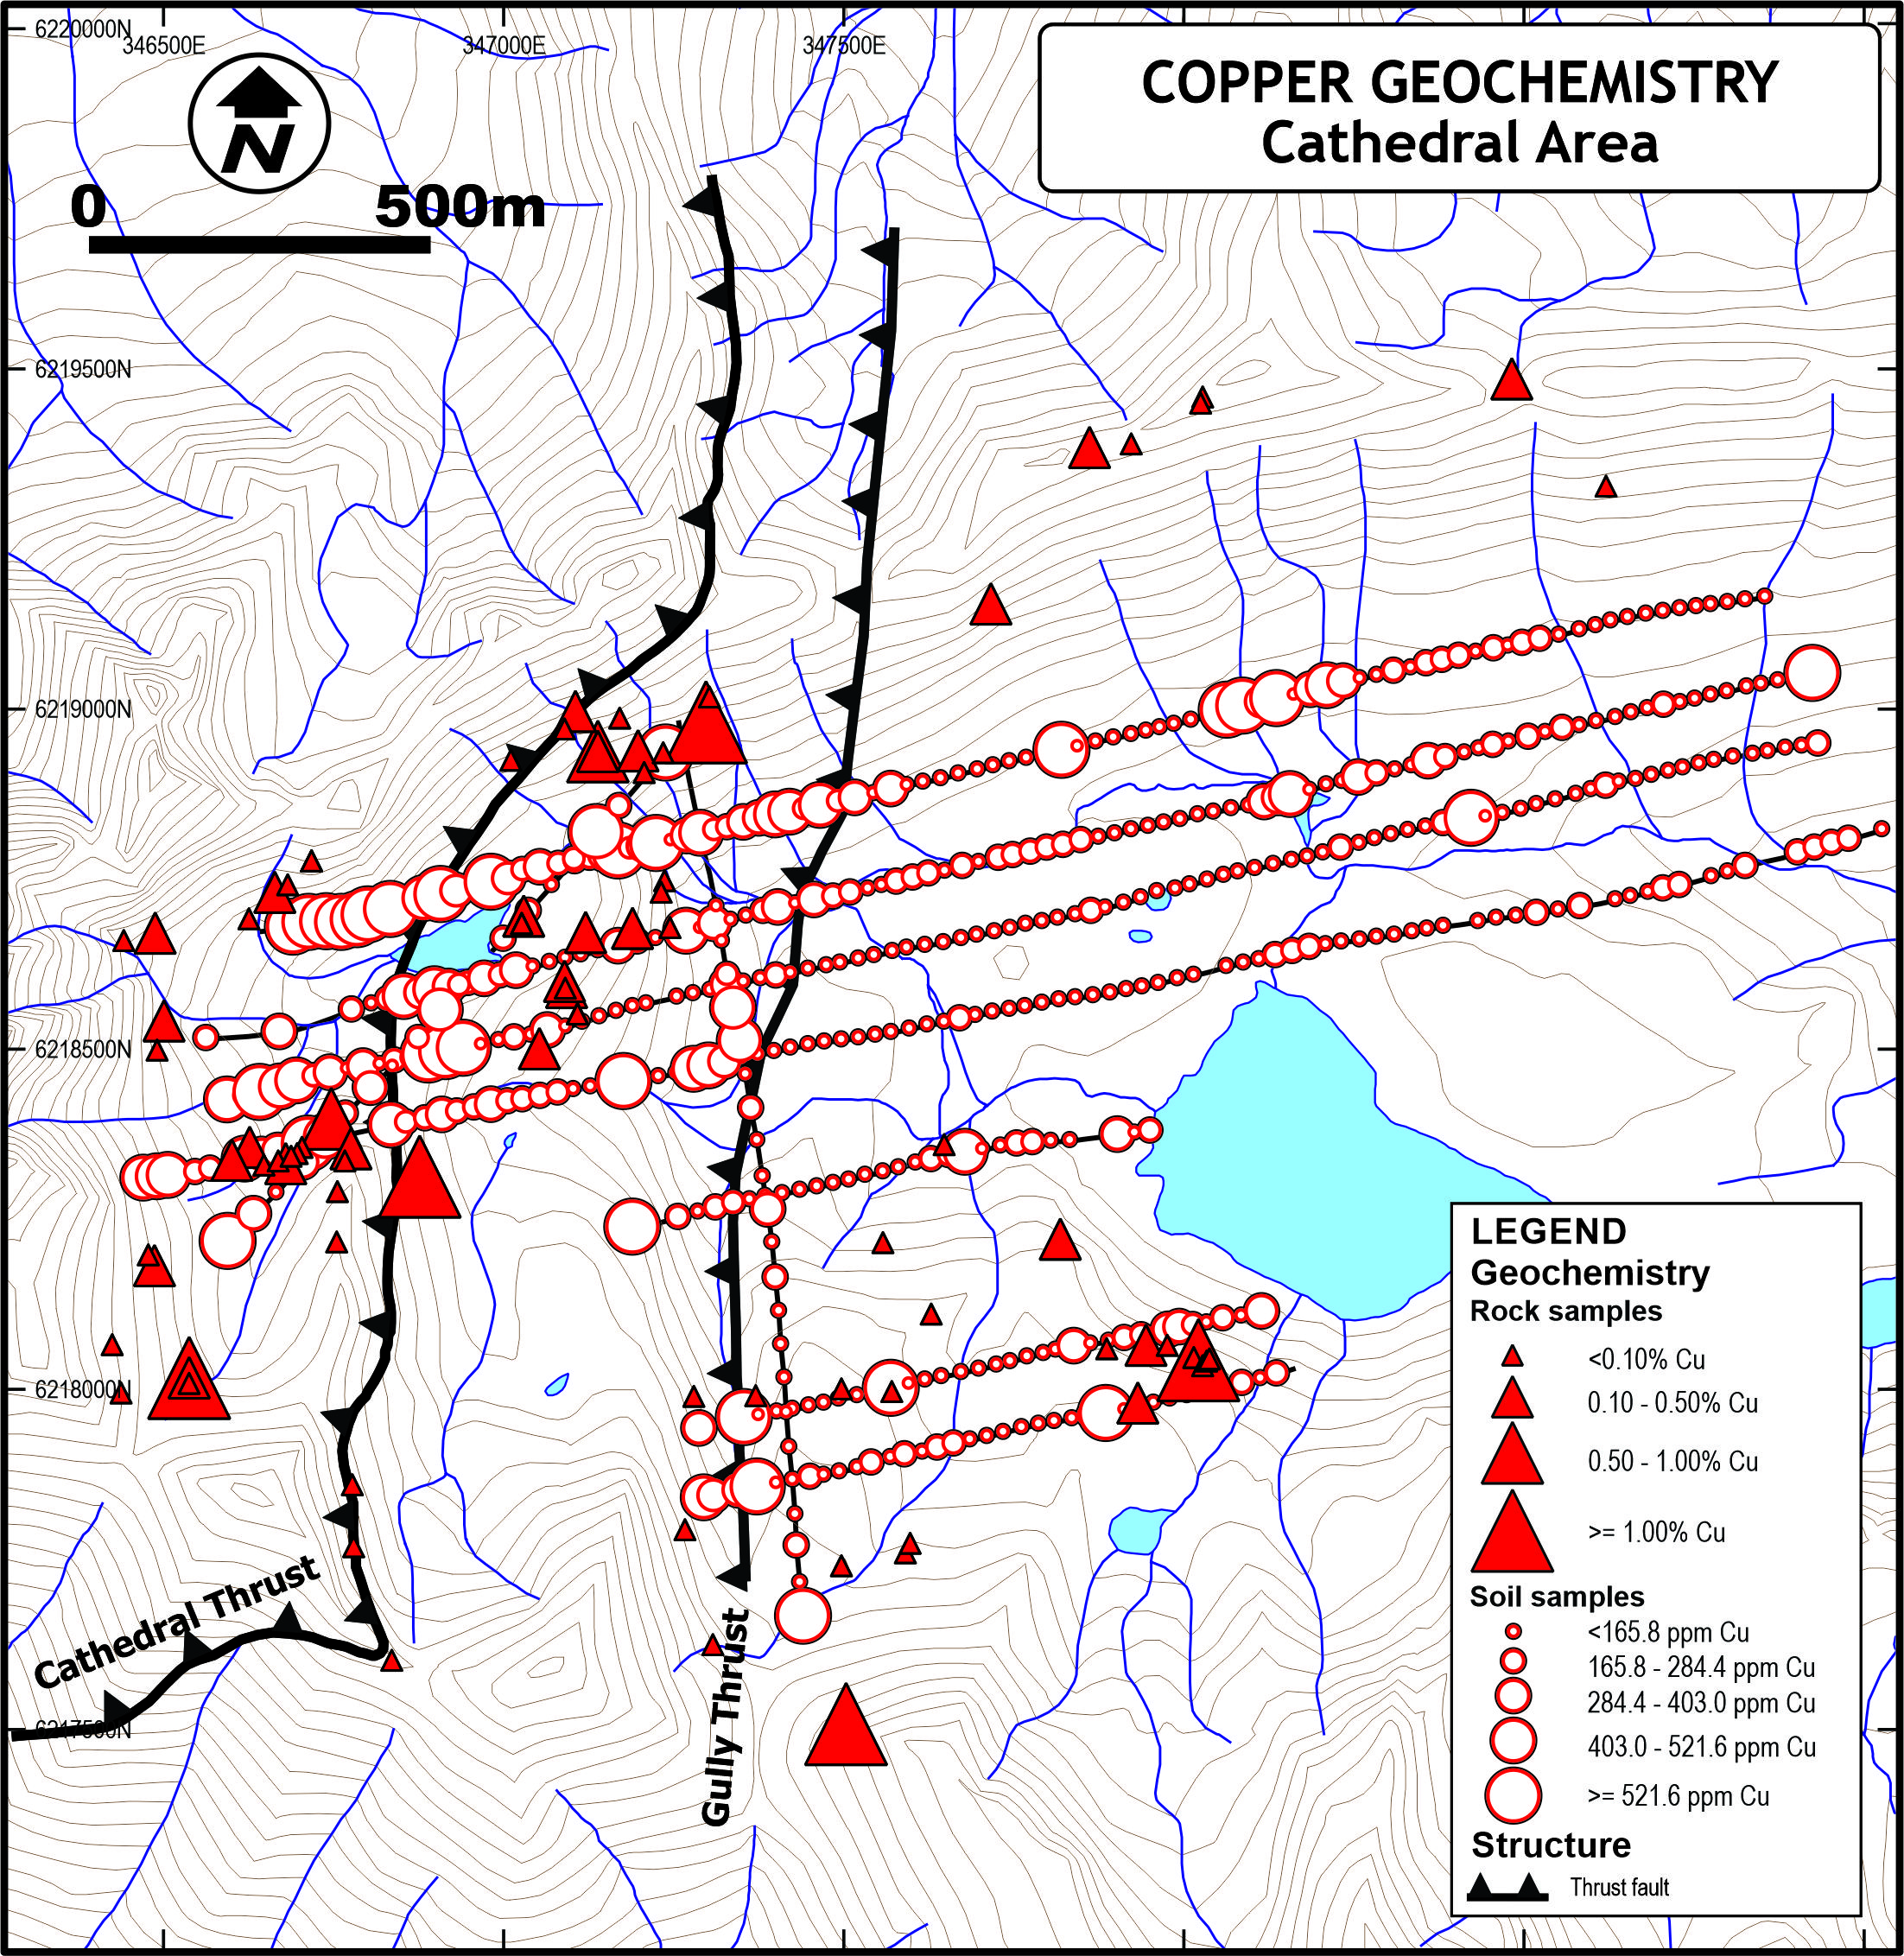

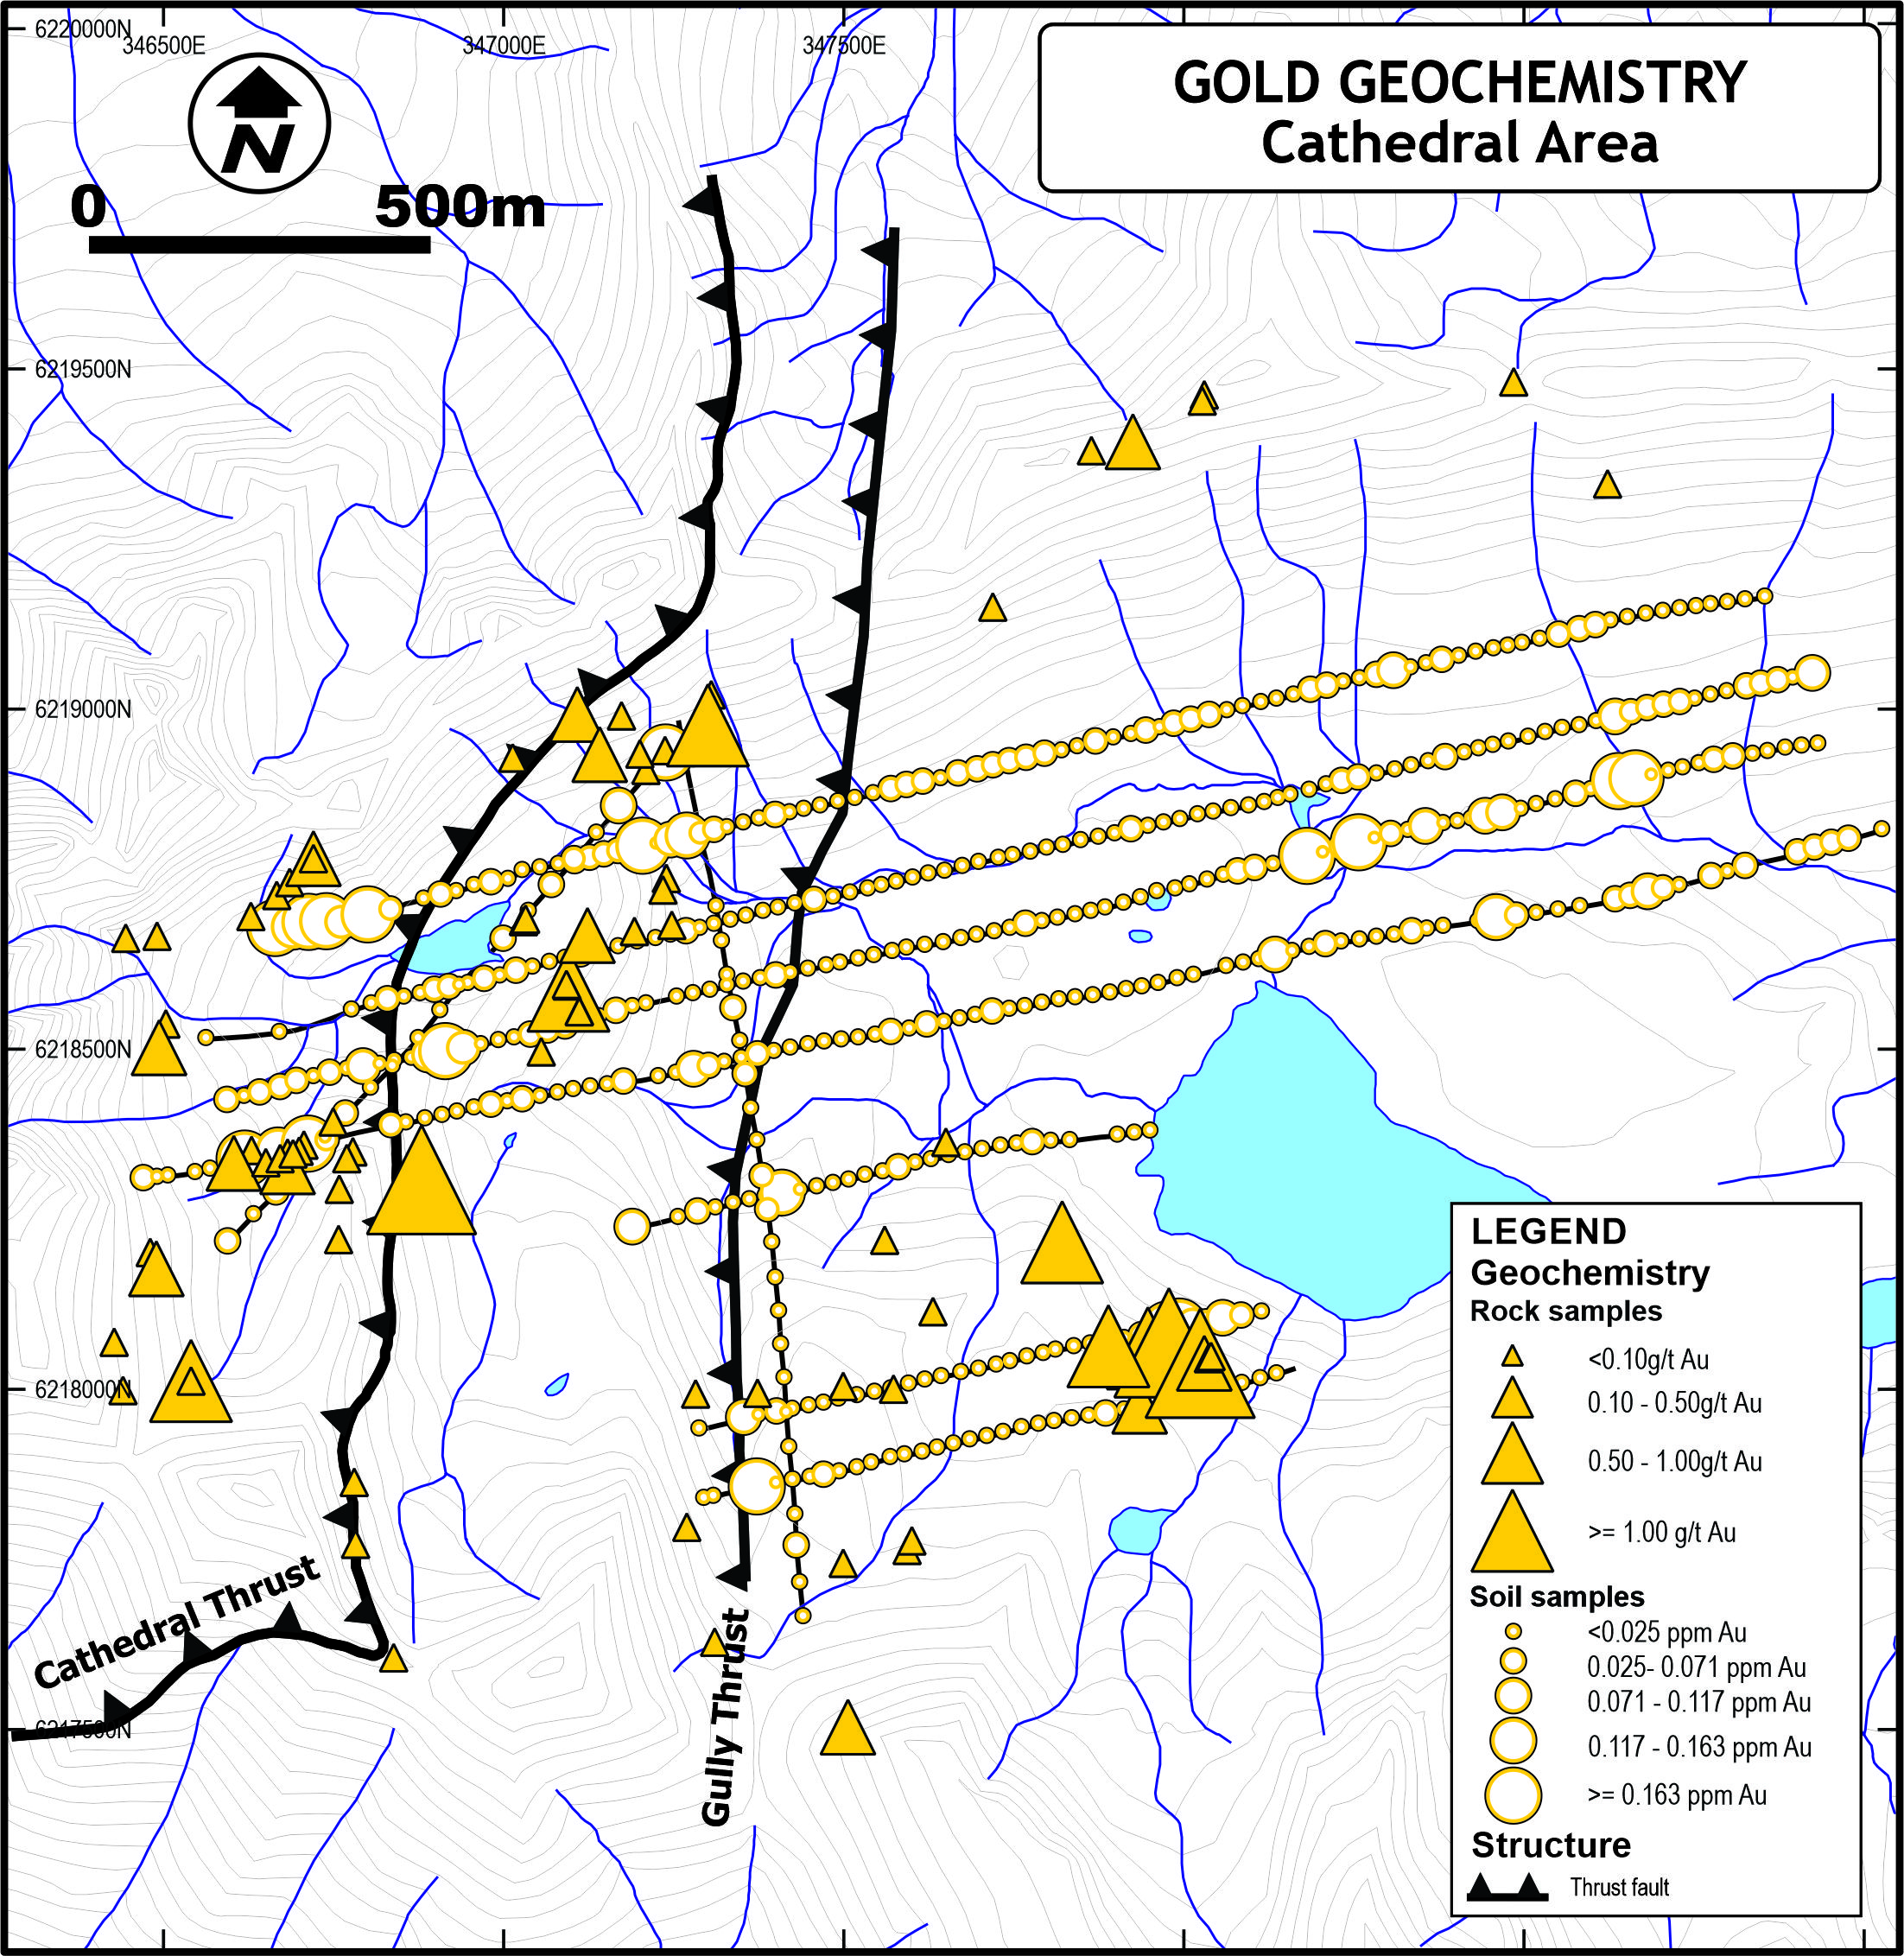

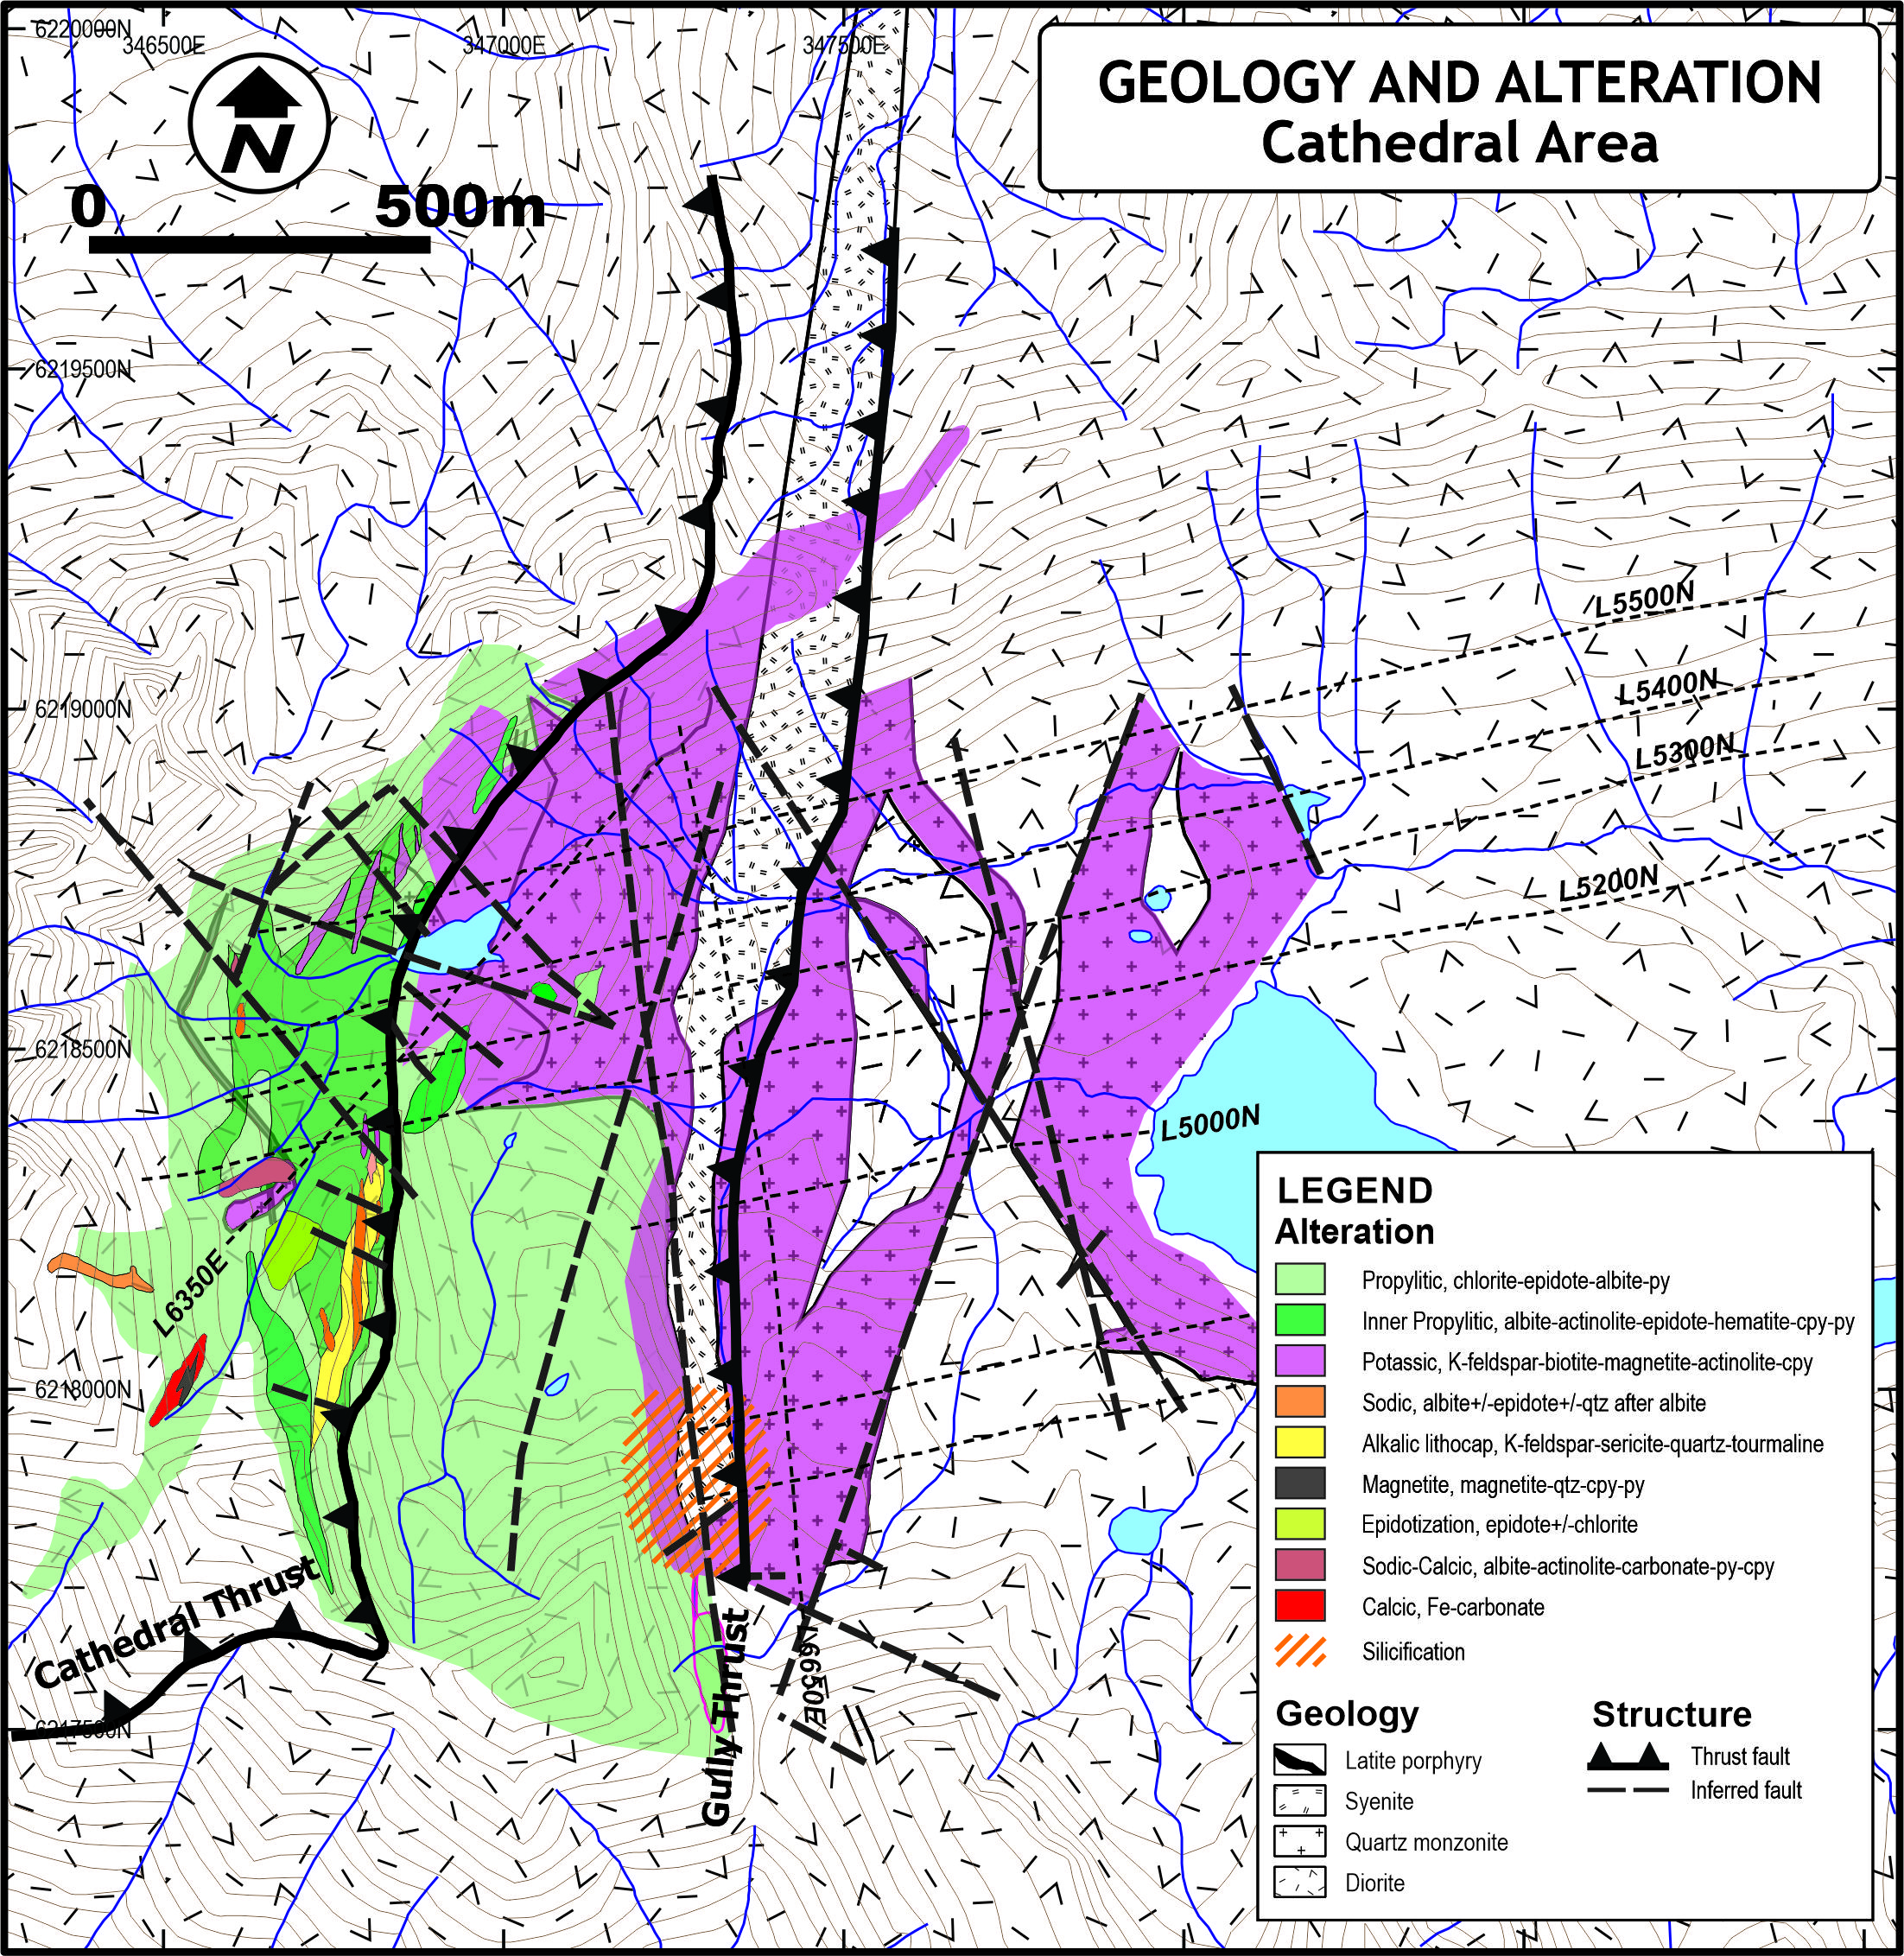

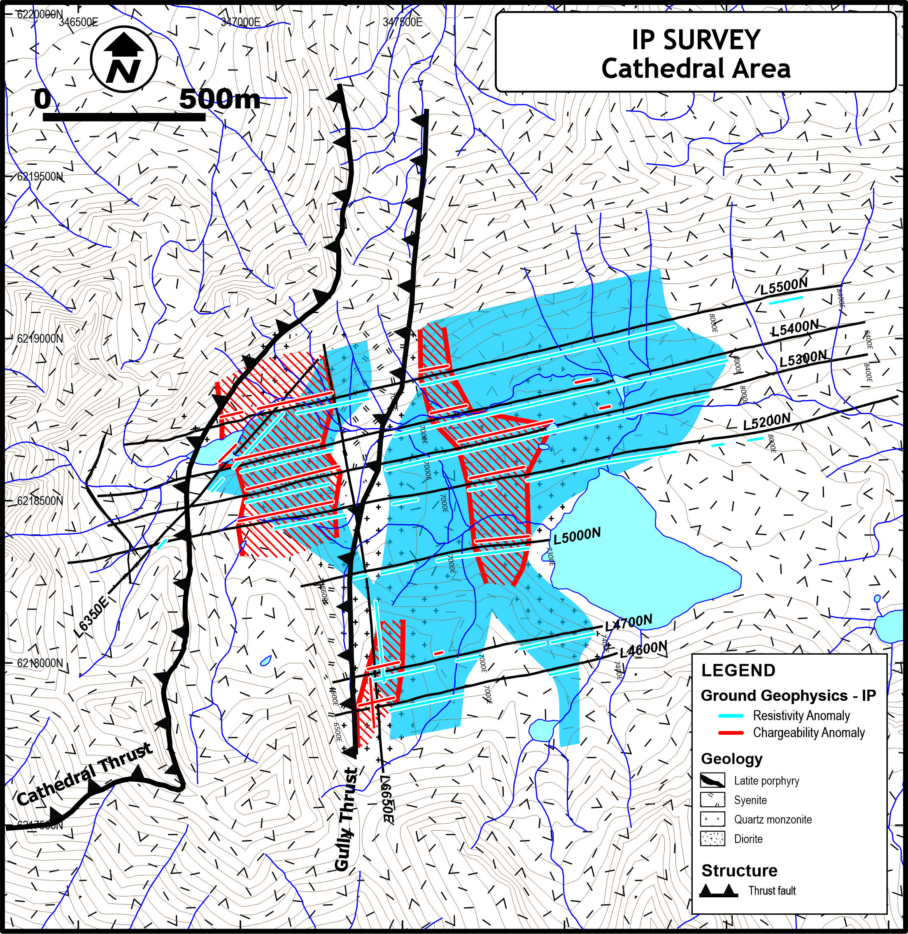

All samples were transported by the exploration team manager. Rock samples were cut by rock saw with one half delivered to ALS Minerals (ALS) of North Vancouver, BC for sample preparation and analysis while the other half of the sample was retained for reference. Analysis consisted of multi-element ICP-MS and gold by fire assay with assays performed on over limits.

Further examination of data and sampling collected from other areas near the Cathedral Area will be reported in the near future.

The scientific and technical information disclosed in this news release was reviewed, verified and approved by Christopher O. Naas, P. Geo., COO of IMC who is a “Qualified Person” as defined in NI 43-101.

ON BEHALF OF IMC INTERNATIONAL MINING CORP.

David McMillan
Interim Chief Executive Officer and Director
Telephone: +1-604-588-2110

Investor Relations:
Email: ir@imcxmining.com
Telephone: +1-604-588-2110
Website: https://imcxmining.com

ABOUT IMC INTERNATIONAL MINING CORP.

IMC is a junior exploration and development company focused on creating shareholder value through the advancements of its current assets that include the Thane Property in north-central British Columbia, and the Bullard Pass Property in Arizona. Utilizing its heavily experienced management team, IMC continues to source and evaluate assets to further generate shareholder value.

The Thane property covers approximately 206.58 km² (50,904 acres) and is located in the Quesnel Terrane of north-central British Columbia. The northern part of the Quesnel Terrane extends from south of the Mt. Milligan Mine northward to the Kemess Mine, with the Thane Property located midway between these two copper-gold porphyry deposits.

Details of some of the key deposits in the northern portion of the Quesnel Terrane include:

Deposit | Tonnes (Mt) | Cu (%) | Au (g/t) | Ag (g/t) | Mo (ppm)
Kemess East¹
Indicated | 177.5 | 0.36 | 0.40 | 1.97 | -
Inferred | 29.3 | 0.31 | 0.3 | 2.00 | -
Kemess U/G¹
Indicated | 173.7 | 0.18 | 0.30 | 1.55 | -
Inferred | 47.7 | 0.20 | 0.30 | 1.65 | -
Kwanika (Swan)²
Central Zone Indicated | 182.6 | 0.29 | 0.28 | - | -
Central Zone Inferred | 28.5 | 0.18 | 0.20 | - | -
South Zone Inferred | 129.1 | 0.30 | 0.09 | 1.76 | 100
Lorraine³
Measured + Indicated | 6.4 | 0.61 | 0.23 | - | -
Inferred | 28.82 | 0.45 | 0.19 | - | -
Mt. Milligan⁴
Proven | 114.75 | 0.23 | 0.41 | - | -
1 - www.centerragold.com/operations/kemess/reserves-and-resources
2 - www.serengetiresources.com /s/Kwanika.asp
3 - (Giroux and Lindinger, 2012)
4 - www.centerragold.com/operations/mount-milligan/production-and-reserves

The Cathedral property includes several highly prospective mineralized areas identified to date, including the ‘Cathedral Area’ on which the Company’s exploration is currently focused.

The Bullard Pass Property is comprised of 171 unpatented federal lode claims totaling 3,420 acres and is located in west-central Arizona, northwest of Phoenix, within the Pierce Mining District of Yavapai County. The property has a regional setting typical of detachment fault gold deposits and has geological, mining and metallurgical similarities to the Mesquite Mine in California. The claims are 100% owned by IMC International Mining Corp.

The Canadian Securities Exchange has not reviewed, approved or disapproved of the contents of this news release.

