FOR IMMEDIATE RELEASE

NORAM COMPLETES CVZ-67: ENDS IN MINERALIZATION AT 502 FT (153 m)

Vancouver, British Columbia – February 23, 2021 – Noram Ventures Inc. (“Noram” or the “Company”) (TSX - Venture: NRM / Frankfurt: N7R / OTCQB: NRVTF) is pleased to announce the completion of CVZ-67 at a depth of 502 ft (153 m) and is the deepest hole drilled to date showing mineralization below 400 ft. An intersection of approximately 281 ft (85.6 m) of favourable claystones was evident and drilling ended in blue claystone which has been shown in past programs to host significant amounts of lithium. CVZ-67 was the farthest southeast hole that will be drilled in this Phase V drilling program.
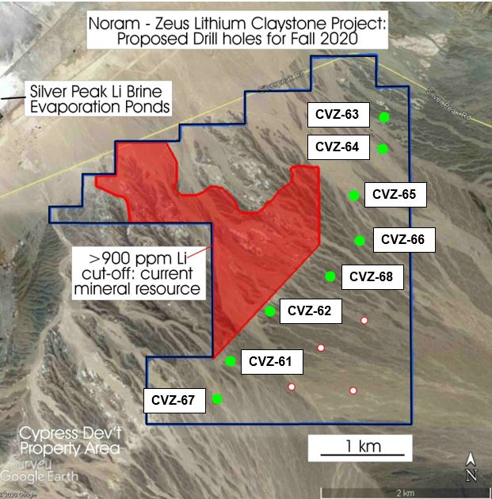
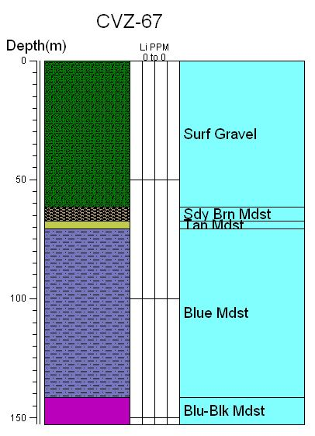
Figure 1a) Strip Log of CVZ-67 outlining the various claystone types encountered at depth from the surface to 502 ft (153 m) b) Zeus Property map showing a) location of current Indicated and Inferred resources at >900ppm Li cut-off; b) location of drill sites completed or in progress (seen in green) to date for the Phase V 2020 program. Proposed drill sites not yet explored indicated in white.
From (ft) | To (ft) | From (m) | To (m) | Rock Type
0 | 202 | 0.0 | 61.6 | Surface Gravel
202 | 221 | 61.6 | 67.4 | Brown Sandy Mudstone
221 | 232 | 67.4 | 70.7 | Tan Claystone
232 | 464 | 70.7 | 141.4 | Blue Claystone
464 | 502 | 141.4 | 153.0 | Blue & Black Claystone
Total Depth = 502 ft.
Table 1 – Summary of Figure 1a Strip Log, describing the lithologies of CVZ-67 from surface to depth of 502 ft (153 m).
The core hole passed through a probable fault zone around 310 feet (94.5 m). The angle of the bedding in the core changed below that point and was tilted at angles varying from 10° to 25° for the remainder of the hole. The tilting should not have affected the grade of the lithium mineralization but indicates that the drill hole passed into a fault block that is somewhat tilted in relation to nearby blocks. Block faulting is a normal occurrence in the Basin and Range physiographic province of the western United States.
“This is another important drill hole for Noram. It is the deepest drilled to date with visually favourable claystones apparent at the bottom. We were very pleased to see this and expect the results to be consistent based upon the yield of these claystones from prior drilling. The Company has not previously drilled in this area, nor at these depths; consequently, the results will significantly impact the resource modelling. From visual inspection alone, it appears that CVZ-67 once again confirms our theories on both the dip and direction of the resource” commented Brad Peek, consulting geologist and Qualified Person for all drilling phases of Noram’s Zeus lithium property.
Samples were sent to ALS Labs in North Vancouver on a rush basis and assays are pending. These lakebed sediments have shown very uniform lithologies and lithium grades over large areas of Clayton Valley.
The technical information contained in this news release has been reviewed and approved by Brad Peek., M.Sc., CPG, who is a Qualified Person with respect to Noram’s Clayton Valley Lithium Project as defined under National Instrument 43-101.

About Noram Ventures Inc.

Noram Ventures Inc. (TSX - Venture: NRM / Frankfurt: N7R / OTCQB: NRVTF) is a Canadian based junior exploration company, with a goal of developing lithium deposits and becoming a low - cost supplier. The Company’s primary business is the Zeus Lithium Project (“Zeus”) in Clayton Valley, Nevada. The Zeus Project has a current resource estimate of 124 million tonnes at 1136 ppm lithium as Indicated Resources, and 77 million tonnes lithium at 1045 ppm lithium as Inferred Resources (900 ppm Li cut-off: 1.18 million tonnes lithium carbonate equivalent – “LCE”.

Noram’s long term strategy is to build a multi-national lithium minerals company to produce and sell lithium into the markets of Europe, North America and Asia.

Please visit our web site for further information: www.noramventures.com

ON BEHALF OF THE BOARD OF DIRECTORS
/s/ “Anita Algie”
Director and CFO
Office: (604) 553-2279
Neither the TSX Venture Exchange nor its Regulation Services Provider (as that term is defined in the policies of the TSX Venture Exchange) accepts responsibility for the adequacy or accuracy of this release. This news release may contain forward-looking information which is not comprised of historical facts. Forward-looking information involves risks, uncertainties and other factors that could cause actual events, results, performance, prospects and opportunities to differ materially from those expressed or implied by such forward-looking information. Forward-looking information in this news release includes statements regarding, among other things, the completion transactions completed in the Agreement. Factors that could cause actual results to differ materially from such forward-looking information include, but are not limited to, regulatory approval processes. Although Noram believes that the assumptions used in preparing the forward-looking information in this news release are reasonable, including that all necessary regulatory approvals will be obtained in a timely manner, undue reliance should not be placed on such information, which only applies as of the date of this news release, and no assurance can be given that such events will occur in the disclosed time frames or at all. Noram disclaims any intention or obligation to update or revise any forward-looking information, whether as a result of new information, future events or otherwise, other than as required by applicable securities laws.

