EasyFi Network’s native token EASY integrated on the Binance Bridge
Seamless EASY Token transfers now activated between Ethereum & Binance Smart Chain
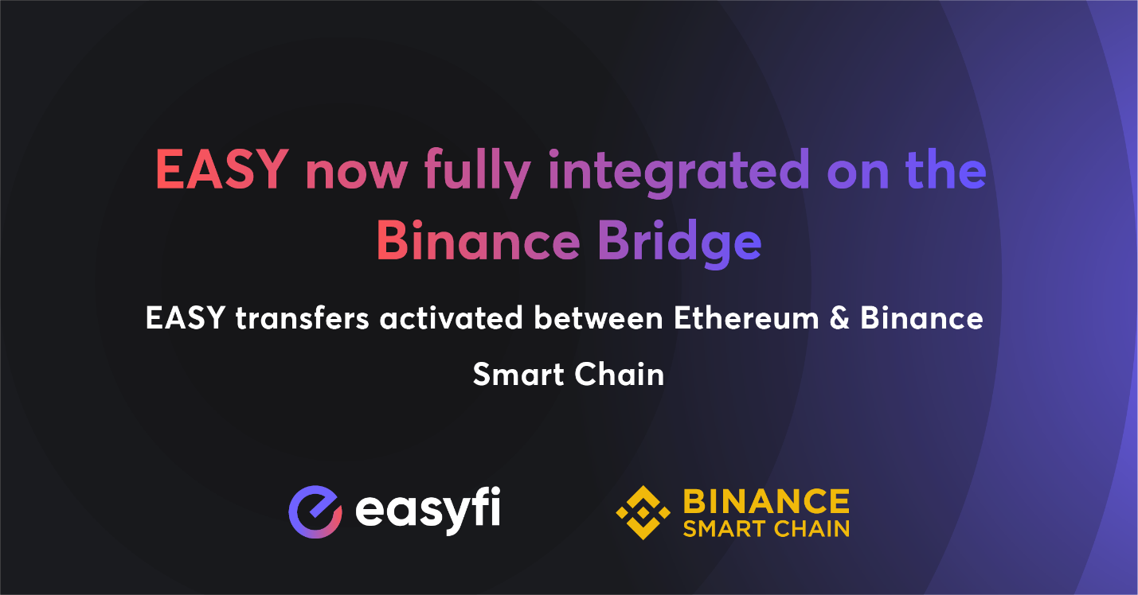
Easyfi Network, the universal Layer 2 DeFi lending protocol for digital assets has announced its We are proud to announce that $EASY is now live on the Binance Bridge for enabling EASY token transfers directly between Ethereum and Binance Smart Chain.
This comes ahead of the full integration of our protocol on Binance Smart Chain (BSC) and is in line with our earlier update on the same subject.
This means that Binance Bridge will now support EASY apart from 35 other popular digital assets for interchain transfers.
This also indicates that EASY is now fully integrated and deployed on the BEP20 Token Standards apart from being an ERC20 token.
This completes two of the three objectives that EasyFi has started off with on the mission to expand to Binance Smart Chain.
✅ BSC Bridge integration, and
✅ EASY Token Deployment on BSC under BEP20 standards
The final step will be the full integration and deployment of the lending protocol on BSC.

What is the Binance Bridge Project?
Token transfers on Binance Smart Chain happen through a token canal or Bridge built on BSC. This is by far the fastest way to bring cross-chain assets to Binance Smart chain. It is a service that provides access to inter-blockchain liquidity between BSC and other chains, including Ethereum-based Decentralized Apps. This will allow users to exchange assets, and transfer them in and out of varied blockchains to the Binance chain ecosystem.
The Binance Bridge Project aims to:
- increase interoperability between different blockchains
- allow a digital asset owner to convert their crypto assets into (and back from) Binance Smart Chain wrapped tokens.

How does the Bridge Integration help?
The expansion of EasyFi lending protocol to Binance Smart Chain is currently underway and absolutely on-track and the team should be able to cover much ground by the end of this month. Here is what The BSC bridge integration with EasyFi will primarily accomplish:
- Bridge liquidity across chains through the protocol which is also available on Polygon and Ethereum networks.
- This integration will also allow seamless conduit connecting the Ethereum and Binance smart chain ecosystems together.
- Enable EasyFi users to transfer their $EASY and other tokens in and out of the Binance Ecosystem effortlessly and seamlessly.
- The users of EasyFi’s products and services such as staking, farming, lending will be able to move collaterals to and from the chains we are deployed on, to the BSC based EasyFi protocol.
- Expand the horizons for EASY token holders, with the inclusion of the growing ecosystem of ERC20 and Non-ERC20 pegged assets on Binance Smart Chain.
How to use the Binance Bridge to transfer EASY tokens from Ethereum to BSC?
There are 2 Ways to Transfer EASY to Binance Smart Chain using the Ethereum and Binance.com paths. Please go through the attached link to the guide to be able to use the bridge for moving EASY tokens between Ethereum network and BSC:
https://bit.ly/3fekx20
Stay tuned for more updates on these soon!
About EasyFi
Easyfi is a universal layer 2 lending protocol built for defi focused on scalability, composability, and adoption. It has been designed as an open and inclusive financial network infrastructure to run on public networks to facilitate an end-to-end lending & borrowing of digital assets and related financial products. Easyfi is being built upon the ethos of permission less networks & automation of smart contracts.
Website | Twitter | Telegram | Whitepaper | App

