Editor : Joanna Philippa

Title:
A MESSAGE IN A BOTTLE...
Love, Loss and Living Though It Expressed In Poetry
by Shajeel D’zyner

International Artist, Designer and Poet Talks about Love and Heartbreak
in His Debut Collection of Poetry.

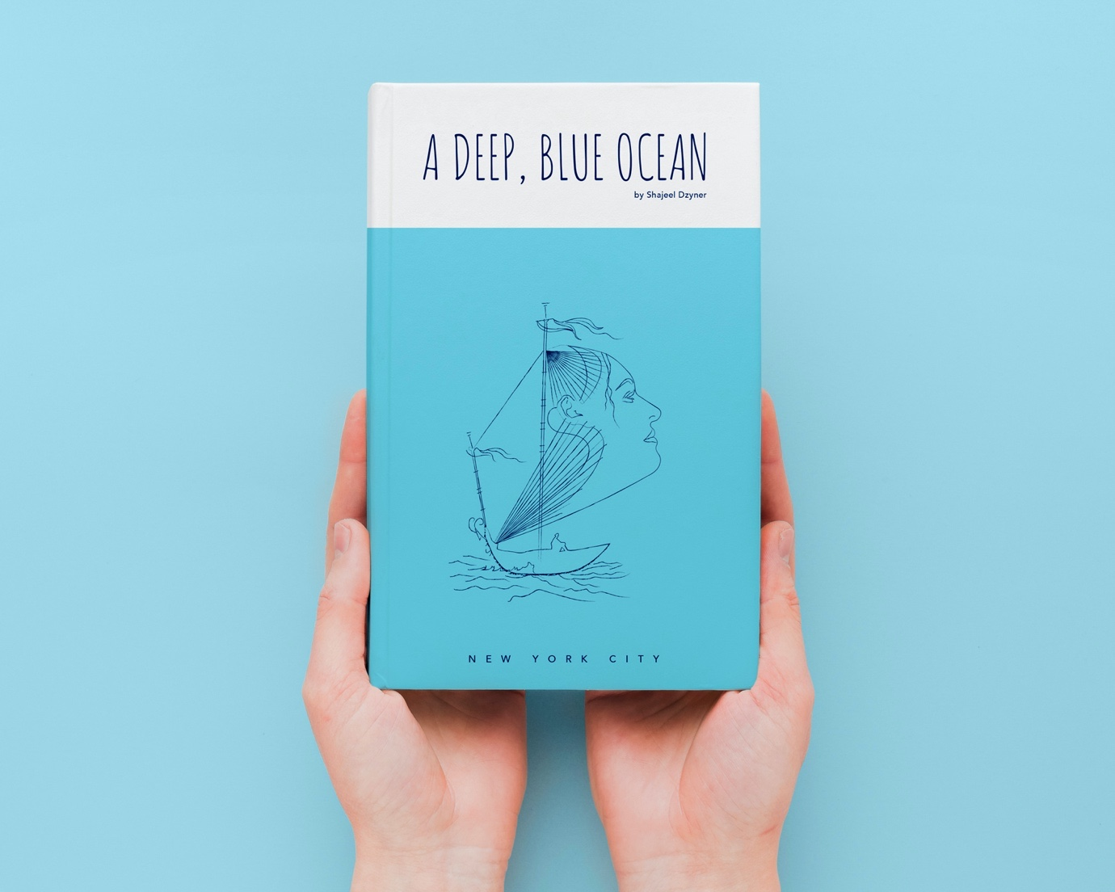

Amazon: https://www.amazon.com/dp/B08MVC893T?ref_=pe_3052080_397514860
Website: https://www.shajeeldzyner.com
Instagram: https://www.instagram.com/poetry_nyc

Globe-trotter and professional artist, Shajeel D’zyner has just published on Amazon his debut collection of poems- A Deep, Blue Ocean: New York City. Born in 1985, Shajeel is no stranger to the art world, growing up in a family of fashion designers, he was drawn to creativity from a very young age. Each one of his poems is unique and based on true events, touching on the intricacies of the heart either spell-bound and submerged by love or depicting the pain that such sweet emotions induce.

If you should stroll down the streets of Upper East Side Manhattan and order a coffee in one of the trendy cafés one Saturday morning, you may be so lucky as to come across him. A discreet observer of people, you could say Shajeel has over the years become an expert on the matters of the heart. He observes and listens. A Deep, Blue Ocean first came to life in 2017 but it was only in the last year that the young poet found an inner force to complete his creative work of no less than 60 poems. He attributes this to the love of his life, a gorgeous lady from Long Island New York, whose identity remains a mystery to the reader. He dedicates this collection to her.

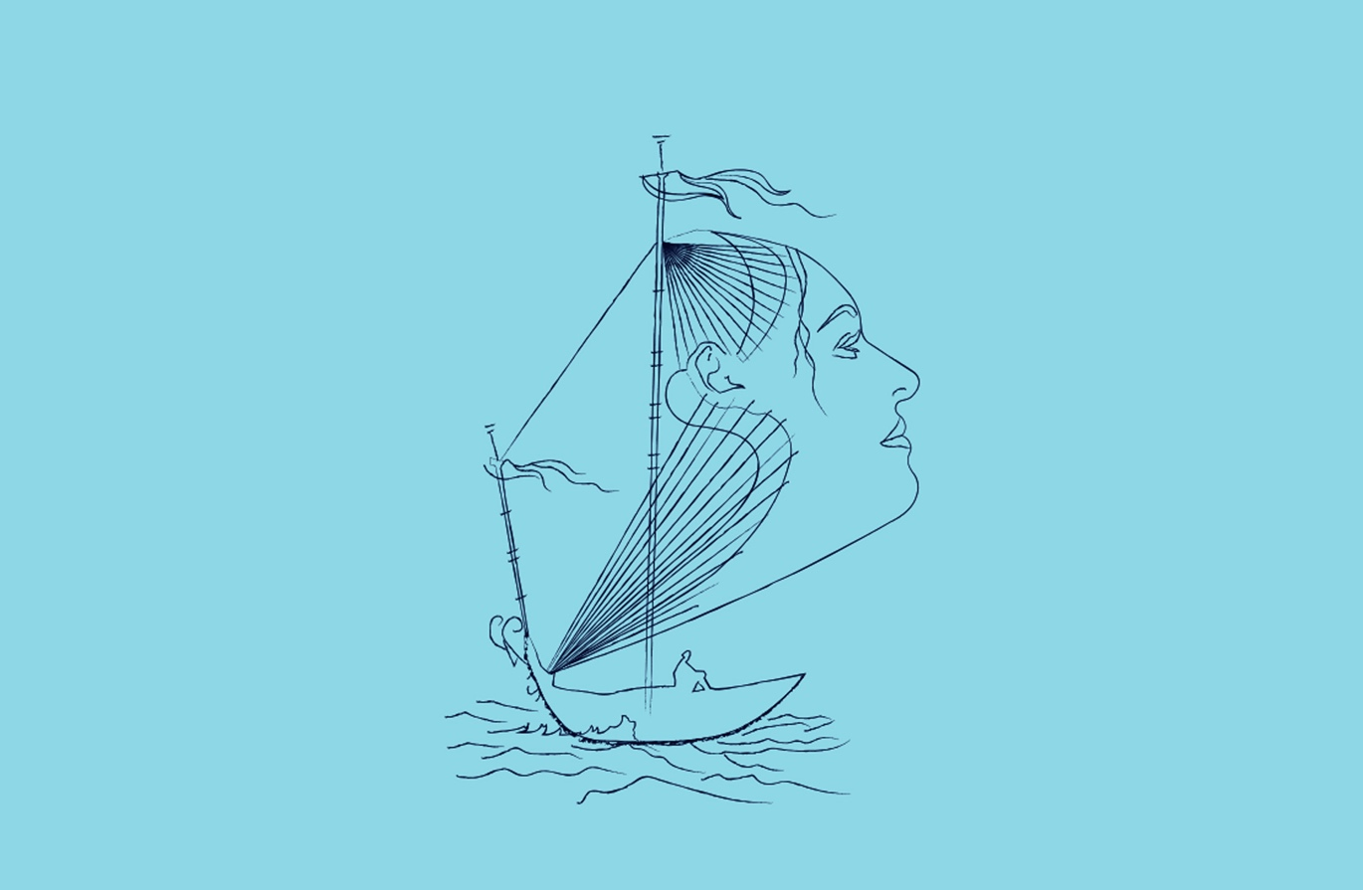

The poet pays a poignant homage to his soul mate by depicting her face in the sails of the boat on the book’s cover. The author is seen sitting on the boat’s deck, while the heroine, and she only, enables him to sail forward through life’s odyssey and beyond into the infinite ocean of love.

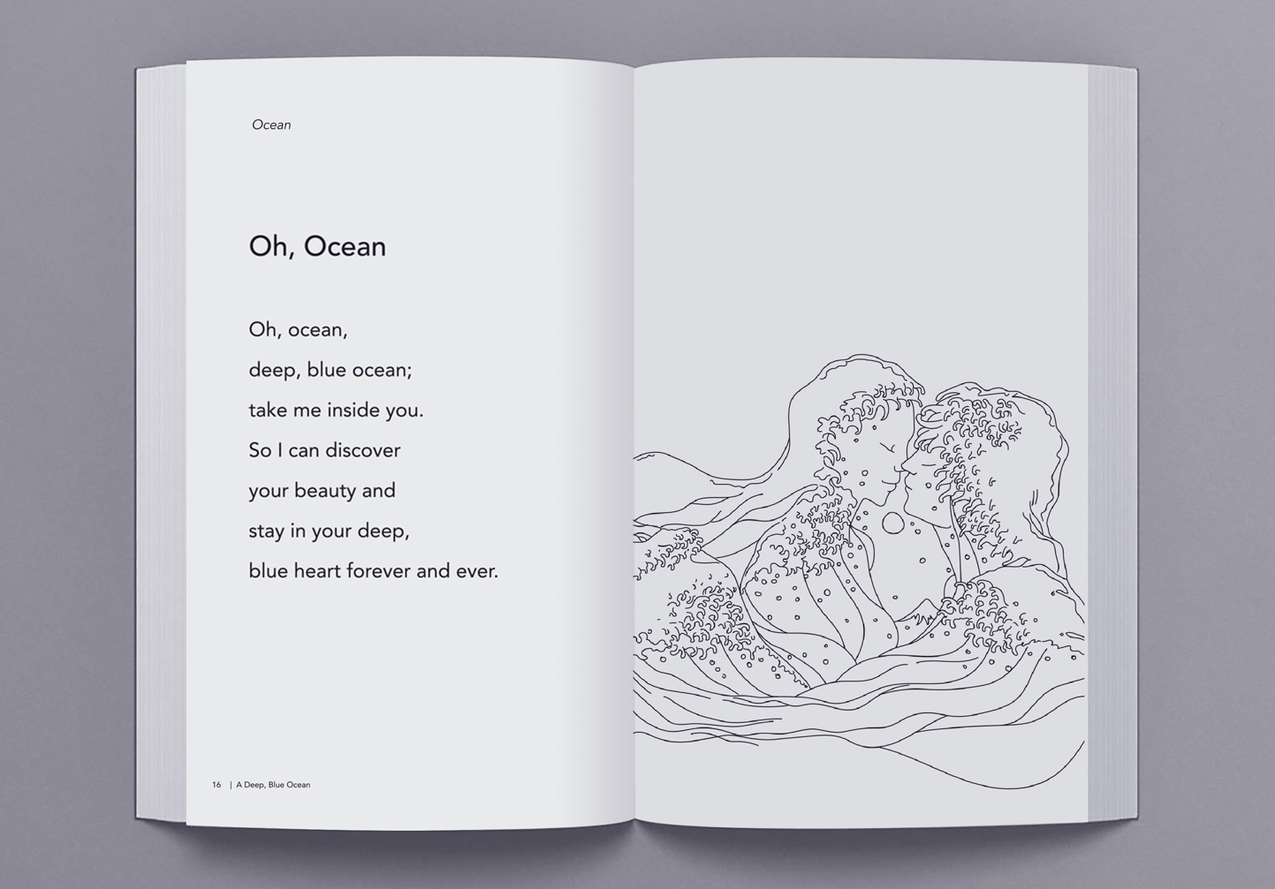

Shajeel is a graduate of Fine Arts from the National Academy of Design in New York and has more than 15 years of experience as an art director and designer, collaborating with some of the biggest names in the industry. It is no wonder then, that the author of A Deep, Blue Ocean should take it upon himself to instill life in the poems through his evocative illustrations. A fervent admirer of women’s qualities, Shajeel remarks:
“I want to transform myself into a souvenir gift
so people will carry me around the world.”

Love will often walk hand in hand with pain and suffering that loss can cause yet love lives on.
With A Deep, Blue Ocean you will learn to love and reshape your life.

