Movano Inc. Provides Business Update and Reports First Quarter 2021 Financial Results

Conference call begins at 2:00 p.m. Pacific time today

Pleasanton, Calif. – May 13, 2021 – Today, Movano Inc. (NASDAQ:MOVE), a health technology company designing devices that empower individuals to optimize their health in order to help prevent and better manage chronic diseases, reported financial results for the three months ending March 31, 2021 and provided a business update. Highlights of the first quarter of 2021 and recent weeks include the following:

- On March 25, 2021, the Company closed its previously announced initial public offering of 8,500,000 shares of its common stock at a public offering price of $5.00 per share. In connection with the closing of the offering, the underwriter exercised in full its over-allotment option to purchase an additional 1,275,000 shares. As a result, the gross proceeds from the offering, before deducting underwriting discounts and commissions and offering expenses payable by Movano Inc., were $48.9 million.
- Dr. John Mastrototaro joined the Company as CEO, effective April 1, 2021. Dr. Mastrototaro’s more than 30 years of experience in the medical device industry, leading innovation and bringing new products to the market will provide critical medtech expertise and strategic vision, as well as bolster the Company’s growth profile.
- During the first quarter 2021, the Company continued to make steady progress toward its wearable, noninvasive Radio Frequency (RF) technology platform solution, which is powered by proprietary integrated circuits (ICs), antennas, algorithms and supporting apps and cloud infrastructure. The solution is designed to allow the Company to produce medical devices in a variety of form factors that give users continuous data and actionable feedback to help improve their quality of life. The net proceeds of the recently completed initial public offering will enable the Company to expand testing and regulatory initiatives, as well as accelerate the growth of the team to augment the planned feature set for the Company’s first commercial device.

“Movano was founded on our core belief - that good health is a fundamental human right,” said Dr. John Mastrototaro, Movano’s CEO. “We are on a multi-year mission to empower individuals, including those with chronic diseases, such as diabetes and hypertension, to optimize their health with medical devices that are personalized, simple, and smart. The scale of the chronic disease crisis is immense, and the need to address it is immediate. We are focused on providing vital health data to a massive and underserved population, delivering insights that help mitigate, delay or avoid the effects of chronic disease for potentially millions of people worldwide, while at the same time building a durable enterprise. Our proprietary technology has tremendous potential, and we’re dedicated to executing on our plan over the next several years.”

First Quarter 2021 Financial Results

- Movano reported a net loss attributable to common stockholders of $8.1 million, or a loss of $1.01 per basic and diluted share, in the first quarter of 2021, compared with a net loss attributable to common stockholders of $4.0 million, or a loss of $1.58 per basic and diluted share, in the first quarter of 2020.
- The Company reported an operating loss of $3.3 million in the first quarter of 2021 compared to an operating loss of $2.0 million in the first quarter of 2020.
- Movano is a development stage company and the majority of our business activities to date and our planned future activities will be devoted to research and development. As such, the Company did not generate revenue in either the first quarter of 2021 or the first quarter of 2020.
- The Company had $46.8 million in cash and cash equivalents as of March 31, 2021, compared to $5.7 million in cash and cash equivalents, as of December 31, 2020.
- The total number of shares outstanding was 32.8 million as of March 31, 2021.
Conference Call and Webcast
Management will host a conference call and live audio webcast to discuss these results and provide a business update today at 2:00 p.m. PDT (5:00 p.m. EDT).

The live webcast can be accessed on the investors section of Movano's website at https://ir.movano.com. The conference call can be accessed by dialing 1-877-407-0989 (domestic) or 1-201-389-0921 (international) and refer to confirmation number 13719127. An archived webcast will be available on Movano's website approximately one hour after the completion of the event and for two years thereafter.

To learn more about Movano Inc., please visit www.movano.com

About Movano Inc.
Founded in 2018, Movano Inc. (NASDAQ:MOVE), is a health-focused technology company creating simple, smart and personalized devices designed to help individuals on their health journey optimize for good health today and prevent and manage chronic diseases in the future. Movano’s technology is being developed to provide vital health information, including glucose and blood pressure data, in a variety of form factors to meet individual style needs and give users actionable feedback in order to improve their quality of life.

Forward Looking Statements
This press release contains forward-looking statements concerning our expectations, anticipations, intentions, beliefs or strategies regarding the future. These forward-looking statements are based on assumptions that we have made as of the date hereof and are subject to known and unknown risks and uncertainties that could cause actual results, conditions and events to differ materially from those anticipated. Therefore, you should not place undue reliance on forward-looking statements. Examples of forward-looking statements include, among others, statements we make regarding expected future operating results; product development, clinical trial and regulatory initiatives; our strategies, positioning and expectations for future events or performance. Important factors that could cause actual results to differ materially from those in the forward-looking statements are set forth in our registration statement on Form S-1, as amended, and any subsequent Quarterly Reports on Form 10-Q, and in our other reports filed with the Securities and Exchange Commission, including under the caption “Risk Factors.” Any forward-looking statement in this release speaks only as of the date of this release. We undertake no obligation to publicly update any forward-looking statement, whether written or oral, that may be made from time to time, whether as a result of new information, future developments or otherwise.

Investor Relations Contact:
J. Cogan
IR@movano.com

Movano Inc.
Condensed Balance Sheets
(in thousands, except share and per share data)
(Unaudited)
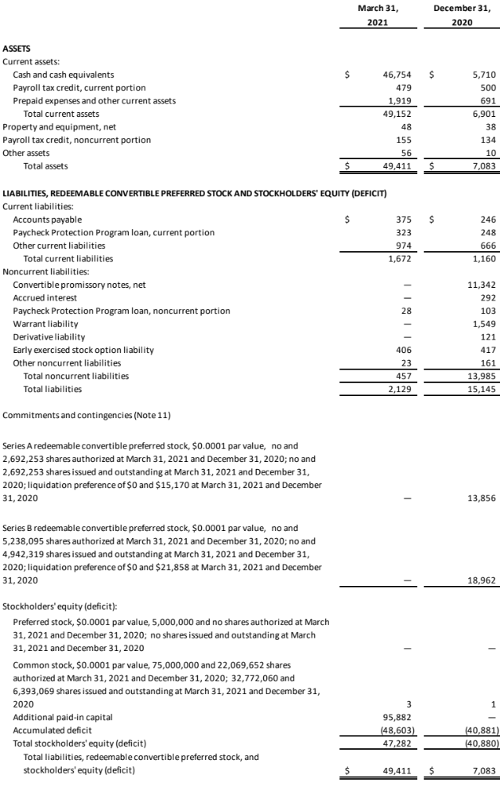

Movano Inc.
Condensed Statements of Operations and Comprehensive Loss
(in thousands, except share and per share data)
(Unaudited)

