Press Release
Popular Brand 883 Police to launch Digital Apparel NFTs in collaboration with Bling
883 Police’s unique wearable NFTs to adorn user’s wardrobe in the Metaverses
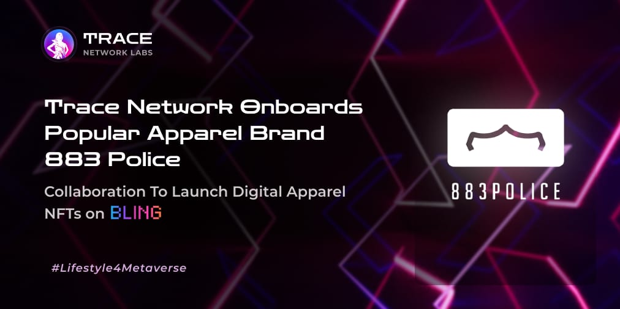
Gurgaon, India 21st october 2021
Trace Network Labs is thrilled to onboard a very popular & globally renowned fashion brand- 883 POLICE on the NFT bandwagon. The global conglomerate & brand has planned to launch a special edition “883 Police NFT Collection” on Bling - Trace’s Limited Edition Luxury & Lifestyle Products NFT Marketplace.
883 Police is synonymous with its universal style and quality and is globally known for its textile traditions and has been recognised as an icon of excellence .
883 Police NFT Collection
This special edition aims at offering uniquely designed wearable digital apparels across different metaverses. The teams at BLING & 883 Police have taken a quantum leap to expand to metaverse & offer it’s users a unique & personalized experience. The sale of these special edition collections shall be conducted on BLING.
Trace & 883 Police
This unique collaboration between Trace and 883 Police will bring forth a unique range of fashion garments to the NFT space and offer NFT collectors & connoisseurs to access a globally renowned brand in ever expanding digital space, strut around in the multiverse with branded apparels to be worn by their avatars.
883 Police on Bling
- Having 883 Police onboard with Trace is in line with our motive of opening the luxury and lifestyle industry to the metaverse space and onboarding new lifestyle brands and companies on our NFT marketplace.
- There will be a limited number of garment NFTs per collection.
- Each NFT created by 883 Police will represent a unique limited edition garment in the real world in future.
- Each NFT is uniquely created and is exclusively available ONLY on the Bling NFT marketplace.
- The NFTs will be auctioned on a predetermined date on the Bling NFT Marketplace
- These NFT will be metaverse-friendly and “wearable” by the winner’s avatar in metaverse.
- One Rare 883 Police NFT will be available for auction only for Trace NFT Holders. This NFT will be specifically designed for gaming metaverses.
CEO Speak
Conveying his thoughts on this partnership, Seetharaman Kannan, CEO, 883 Police India said, “We are delighted to partner with Trace Network Labs to bring forth a revolutionary phase of digital fashion with 883 Police branded NFTs. We are confident that with the 883 Police brand’s legacy of many years we can bring in extraordinarily quirky digital fashion that can be transacted as NFTs and also worn by users of a metaverse.”
Speaking on the occasion, Lokesh Rao, Co-Founder & CEO, Trace Network Labs commented, “We are thrilled to onboard 883 Police on the Lifestyle for the Metaverse journey at Trace Network Labs. What I find most interesting in fashion is that it reflects your moment. 883 Police has a rich history and roadmap in creating those perfect moments by making a differentiating fashion statement. It is exciting to bring 883 Police limited edition wearable NFTs to Bling marketplace to further enhance the user experience on various metaverses!”
About 883 Police
Born in Italy in 1995, 883 Police has over 200 years of combined experience and expertise in Denim evolution which enabled the brand to be at the forefront of Denim Innovation. That’s how 883 Police has been responsible for many of the Washing techniques, Finishing and Textures that have entered the market over the Last three decades.
Website | Facebook | Twitter | Instagram | YouTube
About Trace Network Labs
Trace Network is a completely decentralized protocol enabling lifestyle for any multichain metaverse. We are building a technology platform that will enable lifestyle brands to launch multichain & multiverse products for the 'digital twin' a.k.a. Avatars of the user / resident of a metaverse. Trace Network Labs wants to help empower our digital selves to roam freely between the world as we know it and the metaverse with its foundation constructed around us, enabling the next evolution of the luxury lifestyle as the boundaries between real and virtual continue to blur. We aim to be the de-facto gateway for lifestyle brands, businesses, projects & consumers alike to enter into ANY metaverse.
Website | Twitter | Medium | Telegram | Announcements
About Bling
The 1st Limited Edition Luxury & Lifestyle Products NFT Marketplace brought to you by Trace Network Labs powered by Polygon (Previously Matic). Currently, NFTs around the world only have a digital connotation, which means you can only own a piece of digital art that has been tokenized on a blockchain. This brand new NFT marketplace from Trace Network, will act as a bridge between real-world goods and virtual non-fungible tokens that have been created specifically to represent a unique piece of that limited edition luxury lifestyle product.
…
For more information, please follow us on Twitter (@trace_network) and join our community on Telegram (@tracenetwork).
Contact:
Lokesh Rao
Trace Network Labs
trace.ops@trace.network
+91-9818778986

