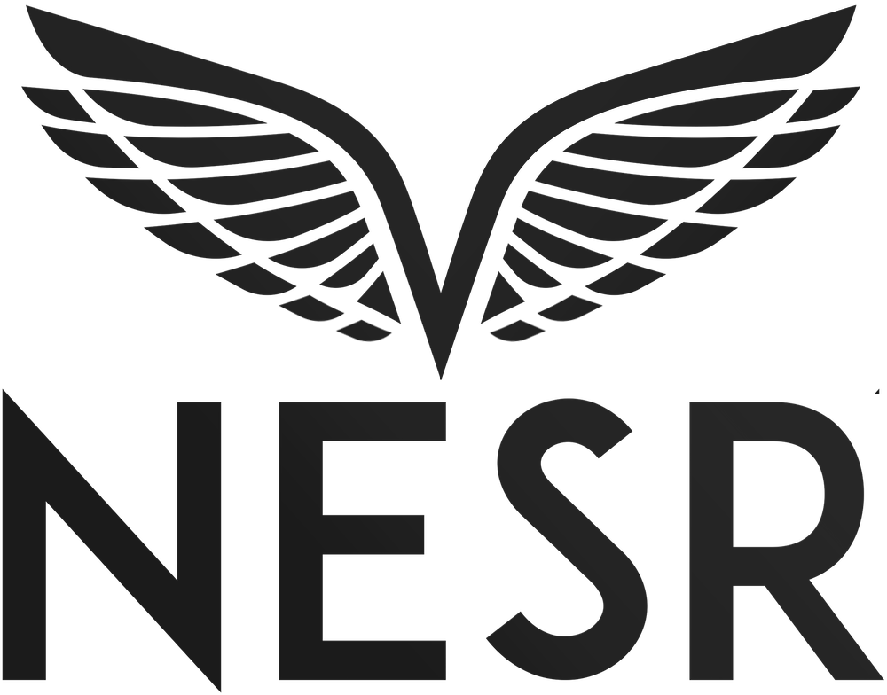

National Energy Services Reunited Corp. to Participate in Upcoming Conferences

HOUSTON, TX / October 24, 2022 / National Energy Services Reunited Corp. (“NESR” or “the Company”) (NASDAQ: NESR) (NASDAQ: NESRW), an international, industry-leading provider of integrated energy services in the Middle East and North Africa (“MENA”) region, today announced that the senior management team will participate in the following upcoming investor conferences and industry events:
- Future Investment Initiative (FII) 25 to 27 October, Riyadh, KSA – NESR CEO Sherif Foda will present on October 26th;

- Abu Dhabi International Petroleum Exhibition & Conference (ADIPEC) – Abu Dhabi, UAE – At the premier industry conference globally, NESR management will showcase new technologies, participate in panel and keynote speaking events, and engage with investors and customers from October 31st to November 4th;

- U.N Climate Change Conference (COP 27) – Sharm El-Sheikh, Egypt – Sherif Foda will present at the Decarbonization Day on November 11th;

- Saudi Green Initiative (SGI) – Sharm El-Sheikh, Egypt – 11 and 12 November

- Bank of America Energy Conference – Miami, USA – Sherif Foda will present on the Int’l OFS panel and host 1x1 meetings November 16-17th;

About National Energy Services Reunited Corp.
Founded in 2017, NESR is one of the largest national oilfield services providers in the MENA and Asia Pacific regions. With over 5,000 employees, representing more than 60 nationalities in over 15 countries, the Company helps its customers unlock the full potential of their reservoirs by providing Production Services such as Hydraulic Fracturing, Cementing, Coiled Tubing, Filtration, Completions, Stimulation, Pumping and Nitrogen Services. The Company also helps its customers to access their reservoirs in a smarter and faster manner by providing Drilling and Evaluation Services such as Drilling Downhole Tools, Directional Drilling, Fishing Tools, Testing Services, Wireline, Slickline, Drilling Fluids and Rig Services.
Forward-Looking Statements
This communication contains forward-looking statements (as such term is defined in Section 27A of the Securities Act of 1933, as amended, and Section 21E of the Securities Exchange Act of 1934, as amended). Any and all statements contained in this communication that are not statements of historical fact may be deemed forward-looking statements. Terms such as “may,” “might,” “would,” “should,” “could,” “project,” “estimate,” “predict,” “potential,” “strategy,” “anticipate,” “attempt,” “develop,” “plan,” “help,” “believe,” “continue,” “intend,” “expect,” “future,” and terms of similar import (including the negative of any of these terms) may identify forward-looking statements. However, not all forward-looking statements may contain one or more of these identifying terms. Forward-looking statements in this communication may include, without limitation, statements regarding the potential scope and timing of the financial restatement, plans and objectives of management for future operations, projections of income or loss, earnings or loss per share, capital expenditures, dividends, capital structure or other financial items, the Company’s future financial performance, expansion plans and opportunities, and the assumptions underlying or relating to any such statement.
The forward-looking statements are not meant to predict or guarantee actual results, performance, events or circumstances and may not be realized because they are based upon the Company’s current projections, plans, objectives, beliefs, expectations, estimates and assumptions and are subject to a number of risks and uncertainties and other influences, many of which the Company has no control over. Actual results and the timing of certain events and circumstances may differ materially from those described by the forward-looking statements as a result of these risks and uncertainties. Factors that may influence or contribute to the accuracy of the forward-looking statements or cause actual results to differ materially from expected or desired results may include, without limitation: the amount, scope and timing of any financial restatement that may be required, information that may be discovered in the course of the Company’s completion of the reconciliations of its financial results and related analysis; the ability to recognize the anticipated benefits of the Company’s recent business combination transaction, which may be affected by, among other things, the price of oil, natural gas, natural gas liquids, competition, the Company’s ability to integrate the businesses acquired and the ability of the combined business to grow and manage growth profitably; integration costs related to the Company’s recent business combination; estimates of the Company’s future revenue, expenses, capital requirements and the Company’s need for financing; the risk of legal complaints and proceedings and government investigations; the Company’s financial performance; success in retaining or recruiting, or changes required in, the Company’s officers, key employees or directors; current and future government regulations; developments relating to the Company’s competitors; changes in applicable laws or regulations; the possibility that the Company may be adversely affected by other economic and market conditions, political disturbances, war, terrorist acts, international currency fluctuations, business and/or competitive factors; and other risks and uncertainties set forth in the Company’s most recent Annual Report on Form 20-F filed with the Securities and Exchange Commission (the “SEC”).
You are cautioned not to place undue reliance on forward-looking statements because of the risks and uncertainties related to them and to the risk factors. The Company disclaims any obligation to update the forward-looking statements contained in this communication to reflect any new information or future events or circumstances or otherwise, except as required by law. You should read this communication in conjunction with other documents which the Company may file or furnish from time to time with the SEC.
For inquiries regarding NESR, please contact:
Blake Gendron – VP Investor Relations & Business Development
National Energy Services Reunited Corp.
832-925-3777
investors@nesr.com

