December 1, 2022
NEWS RELEASE

WAYKA’S KELLY ZONE: CHANNEL 15 RETURNS 0.23 g/t GOLD OVER 13.0 METRES, INCLUDING 0.36 g/t GOLD OVER 4.0 METRES

Vancouver, British Columbia, December 1, 2022 – Lucky Minerals Inc. (TSXV:LKY, OTC:LKMNF, FRA:LKY) (“Lucky” or the “Company”) is pleased to announce it continues geological mapping, trenching and channel sampling at the Wayka epithermal gold discovery at its 100% owned 55,000 hectare Fortuna Property (“Fortuna”) in Ecuador.

Wayka lies along an elevated ridge that trends northeast with elevations ranging from approximately 3,600 metres to 3,700 metres above sea level and is bound to the East by the El Buitre Porphyry and to the West by the Emma Porphyry.

Kelly Zone (North Wayka) Channel 15 returns 0.19 g/t gold over 19 metres, including 0.23 g/t gold over 13 metres.
Channel 15 (C-15) has returned strong anomalous gold values within a silicified breccia zone comprised of subrounded to subangular fragments of dacite, meta-granite and schist. It lies within the Kelly Zone which is located approximately 950 metres north of trench T-5 (Discovery Zone). See C-15 assay table below.
Approximately 30 metres southeast of C-15 and at approximately 3,635 metres elevation lies trench 12 (T-12), which returned an average of 1.21 g/t gold over 10 metres (Please see news release October 25, 2021). Other channels in the Kelly Zone, C-24 and C-25 are in silicified hydrothermal breccias and returned anomalous gold.
Channel C-15 lies at approximately 3,623 metres elevation and includes a 19 metre long channel in silicified breccias hosted in meta-granites which are interpreted to be elongated and have a northeast trend which is similar to the structural orientations interpretated from surface work at the Discovery zone.

See table and maps below.
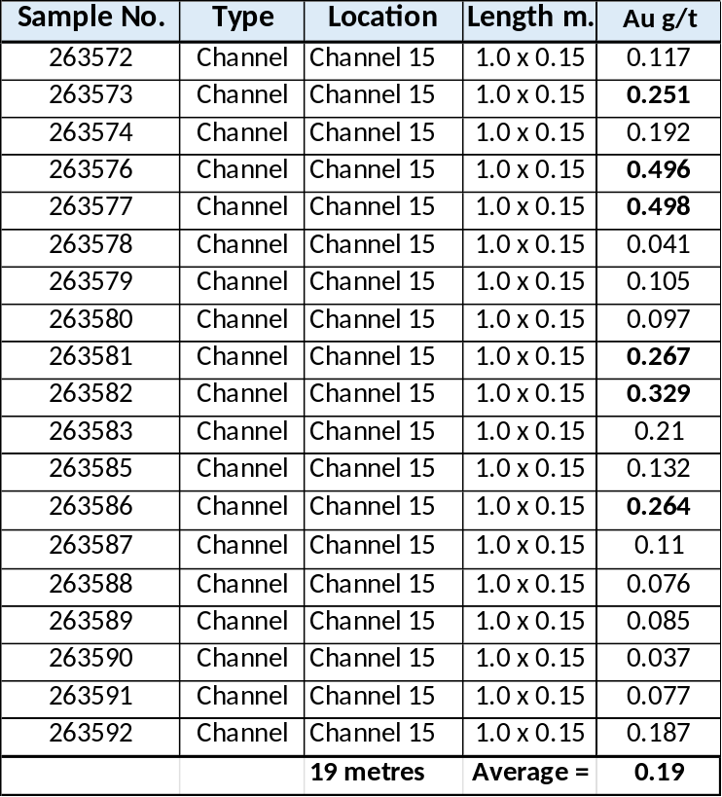
Channel 15 Sample and Assay Table

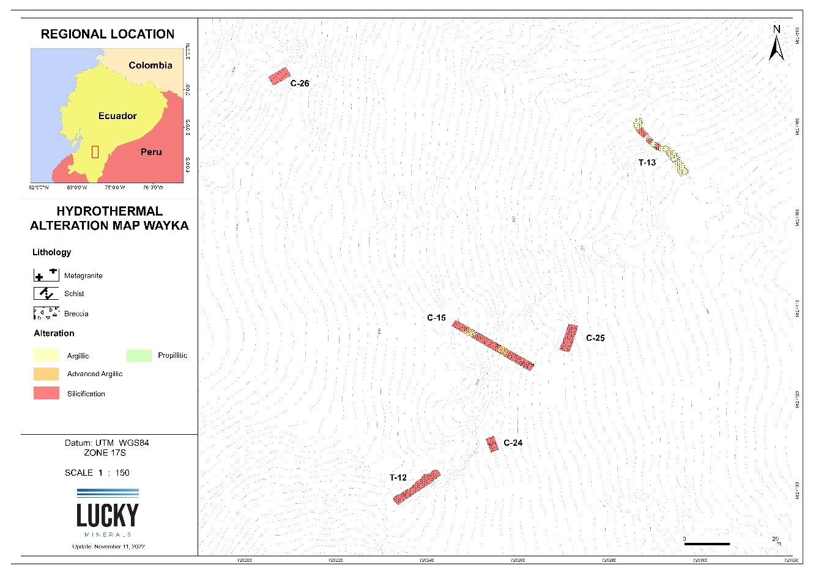
Alteration Map showing location of Channel 15 and Trench 12 in the Kelly zone (North Wayka)

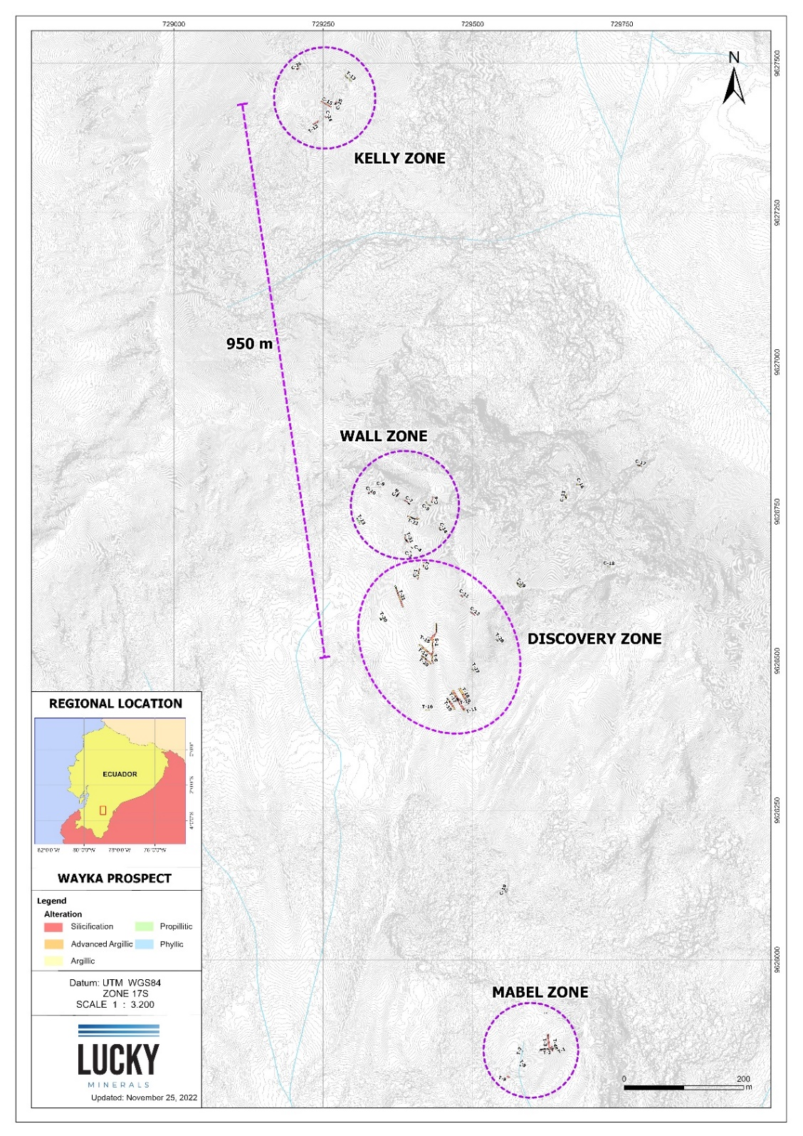
Trench and Channel Location Map showing distance from the Discovery to the Kelly zone (700 metres) at Wayka.

Francois Perron President and CEO states “Recently the team has been working in the Kelly Zone where there is better outcrop exposure. The objective is to continue to identify mineralized feeders and to broaden our understanding of the structural controls. Channel 15 does exactly that. We have recently exposed another structure of scale. Given that we are high up in the system, every mineralized structure in this context is a strong target. With this work, the team is continuing to increase the number of surface confirmed mineralized targets.”

Fortuna - Next Steps

Wayka

Current field work is focused on surface trenching around the Discovery and Kelly zones. There are another 31 assays pending from this ongoing field work.
QA/QC Protocols
All exploration work is completed following QA/QC protocols and include the insertion of a coarse blank, a standard and duplicate sample on every batch of 25 samples.
Samples are being submitted to ALS Chemex Labs in Quito for preparation work, and the analytical work is completed at their lab facility in Lima, Peru. ALS Chemex is an ISO certified and accredited laboratory. Results will be released as they are received.
About Lucky

Lucky is an exploration and development company targeting large-scale mineral systems in proven districts with the potential to host world class deposits. Lucky owns a 100% interest in the Fortuna Property.

The Company’s Fortuna Project is comprised of twelve contiguous, 550 km² (55,000 Hectares, or 136,000 Acres) exploration concessions. Fortuna is located in a highly prospective, yet underexplored, gold belt in southern Ecuador.

Covid-19 Safety Protocols
Lucky Minerals has strict rules in place for all workers arriving to and from field sites. All personnel are tested upon arriving and leaving and are tested every two weeks. All personnel are housed in separate and private accommodations and are isolated from the community.

Qualified Person

Victor Jaramillo, M.Sc.A., P.Geo., Lucky’s Exploration Manager and a qualified person in accordance with National Instrument 43-101, is responsible for supervising the exploration program at the Fortuna Project for Lucky Minerals and has reviewed and approved the technical information contained in this news release.

ON BEHALF OF THE BOARD

“Francois Perron”
Chief Executive Officer

Further information on Lucky can be found on the Company’s website at www.luckyminerals.com and at www.sedar.com, or by contacting Francois Perron, President and CEO, by email at investors@luckyminerals.com or by telephone at (866) 924 6484.

Or by contacting:

Renmark Financial Communications Inc.
Kerry Schacter: kschacter@renmarkfinancial.com
Tel: (416) 644-2020 or (514) 939-3989
www.renmarkfinancial.com

Neither the TSX Venture Exchange nor its Regulation Services Provider (as that term is defined in the policies of the TSX Venture Exchange) accepts responsibility for the adequacy or accuracy of this release.

Cautionary Statement Regarding Adjacent Properties and Forward-Looking Information
This news release contains forward-looking statements relating to the future operations of the Company and other statements that are not historical facts. Forward-looking statements are often identified by terms such as “will”, “may”, “should”, “anticipate”, “expects” and similar expressions. All statements other than statements of historical fact, included in this release, including, without limitation, statements regarding the future plans and objectives of the Company are forward-looking statements that involve risks and uncertainties. There can be no assurance that such statements will prove to be accurate and actual results and future events could differ materially from those anticipated in such statements. Such factors include, but are not limited to: uncertainties related exploration and development; the ability to raise sufficient capital to fund exploration and development; changes in economic conditions or financial markets; increases in input costs; litigation, legislative, environmental and other judicial, regulatory, political and competitive developments; technological or operational difficulties or inability to obtain permits encountered in connection with exploration activities; and labor relations matters. This list is not exhaustive of the factors that may affect the Company’s forward-looking information. Important factors that could cause actual results to differ materially from the Company’s expectations also include risks detailed from time to time in the filings made by the Company with securities regulators.

The reader is cautioned that assumptions used in the preparation of any forward-looking information may prove to be incorrect. Events or circumstances may cause actual results to differ materially from those predicted, as a result of numerous known and unknown risks, uncertainties, and other factors, many of which are beyond the control of the Company. The reader is cautioned not to place undue reliance on any forward-looking information. Such information, although considered reasonable by management at the time of preparation, may prove to be incorrect and actual results may differ materially from those anticipated. Forward-looking statements contained in this news release are expressly qualified by this cautionary statement. The forward-looking statements contained in this news release are made as of the date of this news release and the Company will not update or revise publicly any of the included forward-looking statements as expressly required by Canadian securities law.

