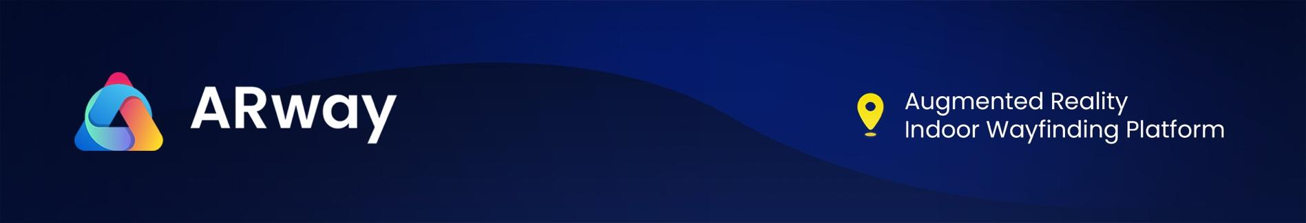

ARway.ai Approved and Now Trading On The OTCQB Exchange
TORONTO, O.N, Canada – May 3 , 2023 - ARway Corporation (“ARway” or the “Company”) (CSE: ARWY), (OTCQB : ARWYF) (FSE: E65) is disrupting the Augmented Reality (AR) Wayfinding market with a no-code, no beacon augmented reality experience platform enabled by visual marker tracking. ARway is pleased to announce that its common shares are now available for trading in the USA on the OTCQB Venture Market under the stock symbol: ARWYF.
Uplifting to the OTCQB Venture Market requires the Company to meet higher financial standards and disclosure requirements. Investors should have full confidence as the uplift indicates that the Company has achieved a certain level of financial and operational success and is committed to maintaining transparency and good governance practices.
After spinning-out from Nextech3D.ai (OTCQB: NEXCF) (CSE: NTAR) on October 26th, 2022, ARway was directly listed in Canada on the Canadian Securities Exchange (CSE), and then duel listed shortly after in the US on the OTC Pink Sheet Open Market on November 7, 2022. At the time, CEO Evan Gappelberg stated the Company’s goal of moving to the more liquid OTCQB - today that goal is realized.
CEO Evan Gappelberg commented, "We are excited to announce that ARway has officially begun trading on the OTCQB Venture Market. This milestone reflects our commitment to transparency, accountability, and growth, and marks a significant step forward in our mission to enhance shareholder liquidity and awareness in the USA. The OTCQB provides the Company greater exposure and, as the OTCQB Venture Market has greater liquidity. With this uplifting, we look forward to welcoming a broader range of investors to join us on this journey and to drive value for all shareholders.”
About the OTCQB
The OTCQB® Venture Market offers investors transparent trading in entrepreneurial and development stage U.S. and international companies that may not yet quality for OTCQX. To be eligible, companies must be current in their reporting and must undergo an annual verification and management certification process.
Recents News
- ARway.ai Announces Magic Leap AR Glasses Integration
- ARway.ai Releases Q2 2023 Financial Results
- Proactive Investors: ARway Livestream - Platform Demo & Presentation
- Harvard University Robotics and AR/VR Workshops Showcase ARway.ai, Snap, and Magic Leap’s Spatial Computing and AR Platforms Capabilities
- ARway.ai Closes Annual Partner Licence and Sees Demand Ramp Up
- ARway.ai Unveils SDK 2.3 With Significant Enhanced AI-Features and AR Experiences, Opening Up New Markets

To learn more about ARway, please follow on Social Media: Twitter, YouTube, Instagram, LinkedIn, and Facebook, and visit our website: www.arway.ai
About ARway.ai
ARway is an AI-powered platform that provides augmented reality experiences for indoor spaces. The platform allows users to easily create experiences for navigation, tours, information sharing, notifications, advertising, and gamification. ARway leverages the power of mobile devices to create environments that can improve visitor experience, boost employee productivity, increase engagement, create new advertising space, and boost revenues. Visitors can scan a QR code to access a venue map, navigate to any point of interest with step-by-step directions, learn information about those POIs, and interact with rich AR content and experiences along the way. ARway has unlimited use cases for augmenting physical spaces in the metaverse, making it a valuable tool for creators, brands, and companies in various industries. The complete ARway platform includes: the Web Creator Studio, the ARwayKit Software Development Kit (SDK) and a mobile app for iOs and Android.

Nextech 3D.ai
On October 26, 2022, ARway.ai. was spun-out from its parent Company, Nextech3D.ai (OTCQX: NEXCF) (CSE: NTAR) (FSE: EP2). Nextech retained a control ownership in ARway.ai. with 13 million shares, or a 50% stake. Nextech3D.ai is a Metaverse Company and leading provider of augmented reality (“AR”) experience technologies and 3D model services. Nextech’s AI-powered 3D modeling platform, “ARitize3D” has contracts with; AMZN, KSS, CB2, Genuine Parts & many others. To learn more about Nextech3D.ai, visit www.nextechar.com

For further information, please contact:
Investor Relations Contact
Julia Viola
investor.relations@arway.ai
ARway.ai
Evan Gappelberg
CEO and Director
866-ARITIZE (274-8493)

Forward-looking Statements
The CSE has not reviewed and does not accept responsibility for the adequacy or accuracy of this release.

Certain information contained herein may constitute “forward-looking information” under Canadian securities legislation. Generally, forward-looking information can be identified by the use of forward-looking terminology such as, “will be” or variations of such words and phrases or statements that certain actions, events or results “will” occur. Forward-looking statements regarding the completion of the transaction are subject to known and unknown risks, uncertainties and other factors. There can be no assurance that such statements will prove to be accurate, as future events could differ materially from those anticipated in such statements. Accordingly, readers should not place undue reliance on forward-looking statements and forward-looking information. ARway.ai will not update any forward-looking statements or forward-looking information that are incorporated by reference herein, except as required by applicable securities laws.

