Fashion Industry events MAGIC, PROJECT and Sourcing at MAGIC Las Vegas Showcased Top-Tier Brands, Retailers and Talent.

Las Vegas, NV (August 30, 2023) – MAGIC, PROJECT and SOURCING at MAGIC Las Vegas, organized by Informa Markets Fashion, the largest producer of wholesale fashion and industry events in the United States, successfully concluded the bi-annual event which hosted hundreds of notable brands, thousands of retailers and top-tier guest speakers.
“The Las Vegas collection of shows is known for its range that offers something for everyone in the fashion industry including brands, retailers of all sizes. We provide exclusive access to industry insights through curated expert led sessions, hands on experiences and opportunities to connect that you cannot find anywhere else,” says Kelly Helfman, President of Informa Markets Fashion. “With our diverse roster of exhibiting brands from a wide range of price points, the industry comes together to celebrate and shop the most robust fashion event where the industry gathers to work and have fun along the way.”
This season an all-star lineup and surprise guests with dozens of industry relevant conversations. Martha Stewart opened the event with a highly attended moderated conversation with Booth Moore of WWD in which they discussed everything from Martha’s fashion and lifestyle to her recent Sports Illustrated Swimsuit Edition cover. Additional topics covered many facets of fashion from trend forecasting to footwear and everything in between.
MAGIC Las Vegas hosted expert led conversations including an informative trend presentation led by Kelly Helfman, President of Informa Markets Fashion. Another session featured curve model and content creator, Remi Bader discussing unique perspectives on the fashion industry and advocating for size inclusivity in an intimate conversation with Rachel McCord of The McCord List.
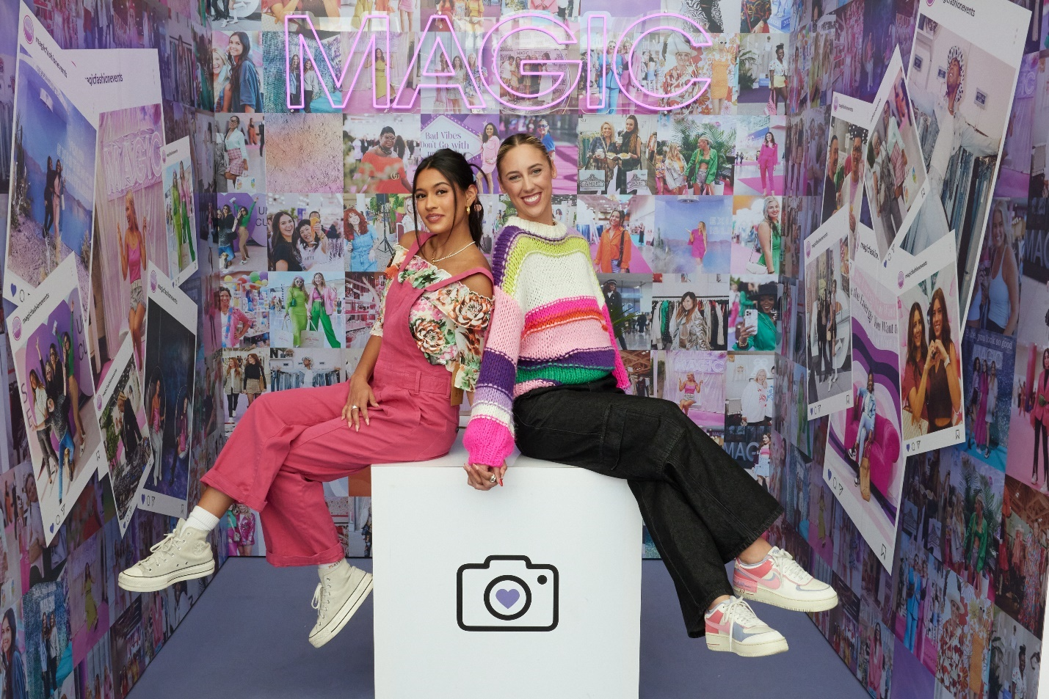
For the first time at MAGIC Las Vegas, Dixie and Marc D’Amelio were on stage to showcase co-owned premium footwear line D’Amelio Footwear and debuted the latest collection on the MAGIC show floor where both Charli and Dixie D’Amelio surprised guests with a meet and greet.
MAGIC is home to trend and young contemporary apparel, footwear, accessories and home gift and beauty brands. This season, MAGIC Las Vegas hosted over 700 exhibiting brands, with 150 in Las Vegas presenting collections for the first time. Top brands previewed next season’s trends included Chinese Laundry, D’Amelio Footwear, Flying Monkey Jeans, Matisse, Pistola, Poppy & Pout and Sofie the Label. Retailers searching for next season’s best sellers included Aritzia, ASOS, American Eagle, Free People, VICI and Urban Outfitters.
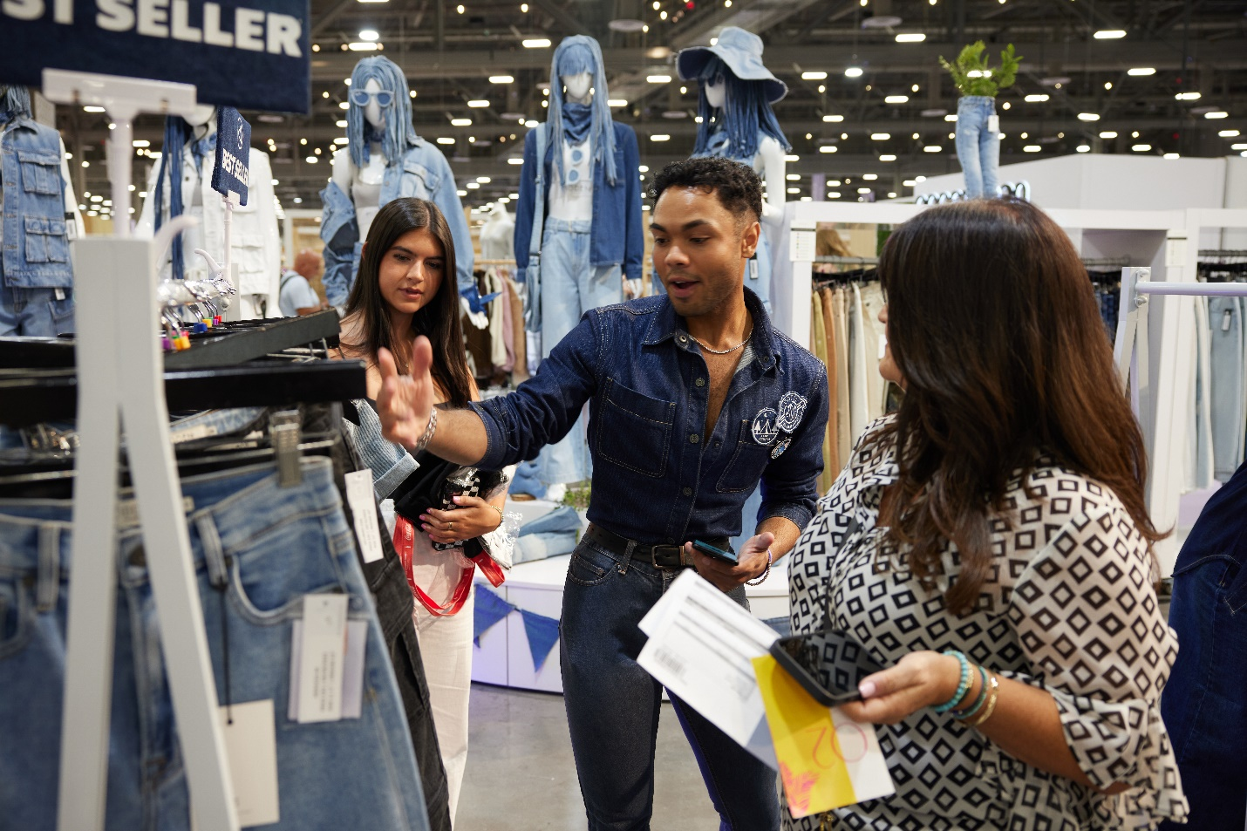
PROJECT Las Vegas displayed both men’s and women’s contemporary brands. The men's floor held nearly 300 exhibiting brands with 19 percent exhibiting at PROJECT for the first time. Attendees shopped for new to show designs from the likes of Blend, Ellesse, Outerknown, Rockridge and Undergold. Essential area on the men’s floor featured a uniquely merchandised apartment style design that featured everyday lifestyle brands from housewares, fragrances and apparel with notable designers including Leisure Lab, House of Him and Novesta.
The women's floor at PROJECT Las Vegas had a strong assortment of contemporary brands with over thirty percent of exhibiting brands being new to show. New brands are a key driver in attracting target retailers like Bloomingdales, Free People, Urban Outfitters and ASOS which shopped on the show floor this season. West Coast showrooms were also essential to the August edition, delivering Show Me Your Mumu, Spell, Jen’s Pirate Booty and Vanessa Mooney. Other brands on the women’s floor at PROJECT included Le Salty, Barefoot Dreams, Rolla’s, Araminta James, Morrison Denim, Spell, Intentionally Blank, Dolce Vita, Z Supply, Johnny Was, B Low the Belt, WYETH and Splendid.
The NOW Stage at PROJECT hosted rock legend and fashion designer, Gavin Rossdale who took the stage with Rolling Stone’s Tim Chan where the two discussed topics covering fashion style, inspiration and gave viewers a first look into Rossdale’s apparel line, Sea of Sound. In a session entitled “There is something about Remy,” where Remy Ma and Datwon Thomas from Vibe Magazine discussed career, fashion and emergence in hip-hop.
Continuing the celebration of Hip Hop’s 50th anniversary, PROJECT highlighted a visual display of the brand’s iconic pieces from the 90s to complement a panel discussion on the parallels of fashion and music with the founders of FUBU Keith Perrin, J. Alexander, Carl Brown and a surprise virtual guest Daymond John.
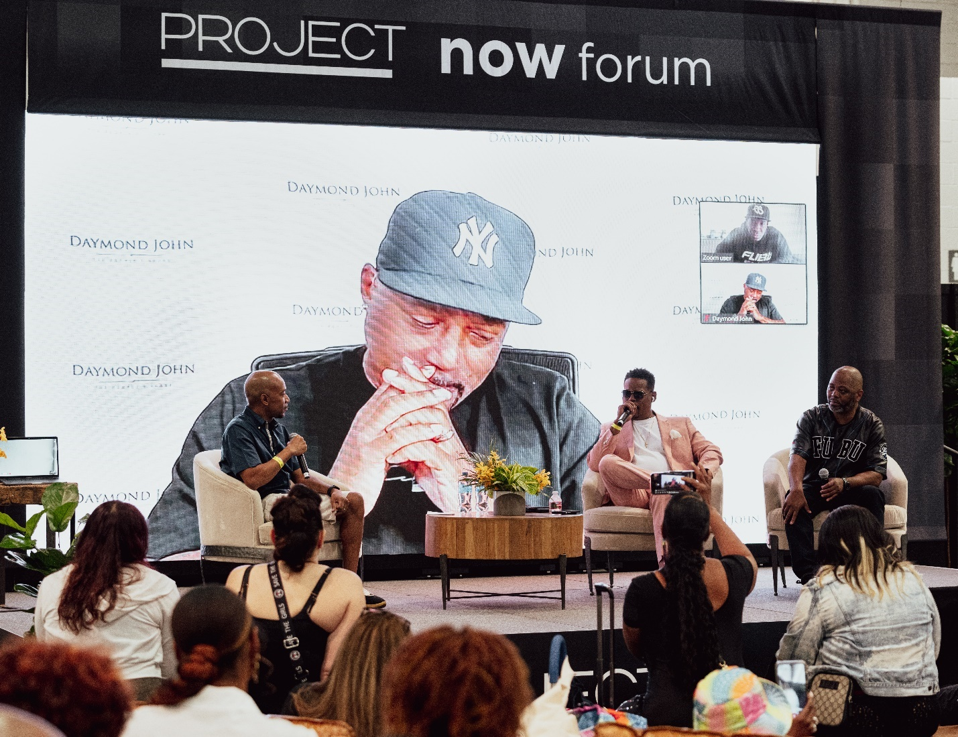
The men’s floor of PROJECT Las Vegas kept attendees entertained as D. rt, Cult of Individuality, Infectur and Official Genius joined together to host a life-sized skateboarding half pipe created by Keen Ramps in the men’s NOW section on the show floor. Cult of Individuality hosted a Best Trick contest.
The celebrations continued as SOURCING at MAGIC hit its milestone 20th Anniversary in August. The show floor was filled with fashion technology, design workshops, verified sustainable businesses and service providers. This season, the SOURCING at MAGIC show floor featured a manufacturer-owned brand curation consisting of manufacturers mastering improved efficiencies in lead time to design and production creating solutions for "ready to ship" stocks to address the need for consolidated turnarounds to retailers. Key attendees at SOURCING at MAGIC included Cult Gaia, MCM, Dillard’s, H&M, HOKA, Lacoste, Pac Sun, Revolve, SKIMS, Stussy and Tom’s shopping and discovering the wide array of exhibitors.

“As we celebrate our 20th anniversary of SOURCING at MAGIC, we are reminded that we are here to serve the industry in a way that supports the entire fashion ecosystem,” said Andreu David, Vice President of SOURCING at MAGIC “We are proud to be the trusted resource that provides our community with the most comprehensive experience both onsite and online for our attendees. We provide insight into everything from fashion technology and supply chain innovation to access to the right manufactures and service providers that keep the business of fashion moving forward.”

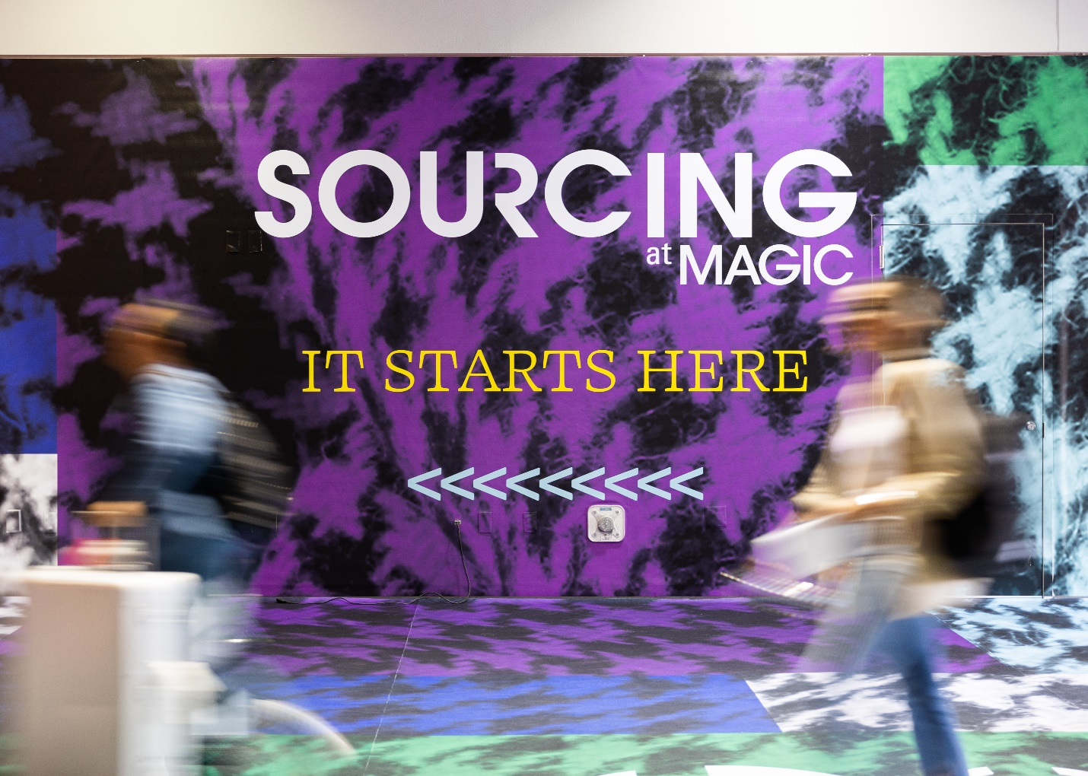
Over 8,000 retail companies were on-site for the co-located shows to view thousands of brands and exhibitors over the three-day show. Half of attending buyers represented boutique and specialty stores and there was an increase in international retail attendance year-over-year. Buyers, brands, guest speakers, press and stylists were among the 26,000 total attendees from over 79 countries worldwide. Product assortment across the three halls included apparel, footwear, accessories, raw materials, manufacturers and service providers.
The much-anticipated New York edition of COTERIE, MAGIC and the inaugural SOURCING at MAGIC New York returns September 19-21 at the Javits Center. Register at www.fashionresource.com to attend.
Next year’s MAGIC, PROJECT and SOURCING at MAGIC Las Vegas will be Feb 13-15, 2024. Early registration is available to accommodate special hotel rates and advance savings www.magicfashionevents.com.

ABOUT INFORMA MARKETS FASHION:
Informa Markets Fashion, a subsidiary of Informa plc (LON:INF), connects and inspires the global fashion community through online experiences, industry insights, and worldwide fashion trade events, including MAGIC, COTERIE, PROJECT, and SOURCING at MAGIC. From more effective manufacturing and supply chain opportunities to creative design inspiration and retail on the wholesale floor, Informa Markets Fashion's diverse portfolio supports the entire fashion ecosystem - fostering innovation and driving creativity year-round. For more information on upcoming events, please visit www.findfashionevents.com.

ABOUT MAGIC LAS VEGAS:
MAGIC Las Vegas is a high-energy fashion experience and home to the largest selection of trend, young contemporary, modern sportswear, footwear and accessories brands in the industry. Fusing scale with curation to foster community, drive connectivity and deliver unique experiences, MAGIC Las Vegas joins a global audience of retail buyers - from big-box to boutique - together with influencers, media, and industry thought leaders. MAGIC Las Vegas is more than just an event: it's a deeply rooted community and a place brands and retailers call home. For more information, please visit www.magicfashionevents.com.

ABOUT PROJECT LAS VEGAS:
PROJECT LAS VEGAS represents what's new, now, and next in men's and women's contemporary apparel, footwear and accessories, PROJECT Las Vegas is where domestic and international buyers go to be inspired by higher-end brands, find products from culturally relevant mid-market labels and connect with like-minded industry thought leaders and fashion insiders. Through a fusion of community, education, media, and experiences, PROJECT Las Vegas propels the next season's top trends, generates global awareness, and ultimately, drives commerce. For more information, please visit www.projectfashionevents.com.

ABOUT SOURCING at MAGIC LAS VEGAS:
SOURCING at MAGIC allows fashion businesses, brands and sourcing professionals to connect and collaborate with a community of global manufacturers, suppliers, and service providers. With a strong presence among international exhibitors and attendees and deep domestic connections, SOURCING at MAGIC is a global community. With a forward-thinking approach and commitment to the evolution of the global apparel supply chain, SOURCING at MAGIC consistently provides access to emerging fashion technology, solutions, sustainable resources, educational content, networking, and extended visibility into the industry's most critical global issues. For more information, please visit: www.sourcingatmagic.com.

Media Contact:
Kristin Borland
Fashionpr@informa.com

