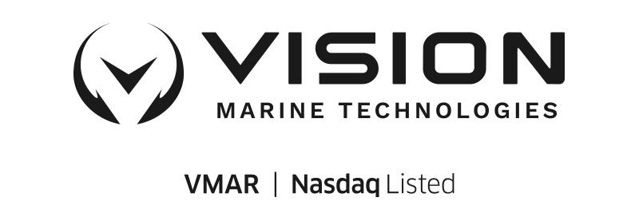
Vision Marine Technologies: Pioneering Electric Propulsion with Innovative Pontoon Integration

"Montreal, Canada — November 20, 2023 — Vision Marine Technologies Inc. (NASDAQ: VMAR), (“Vision Marine” or the “Company”), a global leader and innovator within the performance electric recreational boating industry, is now steering its expertise towards the flourishing pontoon market, which sees annual sales of around 60,000 units. In a strategic move, Vision Marine introduces the P Powerpack, a game-changing solution offering ease of installation for pontoon boats. This innovative approach significantly reduces the time and effort required for installation compared to traditional internal combustion engine (ICE) setups. As Vision Marine targets this new market segment, it celebrates its first order from Wired Pontoons, a testament to the industry's growing interest in the Company’s technology. Since 2020, Vision Marine has been at the forefront of integrating its E-motion™ electric outboard into various pontoon brands, solidifying its status as a leader in the electric boating market.
The P Powerpack represents a pivotal development in Vision Marine’s product lineup, emphasizing the Company's focus on ease of integration and versatility. While the 180E model, part of the state-of-the-art E-Motion™ Powertrain Technology suite, continues to lead the electric propulsion market, the P Powerpack expands the 180E’s applicability across a wide range of boating platforms, starting with pontoons. This strategic move underlines Vision Marine's dedication to making electric boating technology more accessible to manufacturers.

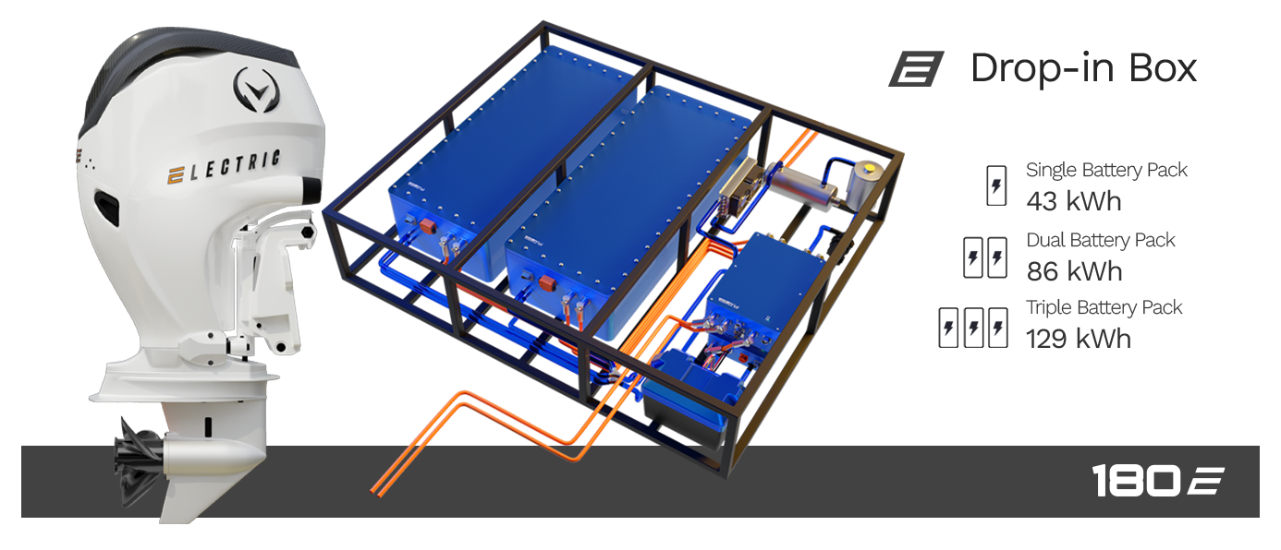

This latest innovation is poised to accelerate market adoption. Alex Mongeon, CEO of Vision Marine, stated,
“We have engineered an even simpler integration method that is both efficient and effective. We continue to innovate, bringing new advancements to the market. We are on the cusp of a new era in boating, and Vision Marine is laying the groundwork, demonstrating that our systems are not only high-performing but will also be a dominant force in the future of boating.”

The recreational pontoon market in the United States is substantial and growing. In 2022, the pontoon market size exceeded USD$7.9 billion and is expected to witness an 8.3% CAGR from 2023 to 2032. Specifically, the US recreational boat market, including pontoons, was valued at USD$17.31 billion in 2022, with projections to reach USD$28.54 billion by 2028, growing at a CAGR of 8.7%. The recreational segment alone accounted for 36% of the pontoon market share in 2022. Additionally, the North America pontoon market generated USD$4.8 billion in revenue in 2022, reflecting a surging interest in water-based recreational activities​​​​​​. Vision Marine’s P Powerpack is custom engineered to seamlessly incorporate the 180E system into pontoon boats, tapping into this significant market.

The E-Motion™ system represents a comprehensive solution for boat manufacturers. It features an integrated user interface, an efficient charger, and Vision Marine’s proprietary marine-manufactured battery packs. A standout feature of the E-Motion™ system is its ability to offer scalable energy architecture, accommodating 1 to 3 battery packs providing 43 to 129 kWh. This flexibility allows for customised power solutions based on specific boating needs.

Vision Marine is committed to leading the charge in the marine electric propulsion sector, demonstrating that sustainable boating solutions can go hand-in-hand with high performance and efficiency.

About Vision Marine Technologies Inc.

Vision Marine Technologies Inc. (Nasdaq: VMAR), strives to be a guiding force for change and an ongoing driving factor in fighting the problems associated with waterway pollution by disrupting the traditional boating industry with electric power, in turn directly contributing to zero pollution, zero emission and a noiseless environment. Our Flagship E-Motion™ 180E electric marine powertrain is the first fully electric purpose-built outboard powertrain system that combines an advanced battery pack, inverter, and high efficiency motor with proprietary union assembly between the transmission and the electric motor design utilizing extensive control software. Our E-Motion™ and related technologies used in this powertrain system are uniquely designed to improve the efficiency of the outboard powertrain and, as a result, enhance both range and performance. Vision Marine continues to design, innovate, manufacture, and sell handcrafted, environmentally friendly, electric recreational boats to customers. The design and technology applied to our boats results in far greater enhanced performance in general, higher speeds, and longer range. Simply stated, a smoother ride than a traditional internal combustion engine (ICE) motorboat.

Forward-Looking Statements

Certain statements made in this press release are “forward-looking statements” within the meaning of the “safe harbor” provisions of the Private Securities Litigation Reform Act of 1995. Forward-looking statements may be identified by the use of words such as “anticipate,” “believe,” “expect,” “estimate,” “plan,” “outlook,” and “project” and other similar expressions that predict or indicate future events or trends or that are not statements of historical matters. For example, when Vision Marine describes the impact of the P Powerpack and its E-Motion™ system, and the future of the boating market, it is using forward-looking statements. These forward-looking statements reflect the current analysis of existing information and are subject to various risks and uncertainties. As a result, actual results may differ materially from these expectations due to changes in global, regional, or local economic, business, competitive, market, regulatory and other factors, many of which are outside of Vision Marine’s control. Important factors that could cause actual results to differ materially from those in the forward-looking statements are set forth in Vision Marine’s Annual Report on Form 20-F, filed with the U.S. Securities and Exchange Commission (SEC) for the year ended August 31, 2022, as such factors may be updated from time to time in Vision Marine’s periodic filings with the SEC. Any forward-looking statement in this press release speaks only as of the date of this release. Vision Marine undertakes no obligation to publicly update or review any forward-looking statement, whether as a result of new information, future developments or otherwise, except as may be required by any applicable securities laws. https://visionmarinetechnologies.com.

LEARN MORE
Website: visionmarinetechnologies.com
Twitter: @marine_vision
Facebook: @VisionMarineTechnologies
Instagram: @visionmarine.technologies
YouTube: @VisionMarineTechnologies

Investor and Company Contact
Bruce Nurse
(800) 871-4274
bn@v-mti.com

https://vimeo.com/838683504

