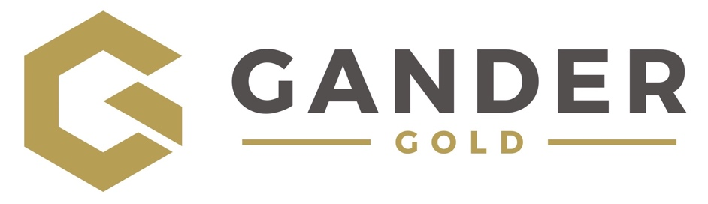 | CSE: GAND
400 – 1681 Chestnut Street
Vancouver, BC V6J 4M6
GanderGold.com
info@GanderGold.com

Gander Gold Intersects Near Surface Gold Mineralization at Thwart Island – BLT Project
Vancouver, British Columbia, December 14, 2023 – Gander Gold Corp. (“Gander” or the “Company”) (CSE: GAND) (OTCQB: GANDF), is pleased to announce preliminary results from its recently completed Rotary Air Blast (RAB) drill program at the “Islander Zone” on Thwart Island, Newfoundland. Gander’s Thwart Island claims form part of the Company’s larger Botwood-Laurenceton-Thwart Island (BLT) Project in the Bay of Exploits region of Newfoundland.
The first-ever drilling at Thwart Island was conducted in in Summer 2023 by Gander Gold and consisted of three RAB drill holes totalling 193.5 meters of drilling. Anomalous gold mineralization was intersected in all three drill holes. (Table 1)
The first hole drilled (BLTRAB23-001) intersected three individual zones of Gold-Silver-Arsenic mineralization and ended in anomalous Gold-Silver-Arsenic mineralization (Au-Ag-As; 118ppb, 0.03ppm, 1213ppm respectively) indicating the fourth intersected zone of Au-Ag-As mineralization remains open at depth. The drillhole was collared near to two surface grab samples grading >1.0 g/t Au.
The second hole drilled (BLTRAB23-002) was drilled in the vicinity of the 5939.5ppb Au-in-soil sample collected from the Islander Zone during the 2022 regional soil geochemistry program. This sample was the single highest grade gold result from the Company’s approximate 40,000 soil sample program across its eight Newfoundland project areas. Anomalous Au-Ag-As-Sb mineralization starts at a downhole depth of 12.2m and continues through 19.8m. This subsurface zone of anomalous Au-As mineralization is indicative of a gold system occurring in this area and is possibly connected with the surface soil sample of 5939.5ppb Au and 654.8ppm As.
The third drillhole (BLTRAB23-003) encountered anomalous Cu mineralization immediately at the bedrock interface through to the end of the drillhole. Anomalous Au-As mineralization was continuous from 18.3m – 24.4m.

“We designed this first Thwart Island RAB program to drill directly under several of the surface geochemical anomalies, and beneath > 1 g/t Au grab samples that were discovered during the 2022 surface program, and while the three preliminary RAB holes did intersect mineralization, we did not necessarily identify the subsurface source of the very robust surface soil geochemical anomalies.” stated Gander Gold VP of Exploration Ian Fraser, adding “This bodes well for the “open” potential of this mineralized system, or systems, at Thwart Island, and logical next steps would include additional surface mapping and possible trenching to better understand the orientation and controlling structural dynamics of this gold system.”
The Islander Zone and Thwart Island area is a developing gold prospect. Positive soil geochemistry surveys (Au-in-soil up to 5939.5ppb) and prospecting results (up to 1.23 g/t Au) accumulated to date and validated by subsurface RAB gold mineralization results has confirmed the prospectivity of the Thwart Island area. Associated with zones of gold mineralization is a strong supporting Silver-Arsenic-Antimony (Ag-As-Sb) geochemical signal, which is consistent with geochemical signals at other developing gold camps in Newfoundland.

Gander Gold President and CEO, Mr. Mark Scott, commented, “Gander Gold is very encouraged by the RAB drilling results returned from the Islander Zone on Thwart Island. The very strong Ag-As-Sb geochemical signal associated with three separate zones of gold mineralization in the RAB program is analogous to other gold systems in the Central Newfoundland gold belt. RAB drilling has confirmed the presence of subsurface gold mineralization at the Islander Zone, as was first suggested by very positive soil geochemistry and prospecting results. The Company’s next steps are to gain a better understanding of the orientation of the three separate gold zones defined to date at Thwart Island. We are pleased that the initial RAB drillhole at Thwart Island was terminated in a very anomalous zone of Au-Ag-As-Sb mineralization, meaning this system remains open at depth. Our staff and Board of Directors look forward to following up on these results in 2024.”

Table 1. Anomalous RAB Drill Intercepts
Drillhole ID | From (m) | To (m) | Width (m)* | Au (ppb)**
BLTRAB23-001 | 32.0 | 33.5 | 1.5 | 244.0
BLTRAB23-001 | 42.7 | 56.4 | 13.7 | 137.1
Including | 51.8 | 56.4 | 4.4 | 203.3
BLTRAB23-002 | 12.2 | 19.8 | 7.6 | 60.4
Including | 18.3 | 19.8 | 1.5 | 188.0
BLTRAB23-003 | 18.3 | 24.4 | 6.1 | 68.3
*Drillhole intercepts are drillhole lengths – true widths unknown currently.
**Note 1000ppb equals 1 gram

The Company will be evaluating all data collected to date with the view of continuing its exploration efforts at the Islander Zone prospect and encompassing a greater area of Thwart Island. See September 13, 2023 news release for more information on the Summer 2023 RAB drill program at Thwart Island and April 21, 2023 news release for additional detail on the Islander Zone soil geochemistry anomaly.

Map of Islander Zone on Thwart Island – BLT Project

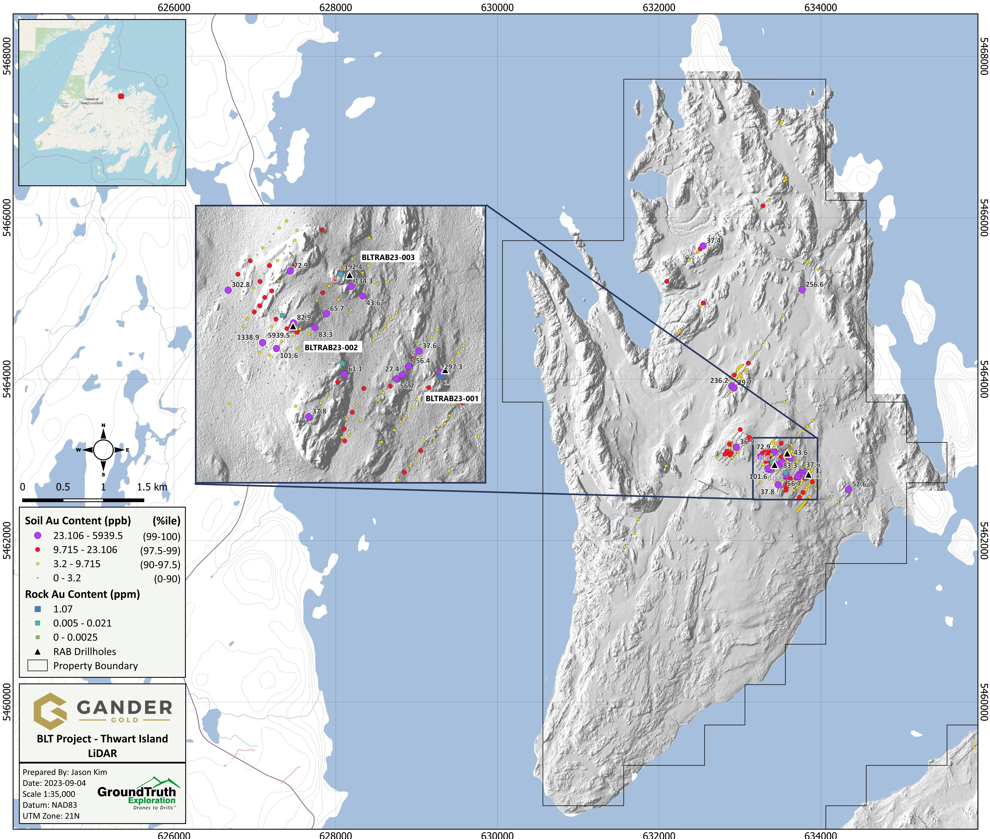

Regional Map of Thwart Island, Gander North, Lizard Pond (Gander South), and Mt. Peyton Projects
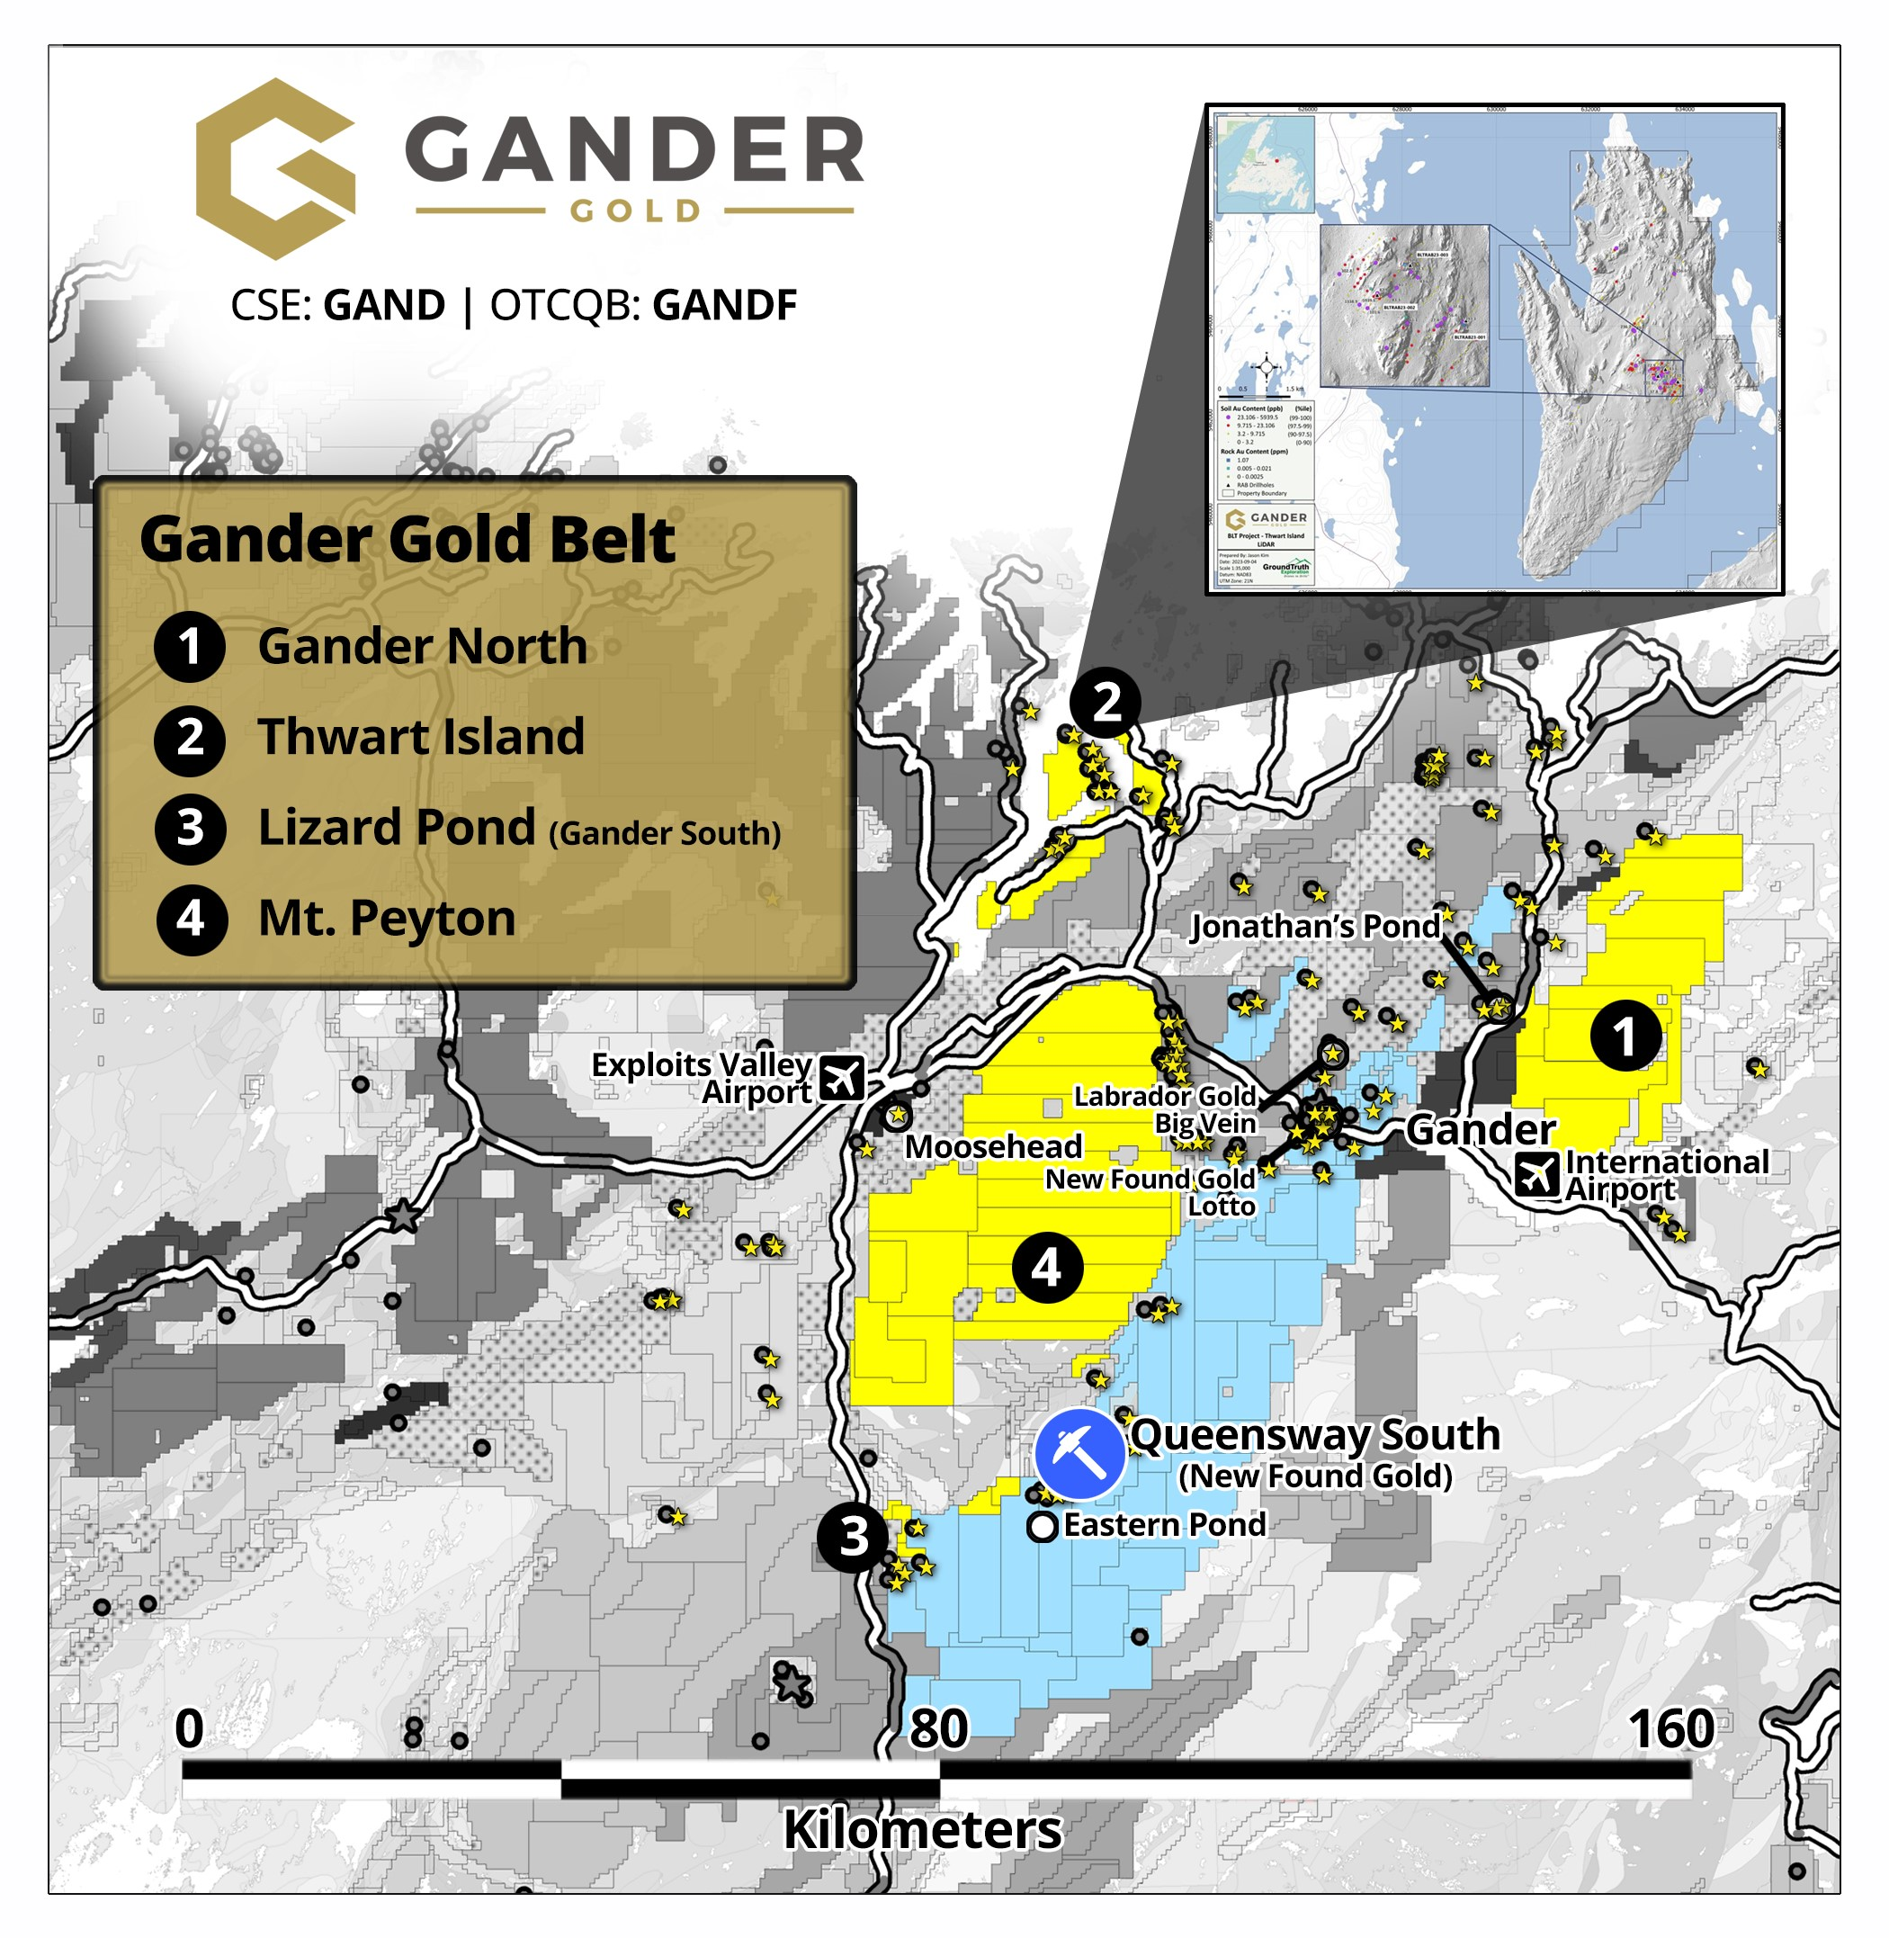

Table of Thwart Island RAB Drill Hole Locations & Orientation
Drillhole ID | Easting* | Northing | Azimuth (°) | Dip (°) | Total Depth (m)
BLTRAB23-001 | 633848.2 | 5462820.3 | 220 | -60 | 65.5
BLTRAB23-002 | 633428.8 | 5462941.3 | 20 | -60 | 65.5
BLTRAB23-003 | 633584.8 | 5463082.5 | 220 | -60 | 62.5
*Easting and Northing in NAD83 (Zone 21N)

Quality Assurance/Quality Control statement
Gander Gold Corporation has contracted the services of GroundTruth Exploration to conduct and manage the RAB drill programs in Newfoundland. RAB drilling produces rock chip samples. A representative sample; typically 2-3kg of material, for each 5-foot (1.52m) interval of drilling is collected for analyses. Once sorted and logged all samples are shipped to SGS prep facility in Grand Falls NL and final analyses is performed at SGS Burnaby BC. At SGS Grand Falls NL individual samples are dried, crushed and pulverized (PRP89) and analyses at SGS Burnaby consists of a 30g Au Fire Assay (GE_FAA30V5), and a 25g sample is analysed for 49 elements by 2 Acid Leach with an ICP-MS finish (GE_ARM3V25). SGS Canada is a certified laboratory independent of Gander Gold Corporation. As part of the sampling protocol a QAQC program is adhered to and includes the insertion of industry approved standards, blanks, and the insertion of field duplicates. Alternating, standards, blanks and field duplicates are part of the sampling stream and amount to six QAQC samples per one-hundred samples collected.
Qualified Person
The technical information in this news release has been reviewed and approved by Ian Fraser, P.Geo., Vice- President of Exploration for Gander Gold Corp. Mr. Fraser is the Qualified Person responsible for the scientific and technical information contained herein under National Instrument 43-101 standards.
Acknowledgment
Gander Gold acknowledges the financial support of the Junior Exploration Assistance Program, Department of Natural Resources, Government of Newfoundland and Labrador.
About Gander Gold Corporation
Gander Gold is “All Newfoundland, All the Time.” The Company is one of the island’s largest claimholders targeting new high-grade gold discoveries with a current focus on the large Gander North, Mount Peyton, and BLT (Botwood-Laurenceton-Thwart Island) projects where there has been very promising early exploration success. Other opportunities advancing through the pipeline are Cape Ray II, Carmanville, Gander South, Little River, and Hermitage.
Contact Info:

Mark Scott
Chief Executive Officer & Director
info@gandergold.com
Terry Bramhall
Gander Gold - Corporate Communications
1.604.833.6999 (mobile)
1.604.675.9985 (office)
terry.bramhall@gandergold.com
Caution Regarding Forward Looking Statements
Investors are cautioned that, except for statements of historical fact, certain information contained in this document includes “forward looking information,” with respect to a performance expectation for Gander Gold Corp. Such forward looking statements are based on current expectations, estimates and projections formulated using assumptions believed to be reasonable and involving a number of risks and uncertainties which could cause actual results to differ materially from those anticipated. Such factors include, without limitation, fluctuations in foreign exchange markets, the price of commodities in both the cash market and futures market, changes in legislation, taxation, controls and regulation of national and local governments and political and economic developments in Canada and other countries where Gander carries out or may carry out business in the future, the availability of future business opportunities and the ability to successfully integrate acquisitions or operational difficulties related to technical activities of mining and reclamation, the speculative nature of exploration and development of mineral deposits, including risks obtaining necessary licenses and permits, reducing the quantity or grade of reserves, adverse changes in credit ratings, and the challenge of title. The Company does not undertake an obligation to update publicly or revise forward looking statements or information, whether as a result of new information, future events or otherwise, unless so required by applicable securities laws. Some of the results reported are historical and may not have been verified by the Company.
The CSE has neither approved nor disapproved the contents of this news release. Neither the CSE nor its Regulation Services Provider (as that term is defined in the policies of the CSE) accepts responsibility for the adequacy or accuracy of this news release.

