Aeris Cloud Connect Form

Sales Engineering

October 16, 2020

Version 1.0

Document History:
Version | Date | Prepared by | Edited By | Comments
1.0 | 10/16/20 | Aeris |  | Initial version
File Location:

Distribution List: |  |  |  |  |  | Distribution Level:
Region | Name | Region |  | Name
 |  |  |  |  |  |  | Confidential
 |  |  |  |  |  |  | Internal
 |  |  |  |  |  |  | External | √
 |  |  |  |  |  |  | Client

INDEX

1 INDEX 2
2 DISCLAIMER 3
3 INTRODUCTION 4
4 COMPANY INFORMATION 4
5 AERIS CLOUD CONNECT INFORMATION 4
6 CONNECTING TO AERIS CLOUD CONNECT 5

List of Tables
Table 1 - Company Information 4
Table 2 - Contacts 4
Table 3 - Request Category 4
Table 4 - ACC Service Dates 4
Table 5 - Subnet 4

DISCLAIMER

Aeris Communications, Inc.
Proprietary and Confidential

All data and information contained in or disclosed by this document is confidential and proprietary information of Aeris Communications, Inc. and all rights therein are expressly reserved. By accepting this material, the recipient agrees that this material and the information contained therein is held in confidence and in trust and will not be used, copied, reproduced in whole or in part, nor its contents revealed in any manner to others without the express written permission of Aeris Communications, Inc.

INTRODUCTION
Once completed, please return this form to support@aeris.net.
Once returned, the request will be processed and you will receive your Aeris Cloud Connect details within 2 business days.

COMPANY INFORMATION
COMPANY INFORMATION
Company Name:
Address:
City, State, Zip / Postal Code:
Table 1 - Company Information

CONTACTS | Name | Email | Office Phone | Mobile Phone
Primary Technical Contact:
Alternate Contact:
24-Hour Contact:
Table 2 - Contacts

AERIS CLOUD CONNECT INFORMATION
REQUEST CATEGORY
New
Update
Disconnect
Comments (Update Details or Reason for Disconnection)
Table 3 - Request Category

ACC SERVICE DATES
Start Date Requested:
Termination Date Requested:
Table 4 - ACC Service Dates

SUBNET OF YOUR VPC
Subnet that you use for your IoT application servers:
Table 5 - Subnet

CONNECTING TO AERIS CLOUD CONNECT
Once the form is completed and submitted to Aeris Support, you will receive an email with your onboarding information within 1-2 business days.

To Connect to Aeris Cloud Connect
The following steps describe how to connect your AWS VPC to Aeris Cloud Connect using the AWS console software. Note that specific UI elements and flows may change over time. Please refer to the AWS documentation if you are unable to locate the exact screens shown below.

- Login to the AWS Console.
- Go to the Services menu and select Direct Connect.
For example, https://console.aws.amazon.com/directconnect/v2/home?region=us-west-2#/
(Your console link may be different depending on what region you are in.)
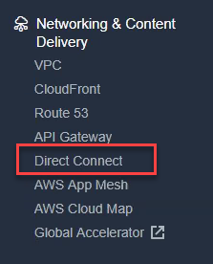
- Go to Virtual Private Gateways. For example,
https://us-west-2.console.aws.amazon.com/vpc/home?region=us-west-2#VpnGateways:sort=VpnGatewayId
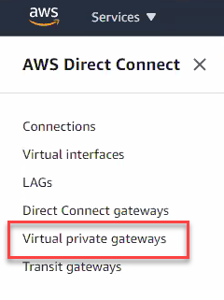
- Select the virtual private gateway that you want to connect to Aeris Cloud Connect.
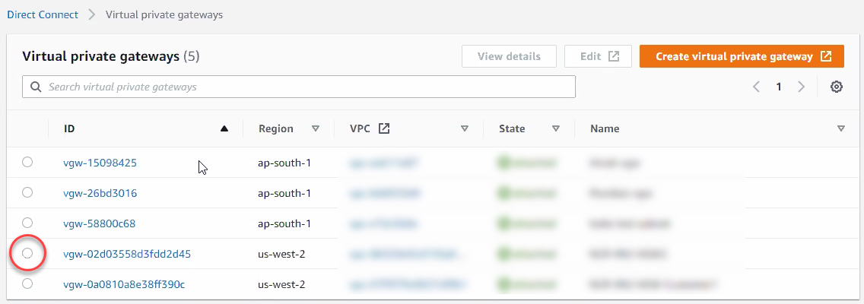
Note: If you do not have a virtual private gateway, then you will need to create one.
- Click the Direct Connect Gateway Associations tab.
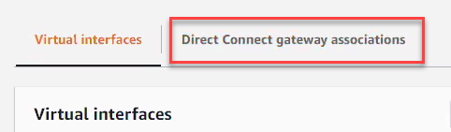
- Click Associate Direct Connect Gateway.
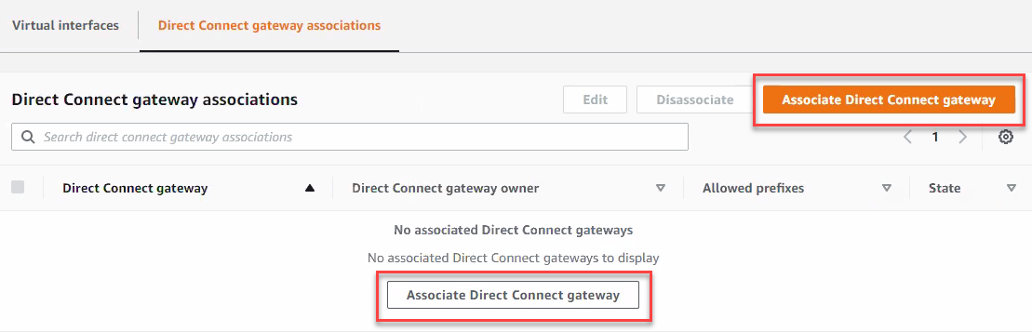
- Click Select another account.
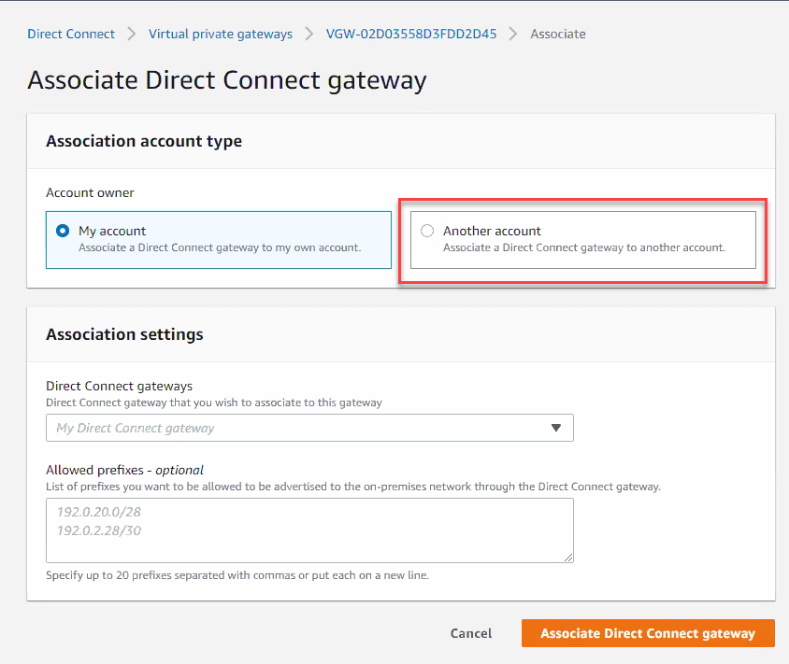
- Fill in the following items from the onboarding email that Aeris sends to you.
  - Direct Connect Gateway ID
  - Direct Connect Gateway Owner (e.g. the Aeris Account)
  - Allowed Prefixes
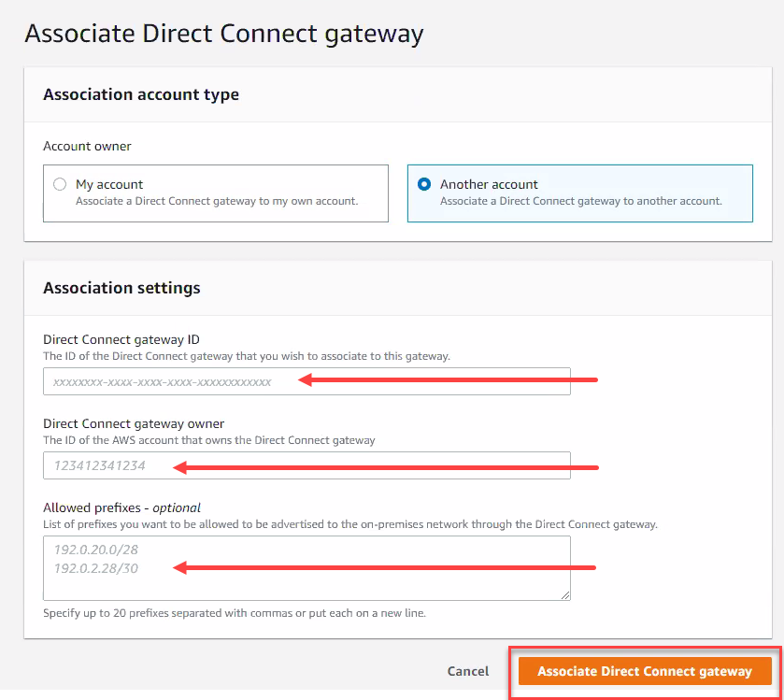
- Click Associate Direct Connect Gateway.

