Software VPN Form

Sales Engineering

September 16, 2020

Version 1.2

Document History:
Version | Date | Prepared by | Edited By | Comments
1.1 | 03/03/2020 |  | Shivesh Rehani | Initial version
1.2 | 16/09/2020 |  | Sales Engineering | Updated version
File Location:

Distribution List: |  |  |  |  |  | Distribution Level:
Region | Name | Region |  | Name
 |  |  |  |  |  |  | Confidential
 |  |  |  |  |  |  | Internal
 |  |  |  |  |  |  | External | √
 |  |  |  |  |  |  | Client

INDEX

1 INDEX 2
2 DISCLAIMER 3
3 INTRODUCTION 4
4 COMPANY INFORMATION 4
5 VPN INFORMATION 4
6 CONNECTING TO AERIS USING CISCO ANYCONNECT VPN 5
7 VPN USER GROUPS 6
8 VPN CREDENTIALS 6

List of Tables
Table 1 - Company Information 4
Table 2 - VPN Contacts 4
Table 3 - VPN Request Category 4
Table 4 - VPN Service Dates 4
Table 5 - VPN Type 4

DISCLAIMER

Aeris Communications, Inc.
Proprietary and Confidential

All data and information contained in or disclosed by this document is confidential and proprietary information of Aeris Communications, Inc. and all rights therein are expressly reserved. By accepting this material the recipient agrees that this material and the information contained therein is held in confidence and in trust and will not be used, copied, reproduced in whole or in part, nor its contents revealed in any manner to others without the express written permission of Aeris Communications, Inc.

INTRODUCTION
Once completed, please return this form to support@aeris.net.
Once returned, the request will be processed and you will receive your new or modified software VPN credentials within 5 business days.
Please complete all relevant sections.

COMPANY INFORMATION

COMPANY INFORMATION
Company Name:
Address:
City, State, Zip / Postal Code:
Table 1 - Company Information

CONTACTS | Name | Email | Office Phone | Mobile Phone
Primary Technical Contact:
Alternate Contact:
24-Hour Contact:
Table 2 - VPN Contacts

VPN INFORMATION
VPN REQUEST CATEGORY
New
Update
Disconnect
Comments (Update Details or Reason for Disconnection)
Table 3 - VPN Request Category

VPN SERVICE DATES
Start Date:
Termination Date:
Table 4 - VPN Service Dates

VPN TYPE
Trial
Development
Table 5 - VPN Type

Software VPN Services
AerAdmin/ AerTraffic / AerFrame API Set
Aeris SMSC (SMPP)
Table 6 - Software VPN Services

CONNECTING TO AERIS USING CISCO ANYCONNECT VPN
Once the form is completed and submitted to Aeris Support, you will receive an email with your Cisco AnyConnect VPN login credentials.

To Connect to the Software VPN

Go to the URL listed below based on the technology type you are using.
- For GSM LTE or Fusion IOT users: https://fusion-vpn-us.aeris.net
- For US-based Global GSM, CDMA, or AT&T LTE users: https://vpnlab.aeris.net
- For EU- or UK-based Global GSM users: https://eu-vpn.aeris.net
Web Links to Access Cisco AnyConnect Services

- For US-based Global GSM, CDMA, and AT&T LTE users:
https://vpnlab.aeris.net/+CSCOE+/logon.html?a0=16&a1=&a2=&a3=1

- For EU- or UK-based Global GSM users:
https://eu-vpn.aeris.net/+CSCOE+/logon.html?a0=16&a1=&a2=&a3=1#form_title_text

- For GSM LTE or Fusion IOT users:
https://fusion-vpn-us.aeris.net/+CSCOE+/logon.html?a0=16&a1=&a2=&a3=1#form_title_text

Sample Screen of vpnlab.aeris.net

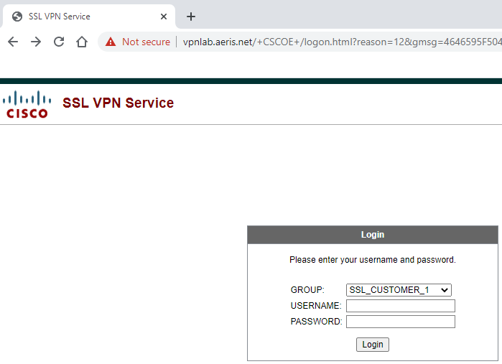

VPN USER GROUPS

When Aeris engineers configure your VPN, a user group is assigned to your account. Once your VPN account is activated, you will be provided with the appropriate user group based on the technology type that you are using. You must select this user group to access the software VPN service.

Below are the VPN groups for specific technology types:

- Group configured for US-based Global GSM, CDMA. and AT&T LTE users:
SSL_CUSTOMER_1

- Groups configured for EU- or UK-based Global GSM users:
EU_AERIS_CUSTOMER or EU_AERIS_CUSTOMER_4

- Group configured for Fusion Global (GSM LTE) or Fusion North America (Sprint IOT) based users:
FUSION

VPN CREDENTIALS

Credentials include a username and password which are configured by an Aeris engineer and provided to the user when the VPN account is created.

USERNAME: Provided by Aeris to the customer.
PASSWORD: Provided by Aeris engineer to the customer.

- Once appropriately authenticated, you are prompted to download and install the Cisco AnyConnect Mobility Client based on your operating system (Windows, MAC, Linux 32-bit, or Linux 64-bit).
Note: You may be asked to install Microsoft ActiveX.

Upon successful installation of the AnyConnect application, the VPN software will be displayed in the taskbar with this icon:
- Click the icon to open the Cisco AnyConnect Secure Mobility Client.
- In the address text box, type the URL for your technology type, such as https://vpnlab.aeris.net.
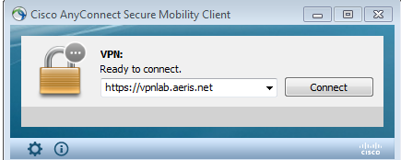

- Click “Connect.” The AnyConnect authentication by Group, Username, and Password is displayed.
- Enter the Aeris-provided username, password, and group to connect to the network.

