MatchBlox Design Document
(First Draft)
©2000 Nothing Special Productions, LLC

Game Overview 1
GamePlay 2
Scoring 3
Board Editor 4
Game Specs 4

Game Overview
MatchBlox is played on a 10x10 board filled with 8 differently colored tiles and empty spaces (See Fig. 1). By clicking on the arrow keys at the edge of the board, all tiles in that row or column will slide towards the edge. After the tiles have moved, the board is checked for a set of same color tiles that connect adjacently to each other in any configuration (See Fig. 2). Any matches that are found are removed from the board, and the player’s score is adjusted accordingly. The goal of the game is to clear the board of all tiles.

Fig. 1 Example Random Board
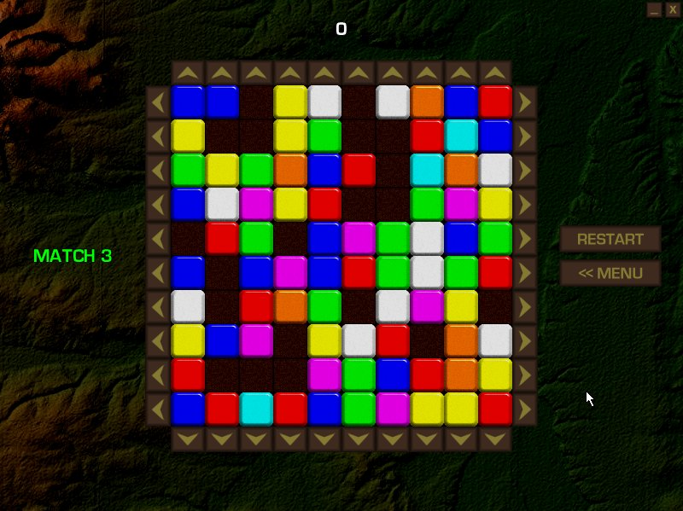

Fig. 2 Example Tile Matches
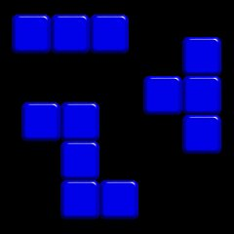

GamePlay
MatchBlox allows for 3 different styles of play: Match 2, Match 3, and Match 4. Each type of game requires a greater number of tiles to be matched to count as a set and be removed from the board. When a game first starts, the board will be filled with randomly placed tiles of every color and empty spaces. Strategy really comes into play as you get closer to clearing the board. If you are playing a Match 3 game, and you have 5 blue tiles left, then you must remove all 5 tiles at the same time, or be left with only 1 or 2 blue tiles, not enough for a match. At this point the player must restart and try again.

In addition to playing random boards, we are also including a Puzzle game, which will have 100 preset puzzles of various Match 2, Match 3, and Match 4 boards. The puzzles will be organized in order of increasing difficulty. After every 5 levels the player will be given a password to return to that stage of the puzzle game. See Fig. 3 for an example of a preset puzzle board.

Fig. 3 Example Puzzle Board
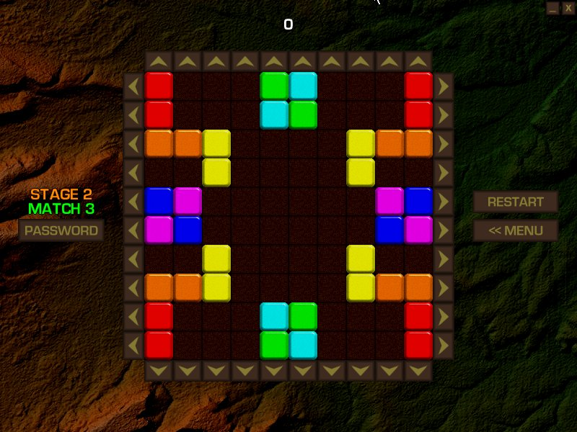

Scoring
For each tile in a match made, 10 points times the number of tiles in the match are awarded. If more than one match is made at one time, all points are multiplied by the number of matches made. See Fig. 4 for examples.

Fig. 4 Example of Scoring
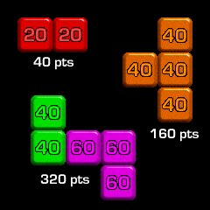

Board Editor
MatchBlox will include a Board Editor to allow users to design their own puzzle boards to play and share with friends.

Game Specs
MatchBlox will run under Windows 95/98/Me using the Win32 API and the GDI for drawing. Minimum screen resolution is 800x600x16. Minimum processor requirement is estimated to be a Pentium 200mhz.

