Planetary Orbit Simulator – Pretest

Answer the following questions.
- Which of the following is not part of Kepler's contribution to planetary orbits?
  - shapes of the orbit
  - speeds of planets in their orbit
  - orbital period
  - gravity
- Rank the following 4 ellipses below in order of increasing ellipticity.
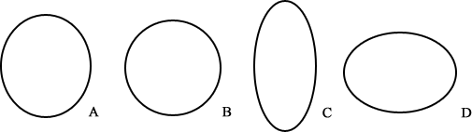
  - A, B, C, D
  - B, A, D, C
  - C, D, B, A
  - D, C, B, A
- Which of the following look most like the orbit of Venus?

  - 
  - 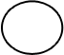
  - 
  - 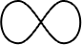

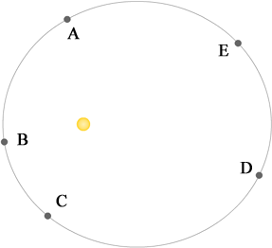
- At which point or points is the planet slowing down? (planets shown here are assumed to be orbiting counter-clockwise)
  - A, E
  - B,C,D
  - D
  - A, B, C, D, E
  - none of the points (the planet is moving at constant speed)
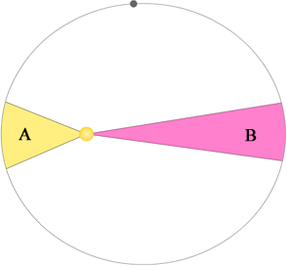
- With respect to the figure above, which of the following statements is true?
  - The planet will cover regions A and B is the same amount of time because of Kepler’s 2nd Law.
  - The planet will cover region A in a faster amount of time than region B, because A has less area.
  - The planet will take longer to move through region A because it is moving slower in region A than it is in region B.
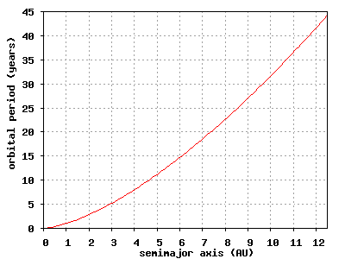
- Using the graph, a planet with a semimajor axis of 10 will have an orbital period of about
  - 4.6 years
  - 10 years
  - 32 years
  - 100 years
- The orbital period of Mars is
  - longer than earth's orbital period because it is farther from the sun.
  - shorter than earth's orbital period because it is farther from the sun.
  - longer than the earth's orbital period because its orbit is less circular.
  - short than the earth's orbital period because its orbit is more circular.
- The acceleration of a planet is
  - directly opposite the planet's motion if it is slowing down.
  - in the same direction of the planet's motion if it is speeding up.
  - always towards the sun.
  - always away from the sun.
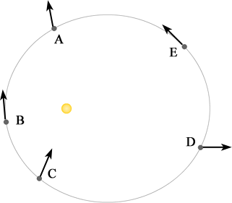
- If the arrows depicted in the picture represent velocity, which planet or planets is shown correctly? (Planets can be orbiting either clockwise or counterclockwise.)
  - A
  - C
  - D
  - B, E
- If a planet has a semimajor axis of 4 and an eccentricity of 0.2, how far is the planet at aphelion?
  - 0.8
  - 3.2
  - 3.8
  - 4.2
  - 4.8
  - 20

