MEDIQCODE
Coding intelligence that pays for itself.
The AI platform for medical coding, audit, and documentation integrity — built for hospitals that actually deploy it.

Faster coding.
Higher accuracy.
Bulletproof audit trail.
MEDIQCODE turns hospital coding from an operational bottleneck into a measurable advantage. AI does the heavy lifting. Coders make the decisions. Auditors get the evidence. Managers get the numbers.
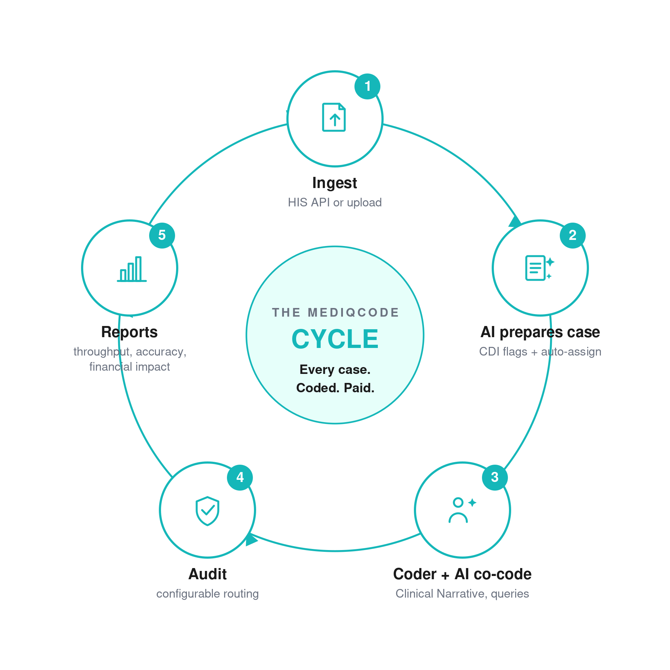

What hospitals get on day one
- Coders work more cases per shift, with confidence, because the AI prepares each case before they open it.
- Documentation gaps are caught and clarified upstream — before they cost you reimbursement or trigger audit findings.
- Every code carries reasoning, the coding standard it follows, and a link to the source documentation. Audit defense becomes click, click, done.
- Clinical communication stays inside the case, not scattered across email. Coders, clinicians, auditors and supervisors all speak in the same thread.
- Managers see the entire coding operation in real time, with the metrics they actually need to make decisions.
Hospitals stop firefighting their coding queue. They start operating it.

Your AI coding sidekick
Ask MEDIQCODE anything.
A coder hits an unfamiliar diagnosis combination at 2pm and needs to know what the standard says. They open the AI Assistant, ask the question in plain language, and get a grounded answer pulled from the actual coding standards. No more lost time flipping through reference books.
For deeper case-specific work, MediqAssist sits inside the episode and reasons about that case only. It is not pretending to know the patient. It is the patient. Two AI companions, each built for a different job.
- AI Assistant — the general-purpose sidekick, available across every screen, for any coding standard or documentation question.
- MediqAssist Copilot — case-specific, inside the episode, taking only the current case as context.
Coders stop searching. They start asking.

Standards-grade by design
Every code MEDIQCODE suggests follows the standards your auditors and regulators actually care about.
- ICD-10-AM diagnostic coding standards
- ACHI procedure classification
- SBS v3 standards (Saudi and broader GCC market)
- Australian Coding Standards (ACS) — Edition 10 and current
- AR-DRG, IR-DRG, G-DRG and MS-DRG grouper logic
Compliance is not bolted on. It is the architecture. The AI cannot suggest a code without grounding it in the rule that supports it, and the coder can click straight to that rule from the suggestion.

The workflow at a glance
- Documentation arrives — through HIS integration (recommended) or manual upload.
- Smart auto-assignment routes each case to the best-fit coder by specialty and current capacity. If the best fit is full, the next best fit takes the case.
- CDI scans the documentation, flags anything missing or ambiguous with severity, evidence, and a proposed coding impact, then auto-fills a query back to the clinical team.
- The coder opens the case with the AI Assistant, the Clinical Narrative reasoning view, and the per-case Queries thread already populated.
- Approved cases route to audit through configurable rules — all to audit, sample, or coders below an accuracy threshold.
- Reports surface the entire operation: throughput, accuracy, audit outcomes, financial impact, case-mix.

Five reasons MEDIQCODE wins

1. CDI that fixes problems before they become problems
Documentation gaps are flagged before coding starts. Each flag carries severity, confidence, evidence, and an explicit coding-impact recommendation citing the standard. When the clinician needs to weigh in, MEDIQCODE auto-generates the query, pre-filled, ready to send. Documentation quality goes up. Audit findings go down.

2. Clinical Narrative — open-box AI reasoning
Every diagnosis comes with the AI's full reasoning visible to the coder. Evidence from the chart. Candidate codes. Verdicts (approved, rejected, warning) with ACS references. Your coders never accept a black-box suggestion. Your auditors never see one either.

3. Queries that live where the work lives
Clarifications, audit questions, coder inquiries — all live on the case they relate to, with status, priority, member assignment, threaded replies, and a cross-episode Inbox. Email chains die. Audit trails are built automatically.

4. Custom coding rules that learn from your coders
Every hospital has its own coding norms. MEDIQCODE lets you encode them as rules with a visual builder — and the AI helps. More importantly, the AI watches how your team codes. When a pattern repeats, the AI proposes it as a rule for your team to adopt. The platform gets smarter the more you use it.

5. Enterprise governance, not a coder gadget
Queue settings, audit routing, turnaround SLAs, engagement rules, audit catalog, clinician response rules, custom coding policies. Every workflow lever is configurable, role-aware and audit-logged. This is software you can run a coding operation on, not a productivity widget.
Not just better coding. A better coding operation.

What every role gets

Coding Managers
- Real-time visibility into throughput, accuracy, audit outcomes and case-mix
- Smart auto-assignment that balances workload without intervention
- Coder accuracy reports that surface who needs support, training or workload rebalancing
- Audit routing rules that target the cases that actually need oversight

Medical Coders
- Cases prepared before they open them. AI suggestions with reasoning, ACS references and documentation links
- Two AI helpers always one click away. Coding standards become a conversation, not a manual hunt
- Queries to clinicians auto-drafted from CDI flags. No more writing the same email three times
- Clinical Narrative gives a clear view of why the AI suggests what it does

CDI Specialists
- Receive cases where the CDI engine has flagged documentation gaps before they reach a coder
- Review flag detail with severity, confidence, evidence summary and coding impact
- Raise clarification queries to clinicians using auto-generated, pre-filled drafts
- Close documentation gaps upstream, before they cost reimbursement or trigger audit findings

Coding Auditors
- Every case arrives with reasoning, source documentation links and ACS standard references
- Audit Outcomes analytics with DRG accuracy, approval rates, financial impact, rejection loop tracking
- Configurable audit routing: all, sample, or threshold-based for targeted oversight
- Audit Catalog as the central library of audit rules applied during review

Clinicians
- Queries arrive pre-filled with documentation context and response options
- Inbox view of every clarification request, sorted by urgency
- Direct deep-link from the query back to the episode for full context
- Closed loop on clinical documentation quality, reflected in your CDI patterns over time

Trust by design
MEDIQCODE is built for regulated healthcare environments from the architecture up, not retrofitted at the end.
- GDPR-compliant data processing with full data subject rights workflows
- EU AI Act decision-support classification. The human coder is always the final authority. The AI never approves a code on its own
- Deployment on regional cloud or on-premise. Data residency contractually committed
- Immutable audit logs on every input, output and override
- We do not train our models on your data without your written consent

Built for hospitals running real coding operations
Eight distinct user roles. Per-user workload capacity. Engagement rules with SLAs. Custom policies you define. Reports that match the way coding operations are actually measured. This is the platform behind the coding team, not a tool the coding team uses.

MEDIQCODE.
Coding intelligence that pays for itself.
Talk to your MEDIQCODE representative or visit us at the contact information accompanying this brochure to schedule a deployment scoping conversation.
MEDIQCODE™ is a registered trademark. Functions and features described reflect the production platform as of May 2026.

