

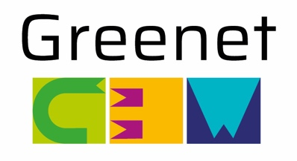

“Competitive Proposals and Success Stories in Cluster 5 - Widening Countries”
Online Training

13 January 2026 | 10:00-13:00
Online via Teams

Register here by 10 January 2026

This training is designed back-to-back with the Horizon Europe Brokerage Event 2026 Cluster 5 and aims to support potential participants in Cluster 5 calls from Widening Countries, though everyone interested is welcome to join.

The session will introduce Cluster 5, providing an overview of its thematic priorities, objectives, and funding opportunities, with a focus on participation for Widening Countries. Participants will also learn about the GREENET and NCP_WIDERA.NET networks, which connect NCPs across Europe, fostering collaboration and knowledge exchange.

Practical guidance on proposal writing will be provided, including tips, tricks, and tools to improve clarity, structure, and competitiveness.

The session will conclude with inspiring success stories from Widening Countries, highlighting effective strategies and lessons learned for successful participation in Climate, Energy & Mobility cluster.

For any questions or further information, please contact us at wideranet@apre.it.
Agenda

Time | Topic | Speaker
10:00 | Welcome and Opening | Angelo D’Agostino & Federica Tanghetti, APRE
10:10 | General Introduction to Cluster 5 and to GREENET | Noemi Tesauro, APRE
10:45 | Introduction to NCP_WIDERA.NET | Project Coordinator, NCBR
11:00 | Proposal Writing Tips & Support Tools | Federica Tanghetti, APRE
12:15 | Case Study n.1
12:30 | Case Study n. 2
12:30 | Q&A session
13:00 | End of the training


NCP_WIDERA.NET project has received funding from the European Union’s Horizon Europe research and innovation programme under the grant agreement No 101055286
The GREENET project has received funding from the European Union’s Horizon Europe programme under the grant agreement No 101069604

The Teams invitation will be sent to the participants the day before the event.

