15th European Forum on the Rights of the Child
CHAMPIONING CHILDREN’S RIGHTS: BUILDING FAIR AND RESILIENT SOCIETIES FOR THE EU’S PRESENT AND FUTURE
A new impetus for the EU Strategy on the Rights of the Child
23-24 June 2025, Brussels, Belgium

Speaker Biography

First name(s): | Sandra
Surname(s): | Aigner-Accardo
Job title: | Project Manager
Organisation (including city and country): | EU Agency for Fundamental Rights (FRA)
E-mail address: | sandra.aigner@fra.europa.eu
Biography (max 100 words, in prose format): | Sandra Aigner-Accardo is Project Manager at the EU Agency for Fundamental Rights (FRA) overseeing the “Towards integrated child protection systems” project and co-author of Towards Integrated Child Protection Systems - Challenges, promising practices and ways forward | European Union Agency for Fundamental Rights.  Previously, she served as Programme Officer providing training and capacity building expertise to Agency projects across various areas of work including on the EU Charter of Fundamental Rights.  Her work spans children’s rights, human rights education and capacity building, professional training, and youth participation.  She holds an MA in European Economy and Business Management. She trained in children’s rights and protection at the University of Geneva.
Headshot: | 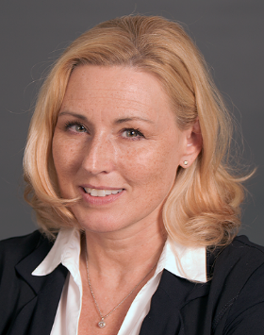
Organisation logo: | 