IPCEI AI
Value-Chain Description

Please note this document reflects the current stage of deliberation among the participating member states and is subject to change and improvement. It is intended to be used in the national procedures such as call for proposals or calls of expression of interest.

Version | Date
1.0 | 24 July 2025

Table
1. Political Rationale 3
1.1 Artificial intelligence as key factor for economic growth and gain competitiveness 3
1.1.1 EU Challenges for AI 3
2. General Objectives 5
3. Description of Value-Chain components 6
3.1 Data processing, orchestration, provisioning 7
3.2 Sovereign foundation model (LLM/LRM) 7
3.3 Sovereign industry sector specific foundation model (SFM) 8
3.4 AI deployment and operations 8
3.5 Open platform for AI 9
3.6 AI Services and sector specific Use Cases 9
3.7 Transversal descriptions 9
4. Research and development (R&D&I) activities 10
4.1 Data processing, orchestration, provisioning 10
4.2 Sovereign foundation model (LLM/LRM) 10
4.3 Sovereign industry sector specific foundation model (SFM) 11
4.4 AI deployment and operations 11
4.5 Open platform for AI 11
4.6. AI Services and sector specific Use-Cases 11
5. First industrial deployment (FID) activities 12
6. Related Initiatives 13
7. Roadmap 13

Political Rationale

1.1 Artificial intelligence as key factor for economic growth and gain competitiveness
The European Union as a unique digital single market is challenged by the rapid digital developments. The European Union faces double challenges: to increase the adoption of key digital technologies in its economy to improve its competitiveness, and to do so in a way that strengthens its technological sovereignty and the resilience of its infrastructure and societies. The engine of the next industrial revolution will be artificial intelligence (AI) which is the major paradigm shift and the technological foundation for the development and use of digital solutions today and tomorrow. Europe´s industry needs access to the latest Software, AI models, high-quality data as well as high-end computing resources. Examples of innovative AI solutions include autonomous production lines, precision robotics powered by AI, and AI-assisted product design. Advanced applications such as digital twins and Industrial Metaverse platforms are also transforming industrial processes. In the telecommunications sector, AI enables the automation and optimization of network management, including predictive maintenance, traffic forecasting, and dynamic resource allocation. Likewise, services can expect similar benefits through AI adoption.
Therefore, it is necessary that European industries need to have equal access to sufficient computing and data resource for AI to reduce their dependence on non-European solutions and providers. The European industries must have the sovereign choice to increase resilience as well as security. This should be reached by combining new and existing European technologies through increased interoperability.
In this context, the European Commission has introduced the AI Continent Action Plan, which is a comprehensive strategy to position Europe as a global leader in artificial intelligence. One key pillar of the plan is the investment in computing infrastructures, allowing innovators and researchers to train and finetune AI frontier models. It includes both strengthening the network of AI-Factories and establishing AI-Gigafactories. Another key pillar is fostering the sectoral application of AI. Within this pillar, the forthcoming Apply AI Strategy which pursues the acceleration of AI adoption and driving innovation while leveraging AI solutions “made in Europe”. Complementary to this the EU Cloud and AI Development Act aims to triple the EU’s data centre capacity within the next five to seven years.
Therefore, it is necessary to be supported by a comprehensive and integrated Important Project of common European Interest (IPCEI). This IPCEI is driven by the Member States and ensures the integration of the different national requirements and bundling competences on European scale. Last year, within the Joint-European-Forum (JEF) 19 Member States discussed and identified possible key digital technologies feasible under the IPCEI-Communication of the EU Commission. A group of 13 Member States endorsed in November 2024 the two digital IPCEI proposals (IPCEI AI and IPCEI CIC) addressing the following challenges.
Prerequisite of the IPCEI is that all projects along the value chain as descripted below need to have the potential to contribute to the objectives of the IPCEI and to be committed to effectively collaborate cross-border with each other within and across the value chain steps, so to have the potential to make part of the IPCEI. The benefits of the projects must not be limited to the undertakings or to the sector concerned but must be of wider relevance and application to the economy or society in the Union through positive spillover effects.

1.1.1 EU Challenges for AI
Global developments in AI are accelerating with fast pace, the sense of urgency is eminent: The European Union must foster an environment in which computing, interconnectivity, cloud, data, AI and software providers can grow and provide AI capacities and services to industries, academia, public sector and citizens. This should be achieved along a distributed computing and software stack, from bare metal solutions to specialised AI services. In this context, the EU need to address the following challenges:
- Low adoption rate of AI solutions:
EU suffers from low adoption rate of AI technologies in industries, due to high ramp-up cost and lack of “plug and play solutions”. Additionally, there is a lack of certified trust for AI solutions. Today, most AI solutions are locked in proprietary ecosystems. This leads to a limited scalability of AI solutions and an increase of AI divides among Member States and hence compromising the competitive advantages and productivity gains of AI.
- Limited availability of compute capacity and high-quality data sets to train AI:
The EU shall seek the opportunity to overcome the dependency on infrastructures and solutions mostly supplied by third-country providers which bear the risk of lock-in effects. Access to computing capacities, together with the availability of high-quality data is the backbone of AI. Today, Europe lacks the sufficient infrastructure, specialized to the need for AI to address its future needs. At current stage, 70% of worldwide AI compute capacity is deployed in the United States with Europe accounting only for a 4% of it. Moreover, European industrial electricity costs are 1.5-3 higher, limiting the competitiveness of European players in the field.
- High fragmentation and lack of state-of-the-art AI and cloud technologies in Europe:
While Europe possesses AI infrastructure capabilities through various national and regional providers, these resources remain fragmented and insufficiently coordinated to compete effectively with the integrated ecosystems of major global players. This fragmentation particularly affects the deployment of AI solutions requiring specialized infrastructure, such as real-time edge computing for autonomous systems or distributed processing for large-scale AI training. The challenge is not an absence of technical capabilities, but rather the lack of a cohesive, interoperable framework that can leverage Europe's existing strengths in computing, connectivity, and data services. Addressing this requires a federated approach that integrates Europe's distributed capabilities into a more unified and scalable ecosystem, enhancing both competitiveness and strategic autonomy in AI development.
- Lack of interoperability of AI solutions:
The integration and the interoperability of AI solutions deployed on different computing resources across different European regions and between cloud and edge fragmented infrastructures is necessary but complex and inefficient. Future AI solutions need to be integrated seamlessly to meet the high requirements in terms of e.g. latency, bandwidth, security, reliability or energy efficiency. Interoperability is a prerequisite for future use cases, e.g. real-time data processing (autonomous trains/ trucks/ cars, smart factories, telecommunications, drones, ...) and is of a highly strategic value for the EU.
- Insufficient readiness for future AI developments:
Due to the current lack of the European providers to meet the requirements of next generation AI solutions, there is a risk of not keeping pace with the rapid global AI development. For certain future AI related use cases, Europe lacking the capability to train and run AI solutions on locations where the data is generated and stored. Therefore, a federated distributed ecosystem needs to be established, based on an intelligent orchestration of distributed computing and connectivity functions allowing for secure and confidential transfer and processing of mass data. This systemic approach is not limited to the infrastructure including storage, network and compute capabilities but also considers software stacks and support services.
An important success factor in supporting the resilience of the EU is to achieve technological sovereignty by ensuring that AI foundation models and the necessary supporting services are offered by the European providers. This implies developing a common infrastructural ecosystem for AI, by making compute resources available and optimizing the hardware and software stacks.
Finally, the EU’s objectives for the digital transition as well as strategic sovereignty shall foster the deployment of AI capacities and capabilities. The aim is to strengthen the development of the sovereign digital value chain and its resilience, from data centre operators to AI service providers.

General Objectives
To comply with the IPCEI communication of the EU Commission, the two proposed IPCEIs (IPCEI AI and IPCEI CIC) as State aid instruments shall be designed in two distinct ways: the first with the focus on R&D&I and the second focussing on deployment of infrastructure. The common objectives of the IPCEI on research on Artificial Intelligence (IPCEI-AI) and the IPCEI on deploying compute infrastructure continuum (IPCEI-CIC) is to boost Europe’s competitiveness in the global digital economy by fostering innovation and investment in developing AI capabilities and facilitating the access of European companies of all sizes to AI technologies and services. EU stakeholders (whether AI users or developers) deserve a resilient and secure environment consisting of hardware as well as software capabilities. The IPCEIs will enable all Member States to follow up on their respective AI strategies and collectively equip the EU to develop a next-generation European AI ecosystem that meets the needs of European stakeholders. The IPCEIs shall allow a better coordination across providers, companies, academia and countries to avoid duplication of work and inefficiencies in AI research and development. The IPCEIs should be able to complement the developments by IPCEI-CIS, as part of the 8ra-Initiative. They shall adhere to strict ethical guidelines and regulations, such as GDPR, DGA, Cybersecurity Act and AI Act.
For the European Union, criteria to improve technological and digital sovereignty are of the essence. Therefore, the establishment of a European wide ecosystem which assure for users/consumers and businesses to choose their competent service providers independently and to prevent vendor lock-ins for compute and data (incl. AI and cloud) services is necessary. In this ecosystem, data shall be processed and transferred according to the users' preferences regarding the scope, duration, subject matter, conditions, and partners of the exchange. Also, data shall be processed and transferred under the latest security and resiliency standards and according to the applicable EU regulations.
The scope of the IPCEI-AI is the development of a next-generation AI ecosystem for the European Union providing latest AI training and development technologies. This requires secure access to high-quality data sets and ensuring the availability of state-of-the-art AI technologies, thereby significantly increasing the adoption rate of AI solutions in European industries by offering easy-to-use AI applications with low ramp-up effort. The project should focus on:
- Development of a first ever next generation AI continuum for the EU that includes:
  - Research and development of open and competitive AI foundation models: New foundational, frontier models, next-generation AI model training technologies and methods, incl. innovative post-training techniques, such as fine-tuning for specific sector offerings.
  - Enablement of sovereign European cloud services and essential components for AI training and deployment (including resource management, computation distribution).
  - Development of new energy efficiency technologies to train and run AI models.
- Secure and safe access to high quality datasets for AI:
  - Development of technologies for the availability and access to high quality and structured datasets for AI under European data privacy and security regulations.
  - Integration of new solutions for data storage and management, database administration, data processing and analytics.
- Development of advanced AI-as-a-service (AIaaS) approaches, tailored to the needs of AI developers and users, especially SMEs. This will enable the broad adoption of AI models to address specific use cases, across various industrial sectors. This includes:
  - Development of advanced tools and frameworks to facilitate the development process and the deployment of AI models.
  - Creation of a framework enabling access through APIs to AI models and end-to-end capabilities.
  - Development and deployment of next generation inference and AI training services.
- Development of a common open-source framework to ensure security and high interoperability of European solutions. Substantial building block is an active developer’s community to create and maintain the code for an open-source toolbox to allow to easily create highly customisable AI solutions for industries.
- Systematic integration of next generation AI models into applications and interconnection services (e.g. telco network services), addressing common use cases within specific industrial sectors and public administrations.
An aspired effect of the IPCEI which goes beyond the R&D&I activities is the establishment of an “AI-Talent Factory”: Developing of schemes for training of AI skills, which are the essential foundation for successful adoption. Skills are critical enabler for the adoption of AI. The range of skills required in workers varies from basic to highly specialized, encompassing technical, cognitive and managerial competencies but also social skills. It’s imperative that micro, small and medium sized enterprises prioritize the enhancement of these skills, improve AI literacy in its many functions, and actively promote AI knowledge among their workforce and their representatives

Description of Value-Chain components
The purpose of the Value Chain description is to support the scoping of the IPCEI AI and to be implemented by the participating Member States in the forthcoming competitive, transparent and non-discriminatory procedures for selection of the direct participants and associated partners for the IPCEI AI, to define the scope of the eligible projects.
The structure of the Value-Chain component features technologies, research and development aspects in a logically combined order. The structure also represents possible centre of gravity for collaboration to build a highly integrated project on European scale.
The developed results are complementary and must be integrated with each other to achieve a comprehensive approach to enable companies in the European Union to set up sovereign AI services. Prerequisite to achieve this objective is the development of a common technical framework for the design and training of sovereign foundation models. This integrated and common, cross-sectoral approach will allow for the feedback from company to industry specific models into the general models. This will not only substantially improve the quality of models and reasoning but will also accelerate the AI development in general.
In addition, the value chain includes research and development for the “enabling services” that allow to perform the hereafter listed tasks (e.g. cloud services).

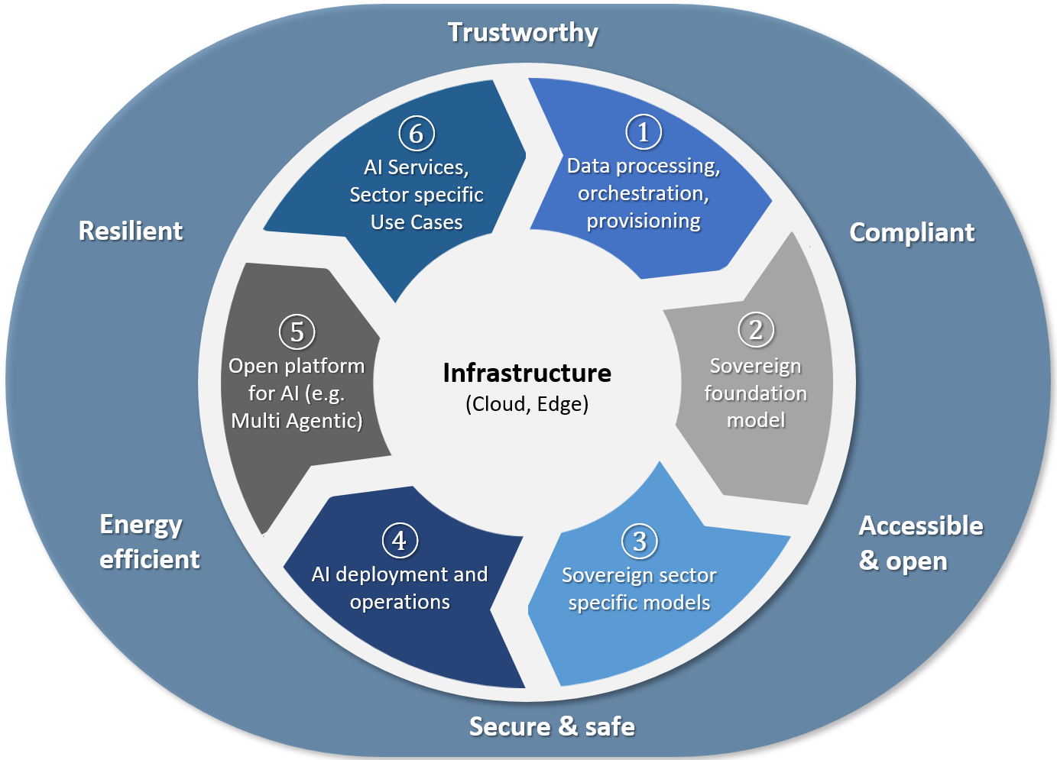
Figure 1: Overview of the Value Chain components and transversals

3.1 Data processing, orchestration, provisioning
Data processing services are a set of foundational system components that manage, process, and deliver data for AI models, handling data collection, transfer, storage, labelling, transformation, and access to ensure high-quality, scalable input for training and inference. These services can be used on-prem or through cloud services. Key capabilities of this component are the comprise of data orchestration and provisioning, vectoring of databases and knowledge graphs. It covers the management of structured & unstructured data, data cleansing, curating, provisioning, data accessibility and connectivity, etc.
Therefore, the development of solutions for data processing, orchestration and provisioning are critical for leveraging the full potential of AI, because data is the foundation of any AI system. Without the right solutions to manage and manipulate data effectively, even the most advanced models will underperform or fail entirely.

3.2 Sovereign foundation model (LLM/LRM)
Large language models are advanced machine learning models with billions of parameters, designed to perform complex tasks like language understanding, image generation, and problem-solving across multiple domains. Examples include GPT, PaLM, and LLaMA.
- A Large Language Model (LLM) is an AI model that is trained on vast amounts of text data to understand, generate, and manipulate human language. Examples include GPT-4, BERT, and Claude.
- A Large Reasoning Model (LRM) is a type of artificial intelligence model designed to perform complex reasoning tasks—going beyond basic language understanding or pattern matching to draw logical inferences, solve multi-step problems, or reason through abstract concepts.
Therefore, the development of sovereign foundation models (LLMs/LRMs) as defined above, is a strategic necessity for beyond-state-of-the-art offerings. Main benefits are:
- Ability to develop, manufacture, and utilize technology independently, including having control over the underlying infrastructure and software
- Independence from third country technology providers
- Building on tech providers adhering to IPCEI objectives
- Ability to customize models to local laws, values, and priorities
- Reduced risk of geopolitical disruption or sanctions affecting AI capabilities

3.3 Sovereign industry sector specific foundation model (SFM)
Industry specific foundation models can contribute to the decisive key differentiation of benefits for the industry. While large language models are developing as a commodity, the added value in this area is considered very high. In connection with technologies such as knowledge graphs, models can be developed that produce very high accuracy results. Cross-industry developments are difficult due to barriers to cooperation and require structured communication and coordination, which can be provided by an IPCEI. Since this is partly highly sensitive data for companies, a high level of security must be guaranteed.
Industry & sector specific AI Models are pre-trained non-language foundation models, which are based on structured business and machine data tailored for specific industry sectors, like healthcare, finance, or manufacturing, optimized to handle sector-specific data, tasks and regulations. These models need a wide range of common open-source services and tools to be developed (from compute to model conception and training), that allow IPCEI partners and European companies to access at full potential the foundation models (used on-prem or through cloud services).
Europe need to leverage AI to maintain its industrial leadership. Europe has strong industrial sectors like automotive, aerospace, pharmaceuticals, machinery and many more. AI tailored to these domains can:
- Boost productivity and engineering capability
- Improve quality
- Enable new business models
- Open Foundation Models Family made in EU should build a core of the AI Ecosystem based on Domain-specific models.

3.4 AI deployment and operations
Deployment and operations (often referred to as AI Ops) involve the end-to-end process of bringing AI models into production and managing them effectively throughout their lifecycle (including maintaining, monitoring, and updating), and can be fulfilled by different means (e.g. cloud services). On the other hand, Inference is the execution of that model to generate predictions or outputs from new input data.
Solutions for AI deployment and operations are essential for transforming AI from experimental prototypes into reliable, scalable, and impactful business solutions and indispensable for various reasons, e.g.:
- Ensuring that models are actually used in live products and systems
- Enabling continuous learning and updates to adapt to new data and conditions
- Supporting automated retraining, evaluation, and redeployment

3.5 Open platform for AI
An open platform for AI refers to a software or infrastructure ecosystem that is designed to be accessible, extensible, and usually based on open-source software code, allowing developers, researchers, and organizations to build, deploy, experiment with, and share AI models and tools either using on-prem infrastructures, or through cloud services. As part of an open platform AI Orchestration will be relevant for integrating, managing, and automating workflows, tools, models, and infrastructures required to build, train, deploy, and monitor AI solutions at scale. It also comprises AI containers. As an area of major innovation potential AI Agent Systems will play an important role as autonomous software entities that perceive the environment, make decisions, and perform actions to achieve specific goals, often using machine learning, reasoning, or optimization techniques.
Open platforms for AI - especially those enabling multi-agentic systems - are increasingly important because they provide the flexibility, collaboration, and composability needed to scale, innovate, and govern AI ecosystems, e.g. to enable agents to interact, share tasks, and build on each other. They allow to combine best-in-class tools, models, or agents without vendor lock-in and encourage rapid innovation by allowing plug-and-play of AI components.

3.6 AI Services and sector specific Use Cases
AI services and applications are systems that are built upon foundation models and use artificial intelligence techniques, such as machine learning, natural language processing, or computer vision, to perform tasks that typically require human intelligence. AI applications analyse data, learn from it, and make decisions or predictions with minimal human intervention. AI Applications will deliver value to many industrial and service areas, such as Agrifood, Energy, Automotive, Public sector, Manufacturing, Health, Telecom (management and optimization of networks), Services, Learning/Training, Consulting, Mobility, Tourism & Travel, Finance, Operations (Monitoring, Anomaly detection & management, etc.). AI Application Platforms provide further tools and solutions for Application Orchestration, Monitoring, Billing, etc, that are often offered as cloud services.

3.7 Transversal descriptions
Transversals are fundamental elements necessary to operate the Value Chain components. Transversals need to foster:
Compliance: Compliance related capabilities and initiatives related to IPCEI AI will ensure that AI solutions adhere to legal, ethical, and regulatory standards, including data privacy, fairness, transparency, and accountability.
Trust & Resilience: Trustworthiness related capabilities and initiatives in IPCEI AI will provide the ability of AI systems to be reliable, transparent, and fair, ensuring it makes decisions that can be understood, justified, and are aligned with ethical standards. Trustworthy AI is a necessary requirement for accepted use. Resilience measures will aim to maintain the performance of AI systems, recover systems from disruptions, and adapt to changing conditions or adversarial threats. The objective is to achieve high resilience throughout the whole AI stack, even if requiring redundancies.
Security & Safety: Security in AI refers to protecting AI systems from threats such as data breaches, adversarial attacks, and unauthorized access, ensuring the integrity, confidentiality, and availability of the AI model and its data. Safety in AI refers to the design, development, and deployment of artificial intelligence systems in a way that ensures they operate reliably, predictably, and without causing harm to people, property, or society.
Energy Efficiency: Sustainability in AI refers to designing and operating AI systems in ways that minimize environmental impact, optimize energy and resource use, and support long-term social and economic well-being.
Accessibility & open (Open-Source): For IPCEI AI the adoption of Open-Source models will be highly relevant:
- to improve sovereignty through reduces reliance on a few dominant players,
- to increase transparency through, where appropriate, open access to model weights and training data,
- to enable reproducibility, crucial for scientific and ethical accountability and
- to empower researchers and developers (also in resource-constrained environments, e.g. SMEs) to create competitive AI applications.

Research and development (R&D&I) activities
R&D&I is essential to achieve the aforementioned objectives of the IPCEI-AI. The following chapters describe currently identified R&D&I challenges which will have to be solved in order to achieve the objectives of a highly integrated project on European scale and represent the “centers of gravity” during the development and implementation phase. Those “centers of gravity” are complementary, build on each other and are all necessary to achieve the common project goal. Those challenges are by no means exhaustive and can be expanded according to actual project proposals. The R&D activities in the IPCEI AI and the projects of the direct participants must be of major innovative nature or constitute an important added value in terms of R&D&I in the light of the-state-of the-art in the sector concerned, i.e. must demonstrate their progress beyond the global-state-of-the-art.

4.1 Data processing, orchestration, provisioning
Objective is the development of a framework for processing of high-quality, harmonized industry-specific data incl. Encryption, anonymization, access control and generation of synthetic data in a highly secure fashion. This enables confidential sharing of data, distributed AI data processing, such as federated learning and secure multiparty computation and data collection for general and industry specific benchmarks.
Priority should be on highly automated methods for data curation based on common syntax and semantic to support high-level interoperability and open modular data architecture and processing pipelines, e.g. automated generation of knowledge graphs. Therefore, methods for leveraging cross-industry equivalences in data and specific foundation Models should be developed, by enabling processing of multi-modal and cross-sectorial data sources by leveraging data spaces. This will lead to fair accessibility and usability of data in the specific industrial sectors.

4.2 Sovereign foundation model (LLM/LRM)
Objective it the development of common sovereign (large) foundation (LLM) and reasoning models (LRM) as base models, including reinforcement and imitation learning, advanced reasoning and automated verifiers, incl. technologies to create ensembles of LLMs/LRMs. Prerequisite is research on concepts for data provenance, model alignment, safety, introspection and explainability of model behaviour.
Challenge is the development of methods for feature engineering, training, administration, inference, performance tracking/optimization. Focus should be on automation frameworks of training processes and life cycle; e.g. feedback loops including human interaction to improve models and the development of evaluation frameworks for assessing model performance, fairness, robustness, and alignment with European values and regulations.

4.3 Sovereign industry sector specific foundation model (SFM)
Key innovation and challenge are the development of common sector specific foundation models, adaptable for multiple domains and industry-grade security and safety. These models shall be based also on non-language data (tabular, csv, data bases, machine data, time-series and signal data), e.g. development of physics-enhanced AI Models. Therefore, a common semantic layer to connect the factory with the business data should be defined. This can be achieved by adapting standards to improve interoperability, e.g. for open benchmarks and shared datasets. This will lead to lowering the costs of fine-tuning to adapt foundation models to company data.

4.4 AI deployment and operations
Challenge is the development of an open framework which provides developer a base deployment functionality, such as optimisation of inference and model ensembles. This includes orchestration tools that abstract infrastructure complexity (using a reference architecture) enabling automatic orchestration, lifecycle management, adaptation and configuration of foundation models across Use-Cases. Additional tools and solutions for application orchestration, monitoring, billing, etc. Product lifecycle management, such as continuous updates, security maintenance, and compliance with international standards should be provided, e.g. for reliable deployment of AI models into production, especially across hybrid or resource-constrained environments.
It’s a prerequisite to develop continuous evaluation and monitoring systems that track model performance, drift, potential biases and compliance in production environments including availability, SLAs, ... In addition, this framework should define major efficiency improvements:
- optimized coding for less resource demand,
- component costs & CO2 footprint monitoring,
- reporting & optimization capabilities for AI models & applications.

4.5 Open platform for AI
Objective is the development of an open ecosystem for AI models, applications & components, tools, e.g. developed in Step 4 of the Value-Chain, to enable easy reuse & integration in a “marketplace” fashion. To achieve this an implementation of a (Multi-model) Agentic Systems Framework, including explicit knowledge modelling for experts based on a reference architecture/platform for multi-agent collaboration is necessary. This could be leveraged with existing capabilities for AI, evolution of existing software, e.g. evolvement of protocols, such as MCP, A2A and Haystack. Additionally new concepts for predictable behaviour and failure modes, particularly in mission-critical domains needs to be developed. This open platform should be deployed with an open-source sharing mindset, to support the spread of sovereign AI-services across EU Member States.

4.6. AI Services and sector specific Use-Cases
To accelerate the development from prototype to product readiness, including demonstrators it is necessary to successfully deploy and scale-up AI Services in production environments. This will serve as reference implementations for end-to-end integration of foundation models into a wide range of scenarios and showcase best practices for globally accepted industry formats.
Focus is the development of AI industrial applications and frameworks in different sectors, e.g. Automotive, Aviation, Aerospace, Public sector, Manufacturing, Health, Services, Learning/Training, Consulting, Mobility, Agriculture, Tourism & Travel, Finance, Operations, Engineering. To compare these AI solutions across vendors standardized evaluation protocols will ensuring compliance with industry-specific quality requirements. These solutions should be integrated in a repository of available AI services and be integrated in a fair system to recompensate various contributions, especially for SMEs.

First industrial deployment (FID) activities
The IPCEI as State aid instrument (and the projects of direct participants that form part of it) may include also first industrial deployment (FID) activities forming part of the projects in all steps of the Value Chain. The FID activities involve the upscaling of pilot facilities, demonstration plants or first-in-kind equipment and facilities covering the steps subsequent to the pilot line including the testing phase and the bringing of batch production to scale. They need to comply with the conditions of points 23 and 24 of the IPCEI Communication. Important is the following:
- The FID must allow for the development of a new product or service with high research and innovation content or the deployment of a fundamentally innovative production process. Regular upgrades without an innovative dimension of existing [facilities], products or services, and the development of newer versions of existing products (or services) do not qualify as FID.
- The FID must follow on (i.e. result from) from a previous R&D&I activity (that is also described in the projects) and itself must contain an important R&D&I component which constitutes an integral and necessary element for the successful implementation of the project.
- The FID however must not encompass mass production and commercial activities. The end of FID is determined by reaching the relevant R&D&I-related performance indicators, as set in advance, that point at the ability to start mass production.

Example:
Taken from IPCEI CIS as inspiration and to the extend it can be applied accordingly to the scope of the projects in this IPCEI AI, through the FID activities additional important R&D that is integral part and necessary for completion of the project will be carried out, which is necessary to test, scale up, mature or validate outcomes in real-world scenarios and conditions so as to meet the requirements for going into mass production and commercial activities (such as, for example, the ability to operate at scale and efficiency, achievement of the required quality of output, testing and adaptation of the performance of products and services on the basis of the technological feedback obtained from downstream industries and use cases executions, requiring the solutions to be further developed and adjusted). In FID activities, the outcomes of the R&D&I phase of the projects have to be integrated into the FID activities; the FID activities should pose specific implementation challenges, for which innovativeness ambition has to be demonstrated that significantly surpasses the global state-of-the-art in the applicable technologies and their adoption; the FID activities have to have the potential to validate and demonstrate in real-world scenarios and in environments of sufficient technological complexity and scale, the applicability of R&D&I results at the required level of quality and efficiency.

Related Initiatives
Initiatives related to IPCEI-AI objectives should be taken under consideration and linked to improve the efficiency of R&D&I processes, such as:
- Manufacturing-X
- IPCEI-CIS (8ra-initiative)
- IPCEI-ME/CT
- Deploy AI (AI on demand platform)
- Open EuroLLM
- Catena X
- EONA X

Roadmap
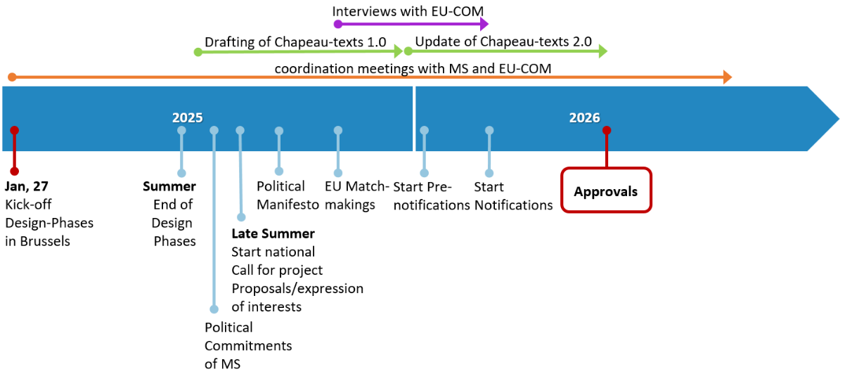
Figure 2: Illustrative Roadmap with important milestones of IPCEI AI;
final date for approval depends on further processes

https://www.oecd.org/en/publications/a-blueprint-for-building-national-compute-capacity-for-artificial-intelligence_876367e3-en.html
https://commission.europa.eu/document/download/ec1409c1-d4b4-4882-8bdd-3519f86bbb92_en?filename=The%20future%20of%20European%20competitiveness_%20In-depth%20analysis%20and%20recommendations_0.pdf & https://geopolitique.eu/en/2025/02/10/financing-infrastructure-for-a-competitive-european-ai/
https://www.mckinsey.com/capabilities/quantumblack/our-insights/time-to-place-our-bets-europes-ai-opportunity

