About Dr. Soumya Ranjan Jena:
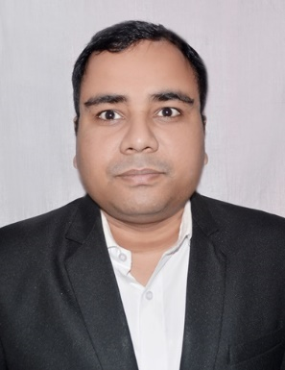
Dr. Soumya Ranjan Jena is the Assistant Professor in Department of Computer Science and Engineering, University Institute of Engineering, Chandigarh University, Mohali, Punjab. He is also one of the Designated Partners of a Startup called as SRJX RESEARCH AND INNOVATION LAB LLP, India which is among Global 100- 2026 Winners in Research and Innovation as per GPMG (Global Publishing Media Group Limited), U.K. report. SRJX RESEARCH AND INNOVATION LAB LLP, India is also a member of UNIDO (United Nations Industrial Development Organisation) and BRICS Center for Industrial Competencies. He has completed his PhD in Computer Science and Engineering from International Management University (IMU), Cambodia in the year 2026. He has received Hon. (Dr.) from Graham International University, USA in the field of Artificial Intelligence. He is pursuing his PhD in Computer Science and Engineering at Suresh Gyan Vihar University (SGVU), Jaipur, Rajasthan, India.

He has completed his Master in Technology degree in Information Technology form Utkal University, Bhubaneswar, Odisha, India in the year 2013, Bachelor in Technology in Computer Science and Engineering degree from BPUT, Rourkela, Odisha, India in the year 2010 and also certified by CCNA and Diploma in Computer Hardware and Networking Management from CTTC, Bhubaneswar, Odisha, India in the year 2011. He has more than 10 years of teaching and research experience from various reputed Universities and Colleges in India. He is basically an Academician, an Author, a Researcher, an Innovator, an Editor, a Reviewer of various International Journals and International Conferences and a Keynote Speaker.

His publications have 620+ citations, h index of 12, and i10 index of 14 (Google Scholar) Scopus- 20, SCIE- 3. He has published 38 international level books, around 32 international level research articles in various international journals, conferences which are indexed by SCIE, Scopus, WOS, Google Scholar etc., and published 50 international/national patents out of which 18 are granted.

Moreover, he has been awarded by Bharat Education Excellence Awards for best researcher in the year 2022 and 2024, Excellent Performance in Educational Domain & Outstanding Contributions in Teaching in the year 2022, Best Researcher by Gurukul Academic Awards in the year 2022, Bharat Samman Nidhi Puraskar for excellence in research in the year 2024, Global Innovative Leader Award 2025, International EARG Awards in the year 2024 and 2025 in research domain and AMP awards for Educational Excellence 2024, Global Innovative Leader Award by NextGen University International Chartered Inc, USA, Excellence in Research Contribution Award by Council for Skills and Competencies (CSC India), and received India Book of Records- IBR Achiever for authoring 33 books in Science and Technology, Swami Vivekanada Research and Innovation Excellence Awards- 2026. Moreover, his research interests include Artificial Intelligence, Edge AI, Green Computing, Sustainability, Renewable Energy Resources, Cloud and Distributed Computing, Internet of Things, Internet of Energy etc.

