Figure Electric vehicle and charging station

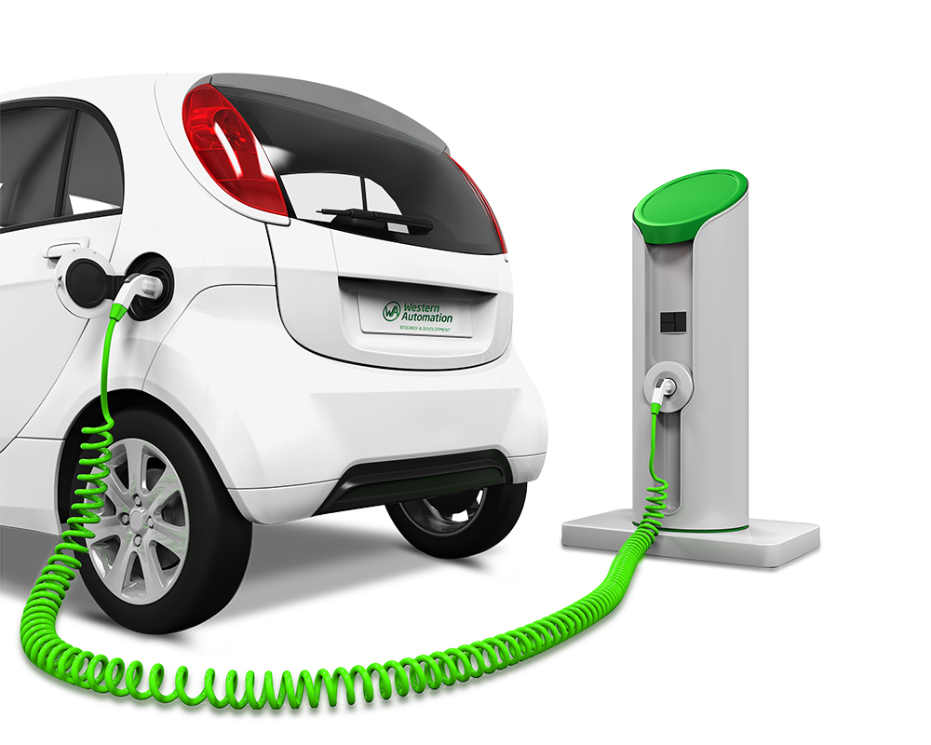

**GRAVITY 99 LIMITED**

Venturing into the Future

Company Profile

# INTRODUCTION

Gravity 99 Limited is an electric vehicle wholesale, retail and infrastructure investment company. The company is seeking to build a portfolio of electric vehicle charging stations and electric vehicle retail and wholesale centres throughout Nigeria and the neighbouring states The company is owned and driven by astute entrepreneurs from divergent backgrounds, some of them with solid business expertise.

# VISION

To become the best performing and well managed electric vehicle supplier and associated services entity in Nigeria and the rest of Africa.

# MISSION

To identify and penetrate strategic electric vehicle sales markets and acquire charging station locations that are geared to enhance its performance.

# INVESMENT OBJECTIVES

* To comply and adhere to all legal requirements of Nigeria.
* To invest in high return charging stations and electric vehicle sales with a potential for higher returns.
* With the assistance of experienced/skilled staff effectively managing the entities to ensure maximum returns.
* Create wealth for funders/investors in line with or beyond market expectation.
* To grow the underlying assets in-excess of **R5 billion** within a period of 5-10 year

# investment criteria

Gravity 99 Limited will invest in assets that meets with the following criteria:

**Electric Vehicle Sales**

* Sale of Income generating assets comprising of domestic and commercial vehicles
* Acquire electric vehicles through joint ventures with reputable manufacturers
* Assets acquired according to the major demand segments within the targeted sectors of commercial and domestic electric vehicle market.

**Charging Stations Outlets**

* Secure prime locations with existing petrol stations or greenfield projects
* Assets within the targeted sectors and within a 100km distance between stations
* Maintenance and mobile charging units where necessary
* IRR of **18%** regarding greenfield projects

# organisational STRUCTURE: Charging stations/Electric vehicle sales



# Project STRUCTURE – green fields projects for charging stations

# GOVERNANCE STRUCTURE



TOP MANAGEMENT PROFILES

CHAIRMAN: PROFESSOR AL-MUSTAPHA USSIJU MEDANER

Professor Al-Mustapha Ussiju Medaner is a seasoned Academic Consultant, financial strategist, governance expert, and business consultant with extensive experience in legislative analysis, economic planning, and institutional restructuring. He has played a pivotal role in national budget reviews, fiscal policy development, and strategic business management, with expertise spanning the public and private sectors.

As the President of Ummah Chambers of Commerce, Al-Mustapha leads initiatives that promote ethical/halal business, economic empowerment, trade development, and investment opportunities across various industries. His leadership extends to key sectors, including finance, energy, agriculture, automobile business, and real estate development and financing, where he has driven business innovation and economic diversification.

His strategic insights have been instrumental in governance reforms, academic curriculum development, financial sustainability, and economic policy implementation. As a multifaceted expert, he continues to shape policies and business strategies that foster sustainable economic growth. Thus providing strategic insights on financial risks, economic policies, and investment strategies for both public and private institutions. He has also developed and executed strategic frameworks for enterprises across multiple industries, optimizing financial performance and operational efficiency .In the energy sector he has consulted on energy policies and infrastructure development, advising stakeholders on sustainable power generation, resource management, and investment strategies in the oil and gas sector. In the automobile industry growth & expansion strategy he has advised on business strategies that focus on manufacturing, trade policies, vehicle assembly, and sustainable transportation solutions.

He is recognised as an outstanding public speaker and a featured expert on governance, economic policy, security and business strategy across major media platforms, including ‘Channels TV, Arise TV, AIT, NTA, Vision FM, and Hausa Radio and Television’ programmes. Published extensively in reputable local and international journals and the local newspapers.

With a solid background in financial strategy, governance policy, and business consulting, Professor Al-Mustapha Ussiju Medaner continues to influence key sectors such as energy, agriculture, the automobile industry, and real estate development. As President of Ummah Chambers of Commerce, his expertise in Halal /Ethical Business, economic planning, institutional reforms, and strategic business development has significantly shaped Nigeria’s political and economic landscape, driving sustainable growth, investment opportunities, and long-term prosperity.

DIRECTOR- ROY NAIDOO

Roy has in excess of 30 years of experience in the property and infrastructure industry. Currently he is the Chief Executive Officer of an infrastructure Company. He serves on the board of the company and is responsible for all corporate governance, strategic, growth, funding and operational issues. He has turned the company into a focused, high income generating entity.

His other experiences are related to the other areas of in property and include property, asset, facilities and project management. He was employed as a Head of Asset Management at a Banking institution where he evaluated viability of buildings for financing and even structured property funds, besides managing the entire asset management division. He has also worked at the Public Investment Commissioners-South Africa as the Head of Property, where he restructured the entire portfolio, including the dissolving of the SEBO structures. After this he was employed by Business Partners, where he was responsible for the restructuring of the portfolio from a low income generator to one that was exceptionally profitable. He has managed commercial portfolios in excess of R4 billion.

Regarding Infrastructure he was involved in EPC+ F regarding renewable projects and is currently busy regarding numerous such projects. He also engages with a diversified group of investors to fund these projects both locally and internationally.

He also holds a Master of Business Administration Degree, completed the Property Development Programme and the Junior Certificate offered by the Institute of Financial Markets.

DIRECTOR- ARUN SANKARAMANGALAM

Arun brings over 25 years of experience in the medical and sustainable energy industries, with a proven track record of driving growth and innovation across multiple countries, further solidifying the company’s commitment to excellence.

Currently, Arun serves as Director for a leading medical organization that develops self-sustaining hospitals. He also holds the position of General Manager for a prominent Middle Eastern company specializing in state-of-the-art dental products.

Arun’s expertise lies in identifying affordable and beneficial solutions for local communities, with a focus on delivering high-quality products and services at reasonable costs. Arun’s extensive background spans over project management, business process optimization, accounting, and human resources. Throughout his career, he has successfully managed complex projects, streamlined operations, and driven business growth. His expertise will be instrumental in overseeing the planning, execution, and monitoring of Gravity 99 Limited Electric Vehicles operations.

He holds a Postgraduate Degree in Management, specializing in Finance and Hospital Management, and is currently pursuing a Law degree. Additionally, Arun is a certified Yellow Belt in Six Sigma.

With his unique blend of experience and expertise, Arun is poised to make a significant impact at Gravity 99 Limited Electric Vehicles.

CONTACT DETAILS

Roy Naidoo

Email: royla.naidoo@gmail.com

Cell: +27 82 568 1247

Professor Al-Mustapha Ussiju Medaner

Email: justme4justice@yahoo,com

Cell: +234 703 510 7922

Arun MATHEW

Email: info@eelagroup.com

Cell: +973 3839 3840