**Project Title**

**LLM4CVC – Large Language Models for Circular Value Creation**

**AI-driven Adaptive Disassembly Planning for Circular Value Creation**  
**Project Duration**: 36 months (2026–2029)  
**Funding Instrument**: Eureka Call 2025 – Circular Value Creation

**Project Summary**

Circular value creation requires that products and components can be efficiently dismantled and reused. However, disassembly processes are still largely manual, undocumented, and cost-intensive — especially in high-variance product environments. LLM4CVC addresses this gap by developing an AI-based system that generates structured disassembly instructions from existing product documentation. By combining **Large Language Models (LLMs)** and **Graph Neural Networks (GNNs)**, the project transforms **unstructured product information** (manuals, digital product passports, engineering data, online sources) into **structured, executable disassembly instructions**. A **scheduler** integrates these instructions with **automatability assessments, condition monitoring**, and **expert knowledge**, resulting in **optimized disassembly strategies**.

These strategies will be validated by **real-world industrial demonstrators** provided by partners.

The Project aims to enable manufacturers and recyclers alike to leverage automated disassembly to remove targeted parts and subassemblies for reuse or repair or recycling. This will create significant progress towards achieving sustainability goals for manufacturers as well as remanufacturing and recycling operations.

**Key Innovations**

**Automated Knowledge Extraction**

The project develops advanced pre-processing pipelines and retrieval-augmented generation (RAG) methods to automatically extract relevant disassembly knowledge from unstructured sources such as PDFs, manuals, and CAD metadata. This ensures that previously unused or fragmented information becomes accessible for circular value creation processes.

**Hybrid AI Pipeline (LLM + GNN Fusion)**

By combining the semantic reasoning power of Large Language Models (LLMs) with the structural analysis capabilities of Graph Neural Networks (GNNs), LLM4CVC generates both human-readable and machine-executable disassembly workflows. These workflows contain step-by-step instructions, safety hints, and task classifications for operators, while at the same time providing structured, automation-ready commands for the control of future fully automated disassembly lines and robotic systems.

**Plug & Play Integration for Circular Value Creation Workflows**

The generated disassembly instructions are exported in standardized, machine-readable formats (e.g. JSON, XML), making them directly usable in repair planning tools, manufacturing execution systems (MES), or semi-automated disassembly stations. This plug & play approach allows seamless integration into existing industrial environments and sets the foundation for scaling towards autonomous disassembly facilities.

**Business Case and Circular Value Creation Assessment**

Beyond technical outputs, the project enriches disassembly steps with quantified economic and sustainability metrics, such as estimated carbon savings from component reuse compared to replacement. These assessments provide an added layer of value for companies, enabling them to evaluate the return on investment (ROI), product carbon footprint (PCF), and strategic benefits of adopting circular value creation practices**.**

**Project Framework**

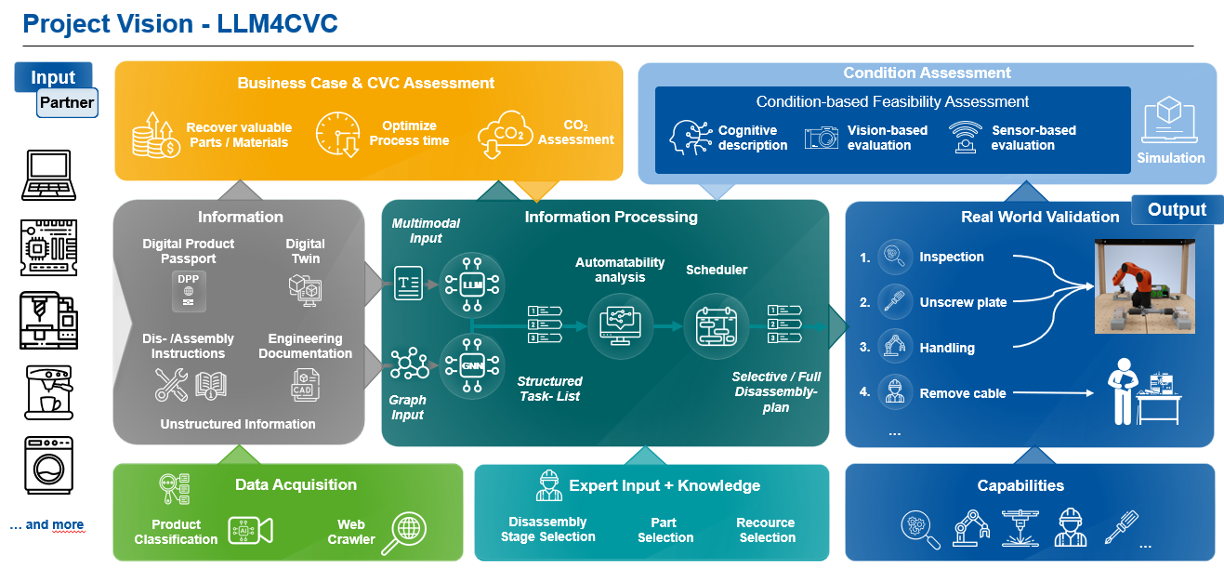

The project is submitted under the **Circular Value Creation (CVC) Call** and focuses on:

* AI and automation to scale reuse and repair
* Cross-system data integration (e.g. DPP, PCDS, CAD)
* Practical, industry-validated tools to support circularity

**What We Offer to Industry Partners**

We are inviting industrial companies and solution providers to co-develop and validate the approach with real-world use cases.

| **Company Type** | **Contribution & Benefit** |
| --- | --- |
| OEMs / Manufacturers | Provide product data; test generated instructions |
| Service / Repair Operators | Pilot the solution in live workflows |
| Automation Providers | Explore downstream automation opportunities |
| Data Platform / MES Vendors | Interface for data exchange and integration |
| Sustainability Units (optional) | Help validate PCF annotations (if applicable) |
| LLM Startups | Support in multimodal processing and generation for LLMs |

**Why Participate?**

* Shape a practical and scalable approach for **automated disassembly planning**
* Access cutting-edge **LLM-based instruction generation**
* Evaluate real-world benefits for **your products and systems**
* Contribute to emerging standards for **CVC-ready data integration**
* Leverage **European R&D funding** to support your participation

**Potential Use Case Examples**

* **Automotive**: Recovery of batteries, electronic control units, or complex mechatronic modules.
* **Consumer Electronics**: Smartphones, laptops, or white goods with high variance and miniaturized components.
* **Industrial Equipment**: Motors, pumps, or machine modules with long life cycles and high reuse potential.

**Contacts:**  
Tim Schnieders  
WZL WM-AUT RWTH Aachen  
[t.schnieders@wzl.rwth-aachen.de](mailto:t.schnieders@wzl.rwth-aachen.de)  
+49 (0) 241 80 – 25434

Carolin Weckendrup  
WZL IQS RWTH Aachen  
 [carolin.weckendrup@wzl-iqs.rwth-aachen.de](mailto:%20carolin.weckendrup@wzl-iqs.rwth-aachen.de)  
+49 (0) 241 80 – 25877

Steffen Wurm  
WZL RWTH Aachen  
[s.wurm@wzl.rwth-aachen.de](mailto:s.wurm@wzl.rwth-aachen.de)  
+49 (0) 241 80 - 26801