

Tech Description

Magconn stands for magnetic connection/magnetic connector.
Magconn technology is same as USB in terms of function (charging & data sync), but the design and the user interface are totally different from that of conventional USB connector.
Magconn technology is magnetic wireless charging & data sync solution and Magconn module can be applied for all the mobile devices and accessories.
Magconn technology has been applied in Smartphones, Tablet PC, Action camera, mPOS, Barcode/RFID reader, Bike light & GPS tracker, Medical device, iPhone & Android phone cases and accessories, Automotive accessories, etc. in global market

Benefits

1. Magnetic wireless charging/data sync solution for all the mobile devices
2. High charging efficiency (98~99%), and Quick Charging
3. Compact size and thin form factor (1.2mm, 0.7mm)
4. No heating issue
5. No harmful electromagnetic radiation (ELF/ELFMW)
6. Waterproof and dustproof (meets IP68)
7. Short circuit protection
8. User convenience (Easy alignment, 360 degrees rotation, etc.)
9. Unique IT device connectivity solution/interface
10. Data security
11. Global patented technology.

12. No extra certification is required to apply Magconn into mobile devices.

Competitive Advantages

Magconn technology is an eco-friendly wireless charging/data transmission technology without energy loss during charging. Its power rating allows quick charging (5V~12V/3A max). Magconn technology can replace the existing wireless charging (Qi) and USB charging and data transfer. Magconn provides stable and fast charging for mobile devices and can be compatible with universal charging accessories. Magconn is currently in the mass production stage and is being used around 1 million pcs per year. The market has acknowledged the usability of Magconn technology.

The existing wireless charging method (Qi) can only charge, and the power loss during the charging is usually more than 30%, which makes it not eco-friendly charging.
The existing USB port method allows both charging and data transfer, but it is still only possible with the plug-in & plug-out method of the charging cable, which makes it quite limited in functionality and usage in various environments.

Qi | USB | Magconn
Charging only | Charging & Data sync
Low charging efficiency | High charging efficiency (No energy loss)
(= energy loss)
Heating issue | No heating issue
Unproven technology | No electromagnetic field
from electromagnetic field
Convenient user experience | inconvenient user experience | convenient user experience
(Simply place it on) | (cable plug in & plug out) | (Simply attach it on and off)

Validation
Magconn technology/modules have been used for many mobile electronics in global market. Here are some examples
- Crosscall (www.crosscall.com) – Smartphone
- AsReader (https://asreader.com/)– Barcode/RFID Scanner
- Vodafone (Curve Bike Light & GPS tracker (vodafone.com)
- Keyence (Communication Unit with Internal Rechargeable Battery (Magnet connector) - DX-BS3 | KEYENCE America ) – Handheld computers/battery
- Zensho (https://www.zensho.co.jp/en/company/outline/priority_areas/) – Self Ordering System. Tablet & Charging Station for restaurant chain stores
What you are seeking
We are seeking Buyer, Licensee, Business Partner, Sales Representative

IP Status

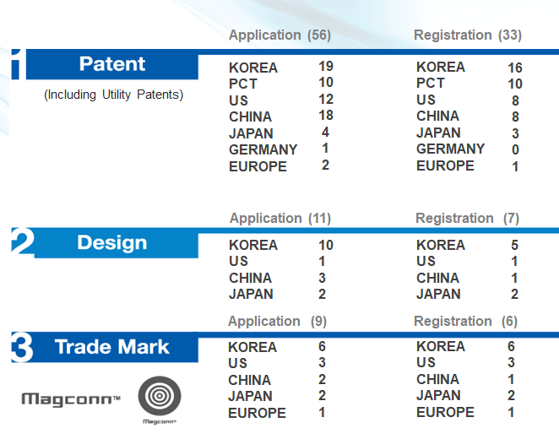

Requirements
To have a desire or idea to create new marketing points for your mobile electronics with Magconn technology

Visual Element

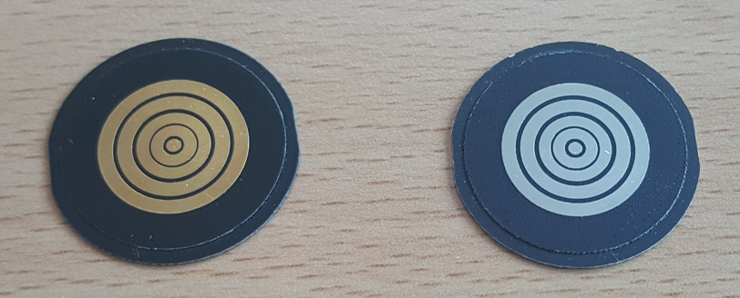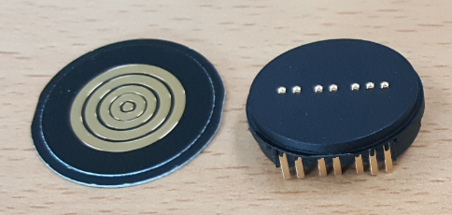
RX TX RX (Photo) TX (Photo)

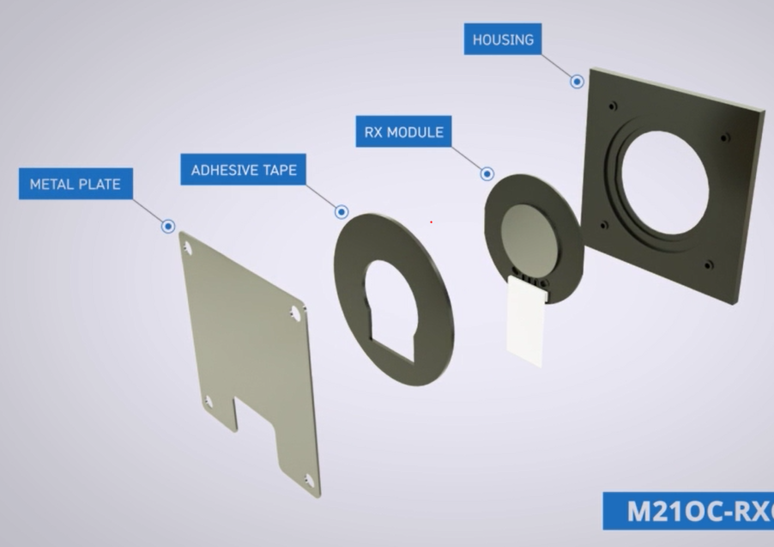
(RX module assembly into product case)

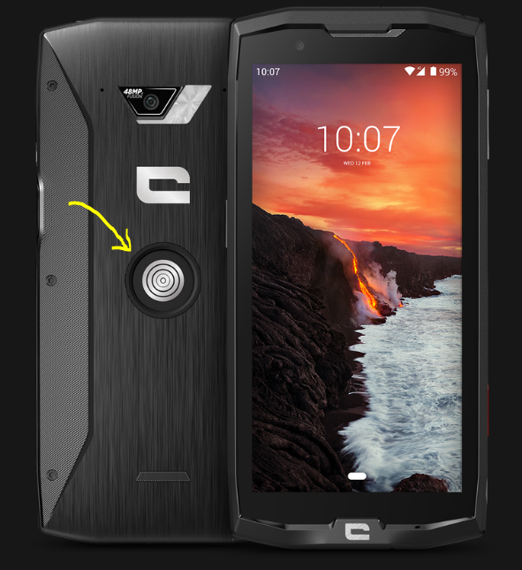
(Example of Magconn RX integrated product – Smartphone)
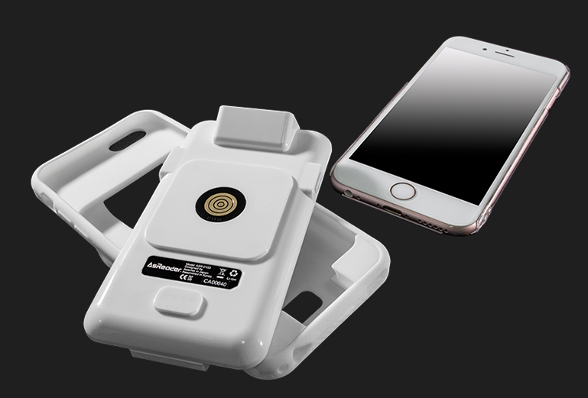
(Example of Magconn RX integrated product – Barcode/RFID Scanner)

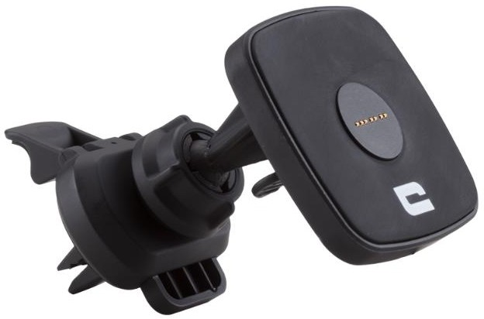

(Example of Magconn TX integrated product – Car Charger)

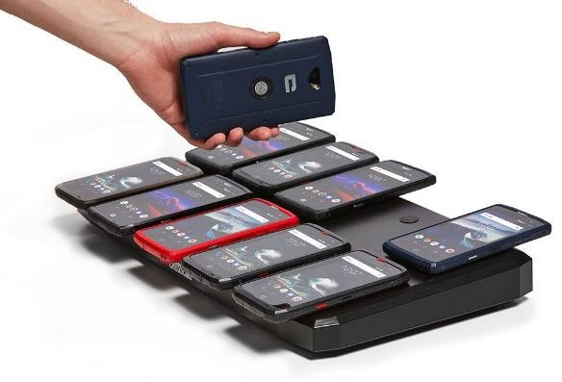

(Example of Magconn TX integrated product – Multiple Charger Station)
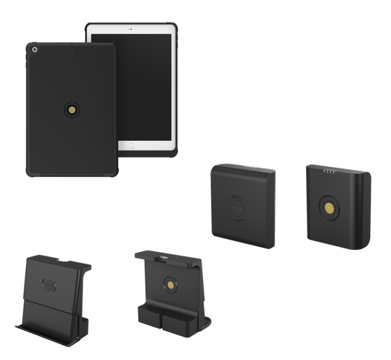
(Example of Magconn RX, TX integrated product – Tablet Case, Powerbank, Charging Stand)

What we are seeking

We are looking for buyers, licensees, business partners, independent sales representatives

Target products/markets

We now target for rugged smartphone, rugged tablet, industrial handheld PC, smartphone for seniors, etc.

Contact

Name: Charles Lee
Title: Managing Director
Address: 70 Techno 8-ro, Yuseong-gu, Daejoen, 34028, Korea
Mobile Phone: +82-10-6757-2917
E-mail: cslee@magconn.net

