**What** [**Conductor Sam**](https://conductorsam.com/) **can achieve for mobile users**

A PWA (Progressive Web App) has been applied so that networks can suggest that Sam is added to a home page etc. Despite Sam not actually being an app it’s UX has been designed with similar functionality   
But Sam doesn’t have to be found in a store or downloaded

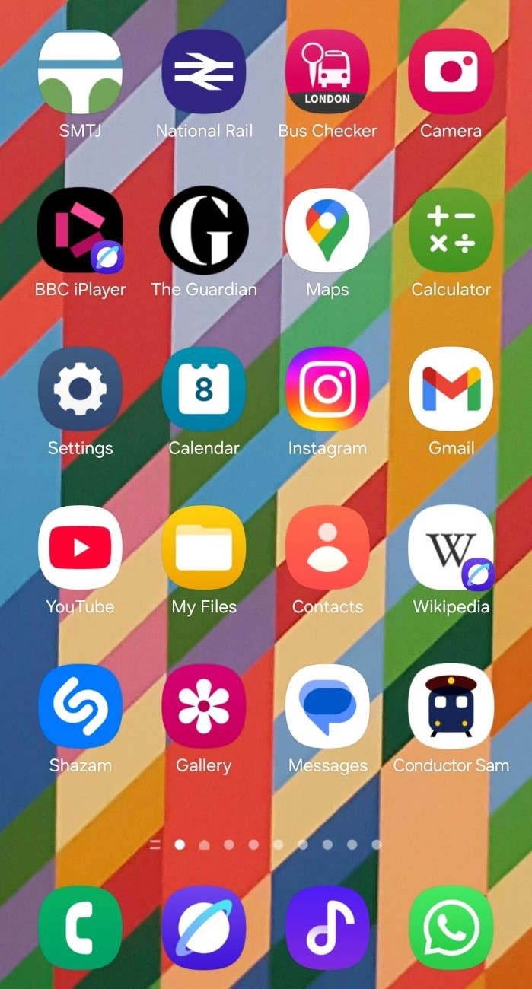

The showcase is a journey from London to Marseille, but queries that can be handled by Sam include:

* Rail trip planning
* How Eurail and Interrail passes can be used and purchased
* How a trip can be experienced – scenery, on train facilities, station access
* What’s good to know about making connections
* Journeys which involve the train + bus (museum to museum, stadium to stadium, not just station to station
* Accessibility
* Questions on the history and future of rail travel

With affiliates plugged into all relevant touch points, because it enhances the user experience.

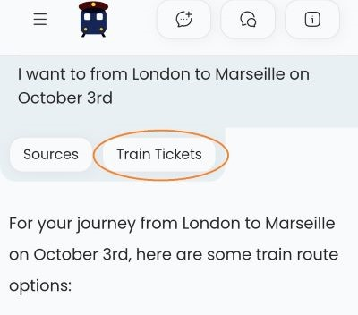

On mobile, a user can click the Tickets tab to access the booking links.

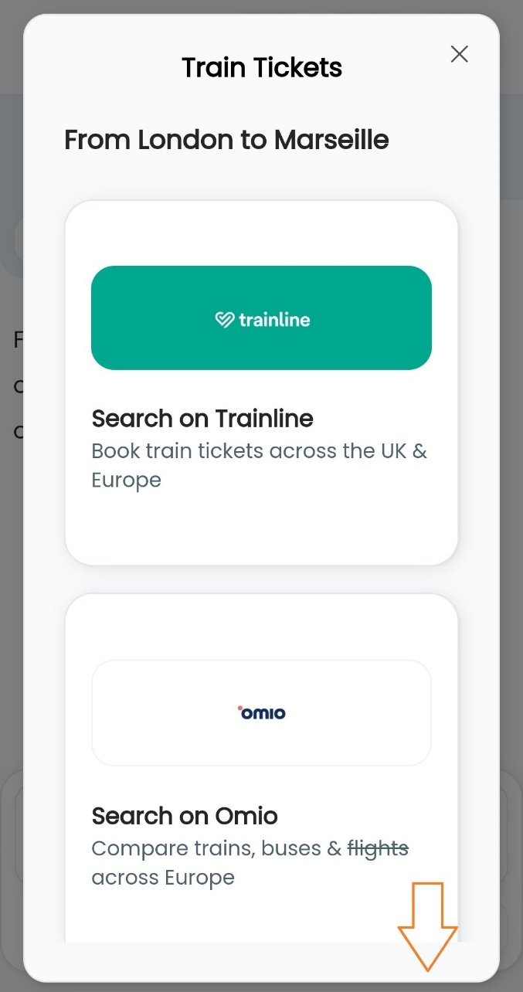

The ticket booking links will appear as a pop-up.  
As can be seen Sam is already an affiliate of both Trainline and Omio, but the plan is for Sam to in effect become the equivalent of a Skyscanner of rail tickets.   
The ‘Skyscanner’ strategy will deliver both an enhanced user experience and additional revenue, plus it also mitigates against the potential for Sam being emulated by a ticket agent.

A future phase of Sam will enable more direct comparison between train and flight – and with other travel modes.

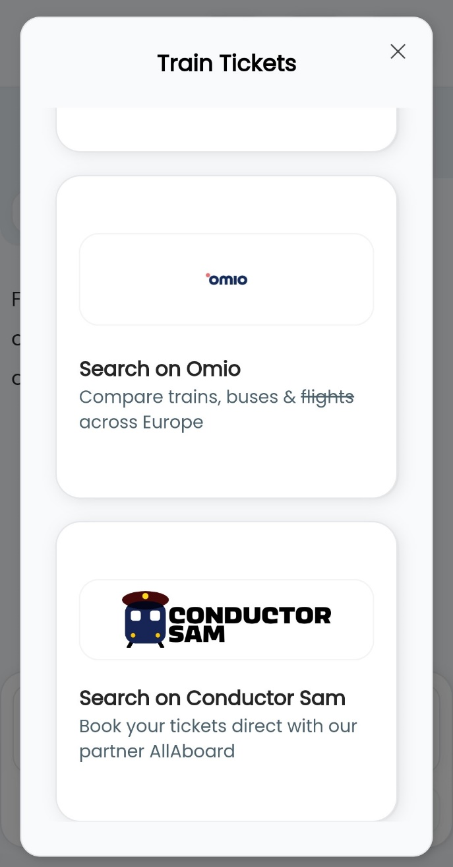

Sam also has its own branded ticket booking service, which is currently in beta.  
 It is necessary as part of an agreement with All Aboard to use its back-end data as a core source for the journey info.  
  
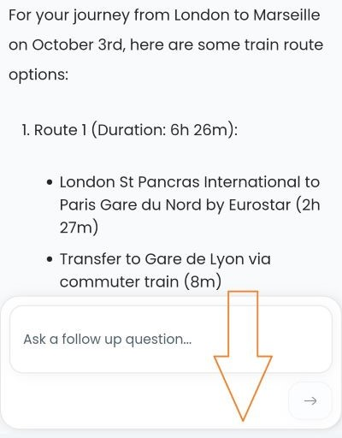

(What’s tricky to showcase on a screenshot is that it will be fairly obvious to the user that they can scroll down to see the rest of the answer).

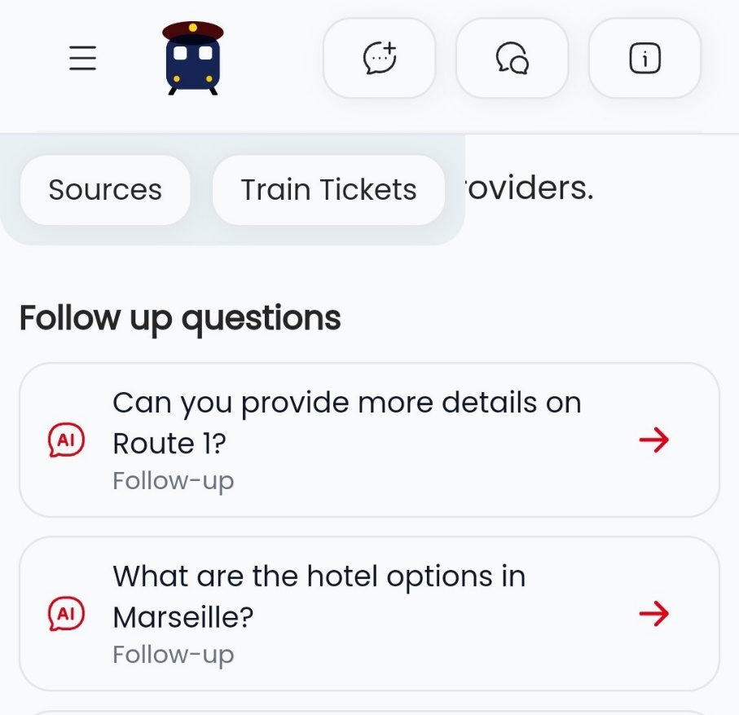

Once the ticket window is closed the user can scroll down through the journey info to the Follow Up questions.  
These Follow Up questions are the key differentiator between Sam and both Chat GPT and Google.  
They enable the user to take repeated deeper dives without having to leave the original query.  
Sam’s initial answers are deliberately more succinct than those provided by Chat GPT, but the Follow Up questions enable a Sam user to ultimately obtain a greater weight of information per question / user session  
  
On this example user path, a short-cut has been provided to the hotel options at the destination.

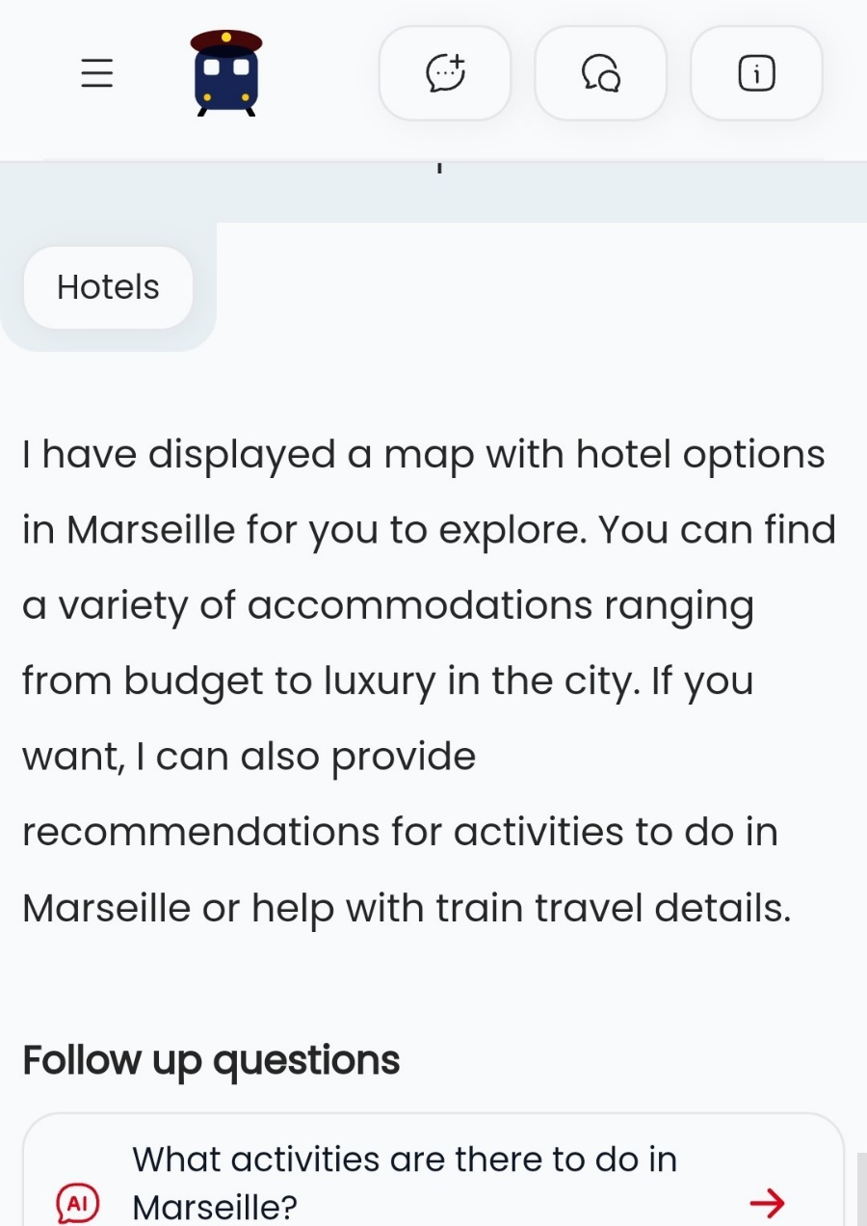

Once clicked a Hotels tab can appear at the top of the answer.  
The tab will appear for around the 100 most visited cities, but this will soon be increased – work is at this end.

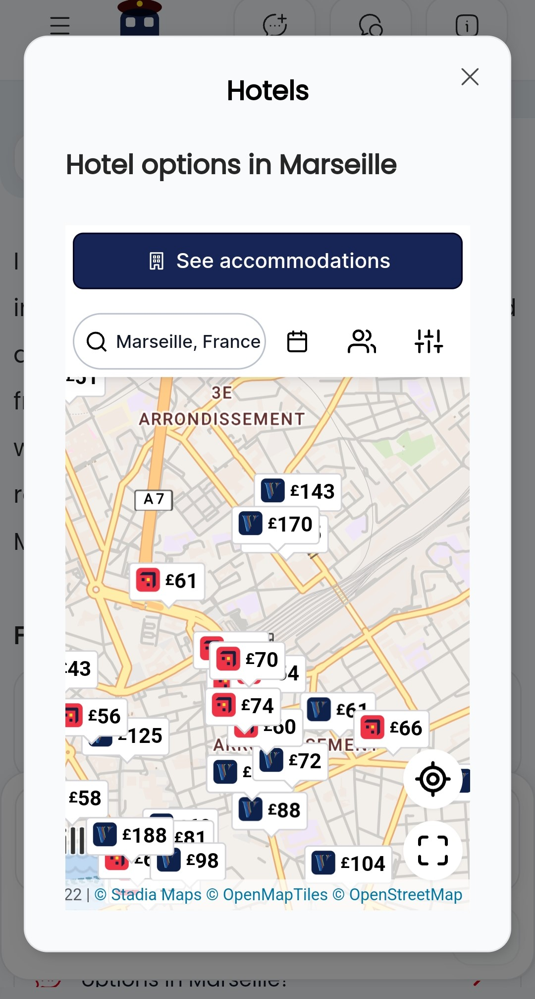

The tab takes the user to a map – when zoomed in they should see that it is centred on the station.  
Note that the map can include Hotels.com, Booking.com and Vrbo.  
The accommodation partner (Stay 22) auto selects whether Booking or Hotels.com has the optimum availability and pricing.

On this user journey the Follow up questions include a path towards knowing what the destination offers.

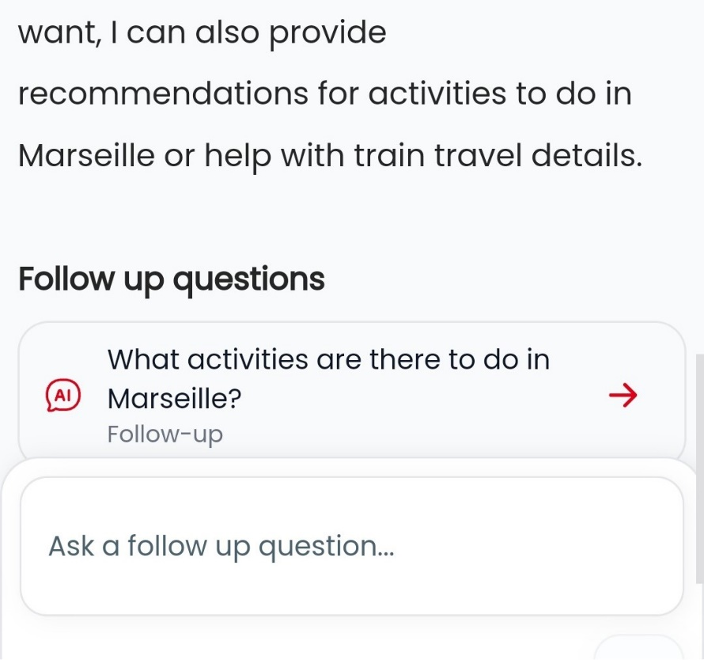

The Activities tab opens up a list of things to do which can be booked on Get Your Guide.

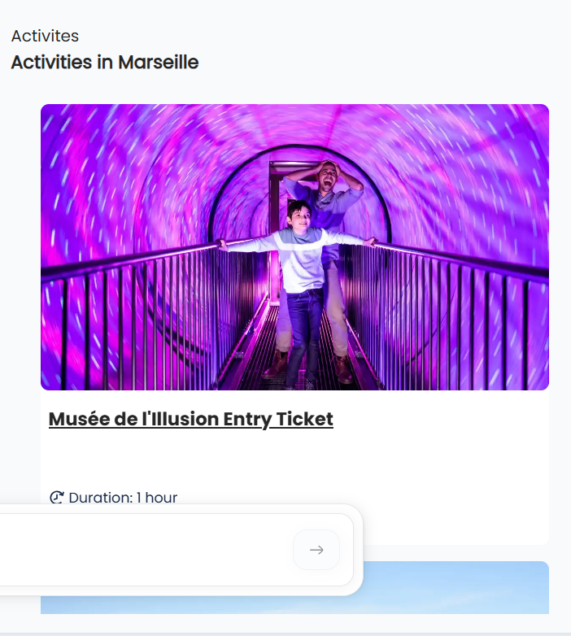

The user may have other interests than those suggested by Get Your Guide.  
But the Follow Up questions included a path to discovering the city’s museums.

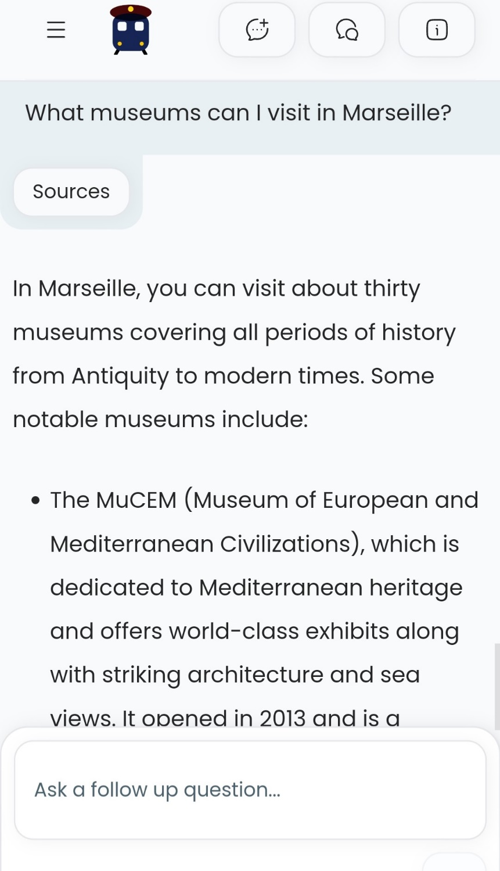

The Sam user may want to know more about these attractions, book tickets etc. These can all be accessed by clicking on the Sources of the answer.

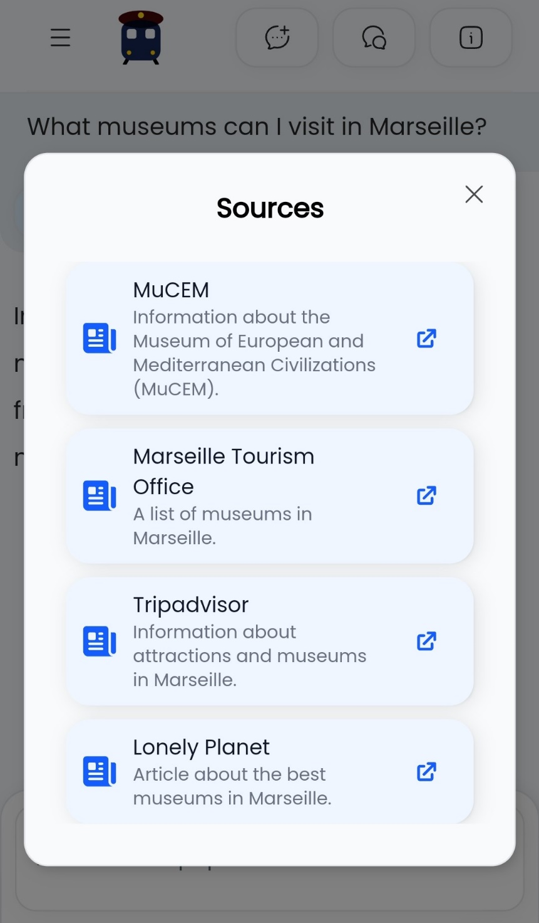

In contrast to Chat GPT, the initial answer provided by Sam can be a summary. It helps with the speed of the answer, which can be an Achilles heel of Sam on initial use.  
But as can be seen the Follow Up Questions can take the use on to the discovery and bookings of both accommodation and activities.  
On Sam the journey doesn’t begin and end at the station.

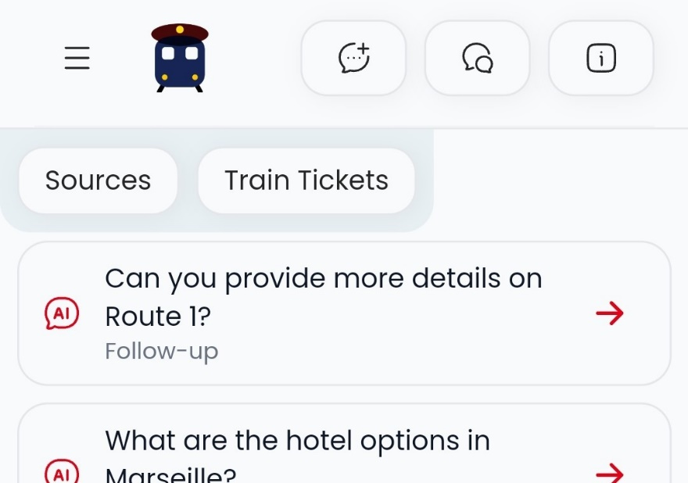

Sam can pick up the departure times and other info from its Sources.  
  
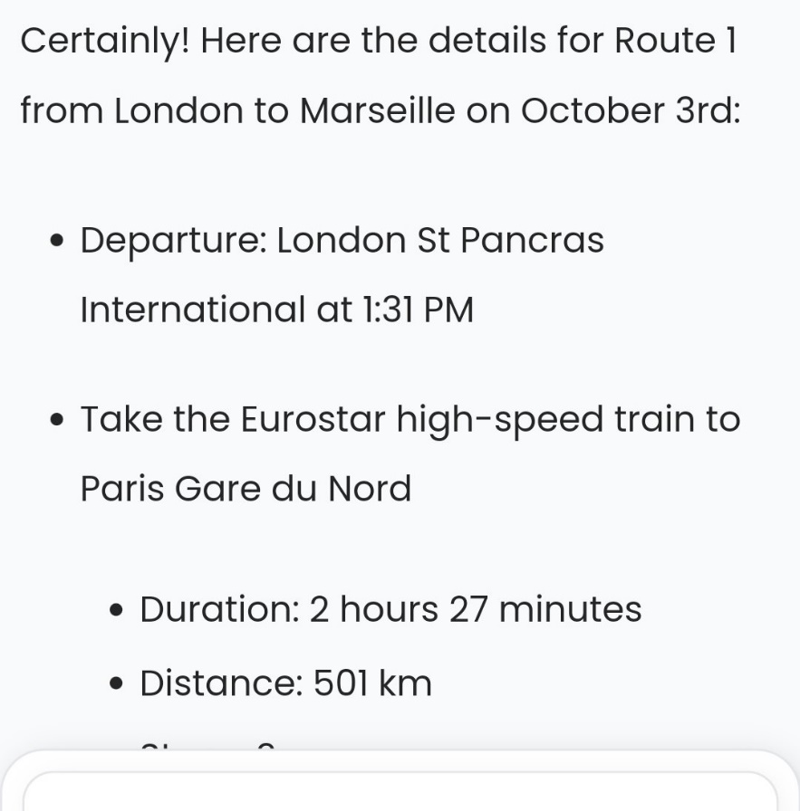

The fact that there can often be more than one route for an end-to-end journey, particularly if a route requires a connection, is covered by Sam.

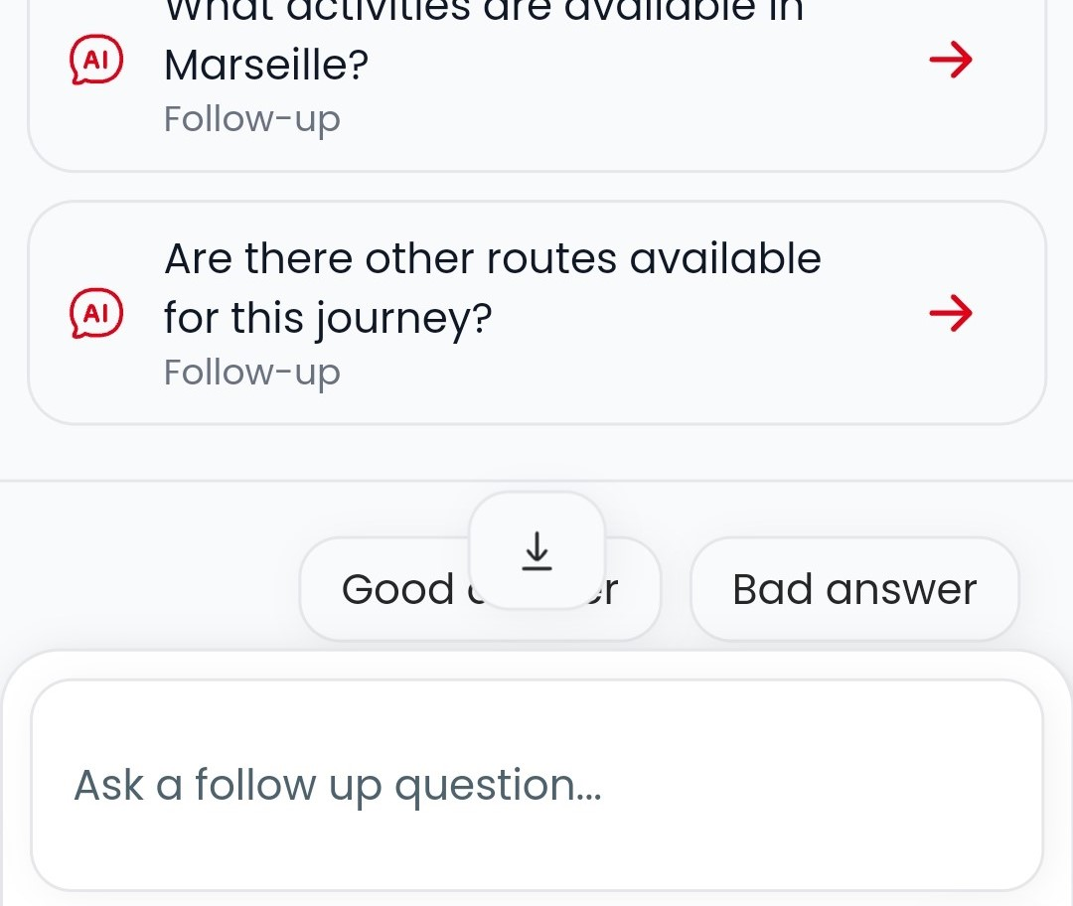

Would rather not squeeze on to a crowed RER train across central Paris? Sam can come up with an alternative.

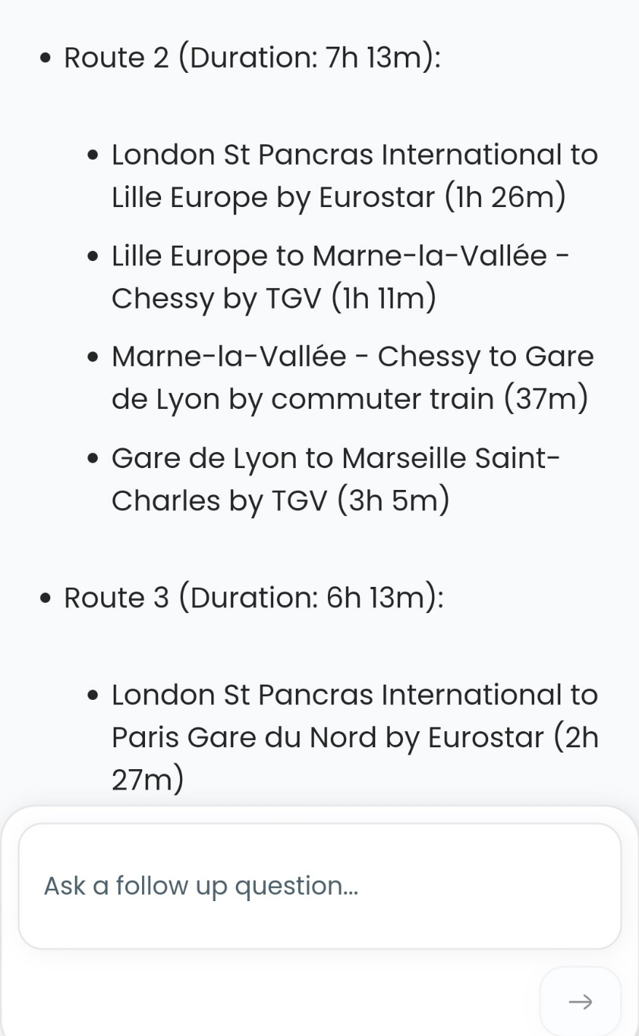

Sam’s Follow up questions don’t follow a formula. The idea is that it will be in line with the user’s usage of the service.  
On this user path Sam didn’t provide a shortcut to find out more about the station – so the easy access to the Question box can be used to hone in on what the user wants to know.

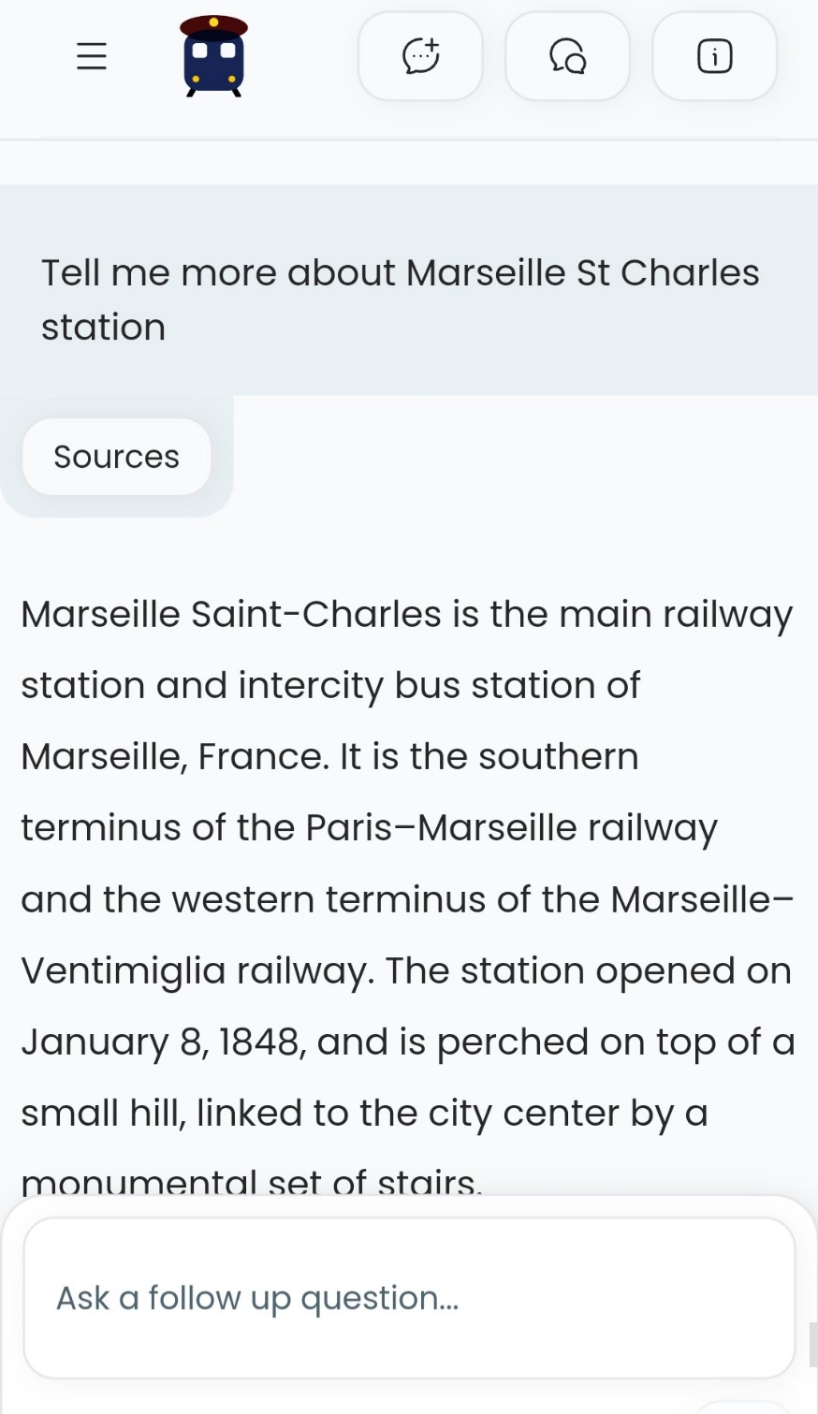

If a user wants to access additional info such as a map, or how to find out how book a Metro ticket, the Sources can be clicked.

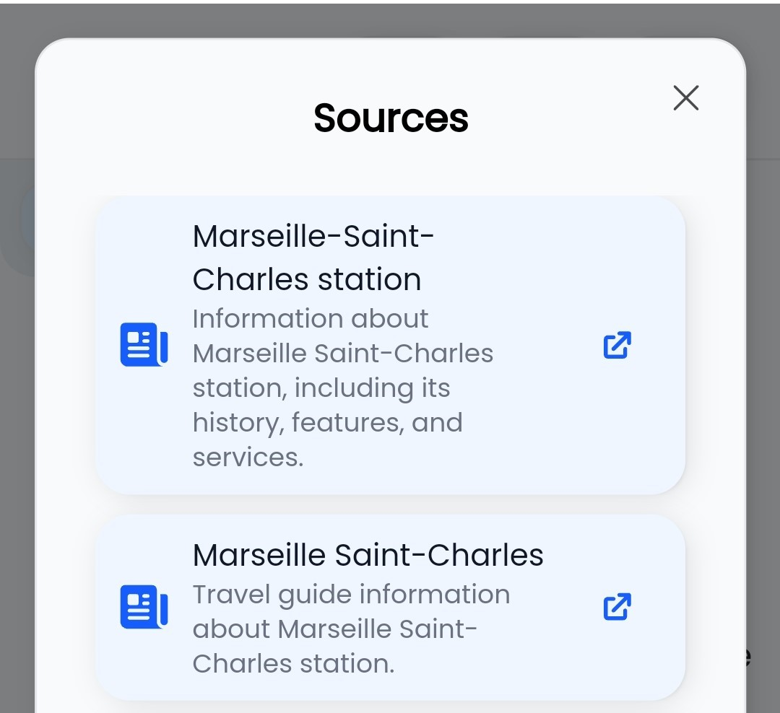

This source takes the user to Sam’s parent website ShowMeTheJourney – the 2nd deepest source of rail info on the web, but Chat GPT and Google are blocked from accessing it.

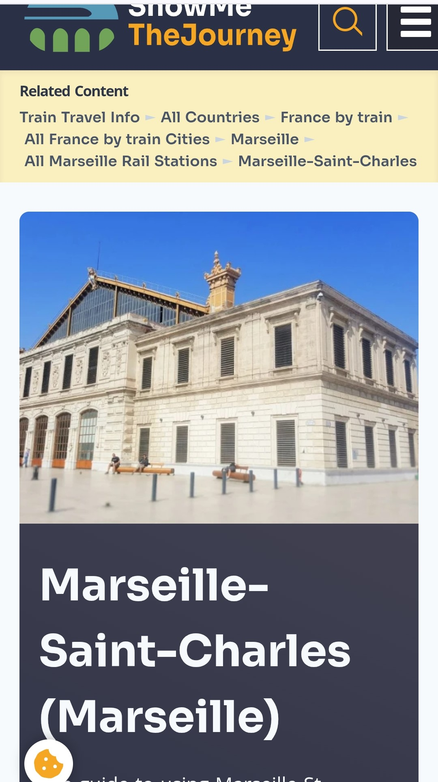

Another source links to the web page provided by the French national rail operator SNCF.

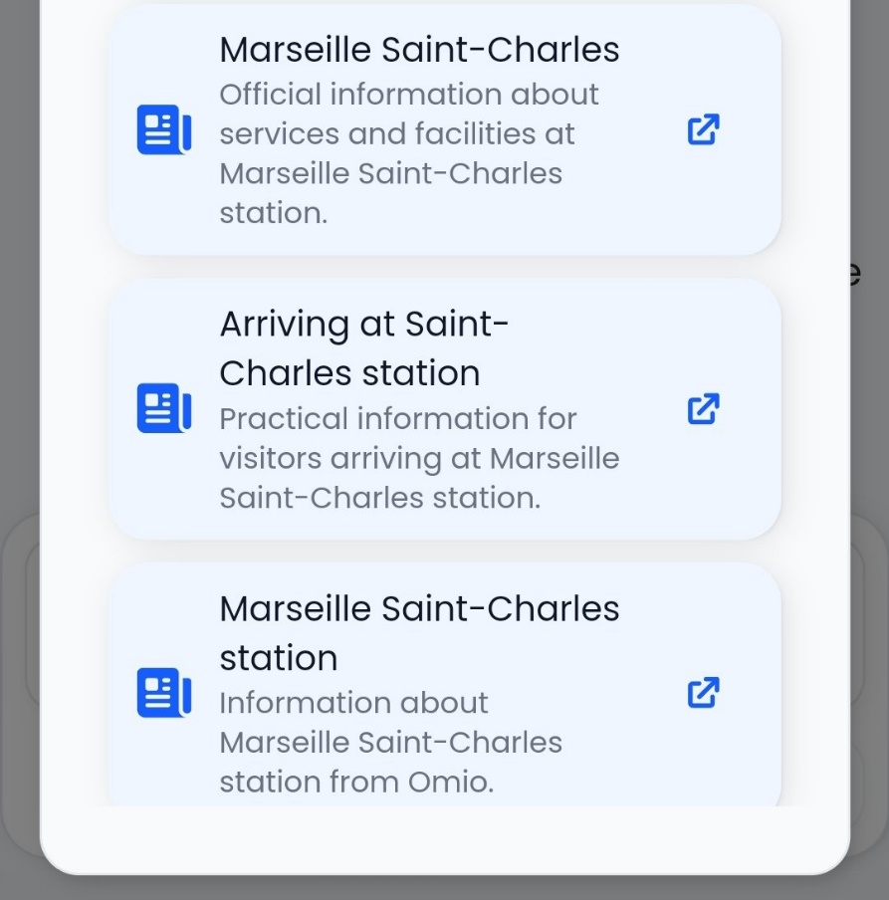

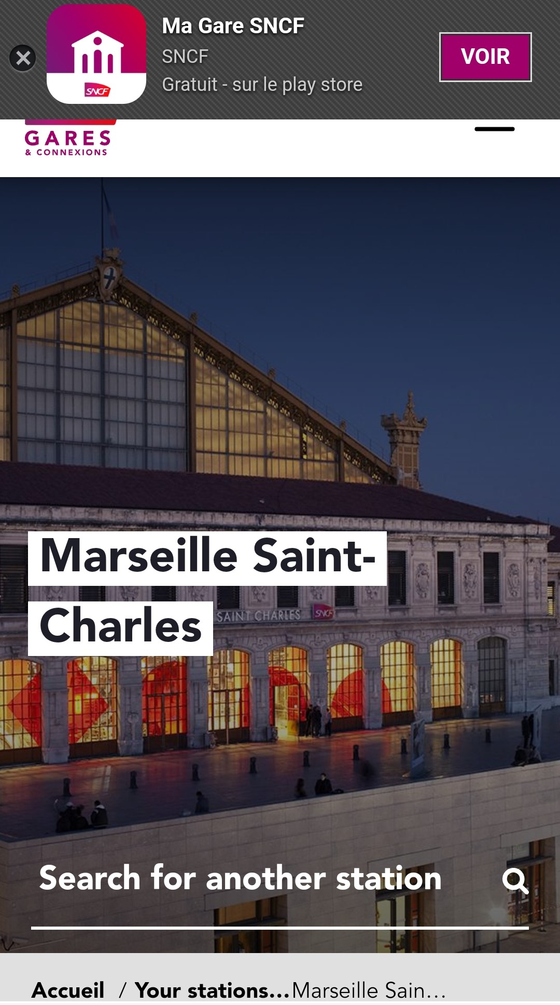

Note that all of the above info has been accessed without the need to leave the initial visit to Conductor Sam.  
All the external links open in new windows and a click-back returns the user to Sam’s original answer.  
  
Asking one question on Conductor Sam can take the user to;

* all the core info about taking the trip,
* the tickets and multiple agents which sell them,
* booking a hotel at the destination,
* booking multiple activities at the end location,

all without leaving the initial answer; There’s no need to open and shut windows.  
  
Though everyone’s experience when telling Sam ‘I want to go from London to Marseille’ will be different, this showcases the user path which Sam gave me on this particular occasion.  
So it’s typical, but not fixed, because the idea is that Sam will ultimately recognise a user’s preferences and hone in on what they’ll most likely want to know and do.  
  
Coming next is a second-to-none itinerary planning tool.  
  
On the to do list:

* Delivering a Skyscanner of rail tickets
* Travel mode comparison
* Door to door journeys
* Multi-lingual
* Images / Maps / Tables within the answers