**CHANGE THE COLOR OF THE TARGET MARK ON THE SCREEN (display) FOR BEST DETECTION, CLASSIFICATION**

**Change color type assigment to Jαβ value for better target detection and classification. Changing colors is done by the user in settings**

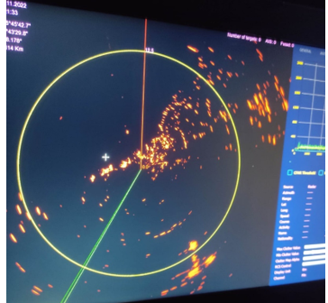

**Changing the color of target markers-1**

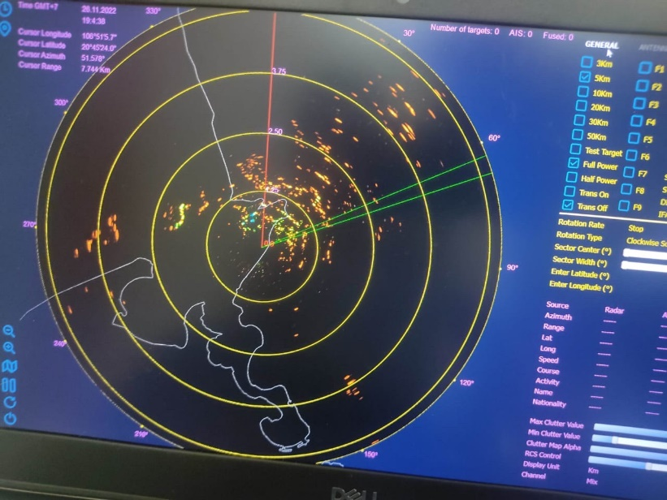

**Changing the color of target markers-2**

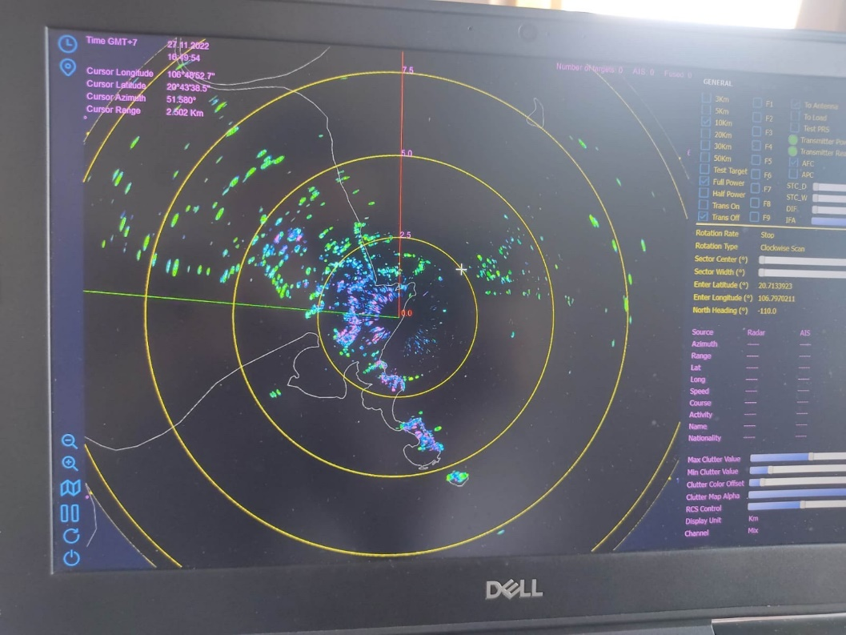

**Changing the color of target markers-3**

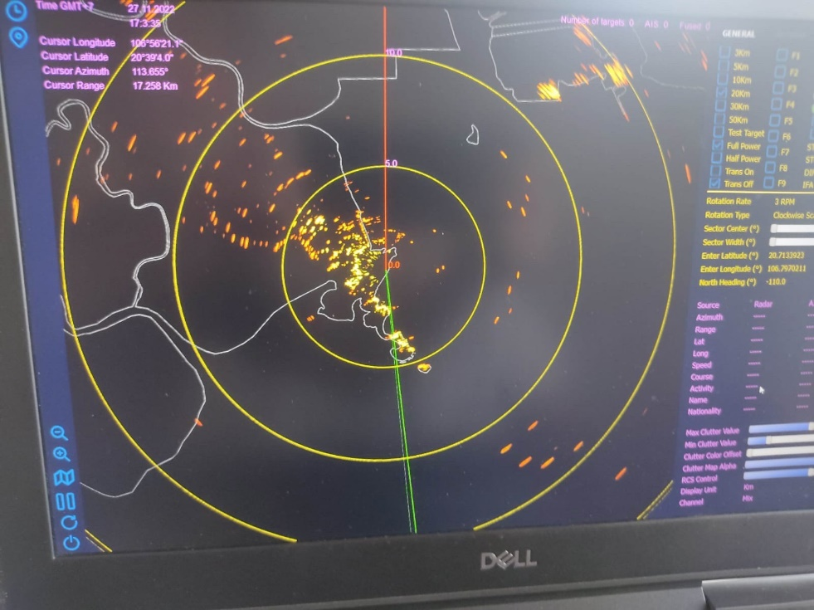

**Changing the color of target markers-4**