*French version below - version Française ci-dessous*

Guidelines and forms

This document is a **detailed summary of the material** **BlueInvest Africa needs from you**, in the quality of selected pitcher to the event, for the promotion of your project and pitch.

**The promotion of your project is fundamental** not only to promote the content of the event but also for you and your company **to stand out** and distinguish yourself in front of **the investors** who will be present at the event.

We intend to produce a short, animated presentation for each of the selected pitchers. These presentations will be publicised in order to create interest and incite investors and other participants to look into your project. Therefore, you may want to provide us with the **best quality images** for your project to shine.

This document presents a **list of deliverables that** must be sent **via email to** [**secretariat@blueinvestafrica.eu**](mailto:secretariat@blueinvestafrica.eu) **before Friday 4 July 2025 EOB**. The deliverables consist of text extracts and images only.

Please, **stick to the requirements specified for each element of the list!**

# Deliverables for promotional video

|  |
| --- |
| Tip! Check the boxes in the list while collecting the material. Send us the material only when all the boxes are ticked. |

## Text:

|  |  |  |  |
| --- | --- | --- | --- |
| **Done?** | **Question** | **Requirements in terms of characters** | **Answer – please answer in dedicated cells below** |
|  | Name of the project | Complete name | Production and Commercialization of solar digital dryers and incubators for drying fish and aquatic products |
|  | Name of the company | Complete name | FOOD-MAC ENGINEERING Ltd |
|  | Role/function/position (inside the project) of the person designated for the pitch | Maximum **42** characters | *Founder/General Manager* |
|  | Short abstract of the project | Maximum **76** characters | *We use Iot, web development, artificial intelligence and solar energy to solve problems in agricultural robotics related issues. We produce and sell solar digital dryers for fish drying. We also operate digital solar powered fish drying centers where individuals who can use at a fee* |
|  | The impact of the project on the community AND/OR on the environment | Maximum **72** characters | *Our technology is solar powered, this curbs deforestation of wood for fish drying. Our locally produced unique solar generators replace petrol engines to power electric drying. This mitigates climate change. We also reduce post harvest losses* |
|  | Answer briefly to the question: Why should investors choose you/your project? or in other words, why should investors invest in your project? | Maximum **91** characters | *Our digital dryers are solar powered so can be used by fish farmers and entrepreneurs in both rural and urban areas with insufficient electricity. This gives us a wide customer base. We also operate centers where individuals can dry their fish for a fee. We already have over 50 billion dollars of market through NGOs in Cameroon and Africa* |
|  | If applicable, apart from SDG 14, Please select up to 2 other SDGs that your project addresses | Please choose the applicable answer(s) presented | 1. No Poverty  2. Zero Hunger  3. Good Health and Well-being  4. Quality Education  5. Gender Equal0ity  6. Clean Water and Sanitation  7. Affordable and Clean Energy  8. Decent Work and Economic Growth  9. Industry, Innovation and Infrastructure  10. Reduced Inequalities  11. Sustainable Cities and Communities  12. Responsible Consumption and Production  13. Climate Action  15. Life on Land |
|  | Please, indicate all of the social media pages used for your project and/or company, if any | (Twitter, LinkedIn, Facebook) | *Facebook: Divine Kobbi*  *Food Mac  Engineering*  *Linkedln : Divine_Kobbi* |
|  | Please, indicate the website link of your project and/or company, if any | Website | *https:foodmacengineering.sarl* |

## Images

|  |
| --- |
| **All images should respect the following requirements:**  Shape: the images should be squared (height = width)  Quality: the images should be between 70 and 100 dpi  Dimension: the images should be 1920 X 1920 pixels → 50 X 50 cm (or equivalent square dimensions)  Format: the image should be in one of the following formats: .jpg, .png, .svg  Copyright: Do not send copyrighted images without a proper license. We strongly invite you to send only photos taken or images made by you (or whose distribution rights are owned by you). |

|  |  |  |
| --- | --- | --- |
| **Done?** | **Requirement** |  |
|  | Photo of the person designated for the pitch. The photo should be formal, the face of the person in the photo should be clearly recognisable, the background should be neutral, the light should be diffuse and avoid strong light/shadow contrasts. |  |
|  | The official logo of the company or of the project if any |  |
|  | At least three images of the project. It is important that the images are unique and clearly identifiable with the project.   * One image should cover the project. This image might cover the production phase, the resulting product (or its design if the project is still not active), the technology, etc. * The other images (at least 2 images) should cover the environmental and socio-economic impacts of the project. These images might cover the resources used in the process (e.g.: project workers), the impact of the project/product on the community, the impact of the project/product on the climate/sustainable development, etc. |  |

Please note that this short animated presentation will be sent to you for validation before being published.

# Deliverables for other communications to investors

|  |  |  |  |
| --- | --- | --- | --- |
| **Done?** | **Question** | **Requirements in terms of characters** | **Answer – please answer in dedicated cells below** |
|  | Role/function/position (inside the project) of the person designated for the pitch | Maximum 60 characters | *Founder/General Manager* |
|  | Abstract of the project | Maximum 540 characters | *We use Iot, web development, artificial intelligence and solar energy to solve problems in agricultural robotics related issues. We produce and sell solar digital dryers for fish drying. We also operate digital solar powered fish drying centers where individuals who can use at a fee* |
|  | Description of the company:   * Years of activity * Last turnover * Number of employees * National level/international level | Maximum 140 characters | * Years of activity: 5 years * Last turnover: 628,000 USD * Number of employees: 11   National level/international level: National Level |
|  | What are your investment expectations? | Precise the maximum investment amount expected and the currency | *Expecting 4 million USD* |
|  | What is the final purpose of this investment? | Please choose the applicable answer(s) presented à | Startup capital: This covers initial costs such as the purchase of assets or stock, the development of technology, and other costs.  Working capital: This pays for day-to-day expenses or covers production or operational costs.  (30 %)  Growth financing: This helps the business expand or grow its operations, product line, footprint, etc.  (40 %)  Asset purchase: This is used to buy new assets (equipment, etc.) for the business.  (30 %)  *If you select multiple answers, please indicate % spent in each (e.g.- Working Capital- 60% Asset Purchase-30%- Personnel- 10% etc.)* |
|  | What kind of Finance are you looking for? | Please choose the applicable answer(s) presented à | *Please choose the applicable answer(s) between the following:*  Debt,  Equity,  Quasi Debt/Equity,  Grants |

# ***How the content will be used on the video – indicative examples of the possible visuals***

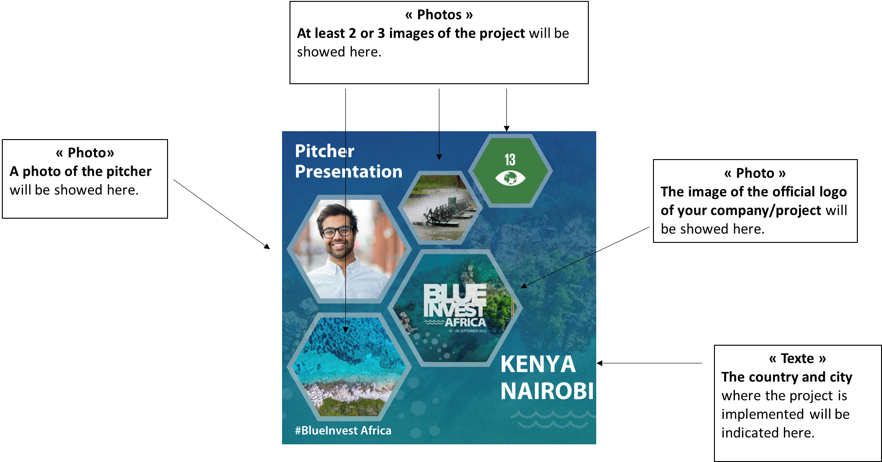

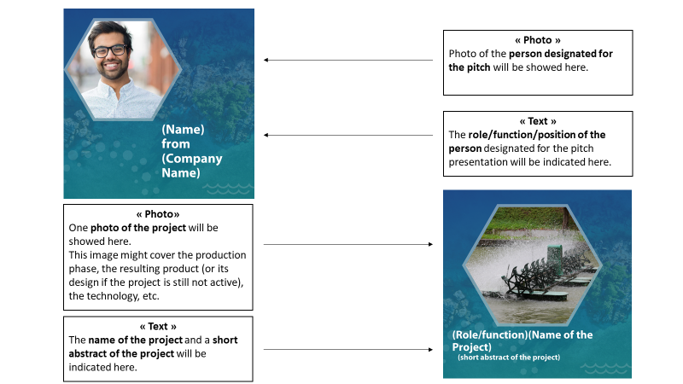

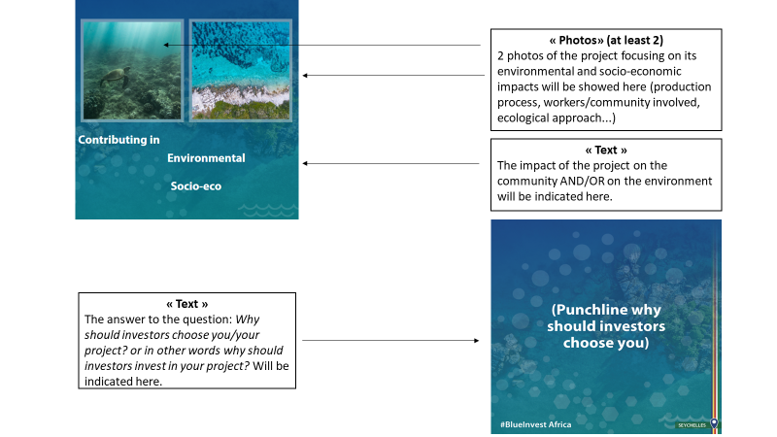

Post for promotion

Please find hereunder image and publication suggestions.

If you wish, you can still adapt the text and use the image of your choice (image to be related to your project).

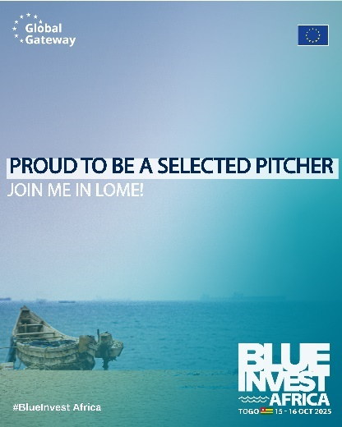

|  |
| --- |
| 🌊 I’m thrilled to share that I’ve been selected to pitch at BlueInvest Africa 2025! 🚀  📍 Lomé, Togo  📅 15–16 October 2025  This is a unique opportunity to present our solution for a sustainable blue economy in front of international investors, policy makers, and experts.  Our project focuses on *[ insert your sector of activity]*, and we cannot wait to showcase our impact and vision at this event.  A big thank you to the BlueInvest Africa team for this chance to scale and connect.  🌍💙  🔗 Learn more about our project: [https://blueinvestafrica.eu](https://blueinvestafrica.eu/)  📲 Join our LinkedIn community [here](https://www.linkedin.com/groups/14605645/)  #BlueInvestAfrica2025 #BlueEconomy #Innovation #SustainableInvestment #AfricaEU #GlobalGateway |