Ziggurat Coordination Ltd.
Subject: Complimentary BIM Coordination Pilot for Your Project
We would like to offer a complimentary BIM coordination pilot for one floor (or a selected section) of your project.
This is a no-obligation opportunity to evaluate our methodology, quality standards, and coordination process before making any commitment.
About Ziggurat Coordination
Ziggurat Coordination is a leading BIM Coordination and BIM Management company with more than 20 years of experience and over 1,000 successfully coordinated projects across residential, commercial, healthcare, industrial, infrastructure, and data center developments.
Our portfolio:
https://www.ziggurat.co.il/projects
- Our BIM Coordination Process
Our coordination workflow includes:
- Integration of all discipline models into a fully coordinated Federated BIM Model while preserving the integrity of the original design data.
- Setup of the Common Data Environment (CDE), project permissions, and implementation of the BIM Execution Plan (BEP).
- Comprehensive clash detection and engineering analysis of coordination issues.
- Evaluation of alternative engineering solutions directly within the 3D model.
- Coordination meetings with the project team to review, agree upon, and document engineering decisions.
- Deliverables
Upon completion of the coordination process, you will receive a complete set of coordinated, construction-ready deliverables, including:
- Federated BIM Model integrating all architectural, structural, and MEP disciplines into a fully coordinated model.
- Coordinated floor plans and sections ready for construction documentation and printing.
- Clash Detection & Resolution Report, providing complete transparency of all identified issues, implemented solutions, and coordination decisions for the developer and project management team.
- We Coordinate Both Revit and AutoCAD Projects
- Full BIM Coordination in Autodesk Revit.
- Complete 3D coordination for AutoCAD-based projects, delivered to Revit coordination standards without requiring redesign or additional software investments.
If this opportunity is of interest, we would be pleased to discuss your project and select a suitable floor or project section for the complimentary pilot.
We look forward to the opportunity to demonstrate how our BIM coordination process can improve project quality, reduce construction risks, and support successful project delivery.
Our Team:
Eng. Uzi Sela, Chairman: Graduated from the Technion – Faculty of Civil and Environmental Engineering, 1971. Since then, has gained extensive experience and has been involved in execution and initiatives in the construction industry. As an entrepreneur & contractor has built hundreds of housing units. Initiated the Observation tower at the Sherover Jerusalem Promenade. Built as a contractor public and complex multiple-system structures, for the IDF, as well as for privet clients. Acquired expertise in the planning process and licensing, possess a profound legal understanding of planning and execution contracts. Ziggurat systems Ltd. Chairman and stock holder.
Arc. Efi Azran, CEO (B. Arch. ED): Graduated from the Wizo School of Design. Efi is a systems coordination expert since 2006, specializing in design coordination and systems coordination in large scale public buildings and factories. Efi is in charge of the BIM operations.
Arc. Ofrit Eshel (B. Arch. ED): Graduated from the Wizo School of Design. Ofrit is a systems coordination expert since 2010, specializing is factories, public buildings, residential projects and infrastructure.
Other employees: The Company Employs 35 more Architects and Engineers.

Only a small selection of our projects is presented on this page. Most of the projects we have delivered cannot be published due to non-disclosure agreements (NDAs) and our clients' confidentiality requirements.

Selected work - Israel

Industrial & Office Buildings
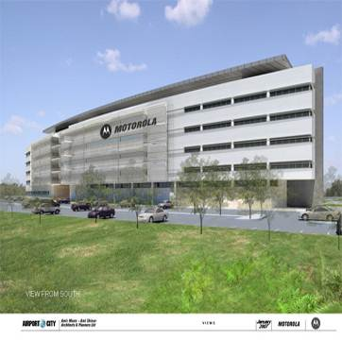  Motorola  Airport City  Architect: Man Shenar  Area: 753,473 SF.  Year: 2008  Client: Motorola Inc. | Flextronix  Yoquneam  Architect: Yoram Poper  Area: 91,494 SF.  Year: 2008  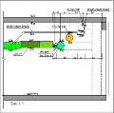  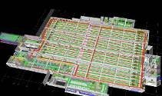  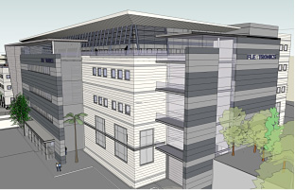  Client: Flextronix Inc.
Azrieli Center  Holon  Architect: Moshe Zur  Area: 161,458 SF.  Year: 2012  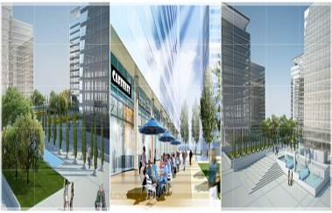  Client: Azrieli Group | 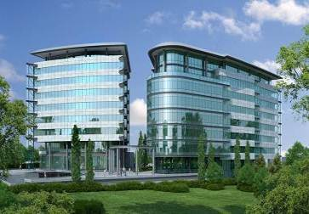  Crytech  Yoquneam  Architect: Leer Arc.  שטח: 27,000 מ"ר  Year: 2011  Client: IBC Group
IBC Buildings  Ashkelon Offices  Architect: Yashar Arc  שטח: 10,000 מ"ר  Year: 2011  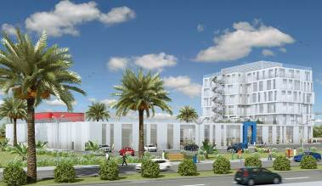  Client: IBC Group | NeuStar  Haifa  Architect: A.Shraga Arc.  Area: 430,556 SF.  Year: 2008  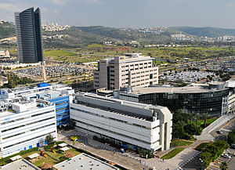  Client: NeuStar Israel
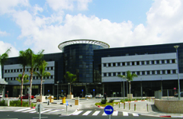  Giga Center  Holon  Architect: Bareli- Levizki – Casif  Area: 161,458 SF.  Year: 2007  Client: IBC Group | 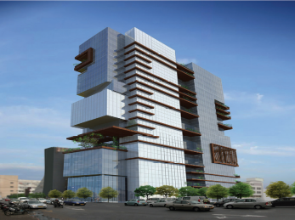  Eco - Tower  Tel Aviv  Architect: OKA Arc.  שטח: 31,000 מ"ר  Year: 2009  Client: Azuri Bros.
Sports & Community Centers
Arena Pais Hall  Jerusalem  Architect: A.Spector & M. Amishar  Area: 430,556 SF.  Year: 2012  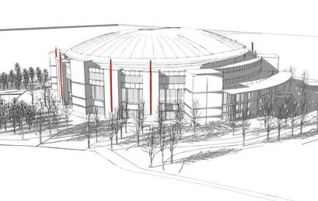  Client: Jerusalem  Development Group | Sports Arena  Be'er Sheva  Architect: Gidi Povsner  Area: 430,556 SF.  Year: 2012  Client: Be'er Sheva  development Group  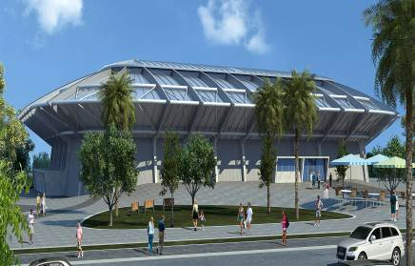

Retail & Commercial
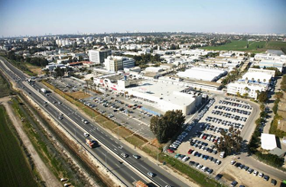  Big Center  Yehud  Architect: Man Shenar  Area: 258,333 SF.  Year: 2010  Client: BIG Group | Lev Ha'Shdera Mall  Hadera  Architect: Pinchi Rave  Area: 47,361 SF.  Year: 2009  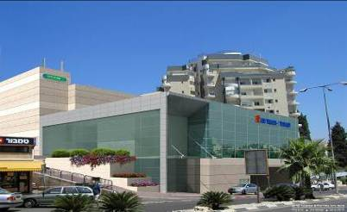  Client: British Israel
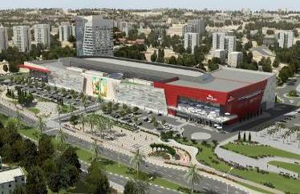  Grand Mall  Be'er Sheva  Architect: Yaski- Mor -Sivan  Area: 1,506,947 SF.  Year: 2010  Client: British Israel | 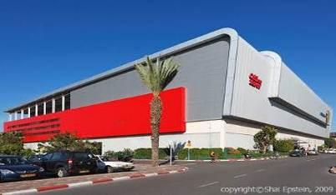  Ayalon Mall  Ramat Gan  Architect: Yaski – Mor - Sivan  Area: 215,278 SF.  Year: 2006  Client: Azrieli Group
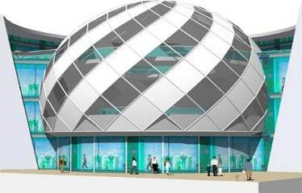  Kiryat Ata Mall  Architect: Zamir Arc.  Area: 48,437 SF.  Year: 2011  Client: Azrieli Group | 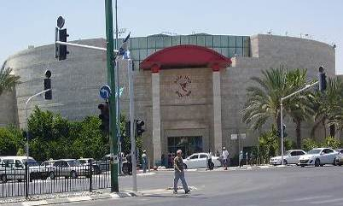  Negev Mall  Be'er Sheva  Architect: yaski- mor -sivan  Area: 252,951 SF.  Year: 2010  Client: Azrieli Group
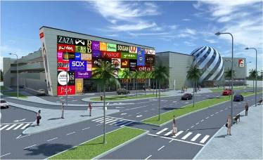  Akko Mall  Architect: Zamir Arc.  Area: 134,548 SF.  Year: 2010  Client: Azrieli Group | Rishonim Mall  Rishon Le Zion  Architect: Man-Shenar  Area: 1,291,669 SF.    Year: 2009  Client: Azrieli Group

Education & Culture
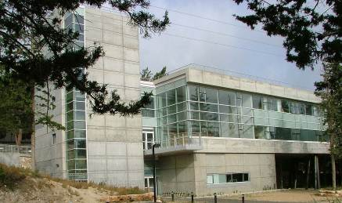  Asher Space Research Institute  Haifa  Architect: Moshe Zur  Area: 15,069 SF.  Year: 2007  Client: Technion | 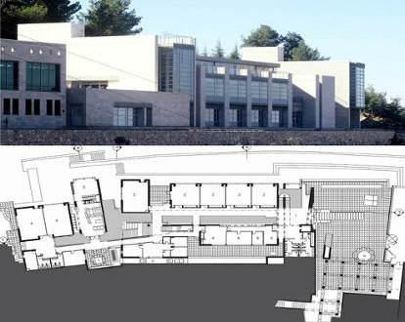  Yad Va'Shem  Holocaust  Jerusalem  Architect: Guggenheim & mintz  Area: 21,527 SF.  Year: 2009  Client: Yad  Va'Shem
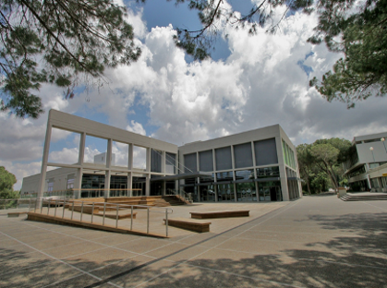  Student's Hob  Technion  Haifa  Architect: Moshe Zur  Area: 32,291 SF.  Year: 2007  Client: technion | 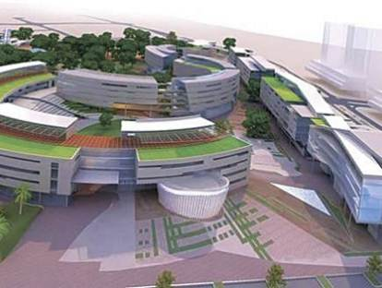  Ashdod Campus  Architect: David Knafo & Hagit Klimor  Area: 69,965 SF.  Year: 2012  Client: Ashdod Musicality

Residential
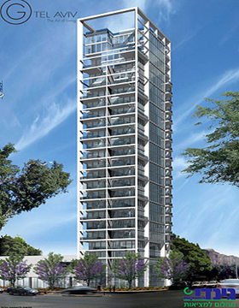  G Tower – Ha'Shoftim  Tel Aviv  Architect: Gidi Bar Orian and Rani Zis  Area: 193,750 SF.  Year: 2012  Client: Gindi Group Corp. | 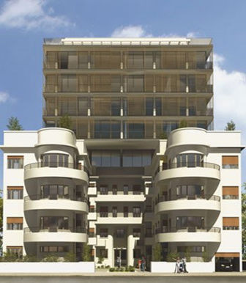  Ha'Yarkon 96  Tel Aviv  Architect: Gidi Bar Orian & Amnon Bar Or  Area: 48,437 SF.  Year: 2011  Client : Fair Foundation
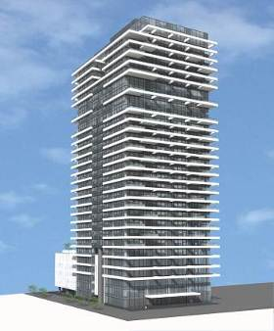  Rothschild 1  Tel Aviv  Architect: Yashar Arc.  Area: 252,951 SF.  Year: 2008 Client : Habas Group | 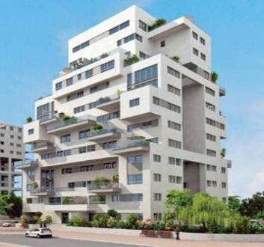  Neve Gan  Ramat Ha'Sharon  Architect: Giora Rotman  Area: 21,527 SF.  Year: 2007  Client: Azorim & Ashdar
T Tower – Seas City  Netanya  Architect: Ilan Pivko  שטח: 11,000מ"ר  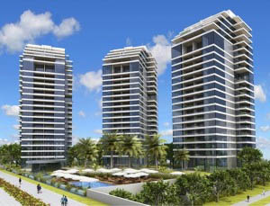  Year: 2011  Client : Itzik  Tshuva | New Gimel  Tel Aviv  Architect: Tamar Israel  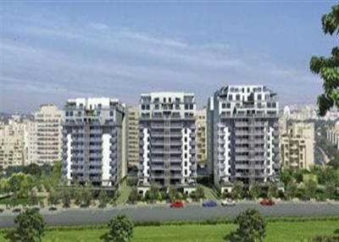  Area: 193,750 SF.  Year: 2008  Client : AFI group
Transportation
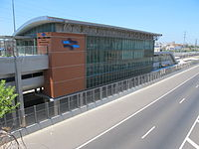  Railway Station  Dayan Center  Architect: Mario Bork  Area: 7,534 SF.  Year: 2010  Client: Israel Railway | NETA  Urban Transportation  Tel Aviv  Architect: Yael Almog – Nir Kutz Arc  Area: 107639 SF.  Year: 2012  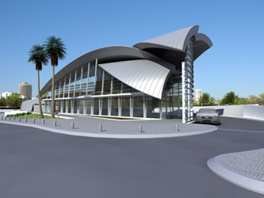  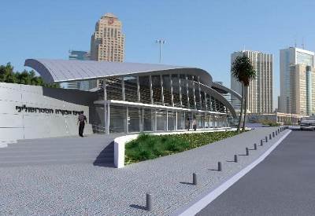  Client: NETA
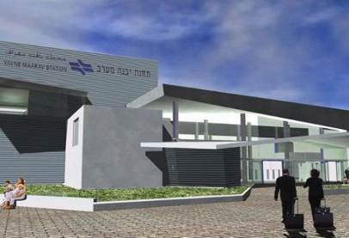
Railway Station
West Yavne
Architect: Batya Sibirsky
Area: 6,458 SF.
Year: 2012
Client : Israel
railway

Healthcare
Levinstien Hospital  Ra'anana  Architect: Yaski-Mor -Sivan  Area: 107,639 SF.  Year: 2010  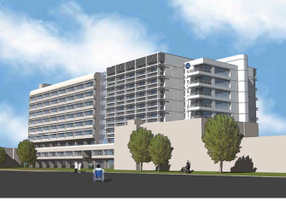  Client: Levinstien | Ichilov Hospital  Rehabilitation Center  Tel Aviv  Architect: Sharon Arc.  Area: 30,138 SF.  Year: 2008  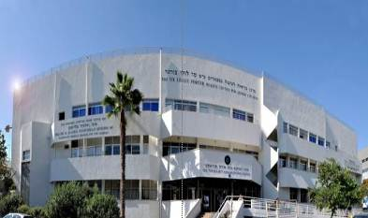  Client: Ichilov Hospital
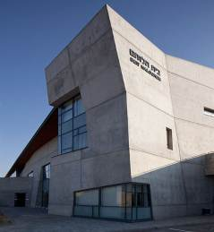  Beit Ha'Lohem  Be'er Sheva  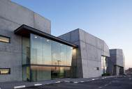  Architect : Kimel-Eshkolot  Area: 32,291 SF.  Year: 2012  Client: IDF | 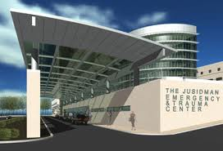  Beilinson Hospital  Petach Tikva  Architect: Rani Zis  Area: 107639 SF.  Year: 2009  Client: Clalit Briut
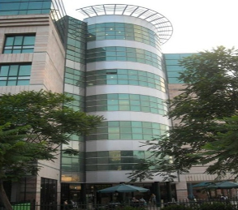  Naot Kipat Ha'Zahav  Nursing Home  Haifa  Architect: David Knafo & Hagit Klimor  Area: 53,819 SF.  Year: 2006  Client: Naot Ima | West Galilee Hospital  Naharya  Architect: Mansfeld Kahat  Area: 215278 SF.  Year: 2009  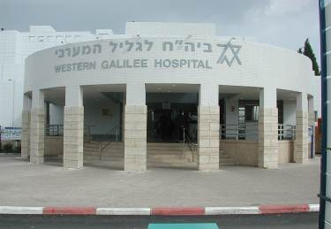  Client: Naharya  Hospital

Select work – over seas

Residential
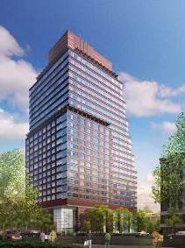  5th on the Park  1481 5th Ave. New York, NY  Architect: FxFowle Architects  Area: 400,000 sf.  Year: 2008  Client: Artimus Constructions | 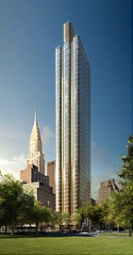  50 UN Plaza  New York, NY  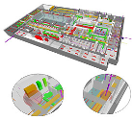  Architect: SLCE  Area: 330,000 sf.  Year: 2008  Client: Zeckendorf Development

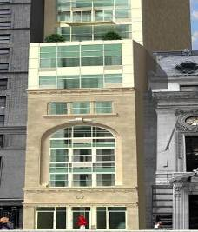
67 Liberty
New York, NY
Architect: Newman Design Architects
Area: 32,000 sf.
Year: 2011
Client: 67 Liberty LLC

Retail & Commercial
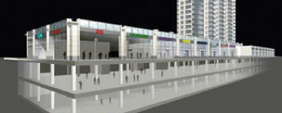  808 Columbus  808 Columbus Ave. New York, NY  Architect: Costas Kondylis & Partners  Area: 520,000 sf.  Year: 2007  Client: PAR Group | 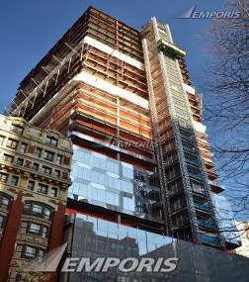  Diamond Tower  55W 46th St. New York, NY  Architect: SOM  Area: 700,000 sf.  Year: 2008  Client: Extell Development
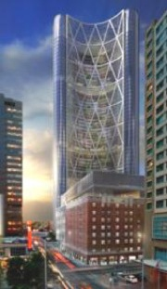  The Bow  Calgary, Alberta, Canada  Architect: Norman Foster  Area: 1,700,000 sf.  Year: 2007  Client: Cosentini Associates | AFI Palace Ploiesti  Bucharest , Romania  Architect: Asaf Dagan  Area: 43,055,641 sf.  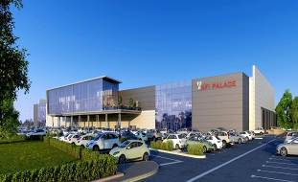  Year: 2011 Client: AFI Europe
Grand Mall  Varna, Bulgaria  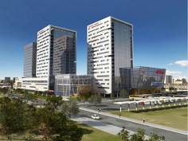  Architect: Yaski Mor Area: 1,100,000 sf. Year: 2010 Client: Orchid Developments Group | AFI Palace Cotroceni  Bucharest, Romania  Architect: Asaf Dagan  Area: 80,729,328 sf.  Year: 2011  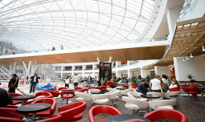  Client: AFI Europe

Hospitality
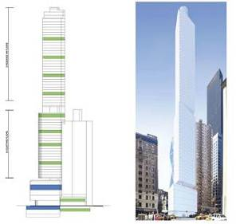  1717 Broadway  1717 Broadway AV. NY  Architect: Nobutaka Ashihara  Area: 375,000 sf.  Year: 2011  Client: G-Holdings | 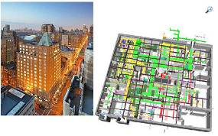  The Mark Hotel  25E 77th St. New York, NY  Architect: SLCE Architects, NY  Area: 230,000 sf.  Year: 2008  Client: Alexico Group

Marriot Courtyard
29-07 Queens Plaza N. Long Island City, NY
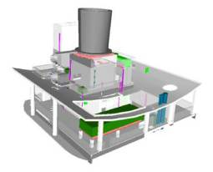
Architect: Nobutaka Ashihara Area: 125,000 sf. Year: 2008 Client: Cosentini Associates

Education & Culture
Sterling and Francine Clark Art Institute  Williamstown, MA  Architect: Tadao Ando  Area: 85,000 sf.  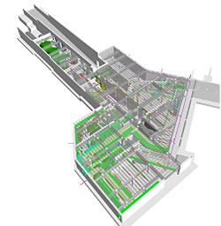  Year: 2010  Client: The Clark Art Institute | 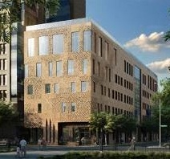  New York University  58 Washington SQ. NY, NY  Architect: Machado & Silvetti  Area: 100,000 sf.  Year: 2010  Client: New York University
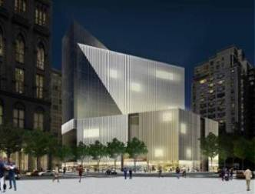  51 Astor Place  51 Astor Place, NY, NY  Architect: Fumihiko Maki  Area: 350,000 sf.  Year: 2008  Client: EJM Equities | 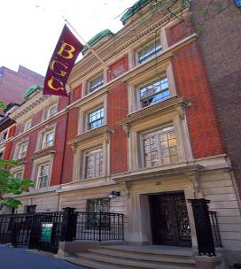  Bard Graduate School  36-38W 86th Street, New York, NY  Architect: Machado & Silvetti  Area: 15,000 sf.  Year: 2008  Client: Zubatkin Owners
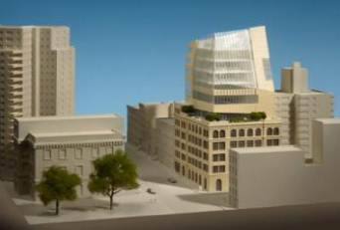  The Educational Alliance  197 East Broadway, NY, NY Architect: Norman Foster  Area: 100,000 sf. Year: 2010 Client: The Educational Alliance | Sperone Westwater Gallery  257 Bowery St, NY, NY  Architect: Norman Foster  Area: 100,000 sf.  Year: 2010  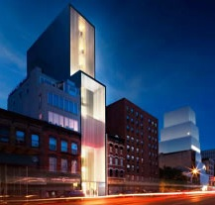  Client: Sperone Westwater Gallery

