 DENİZLİ METROPOLITAN MUNICIPALITY
Denizli Metropolitan Municipality (DMM) is a local authority. It provides services to a population of 1.062.698 (2025).
It endeavors to meet the joint needs and the environmental, social, spiritual and physical well-being of its citizens.
It prepares city plans, organizes city transportation, controls the city development and growth according to these plans. It makes infrastructure for healthy living environment for its citizens, forms green areas, provides cleaning and conducts activities concerning to climate change.
In the scope of social municipality; it organizes cultural activities within the city, activities towards informing the public, education and sport activities towards the development of its citizens.
It has responsibility for improving social welfare (providing assistance to poor, elderly, disabled, children etc).

PROJECTS DEPARTMENT
Established in 2007. The unit, prepares and implements the projects not only for international funds but also local and national funds, has a rich experience on project management at international level. The wide range of projects have been carried out in the field of climate change, environment, cultural heritage, innovation, citizenship, social inclusion, education, youth and municipal services regarding to vision and mission of Denizli Metropolitan Municipality. The department also carries out the foreign relations of Denizli Metropolitan Municipality.

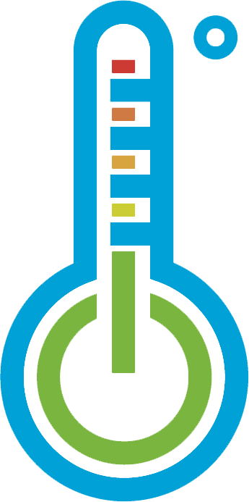CLIMATE CHANGE DEPARTMENT
Established in 2019. Denizli Climate Change Action Plan 2016-2030 which includes both mitigation and adaptation actions was prepared. DMM is member of GCoM. Denizli has been selected 2020 National Champion of Türkiye at One Planet City Challenge and 2nd of the World ‘’We Love Cities’’ Campaign. 21% reduction from increase was identified covering all emission sources at the provincial level of Denizli for 2030.
According to 2020 GHG Inventory report, the total GHG emissions of the city for the year 2020 were estimated to be 6.9 mtCO₂e. This amount refers to 6.6 tCO₂e per capita, which is proportional to the population of it’s in the same year (1.040.915).42% of total emissions are based on stationary sources, 31% transportation, 14% agriculture and livestock, 11% industrial processes and 2% waste. For 2021, Denizli has achieved an overall score of B ‘’Management’’ on CDP-ICLEI Unified Reporting System. According to 2021 GCoM Compliance Results, Denizli achieved the Adaptation-RVA badge. Denizli’s CDP score improved from B+ in 2024 to A- in 2025.

 DISCOVERING DENİZLİ
Denizli is located in Aegean Region, South West of Türkiye.
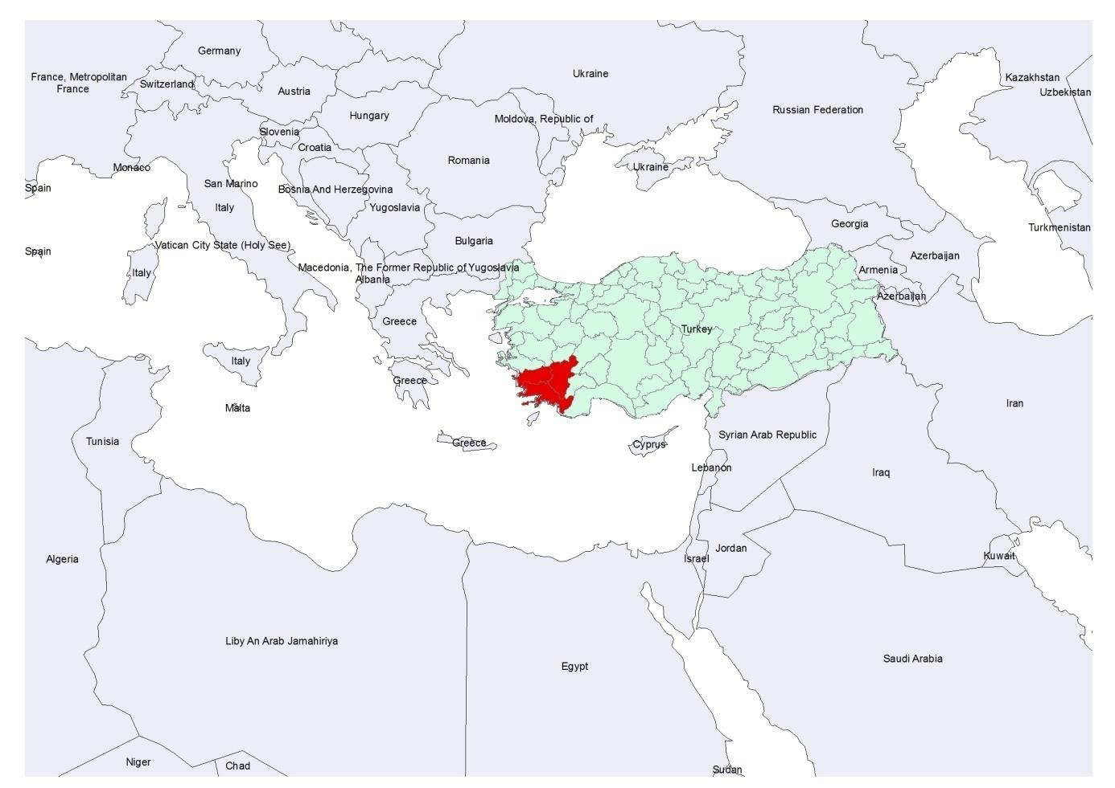
Population is 1.062.698. The history of Denizli and its surroundings stretches back to Ancient Era. Pamukkale (in the Unesco World Heritage List), Hierapolis is located in Denizli.
Denizli is one of the main centers of faith tourism (St. Philip’s Martyr is in Denizli). It has geothermal energy and solar energy.Annual sunshine duration of Denizli is 7.51-7.75 (hour/day) for 1991-2020.
Denizli is a city of tourism, travertine, textile, thermal, history, technology and agriculture (7 T).
Denizli is the leader in textile products and copper cable industry.

 TRANSPORTATION DEPARTMENT
The Transportation Department aims to provide safe, comfortable, and economical urban public transportation services to the people of Denizli, continuously improving the quality of transportation to maximize social satisfaction.
DMM is actively transforming Denizli into a smart mobility hub by operating 70 adaptive intersections and a smart fleet of 258 buses, while utilizing a dynamic digital twin model to simulate and optimize traffic scenarios.
In this context, DMM has successfully finalized the Denizli Sustainable Urban Mobility Plan (SUMP/Denizli SKUP). Notably, this is Türkiye’s first comprehensive sustainable urban mobility plan prepared entirely by a metropolitan municipality’s own technical team and resources.
The Strategic Framework (2025–2040), developed using advanced dynamic transport modeling, outlines a vision for a “Human-Oriented, Livable, Safe, and Innovative” Denizli. At the neighborhood level, this vision promotes 15-minute accessibility, 30 km/h zones, safer crossings, and continuous pedestrian infrastructure.
The roadmap encompasses 8 measure packages, 66 measures, and 425 specific projects to be implemented by 2040.
Transportation Department possesses:
• A central Urban Transport Unit with GIS and traffic analysis capabilities,
• ITS infrastructure including CCTV and traffic signal control integration,
• Experience in coordinating multi-stakeholder platforms for public engagement and participatory planning,
•An open and collaborative policy environment enabling the piloting of innovative safety and mobility solutions in real-life conditions.

CIRCULAR ECONOMY IN DENİZLİ
Located in a region increasingly vulnerable to climate change and drought risks, Denizli must prioritize resource efficiency. To build a resilient city, DMM is shifting from a traditional consumption model to a "Circular Economy" approach. DMM is committed to minimizing waste, protecting water resources, and transforming potential waste into economic value through a series of planned and ongoing initiatives.
Current Actions:
• Sevgi Eli: DMM’s Sevgi Eli project exemplifies 'social circularity' by repairing and redistributing thousands of donated items to families in need, extending the lifespan of products. By turning potential waste into essential resources for over 26,000 instances of reuse in 2025, the project demonstrates how the circular economy can powerfully serve both the community and the environment.
• Home Repair Services: DMM has expanded its free 'Home Minor Repair' service to all 19 districts, offering plumbing and electrical maintenance to all citizens. This project extends the lifespan of household infrastructure through timely repairs, combining social support with the circular economy principle of maintenance.
Future Actions:
• Excavation Waste Recovery: DMM plans to construct a new facility designed to recycle construction and excavation waste, transforming it into usable raw materials instead of disposing of it in landfills.
•Circular Economy Action Plan: DMM plans to develop a comprehensive roadmap to systematically manage environmental goals and ensure long-term sustainability for the city.

 AGRICULTURAL ACTIVITIES IN DENİZLİ
DMM acts not just as a local authority but as a strategic partner in rural development, fostering a resilient and productive agricultural sector. So, it has implemented a multi-layered support system to empower local farmers and strengthen agricultural associations. DMM provides substantial subsidies to reduce the financial burden on farmers. This includes the distribution of certified seeds (such as silage corn, Hungarian vetch, and cereals) and saplings (olive, walnut, almond). In recent years, millions of liras have been allocated for these grants, directly benefiting thousands of producers across 19 districts. To modernize production, critical machinery to agricultural cooperatives and associations are supplied. Supports livestock breeders by distributing breeding rams and goats to improve herd quality. On the other hand, investments heavily in agricultural irrigation is realized; distributing hundreds of thousands of meters of irrigation pipes to prevent water loss and promote efficient water use are some of them. The shift from wild irrigation to drip irrigation is a key priority to protect water resources. Furthermore works also in close coordination with the stakeholders and local agricultural chambers to identify needs and execute projects. This collaborative approach ensures that support reaches the right beneficiaries and addresses the specific needs of each district.

 OVERALL FUNDING FOR EXECUTED PROJECTS
PROJECT NAME | FINANCIAL INSTITUTE | OBJECTIVES | FUNDING € | YEAR
Exploring New Service in Waste Management | Dutch Union of Municipalities (VNG) –Logo East I Programme | Improvement of Denizli Municipality's services; preparation of 5-year Management Policy and Methane Gas Feasibility Report | 64.000,00
Improving the Disaster Management Capability of Denizli Fire Bridge | Dutch Union of Municipalities (VNG) –Logo East II Programme | Improvement capacity of Denizli Municipality Fire Department related to disaster management | 70.000,00
Disabled at Work | Foreign Affairs Ministry of the Netherlands Matra Programme | Providing employment opportunities of the physically disabled people and supporting their participation into social life | 700.000,00 | 2007-2010
Municipal Support to Municipalities | Central Financial Contract Unit | Effective implementation of public services such as water supply, energy supply and sewerage | 181.000,00 | 2008-2009
Social Work for Public | Provincial Employment Agency | Vocational trainings and employment for public | 355.000,00 | 2009-2011
Strengthen Infrastructure of Waste Water Treatment Plant | South Aegean Development Agency | Strengthen Infrastructure of Waste Water Treatment Plant | 409.196,00 | 2010-2012
Improvement of Municipal Services | National Agency – LdV Mobility Programme | Improvement capacity of Municipal’s personnel with mobility to Portugal, Spain, Denmark. | 50.433,00 | 2012-2013
Planning for Real | France National Agency- LDV Transfer of Innovation Programme | Familiarization and implementation of innovation methods of public participation that have been used for many years in the UK | 261.862,57 | 2013-2015
Wakening of Cultural Heritage Laodikeia | South Aegean Development Agency | Structural works for church roof coat of Laodikeia Holy Cross Church | 430.574,45 | 2013-2015
Zeytin Plateau Is Introduced to | South Aegean Development Agency | Realization of construction works for camp sites with tent and bungalows in Zeytin Plateau | 2.107.142,85 | 2013-2015
Denizli Cultural Inventory | South Aegean Development Agency | Mapping out of cultural traditions, historic buildings, archaeological sites and cultural landscapes for identification, protection, interpretation and preservation | 22.900,76 | 2014
Geothermal Resources | South Aegean Development Agency | Mapping out of geothermal resources within the city | 24.167,94 | 2015
Denizli Strengthen with Solar Energy | South Aegean Development Agency | Electricity production by making use of solar energy. Installation of photovoltaic panels on an area of 2500, awareness raising activities on renewable energy, installation of mobile phone recharging stations in five locations | 369.758,77 | 2015-2016
Denizli City Map | South Aegean Development Agency | Production of a city map in which local and international tourists can use | 12.722,65 | 2016
TUSELOG (Turkish-Swedish Partnership for Local Governance) | Swedish International Development Cooperation Agency | Contribute to enhance local governance in Türkiye. Denizli taking part in pilot project activities. | Technical support | 2011-2015
Power the Revolution for Climate Action (Climaction) | Central Financial Contract Unit | Capacity building of municipal staff and good quality municipal services for adaptation& mitigation to climate change. | 186.463,75 | 2017-2019
Laodikeia West Theatre is Calling | South Aegean Development Agency | Restoration works for east theatre of Laodikeia Ancient City | 459.574,46 | 2018-2020
Medium-Term Development Planning and Financing in Metropolitan Municipalities | EU through the World Bank under the Sustainable Cities Project – Component a Grant | İller Bankası Anonim Şirketi is the lead applicant and DMM is the client in the project. DMM is going to be among the first 10 metropolitan municipalities in Türkiye which prepare its Medium-Term Investment Plan. | Technical support | 2020-2022
Denizli Science Center | The Scientific and Technological Research Council of Türkiye (TUBITAK)) | Denizli Science Center is established on an area of 4000 m² | 1.677.477,07 | 2021-2023
Public Transportation Gets Smarter in Denizli | EU IPA Funds | Transportation Management Centre is established. In addition to this capacity building of technical staff, production of “Intelligent Transportation Systems Strategy Action Plan”, raising awareness activities were carried out. | 2.918.645 Euro | 2024-2025
Denizli is Becoming a Brand in Tourism | South Aegean Development Agency | Trainings will be given to local entrepreneurs and owners of kebap shop | Technical support | 2025
Denizli’s Taste, Colour and History is Revealing | South Aegean Development Agency | Training and consultancy services will be provided in the field of creating tourism routes. | Technical support | 2025

 CONTACT INFORMATION
e-mail : foreignrelations@denizli.bel.tr
phone : +90 258 280 2524
Denizli Metropolitan Municipality
Survey and Projects Department

