**National Research and Development Institute for Industrial Ecology – ECOIND**

**Pollution Control Department**

**BIOASSAY – BIOLOGICAL ANALYSIS LABORATORY**

**BIOASSAYS FOR CHEMICALS / CONTAMINATED SAMPLES / MICROPLASTICS**

|  |  |  |  |
| --- | --- | --- | --- |
| **AQUATIC TOXICITY TESTS** | | | |
| **Aquatic organism** | **Reference document** | **Array** | **Parameter / Final Result** |
| **Freshwater fish**    *Cyprinus carpio (carp)*  *Carassius auratus gibelio (caras)* | **Acute toxicity**  OECD 203 / SR EN ISO 7346-1,2:2004 [*] | Chemicals  Wastewater / surface  / Sediment | Mortality / acute lethal conc. (LC50-96h) |
| **Chronic toxicity**  Internal procedure | Chemicals | Biological and biochemical indices / maximum allowed conc. in water (MATC) – minimum 3 months |
| **Bioaccumulation /** OECD 305 | Chemicals | Bioconcentration Factor (BCF) – minimum 3 months |
| **Plankton crustaceans** | | | |
| *Daphnia magna* | **Acute toxicity**  OECD 202/ SR EN ISO 6341 :2013 [*] | Chemicals  Wastewater / groundwater /  surface/ leachate /waste | Mortality /immobilization / effective conc. for 50% of organisms after 48h (EC50-48h) |
| **Ciliated protozoa** | | | |
| *Tetrahymena thermophilea* | **Chronic toxicity**  Protoxkit F | Chemicals  Wastewater / groundwater /  surface/ sediments | Reproductive inhibition/ effective conc. for 50% of organisms after 24h (EC50-24h) |
| **Rotifers** | | | |
| *Branchhionus calyciflorus* | **Acute toxicity**  ASTM Standard E1440-9 | Chemicals  Wastewater / groundwater /  surface/ sediments | Mortality / lethal conc. for 50% of organisms after 24h (LC50-24h) |
| **Aquatic plants** | | | |
| *Spirodela duckweed (duckweed)* | **Acute toxicity**  ISO 20227:2017 | Chemicals  Wastewater / groundwater /  surface/ sediments | Rate of inhibition of growth / effective conc. for 50% of organisms after 72 h (EC50-72h) |
| *Selenastrum capricornutum (algae)* | **Acute/chronic toxicity**  OECD 201/ SR EN ISO 8692 :2012 [*] | Chemicals  Wastewater / groundwater /  surface/ leachate /waste | Growth rate/biomass/ effective conc. for 50% of organisms after 72h (EC50-72h) |
| **Benthic crustaceans (ostracods)** | | | |
| *Heterocypris incongruens* | **Chronic toxicity**  **ISO 14371:2012** | Chemicals  Waste water / surface/ leachate / mud/ soil/ sediment | Mortality/ Inhibition of growth/ effective conc. for 50% of organisms after 6 days (EC50-6 days) |

**Ecotoxicological information will help for:** completing Technical Security Files (Ecological Information section), obtaining authorization/marketing product approvals, environmental opinions, evacuation notices, risk assessment studies, environmental impact assessment studies, obtaining the eco label, etc.

|  |  |  |  |
| --- | --- | --- | --- |
| **AQUATIC TOXICITY TESTS** | | | |
| **Aquatic organism** | **Reference document** | **Array** | **Parameter / Final Result** |
| **Bacteria** |  |  |  |
| *Aliivibrio fischeri* | **Acute toxicity**  SR EN ISO 11348-3:2009 | Chemicals  Waste water/ groundwater | Inhibition of bioluminescence /  conc. inhibitors (IC50) |
| *Escherichia coli* | **Genotoxicity**  ISO 13829:2000 | Chemicals  Waste water / groundwater / surface / leachate / waste / mud / | Enzymatic activity  (β-galactosidase and alkaline phosphatase) / Induction factor (SOSIF) |
| *Microbacterium sp. Brovundimonas diminuta, Citrobacter freundii, Comamonastestosterroni,*  *Enterococcus casseliflavus, Deltftia acidovorans, Kurthia gibsonii, Staphilococcus warnerii, Pseudomonas aurantiaca, Serratia rubidae, Pichia anomala* | **Chronic multi-species** test - **MARA** (Microbial Array for Toxicity Risk Assessment) /  Internal procedure | Chemicals / wastewater | Inhibition of microbial growth / microbial toxic conc. (MTC) |
| *Fish cell line RT gill-W1*  **(**in collaboration with University of Bucharest, Faculty of Biology) | **Acute toxicity**  OECD 249 / ISO 2115:20219 | Chemicals  Water sample | Inhibition of cell viability (EC50) |

|  |  |  |  |
| --- | --- | --- | --- |
| **TERESTRIAL TOXICITY TESTS** | | | |
| **Terrestrial plants** | | | |
| *Lepidium sativum (cress)*  *Sinapis alba (mustard)*  *Sorghum saccharatum (sorghum)* | **Phytotoxicity**  SR EN ISO 11269-1,2:2013 / OECD 208 | Chemicals / waste water irrigation/ sludge/ soil/ waste/ leachate | Inhibition of germination and root growth / EC50-72h |
| **Earthworms** |  |  |  |
| *Eisenia andrei* | **Acute toxicity /**  SR EN ISO 11268-1:2016  OECD 207 | soil, compost, sludge, waste, chemicals | Determination of acute lethal concentration LC **50-14 days** |

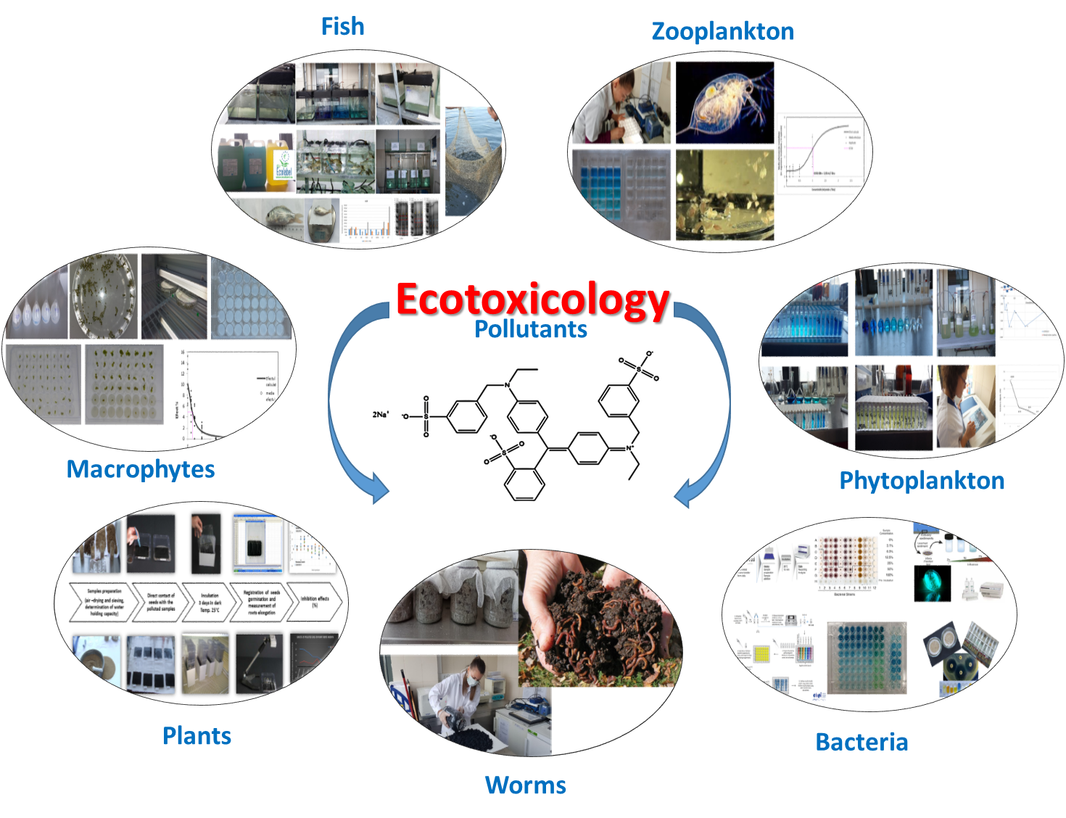

|  |  |  |  |
| --- | --- | --- | --- |
| **BIOCIDE TESTS (ALGICIDES/DISINFECTANTS)** | | | |
| **Organism** | **Reference document** | **Array** | **Parameter / Final Result** |
| **Aquatic plants** | | | |
| *Selenastrum capricornutum (algae)* | **Acute/chronic toxicity**  **/ Algaecide efficacy**  OECD 201/ SR EN ISO 8692 :2012 [*] | Algicides / Products for Swimming Pools | Growth rate/biomass/ effective conc. for 50% of organisms after 72h (EC50-72h). Efficacy at the recommended dose / Recommended effective dose |
| *Spirodela duckweed (duckweed)* | **Acute toxicity**  ISO 20227:2017 |
| **Bacteria** | | | |
| *Pseudomonas aeruginosa*  *Escherichia coli*  *Legionella pneumophila*  *Staphylococus aureus* | **Internal standard** | Disinfectants | Bactericidal efficiency tests |

|  |  |  |  |
| --- | --- | --- | --- |
| **ULTIMATE** **AEROBIC BIODEGRADABILITY** | | | |
| **Test** | **Reference document** | **Array** | **Parameter / Final Result** |
| Static test for the evaluation of "inherent" aerobic biodegradability under action of aerobic microorganisms – Zahn-Wellens method | *SR EN ISO 9888:2004 /*  *OECD 302B/ EC-C.9 method* [*] | Chemicals/  Waste water / surface water | % abiotic degradation  >20% COD / COD removal – primary biodegradation  ≥70% COD / COD removal – inherent biodegradation |
| **Watery environmental assessment of "rapid" aerobic biodegradability**by experiments in biological installations with active sludge, conducted in a discontinuous system (batch) | Dissolved organic carbon (COD) analysis method *(SR EN ISO 7827:2013 /*  *OECD 301A / EC-C.4-A method)* | Chemicals/  Waste water / surface water | ≥70% COD removal in 28 days |
| Method by analysis of biochemical oxygen consumption (BOD5) - Closed container *test* [*] *(SR EN ISO 10707:2001 / OECD 301D / EC-C.4-E method)* | Specific BOD5 (mg oxygen /mg tested compound) /  ≥60% theoretical oxygen consumption (CTO) in 28 days |
| Test to assess the inhibitory effect on oxygen consumption of active sludge microorganisms with oxidation of carbon and ammonium *(SR EN ISO 8192:2007 /*  *OECD 209 / EC-C.11 method)* | Inhibition of total oxygen consumption (*I%*); which inhibits 50% oxygen consumption (EC50) in 30-180 min. |
| Determination of elimination and biodegradability in a continuous testing system that simulates the biological process with activated sludge | Simulation test in aerobic treatment plants with activated sludge (simulates a wastewater treatment plant)  *(SR EN ISO 11733:2005/ OECD303A/EC-C.10 method)* | Water-soluble organic compounds | Determine daily COD/COD in influence and effluent.  Test duration: 12 weeks  >80% COD/COD removal in 28 days |
| Determination of the biodegradability of surface agents | Reference method described in Annex VIII.1 to Reg.EC 648/2004  *OECD Confirmation Test 303A* [*] | Detergents / cleaning products | % remove COD / COD at time t  % removal surfactant at time t  >80% COD /COD removal for 2 weeks |
| Assessment of degradation capacity by determining global indicators: COD and BOD5 | SR ISO 6060:1996 (validated standard) [*]  SR EN ISO 5815-1:2020 [*]  SR EN 1899-2:2002 [*] | Chemicals/ Waste water | BOD5/COD report >0.5 |

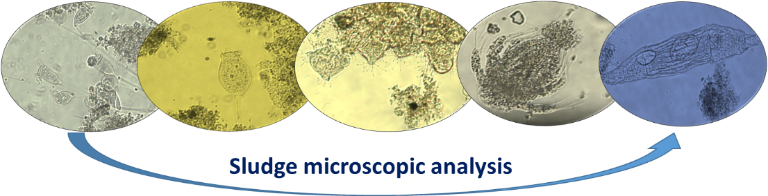

|  |  |  |  |
| --- | --- | --- | --- |
| **BIOLOGICAL ANALYZES** | | | |
| **Test** | **Reference document** | **Array** | **Parameter / Final Result** |
| Spectrometric determination of "chlorophyll a" content | SR ISO 10260:1996 [*] | Surface water, algal solutions, groundwater, mineral water, wastewater | "Chlorophyll a" / concentration expressed in µg/L |
| Microscopic analysis (qualitative detection of biotic communities) | Internal standard | Surface water (lotic and lentic aquatic ecosystems), sediment and groundwater | Taxonomic composition |
| Qualitative and quantitative detection of benthic invertebrates | SR EN ISO 8689/1,2:2003 SR EN 16150:2012 SR EN ISO 10870:2012 | Lotic and lentic aquatic ecosystems | Taxonomic composition and structure |
| Bacteria at 22°C and 37°C Total coliforms Fecal coliforms  *Escherichia coli*  *Salmonella spp.*  *Legionella sp.*  *Clostridium perfringens* | SR EN ISO / EPA standards / Internal standards according to RENAR Accreditation Certificate LI 941 dated 15.12.2023 (Annex 1) | Drinking water, mineral water, bathing water, groundwater, wastewater, surface water, soil, sediments, waste, sludge | Number of bacteria in analyzed volume / Present or Absent |
| Sanitation tests | Internal standards | Surfaces and objects | Total number of colonies at 37°C in 48 h / No. of germs per cm² |
| Aeromicroflora tests | |  | | --- | |  |   Indoor air | Total number of bacteria at 37°C (no./plate) / No. of germs per m³ of air |
| Mold tests | Products (paints) | No. of germs per cm² at 22°C in 48 h |
| Identification of microorganisms (especially bacteria) using the Biolog Omnilog system | |  | | --- | |  |   All types of water | Bacterial species |
| **SAMPLING** | | | |
| Water / sediment sampling | According to RENAR Accreditation Certificate LI 941 dated 15.12.2023 (Annex 1) | All types of water, sediments, sludge | Sampling for physico-chemical and biological analyses |
| On-site analyses: pH, dissolved oxygen, oxygen saturation, temperature, free residual chlorine | According to sampling standards | Water samples | multiparameter devices and analysis kits |

[*] accredited method SR EN ISO/CEI 17025:2018; the rest of the methods are applied in a SR EN ISO 9001 and SR EN ISO 14001 certified infrastructure

Request the recommendations of INCD ECOIND specialists for the selection of test methods according to your needs.

** For chemicals toxicity classification according to REACH regulation are needed tests on daphnia, algae and fish and ultimate biodegradability test.

|  |  |  |  |
| --- | --- | --- | --- |
| **Microplastics analyses** | | | |
| **Test** | **Reference document** | **Array** | **Parameter / Final Result** |
| Visual analysis and sample pretreatment (sorting and separating the suspected particles0 | SR EN ISO 24187:2023  ISO/TR 21960:2020  Internal methods  Scientific literature  <https://doi.org/10.3390/w16020233>  <https://doi.org/10.3390/toxics13040246>  <https://www.incdecoind.ro/microplastice-efecte-ecotoxicologice-si-mecanisme-de-actiune-in-pesti-microplasfish/> | Surface water, wastewater, drinking water, sediment | Present/ Absent  Number per liter  Particles dimensions  Shape  Color  Type of polymer  Pictures |
| Conventional microscopic analysis (Stereomicroscope Leica M205FA) to highlight the shape, morphology, size, and number of these particles |
| Electron microscopy (SEM QUANTA FEG 250) analysis - morphology of the suspected microplastic particles (less than 100 µm). |
| Qualitative determination of polymer type using micro-RAMAN or FT-IR analyses - collaboration with the National University of Science and Technology Polyethnic Bucharest |

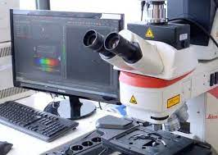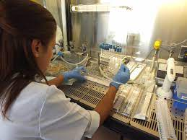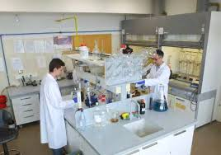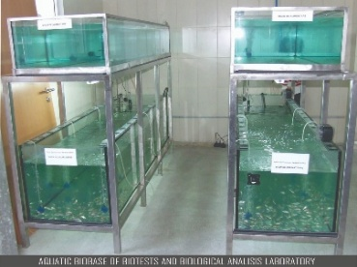

|  |  |
| --- | --- |
|  | **Dr. Alina Roxana BANCIU**  *Head of Biotests and Biological Analysis Lab*  **Dr. Stefania GHEORGHE**  *Ecotoxicological Studies Coordinator*  **Dr. Catalina Stoica**  *Freshwater Ecology Coordinator*  *Control Pollution Department*  **Address:**   Drumul Podu Dâmboviței 57-73, District 6, Bucharest  **Mobile:**    +4.0724004625; P**hone:**  +4.021.410.03.77, int. 156  **e-mail:**   [alina.banciu@incdecoind.ro](mailto:alina.banciu@incdecoind.ro)  [stefania.gheorghe@incdecoind.ro](mailto:stefania.gheorghe@incdecoind.ro)  [catalina.stoica@incdecoind.ro](mailto:catalina.stoica@incdecoind.ro)  **Website:** [www.incdecoind.ro](https://urldefense.com/v3/__http:/www.incdecoind.ro/__;!!Nkc5UzxO!ouARk_mmlNqjrvHkS1wNfYfBms5wAEi7KbKoC_xgTZIhMdshmJTj32LUGGFNN_aBsmtHeDY6Kfj7UCw30lygr32yaJbQ01U$) |