
Subject: MGK Rulman – Partnership Invitation with a Strong Authorized Distribution Network

Dear Business Partner,
As MGK RULMAN OTOMOTIV INDUSTRY AND TRADE INC., we proudly serve as the authorized distributor of the world’s leading brands in the automotive and industrial spare parts sectors. With our extensive experience and wide product portfolio, we are committed to being a reliable and solution-oriented partner for your business.

📌 Authorized Distributorships in Turkey:
We are the official distributor in Turkey for the following globally recognized brands:
- TIMKEN
- SKF
- DAYCO
- GATES
- CORTECO
- LOCTITE
...and many other prestigious manufacturers in the industry.
These brands offer high-performance solutions that exceed international standards, even in the most demanding conditions. Our strong supply chain and broad stock capabilities enable us to deliver the most suitable and competitive solutions tailored to your needs.
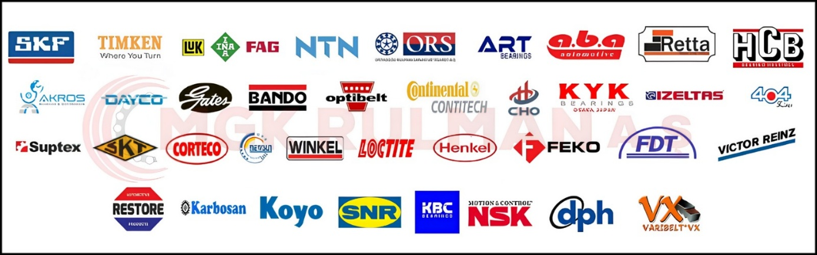

💼 Our Key Advantages:
- Guaranteed supply of original, high-quality products through authorized distribution
- Fast and reliable delivery
- Direct technical support and customer service
- Strategic support for your marketing campaigns
- Special bulk pricing for export and large-scale procurement

📍 Our Presence:
- 1 Headquarters
- 1 Main Warehouse
- 6 Branches across Turkey, enabling wide regional coverage and operational efficiency

Since the late 20th century, MGK Rulman has maintained its leadership in Turkey’s bearing and automotive markets by focusing on customer satisfaction, product authenticity, and long-term partnerships.
We would be honored to collaborate with your company and support your growth with our reliable product supply and professional service approach. For more detailed information, please feel free to contact us via email or phone.
Sincerely,
MGK Rulman Industry and Trade Inc.

DOLAPDERE BRANCH
İSTANBUL/BAŞAKSEHİR Dolapdere San. Sit.17. Ada No:58/60

GÜNGÖREN BAĞCILAR 2 BRANCH
İSTANBUL/BAŞAKSEHİR Güngören San. Sit. 23.Blok No:9

TOPKAPI BRANCH
İSTANBUL/TOPKAPI Teknik Oto. San. Sit. 5.Blok No:125/126

GEBZE BRANCH
KOCAELİ/GEBZE Gebze Küçük Sanayi Sitesi A12 Blok No:7

NİLÜFER BRANCH
BURSA/NİLÜFER Üçevler,Oto Yedek Parç. Sitesi,48.Sk.No:7

DOLAPDERE MERKEZ OFFİCCE
İkitelli Osb/ Başakşehir/ İstanbul
Dolapdere San. Sit.17. Ada No:59

ÇORAPÇILAR SANAYİ SİTESİ WAREHOUSE
İkitelli Osb/ Başakşehir/ İstanbul
CORAPCILAR SAN. SİT.. D BLOK NO:5/6

