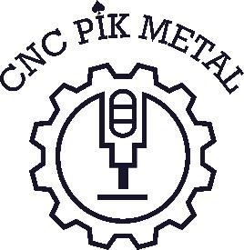
„CNC PIK METAL”
Vlada Pavlović PR – craft shop for metalworking
Timocke divizije 18/17, 19210 Bor; phone: 069/1482007
MB – 67050410; PIB – 113742082; account: 160-6000001727694-65 – Banca Intesa AD Beograd
e-mail: cncpikmetal@gmail.com

We founded a company for CNC metalworking.

As a newly founded company for machining we are looking for associates as well as for work. My occupation is traffic engineer with nine years of work experience as CNC programmer/operator.

I program in NX Ideas, SOLIDWORKS/CAM, experience with machines: Famup ,Stama, Kitamura, DMU50, MTU BT2200, MAHO 432, Daewoo Puma.
The acquired experience and knowledge I will try at business and self-improvement in the field of business.

I own a lathe COLCHESTER 350 (for now) and I offer you every kind of cooperation and services if we are able to fulfill your requirement.

CNC machine has a possibility of product cylindrical and conical profiles of various shape:
shaft, cocoon, pulley, threaded rod (all kind of treaded), flanged, screw...

You as a organization that in a constantly expanding and developing I hope you can give me a chance to connect with your company .
I will improve myself and the company why I can to meet demands of the market.
It would be a great incentive for us as a small, newly founded family company.

