Concept Research project PSI Hamid

Topic: Characterization of degradation pathways of supra molecular photocatalysts under

repair with HPLC

Background

* Photocatalytic water splitting with supra molecular photocatalysts leads to formation of hydrogen using visible light
* Long term catalytic activity is hampered by limited TON’s (upto 500) and life times of active catalysis of 48 h max.
* Analysis of degradation products at the endpoint of catalysis have revealed that the catalyst is intact but the bridging ligand hydrogenated
* Reoxidation of the bridging ligand with 1O2 was accomplished and lead to regeneration of the photocatalytic activity
* Successive repetition of this repair process improved overall TON and lifetime

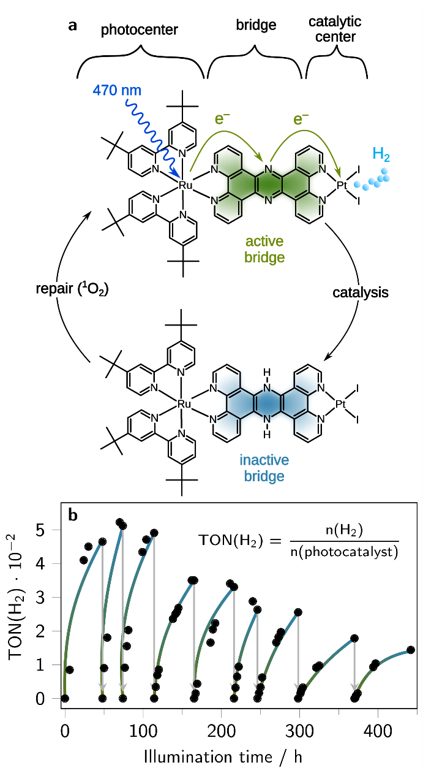

**Fig. 1. Visible light-driven hydrogen production with a photochemical molecular device (PMD).** Molecular structure of the **Ru(tpphz)PtI2** photocatalyst, consisting of a bis(*tert*-butyl-bipyridine)-ruthenium (II) photocenter, a tetrapyridophenazine (tpphz) bridging ligand and a diiodo-platinum(II) catalytic center (**a**). Photocatalytic hydrogen production with **Ru(tpphz)PtI2** (**b**, TON = turnover number). Through the short exposure of the hydrogenated PMD to *in situ* generated singlet oxygen (1O2), the photocatalystis re-oxidized to its active form and is again applicable for light-driven hydrogen production. By the repetitive active repair of the *damaged* photocatalyst, the long-term activity of the PMD is prolonged to weeks of active hydrogen formation.

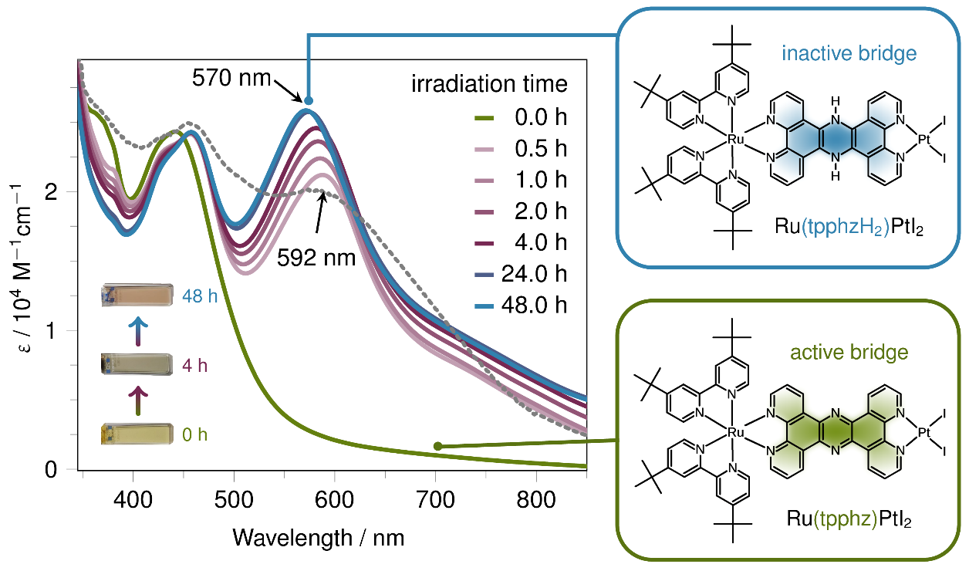

**Fig. 2. UV/vis absorption spectra of the catalytic solution at different irradiation times.** The *in situ* absorption spectra of the catalytic solution show a rapid rise of a new absorption band between 500 nm and 650 nm, which is assigned to reduction of the tpphz bridging unit of the **Ru(tpphz)PtI2** photocatalyst. Besides a fast increase of the absorption intensity, the maximum of the new band slowly shifts hypsochromically from 592 nm to 570 nm with continuous LED irradiation at 455 nm. This is attributed to the formation of the catalytically inactive species, **Ru(tpphzH2)PtI2**.No further spectral changes are observed after 48 hours of catalysis. The gray, dashed line shows the UV/vis absorption spectrum of the singly reduced photocatalyst (**Ru(tpphz•–)PtI2**) in acetonitrile (-1.35 V *vs*. Fc/Fc+, 0.1 M *n*-Bu4NBF4).

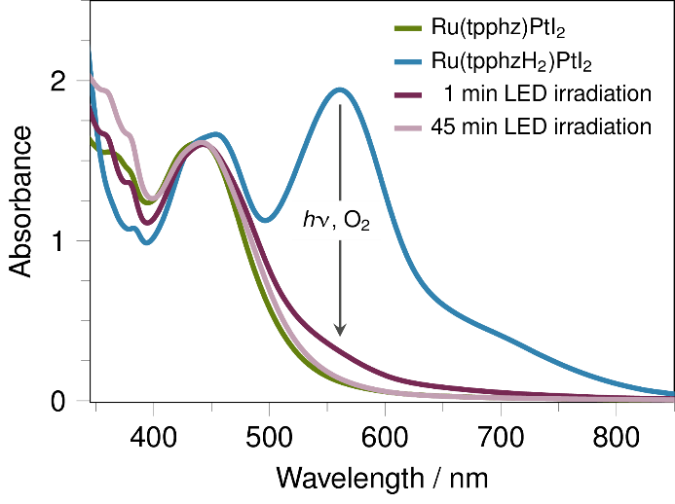

**Fig. 4. UV/vis absorption spectra showing the dehydrogenation of the photocatalyst Ru(tpphzH2)PtI2 by singlet oxygen.** The orange spectrum illustrates the hydrogenated photocatalyst **Ru(tpphzH2)PtI2** generated chemically by the reaction of **Ru(tpphz)PtI2** with hydrogen. After 1 minute of LED-irradiation (470 nm) under aerobic conditions the *in situ* generated singlet oxygen‑driven dehydrogenation of **Ru(tpphzH2)PtI2** is almost complete and forms the original (oxidized) form (dark violet line). After 45 min of LED-illumination no significant amounts of the hydrogenated species are detected anymore (bright violet line).

Research question

* Why is the catalytic performance of the photocatalyst in consecutive runs getting lower?
  + 🡪 Hypothesis – 1O2 attacks the structure of the catalyst leading to oxidative destruction of the ligand units
* HPLC of the supramolecular photocatalyst before photocatalysis, after photocatalysis, after repair for the consecutive repair cycles may lead to the identification of the degradation processes occurring
  + See hypothetical strucutres, (note Ru-tpphz-PtI2 is chemically, photochemically a very stable molecule)

