The Challenge Water distribution networks, mostly underground, are the world's largest engineering infrastructures that do not receive direct periodical inspection. Partial or no solutions exist to water network challenges: leaks, faulty welds, corrosion, blockage, pirate connections, and unmapped network segments, resulting in substantial water and energy loss and a high cost of network maintenance.
The Solution iPIPE’s innovative solution is a mini device (“submarine”) capable of maneuvering inside active pressurized water distribution networks while the pipes are still in service, inspecting and providing precise information regarding pipe conditions, system integrity, and location. The unique database along with the pipe's age, material, etc. enables using AI and deep learning to predict maintenance plans.
The Market The World Bank has assessed leakage worldwide as 36 billion m³ of water annually accounting for up to half of all the water pumped worldwide. Major cities lose 30 - 50% of drinking water. Water companies are concentrating on fixing visible pipe breaks, and not dealing with non-visible water loss. The regulations demand the system to be renewed every 40 years (2.5% per year). a pre-detection can save 90% of the budget. iPIPE is targeting water companies, and engineering service companies as its customers.
The company - Registered 10/2017, iPIPE is developing a revolutionary system that provides direct inspection and asset management capability of potable water pressurized pipe networks. iPIPE was funded by the Ministry of Energy of Israel (2018-19 and again 2023-24), the IAI (2020), and i-HLS (2022).
iPIPE has launched the ‘Neptun’ (mini model for a 4”-8” pipe diameter), the ‘Coi’ (for 8”-12” pipe dia.), and the ‘Dolphin’ (for 12”-24” pipe dia.) 12/24.
The technology - An autonomous sensor-carrying platform for long distances. The core capabilities are:
- Navigation – device locating and response to obstacles in a pressured water network.
- Inspection – implement video and audio sensing devices.
- Mapping – Implement an IMU (enabling the pipe route's drawing on a GIS map).
- Communication – long-distance signals transfer in water pipes (in progress).
Competitors – “pipe inspector” and “smart ball” are the only known relevant platforms, both passive with limited capabilities carrying a camera and/or a microphone only.
The team:
Menashe Rajuan (PhD) – CEO and Founder. A serial entrepreneur with a strong physics, chemistry, and SW background with over 30 years in high development and management positions.
Shimon Mizrahi (PhD) – CTO, an expert in ultra-low power-operated systems. Dr. Mizrahi served in various development and management positions for three decades.
Prof. Dani Weise (advisor) is a leading expert in the field of robotics, former head of the Robotics Institute in the Technion, and a member of the Israel Academy of Science.
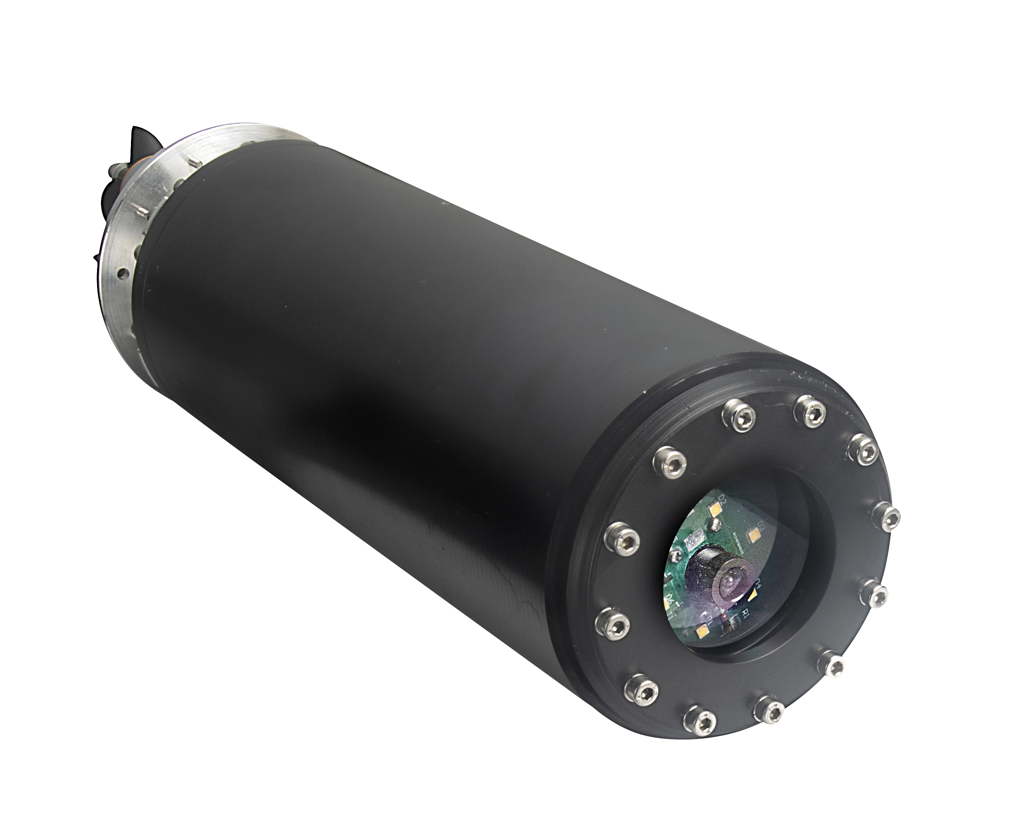
Eng. Benyamin Schmid – Expert in electronics and SW.
Eng. Musaab Salame – Mechanical engineer.

Website / Contact: www.ipipe-tech.com
YouTube: https://www.youtube.com/@ipipe-tech/
Investment’s Opportunity iPIPE is seeking 2.0M$ to farther enhance its capabilities in:
Sells and Marketing
Operations (worldwide services)
R&D - Long distance communication, Data analysis, EM & US sensing, Leak sealing.

Expected income (M$):

20252026202720282029Sum Total24.77.812.118.044

