**Curriculum Vitae**

**Czesław Siekierski**

**Minister of Agriculture and Rural Development of the Republic of Poland**

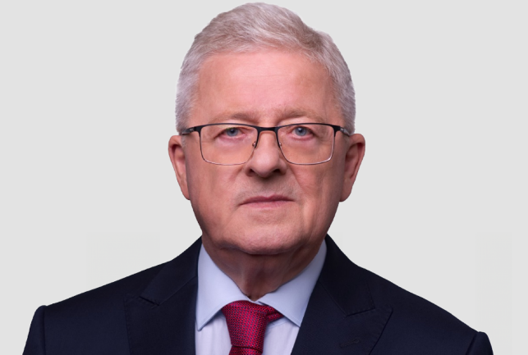

Czesław Siekierski wasborn in the village of Pieczogi, Oleśnica commune, province Świętokrzyskie. Doctor of economic and agricultural sciences, academic teacher   
at the Warsaw University of Life Sciences (SGGW) in Warsaw, author of many scientific and popular science publications.

As Director of the Foundation for Assistance Programs for Agriculture FAPA (1993-1998), he made a significant contribution to activities aimed at preparing the Polish countryside and agriculture for integration with the European Union.

In the years 1997-2004 he was a member of the Sejm of the Republic of Poland.

**Among others, he has served as:**

* Secretary of State at the Ministry of Agriculture and Rural Development (2001-2003);
* Government Plenipotentiary for Preparing Polish Agriculture for Integration   
  with the European Union.
* Member of the European Parliament in 2004-2019. Chairman (2014-2019)   
  of the Committee on Agriculture and Rural Development of the European Parliament, previously Vice-Chairman of this Commission (2009-2014).
* Member of the Sejm of the Republic of Poland of the 9th term;
* Member of the Public Finance Committee and the Foreign Affairs Committee.
* Member of the Sejm of the Republic of Poland of the current 10th term.
* Creator and head of the PSL think tank - the Political Institute. Maciej Rataj.
* Chairman of the NKW PSL Advisory Team.
* Vice-Chairman of the Supreme Council of the Polish People's Party.

Married, daughter, three grandchildren.

He comes from a family with patriotic traditions, the son of an activist of ZMW Wici, a soldier of the Peasant Battalions, active in the structures of the peasant movement, cooperatives and local government.