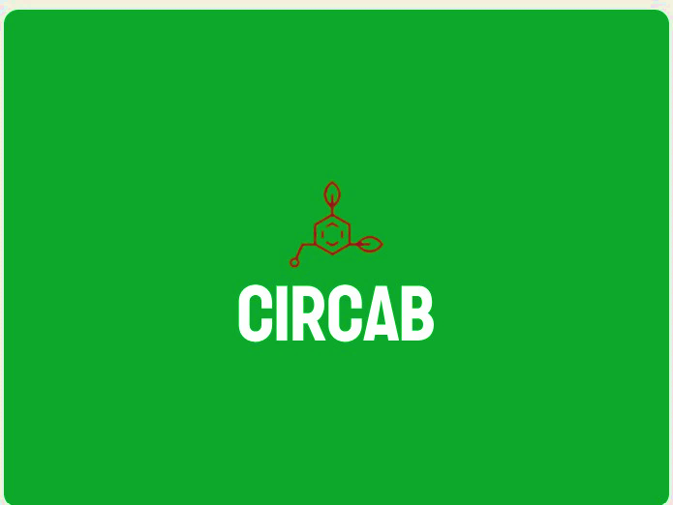
Examples of our current circular and sustainable demonstrations :
https://tus.ie/rdi/research/institutes/life/circlebio-p/
https://tus.ie/rdi/research/institutes/life/circoval/
https://soilcratesireland.ie/
Location of our large-scale demonstration facilities and BioScaleUp project
https://www.youtube.com/watch?v=N9tJeTYq09s

