**Projesis Exclusive Short Document**

Our Projesis Exclusive Cloud Software presents many new technologies such as Cloud and WEB Technology, Multilingualism, Microservice architecture, token-based security, integration capabilities such as O Data – Open API – Swagger. Your Factory Monitoring Screens, Analysis and Reports and Mobile Push Notification alerts can also be easily used from your mobile devices.

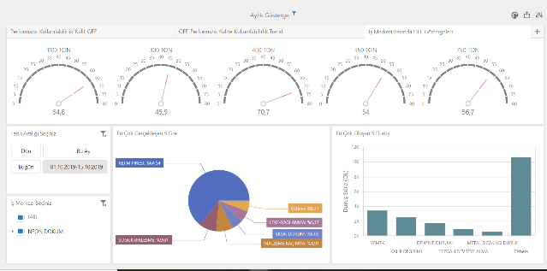

In addition to the cloud deployment, Projesis Exclusive Cloud can be deployed on your server and special developments can be made in the software.

Main modules with functions:

* MES Manufacturing Execution Systems
* ATS Advanced Traceability Systems
* FCS Finite Capacity Planning Systems
* KPS Kanban Planning Systems

are produced to add value to your factories.

Our Cloud platform has a modular structure. You can develop your system step by step, starting with the BM Base MES module.

**Modules:**

1. BM Base MES
2. EA Event Based Alarm
3. DV Document Viewer
4. FD Form Designer
5. LC Lost Cost
6. TM Tool Management
7. PV Polivalance
8. LM Line Management
9. GC Gannt Chart
10. XI Excel Integration
11. EP+EC ERP Integration
12. AP+AA Manufacturing Automation
13. AT Advanced Traceability
14. KP Kanban Planning
15. FC Finite Capacity Planning
16. AI Artificial Intelligence
17. BP Barcode Printing

**For detailed information:**

İstanbul : [dkemahli@projesis.com](mailto:dkemahli@projesis.com)

İzmir : ekesfeden@projesis.com

Our team will reply to your mail requests.

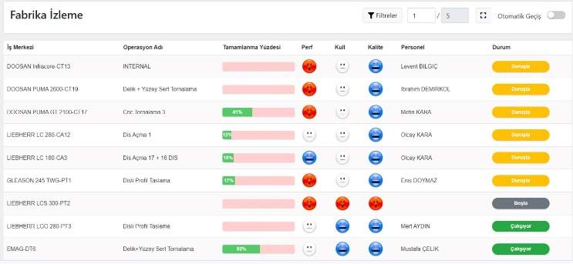

**Document : 0100-ECShortDocument-R0005**

**First Published : 22.10.2022**

**Revision Date : 18.04.2024**