**What** [**Conductor Sam**](https://conductorsam.com/) **can achieve for PC / laptop users**  
  
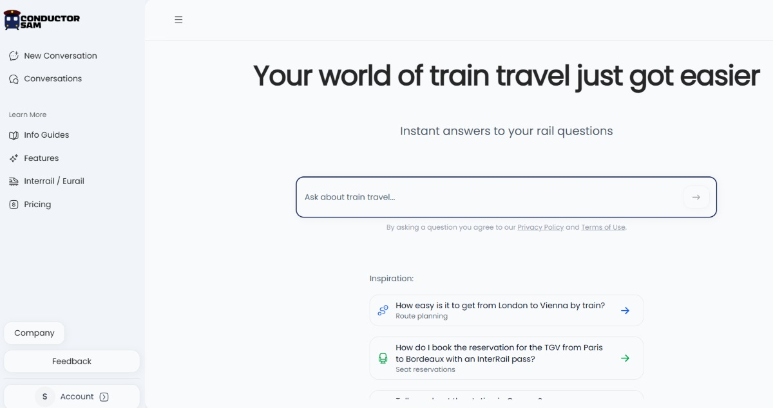

The showcase is a journey from London to Marseille, but queries that can be handled by Sam include:

* Rail trip planning
* How Eurail and Interrail passes can be used and purchased
* How a trip can be experienced – scenery, on train facilities, station access
* What’s good to know about making connections
* Journeys which involve the train + bus (museum to museum, stadium to stadium, not just station to station
* Accessibility
* Questions on the history and future of rail travel

With affiliates plugged into all relevant touch points, because it enhances the user experience.  
  
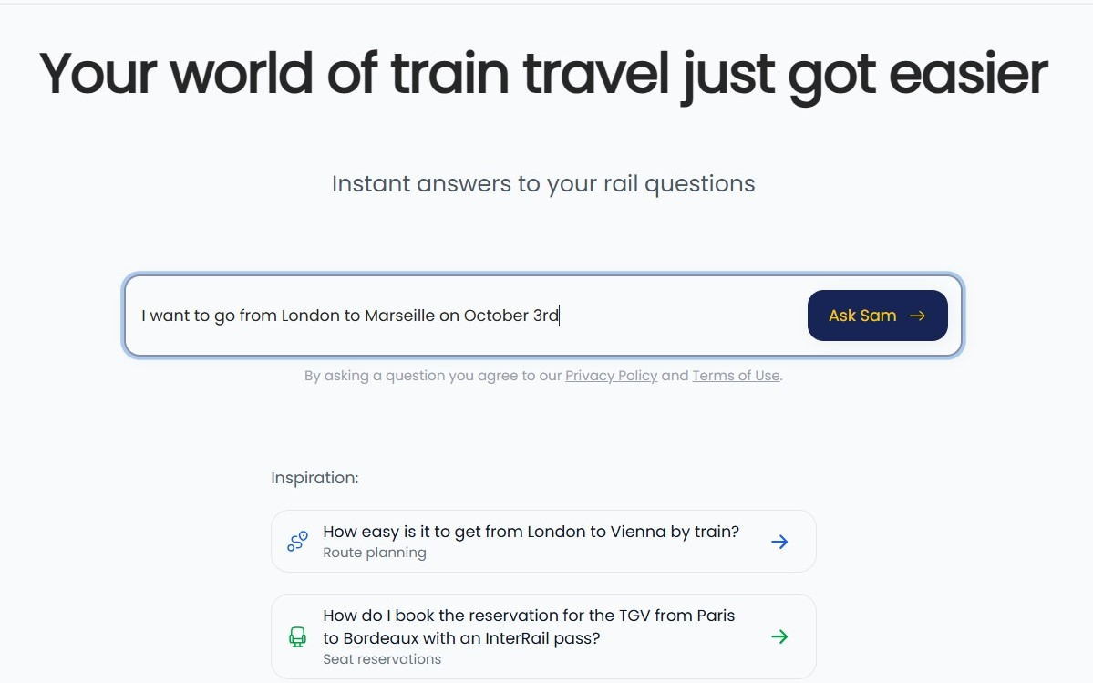

Asking the question leads to summaries of how to make the journey + access to ticket agents.

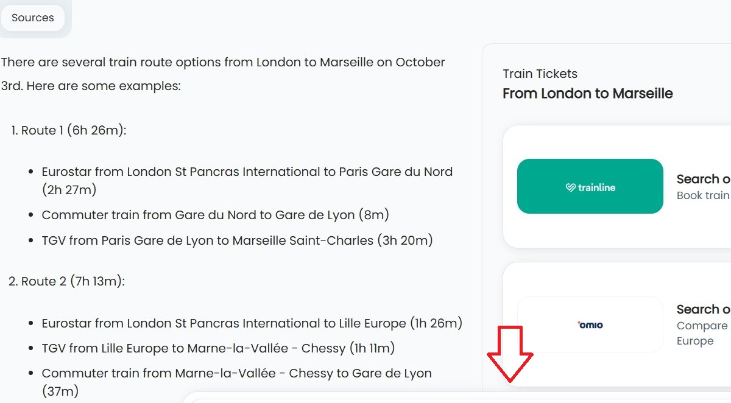

Scroll down to see the Conductor Sam ticket shop (currently in beta)

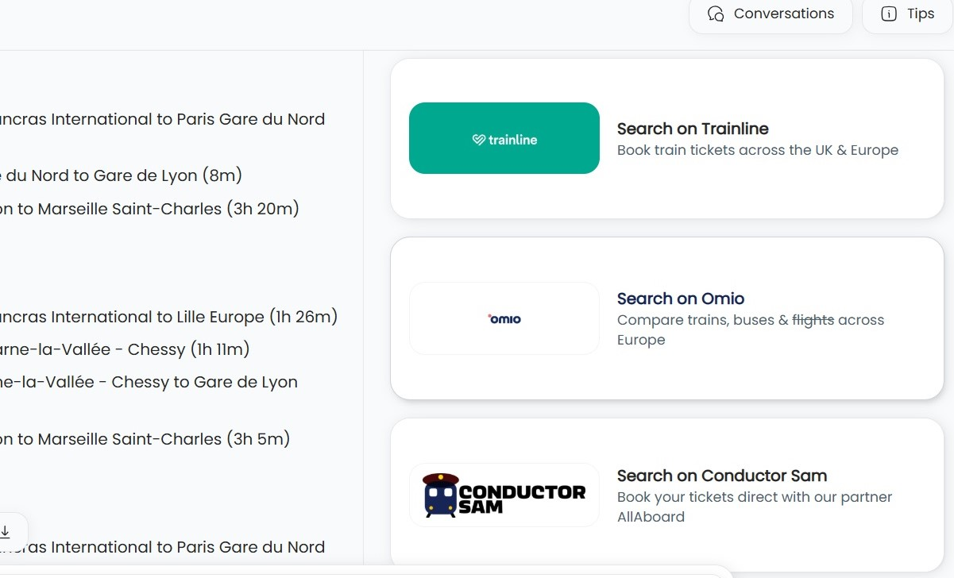

The user has asked about a London to Marseille journey on October 3rd, so the Trainline link takes them directly to the booking options for this route and on this date - no need to re-ask on Trainline / any other agent.  
The idea is that Conductor Sam will in effect be akin to a ‘Skyscanner of rail travel’.

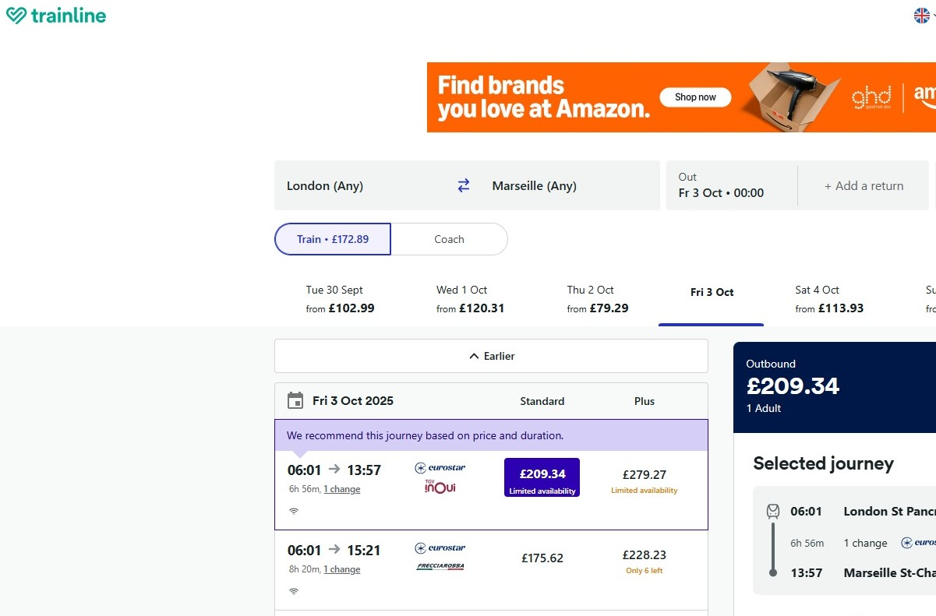

If the user wants to know where the journey info has come from and to take a deeper dive, the Sources tab can be clicked  
The tab also ensures that the page has a less cluttered appearance

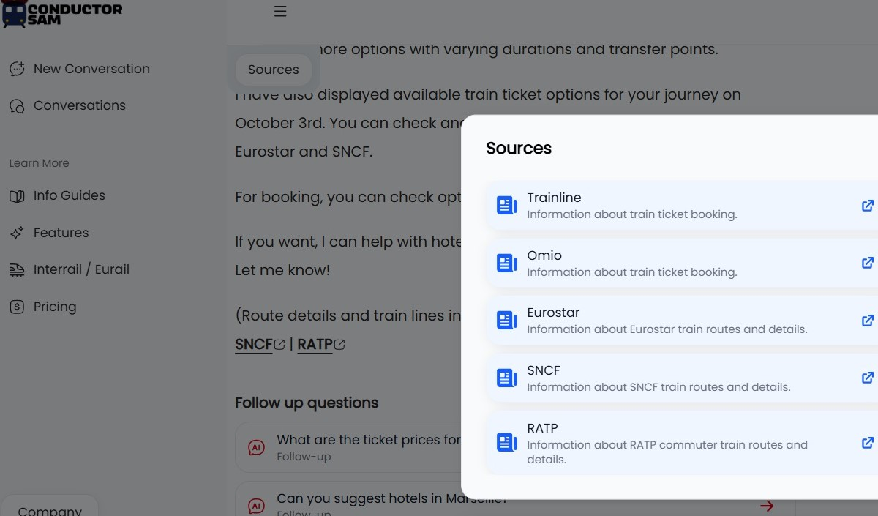

Scroll down on Sam to see the ‘Follow up questions’.  
There is no need to click away into a third-party source, or to ask a separate question – if Sam can suggest an onward path to take the user to what they want to know.  
On this particular user path the ‘Follow up questions’ include access to hotel info at the destination.

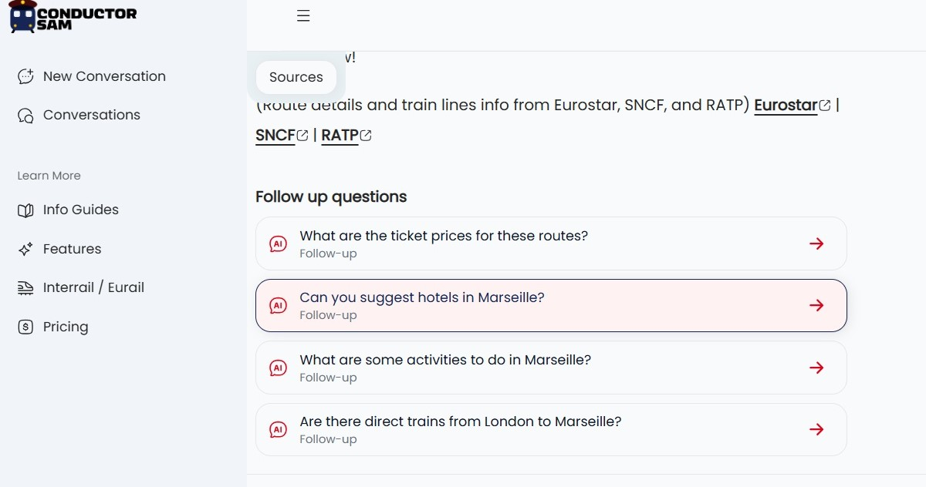  
  
When clicked, the hotel booking interface, automatically appears on a PC, the options will include Hotels.com, Bookings.com and Vrbo.  
The bookings partner, Stay 22, will use its algorithm to select the services with the optimum availability.  
The idea is that the map is close to the city’s main rail station.

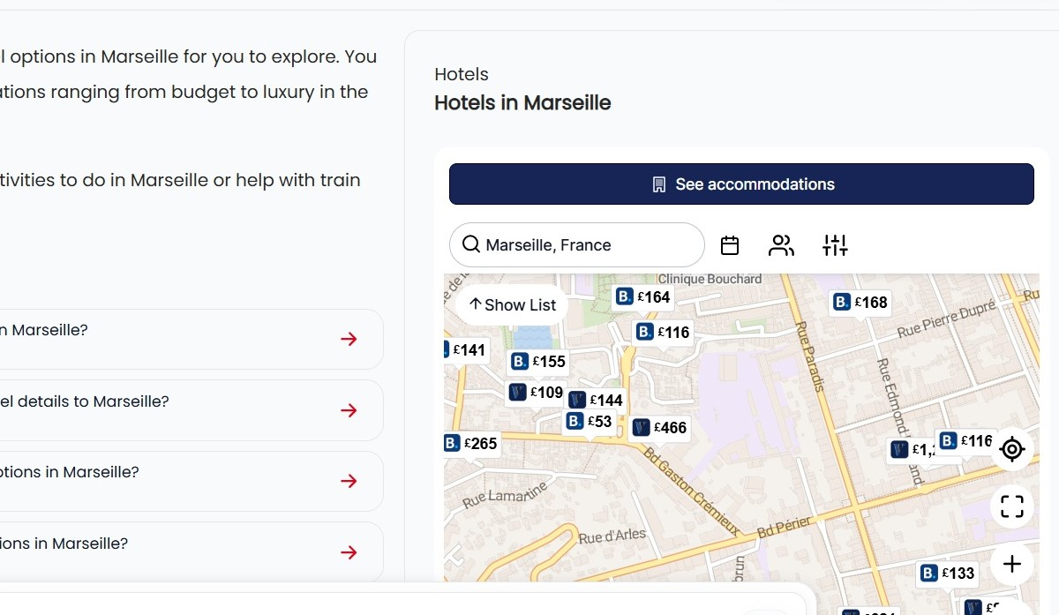

Another ‘Follow up question’ leads the user towards discovering what they can do at their destination.

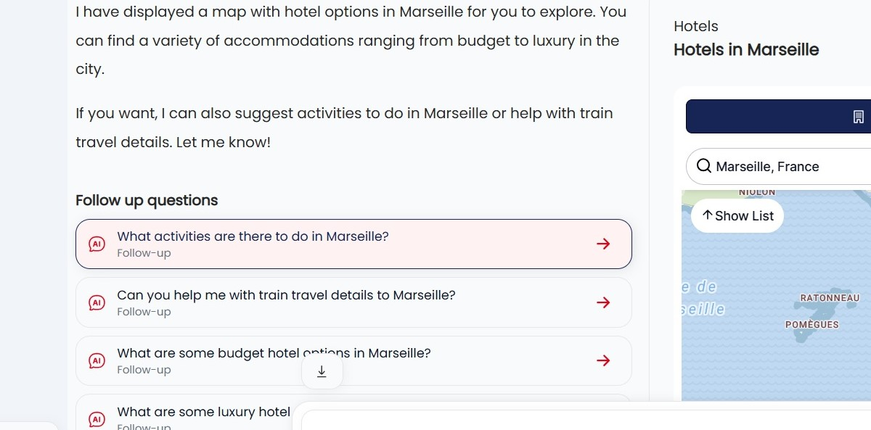

When clicked on a PC or laptop, a list of activities will appear in the box on the right.   
Though if none of the automatically included activities are of interest, the follow up questions will take the user on to more tailored suggestions.

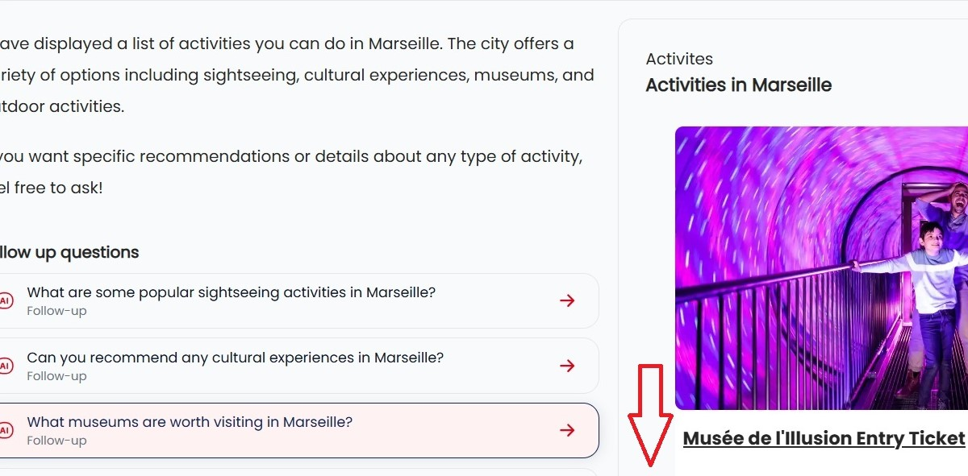

When clicked the Activity ticket link will take the user to the corresponding page on Get Your Guide…

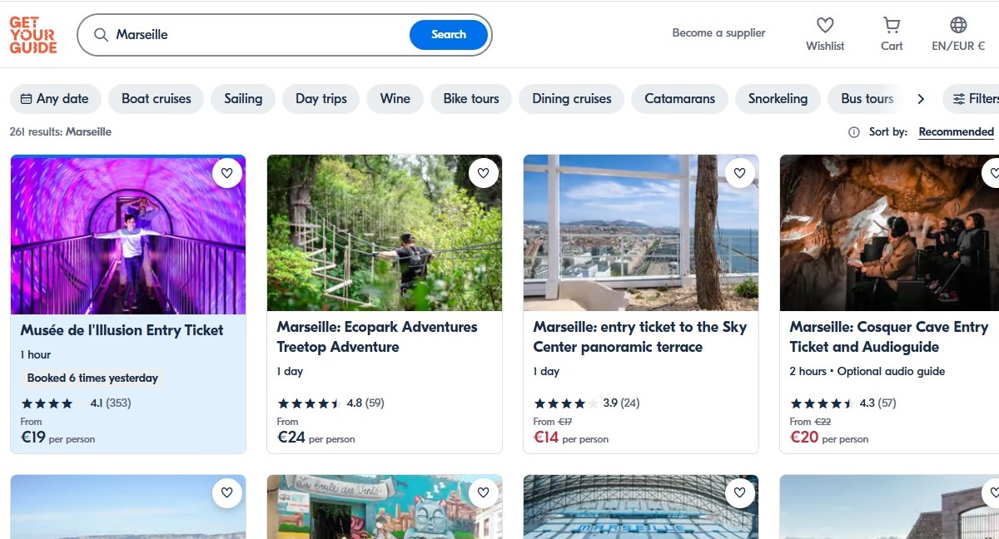

One of the other follow up questions on the original query leads the user to the price info for the requested journey…

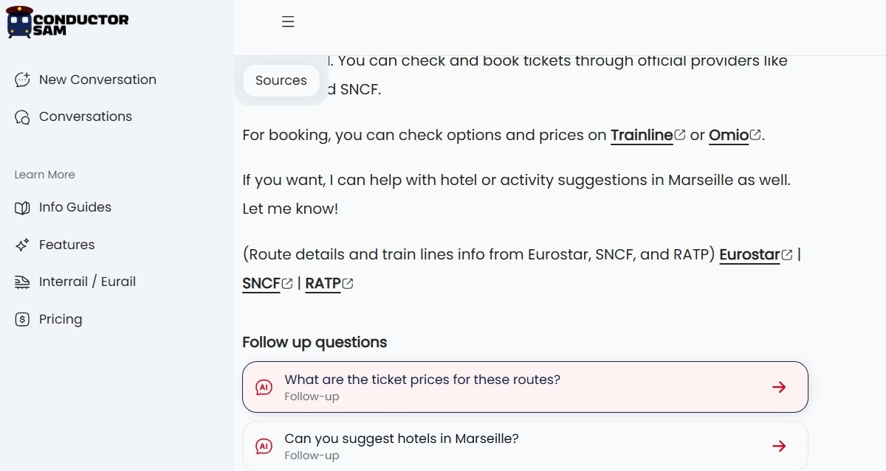

…Sam’s gives an answer, which the user can easily verify by checking the sources.

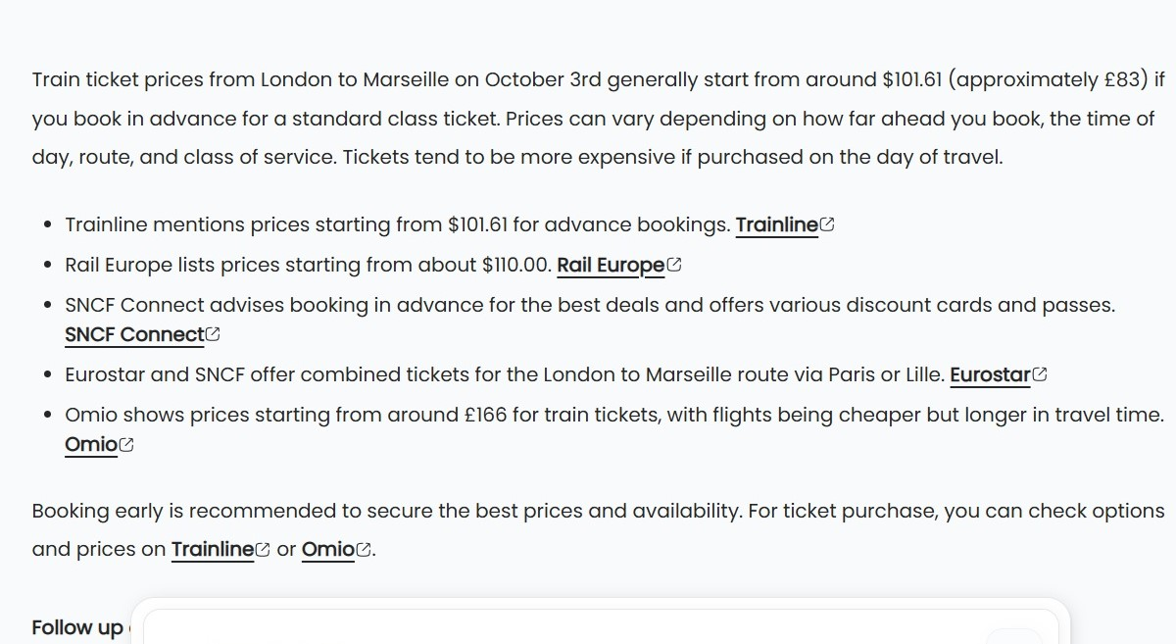

Yet another Follow Up Question on this particular user journey, meets a common user need head on, by providing access to a comparison between taking a train and taking a flight…

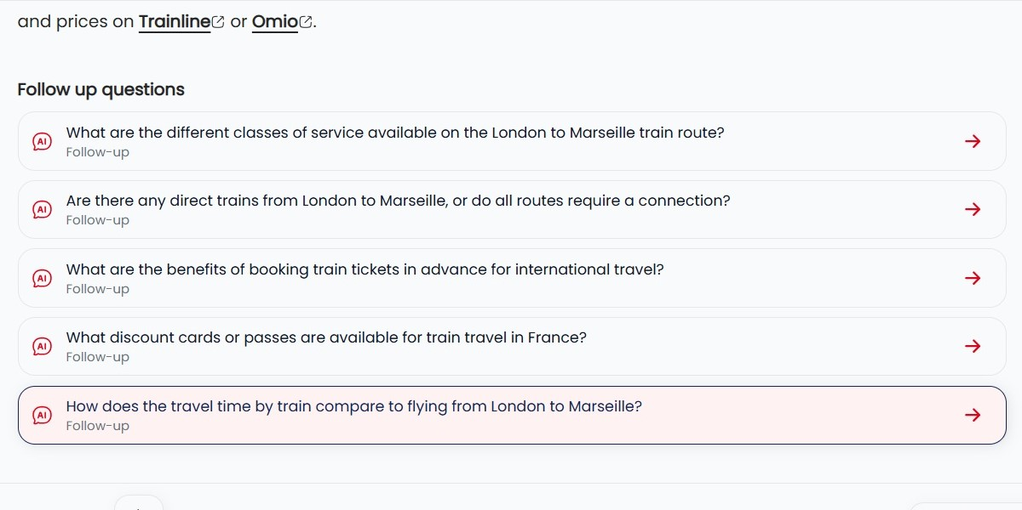

…so Sam gives a summary of the comparison…

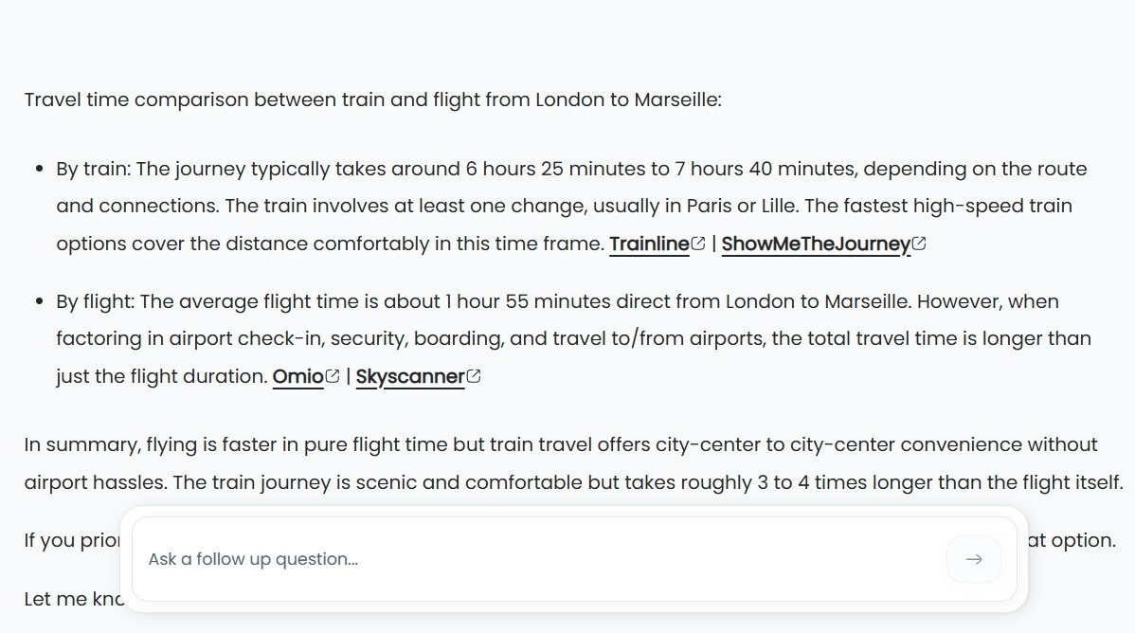

The answer includes ShowMetheJoumey, the website from which Conductor Sam was spun off, as a source.  
However Chat GPT and Google are blocked from showing ShowMeTheJourney as a source – and they cannot harvest info from ShowMeTheJourney either.

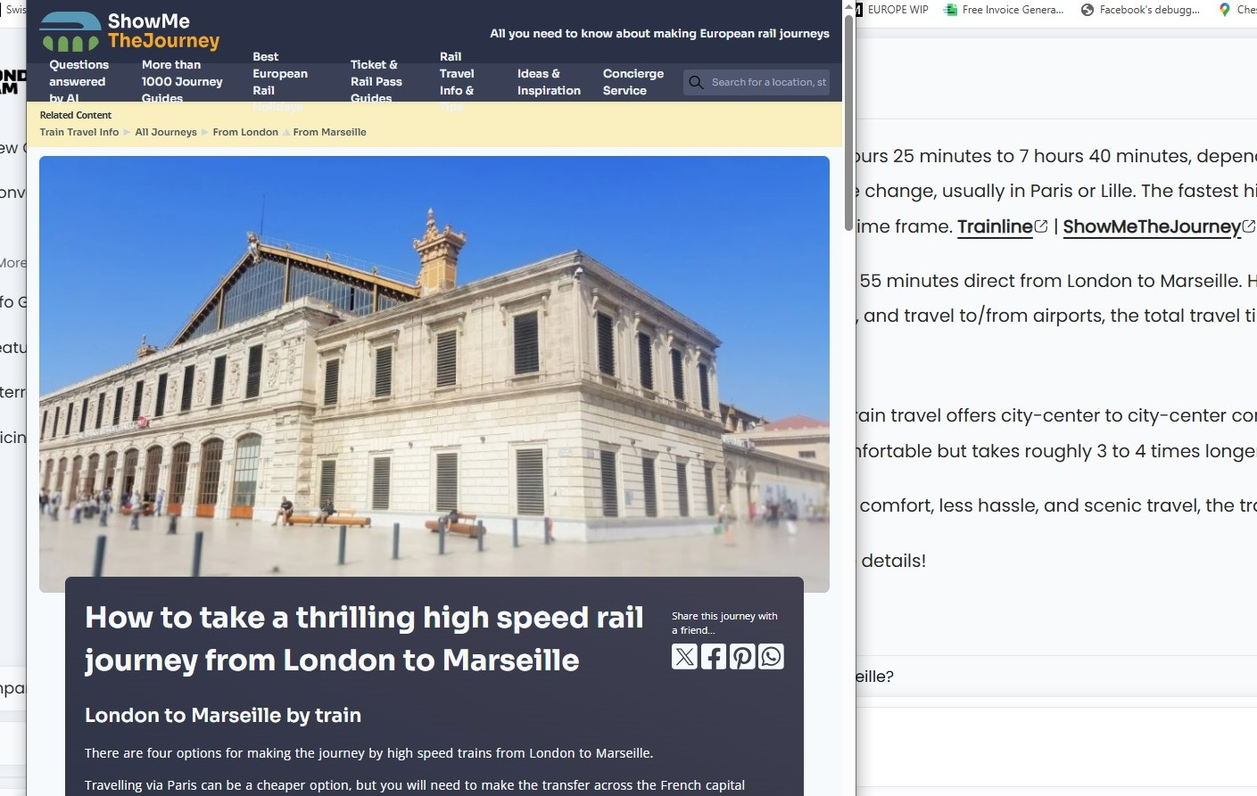

Note that all of the above info has been accessed without the need to ask another question, it’s all just one click away from the user path.  
All the external links open in new windows and a click-back returns the user to Sam’s original answer.  
  
So asking one question on Conductor Sam can take the user to;

* all the core info about taking the trip,
* the tickets and multiple agents which sell them,
* booking a hotel at the destination,
* booking multiple activities at the end location,

all without leaving the initial answer, no need to open and shut windows or ask multiple questions.  
  
Though everyone’s experience when telling Sam ‘I want to go from London to Marseille’ will be different, this showcases the user path which Sam gave me on this particular occasion.  
So it’s typical, but not fixed, because the idea is that Sam will ultimately recognise a user’s preferences and hone in on what they’ll most likely want to know and do.  
  
Coming next is a second-to-none itinerary planning tool.  
  
On the to do list:

* Delivering a Skyscanner of rail tickets
* Travel mode comparison
* Door to door journeys
* Multi-lingual
* Images / Maps / Tables within the answers