BLISK MONTAŽA Ltd. Murska Sobota

Blisk Montaža Ltd. with its headquarters in Murska Sobota, presents itself as a professional company in the entire field of technical building equipment. With 75 employees and over 50 years of experience, we are one of the country's leading companies in our sector.

Our customers benefit from a central point of contact and a comprehensive product, as we offer everything to do with the house.

The company carries out the following activities:

heating systems:
o Outdoor hot water installations
o Gas installations
o Central heating installations (interior design and installation of all types of appliances)

Water work, sanitary installations, water supply
o Outdoor installations
o Indoor sanitary installations

Ventilation and air conditioning

Production of ventilation ducts

Electrical:
o External installations
o Internal installations
o Measurement of electrical systems and lightning conductors

Plumbing work:
o Canopies
o Plumbing work

Cooperative work:
o Construction services
o Other services in the construction industry
o Renovation work

Maintenance of all types of installations:
With the appropriate technology, high-quality technical equipment and professionally qualified personnel, we offer a competitive advantage over other contractors because we can offer the following:
- Implementation of complete building installations on less demanding, demanding and very demanding objects,
- Alternatives for optimizing the technical solution and selecting suitable materials based on many years of experience in order to achieve the goal of improving energy efficiency and reducing investment costs

If you are preparing projects for installation work, invite us to participate. We will be happy to prepare an offer for you, which we will certainly offer at a more favorable price, a guarantee of high quality work performance and meeting deadlines.

Contact person:

Managing Director: Igor Banič, univ.dipl.oec.
GSM: +386 41 616 579
E-mail: igor.banic@blisk-montaza.si

Distribution - Sales: Robert Lipič, dipl.oec.
GSM: +386 41 733 843
E-mail: robert.lipic@blisk-montaza.si

Purchasing: Sašo Tomašek, ing
GSM: +386 31 732 877
E-mail: saso.tomasek@blisk-montaza.si

Calculation HVAC: Milan Ifko, dipl.ing.
GSM: +386 51 308 091
E-mail: milan.ifko@blisk-montaza.si

Calculation construction: Slavko Gjergjek, ing.
GSM: +386 41 760 262
E-mail: slavko.gjergjek@blisk-montaza.si

Electrical engineering: Franc Kalamar, electrical engineer
GSM: +386 41 793 373
E-mail: franc.kalamar@blisk-montaza.si

Technology HKLS: Bojan Gojkošek, dipl.ing
GSM: +386 41 479 072
E-mail: bojan.gojkosek@blisk-montaza.si
Important references:

- Police station, Ormož
- Reconstruction of the telecom complex, Murska Sobota
- Elos Escada business production facility, Gornja Radgona
- Freeway rest stop, Murska Sobota
- Tuš store and petrol station, Gornja Radgona
- Old people's home, Radenci
- Waste management center, Puconci
- Pharmacy, Gornja Radgona
- Displacement of the Gančani water supply system,
- Rest stop, Dolinsko
- Water city / Phase 1
- Terme Radenci / Construction of a boiler room
- Sales exhibition space Noršinska, Murska Sobota
- Nursing home, Kuzma - 2008
- Gomboc business production complex, Murska Sobota
- Shopping center, Lendava
- Plumbing work in a Roma hamlet, Kuštanovci
- Salon Ford, Murska Sobota
- Commercial building, Ljutomer
- Apartment complex Vivat / Lamelle III, Moravske Toplice,
- Refurbishment of the energy system, Radenci
- Reconstruction of the road through Tešanovci
- Clarus office building, Murska Sobota
- Merkur Shopping Center, Murska Sobota
- General hospital / Preparation of pure steam, Murska Sobota
- Tuš market, Goričanka, Mačkovci
- Stari Mir shopping center, Gornja Radgona
- Water city - Phase 2
- Municipality of Branoslavci - Cezanjevci water pipeline
- Lidl, Šentjur
- Maximus shopping center, Gornja Radgona
- Secondary water supply to the most vulnerable areas of the municipality of Grad
- Underwater sewage, Velika Polana
- Production hall, Slovenj Gradec
- Old people's home, Hodoš
- Oaza, Tešanovci
- Business warehouse, Zagožen
- Reconstruction of the BTC City, Murska Sobota
- NKBM, Gornja Radgona
- Water supply city II. Phase
- Avtostest, Slovenska Bistrica
- Sports and leisure center, Vaneča
- Police station, Gornja Radgona
- Reconstruction of the Vičava barracks, Ptuj
- Construction of the low-energy kindergarten, Apače
- Renovation and modernization of the Kodil hammer
- Old people's home, Slovenska Bistrica
- Grammar school school center, Ravne na Koroškem
- Construction of the low-energy kindergarten, Lendava
- Renovation and modernization of the Kodil hammer
- Renovation of the retirement home, Rakičan
- Rehabilitation of the Drava boarding school
- Energy refurbishment of the Murska Sobota General Hospital
- Seaway, Puconci production hall
- Boiler plants and substations of GCC Radgona
- Planika Turnišče - Production hall III
- Construction of the low-energy kindergarten, Lendava
- Construction of the low-energy kindergarten Lavra, Murska Sobota
- Garden of low energy Moravske Toplice
- Renovation of the municipal assembly's energy supply, Puconci
- Boiler room, Ljutomer
- Borovnica Health Center Murska Sobota
- Merido Radiology OI Ljubljana-CT
- Merido Radiology Oncology UKC Maribor Assembly 2
- Gorenje Projekt d.o.o. Drinking water supply Pomurje System B, Assembly2
- Medizintechnik d.o.o. Dringen Center of the General Hospital Murska Sobota
- SWP Pomgrad Construction of the Muzge and Beltinci irrigation system
- Energy rehabilitation of the municipality of Lendava, DOŠ Genterovci
- GP Vigrat office building Virs
- Puconci City Council, VIZ Energy Restoration, Phase II.
- Timo d.o.o. completes the pool hotel Vivat 2014
- Nograd d.o.o. Puch business zone in Ljutomer
- Murska Sobota Hospital Construction of a hot water pipe and a steam bath in the laundry room and kitchen
- Pomurje drinking water supply - system B, assembly 3
- Jata emona d.o.o. Reconstruction of the factory of strong feeders, Ljutomer
- Merido-Radiology OI UKC MB Department of Clinical Oncology
- Frbejzar d.o.o. Hall Frbejzar
- Pomgrad d.d. Construction of transport waterworks Križevci - Sv. Jurij ob Ščavnici 2015
- Merido Radiology UKC Maribor - Cardio
- Rehabilitation works and gas pipeline (Lendava, Žalec, Murska Sobota, Ljutomer, Polzela, Zreče, Ormož, Radenci, Prebold ...) including with construction works
- Mechanical and electrical renovation works in Pomurje (post office, NLB offices, police stations, schools, stores and restaurants, Mura a.g, car dealerships, public institutes ...)
- Codex, Murska Sobota
- Lidl, Murska Sobota
- Still, Komenda
- Faculty of Medicine, Maribor
- Soccer stadium Ljudski vrt, Maribor
- McDonalds, Murska Sobota
- Paloma, Sladki vrh
- General Maistra barracks, Maribor
- Eurospin, Gornja Radgona
- Panorganic - CEA Grünaus, Ljutomer
- Shopping center (Hofer, DM, ...), Lenart
- Hotel Vivat, Moravske Toplice
- Bilingual elementary school, Prosenjakovci
- Apartment house, Graz
- 5* Hotel Habakuk, Maribor
- Merido Radiology OI UKC NM Department of Clinical Oncology
- Soccer Academy, Lendava
- Mercator, Murska Sobota
- Hospital, Murska Sobota
- MERCK Sigma-Aldrich, Schnelldorf, Germany

Petrol stations:

- Petrol Dolga vas
- Petrol Beltinci
- Petrol highway north Murska Sobota
- Petrol highway south Murska Sobota
- Petrol Murska Sobota Center
- Reconstruction OMV Murska Sobota
- TUŠ Gornja Radgona
- MOL Murska Sobota
- Catering Center Maribor, West
- Petrol Lipovci, freight wagon
- Petrol Križevci, Ljutomer
- MOL Pince (North) Shopping center
- Petrol Plese, Murska Sobota

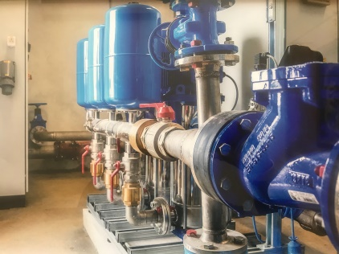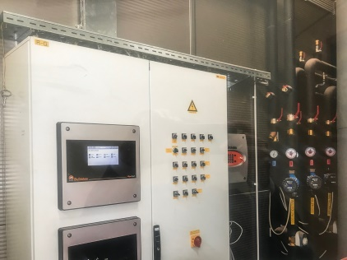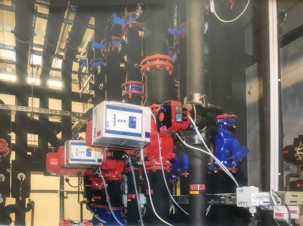

Our installers are mobile and on the road every day with more than 15 service vehicles. All installation teams have the equipment they need for professional use.

We have certified installers for the following types of installation:

- Welding of all types of steel systems (flame, TIG, electric)
- Welding and joining of stainless steel systems (TIG)
- Welding and joining all types of plastic installations
- Welding and joining - soldering of all types of copper installations
- Installation and connection of all types of multilayer pipes (compression in cold rooms)

We would like you to convince yourself of our competitiveness.

If you are interested in business cooperation or already have an ongoing project, we look forward to hearing from you. We will be happy to offer you our solution or an offer for your already prepared project.

We will be happy to organize an appointment to give you more information about our company.

You can also reach us at any time at www.blisk-montaza.si

Murska Sobota, October, 2023

Director:
Igor Banič, univ. dipl. oec.

