SUPPLY OF MATERIAL AND EQUIPMENT, PREPARATION OF CULTURE MEDIUM FOR MICROBIOLOGY AND PROVISION OF SERVICES, SPECIALIZED IN THE SECTOR OF RESEARCH, TEACHING AND DIAGNOSTIC LABORATORIES.

**ADVICE SUPPLY TRAINING TECHNICAL SERVICE🡪🡪🡪**

* **IMAGING FOR DIAGNOSIS**

**MICROSCOPY**

Wide range of microscopic image acquisition and processing, measurement and analysis solutions for fast and reliable diagnostic and research results, in order to meet the highest production standards or to perform cutting-edge microsurgery.

Applications for fundamental research, clinical, surgical specialties, disciplines associated with physical sciences, industry, forensic services,...

Sample preparation and imaging in pathology, hematology, histology, microbiology...

Wide range of microscopes, microtomes, tissue processors

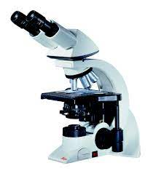 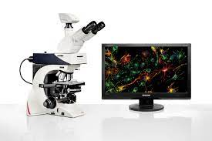

* **MOLECULAR BIOLOGY**

**REAL TIME PCR (QPCR)**

Range of QPCR equipment specially designed to meet your needs in the field of molecular diagnostics. These state-of-the-art equipment are designed to deliver accurate and reliable results with high sensitivity, giving you the ability to perform cutting-edge molecular testing efficiently and effectively.

Our QPCR equipment is equipped with advanced technology that allows sensitive and specific detection of DNA or RNA sequences relevant for clinical diagnosis. This will provide you with fast and reliable results, helping you make informed and accurate decisions in the diagnosis of diseases.

Our equipment has an intuitive and easy-to-use interface, which facilitates its operation even.

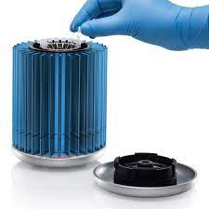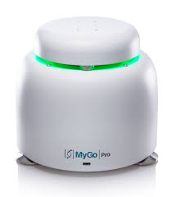

Equipment with capacity for 16 or 32 samples – MyGo Mini and MyGo For

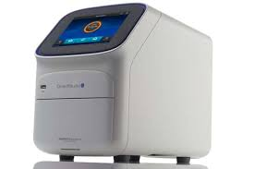

Equipment with capacity up to 96 samples – QuantStudio Applied BioSystems

**DNA/RNA EXTRACTION AND PATHOGEN DETECTION**

We have a wide range of Kits DNA and RNA extraction **Zymo Research** suitable for all types of samples, as well as kits for the detection of pathogens by Q PCR **Genesig**. Designed for easy implementation and accurate results, our kits will allow you to obtain high-quality DNA samples and perform pathogen detection tests quickly and efficiently.

While Genesis have a very wide catalog of kits for the diagnosis of diseases with Malaria, Ebola, Dengue,... Zymo Reserch is a worldwide reference in terms of obtaining nucleic acids, obtaining results of great purity and quality.

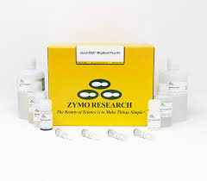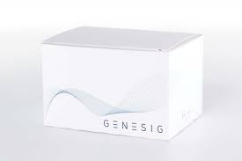

**CENTRIFUGATION**

Neya centrifuges ventilated and cooled with both fixed angle and tilting rotors.

With a compact size and a great versatility of accessories, they are a perfect solution for any laboratory. The model shown has a maximum capacity of 4 x 175 ml, with capacity to accommodate tubes of 1.5 – 2 ml, 5/7 ml, 10 ml, 15 ml, 50 ml, 100 ml, 175 ml. (for larger capacity equipment with consult).

With a very intuitive operation and a backlit LCD screen for the visualization of all the parameters and color coding to differentiate the different processes. Automatic rotor detection and safety locking system.

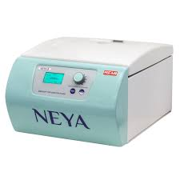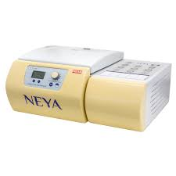

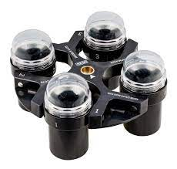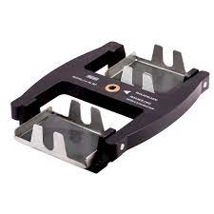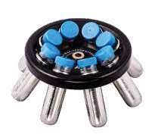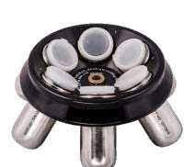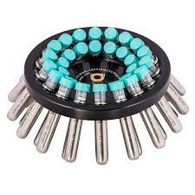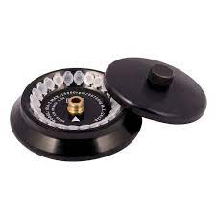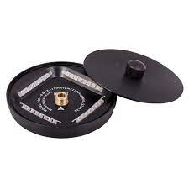

**LABORATORY REFRIGERATORS AND FREEZERS: EFFIMED**

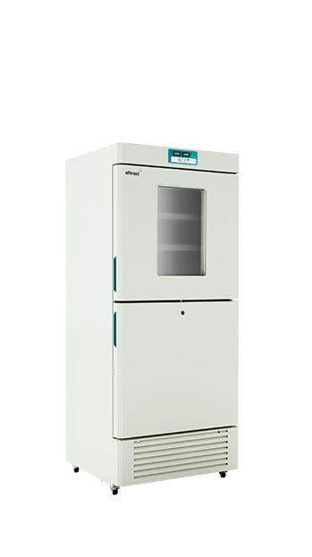**Laboratory refrigerators**

Mixed storage with temperature adapted to the biomedical sample. We offer freezing down to -40º within its range of combined refrigerators equipped with independent refrigeration circuits. Thanks to its temperature control by microprocessor and various sizes, it is the most versatile equipment for the custody of samples, reagents, standards and all kinds of thermolabile material in the pharmaceutical, clinical, analytical and industrial environment.

Temperature range: 4°C » 8°C / 10°C » -40°C. Digital display, alarm system, environmentally friendly refrigerant cooling system, high efficiency compressors.

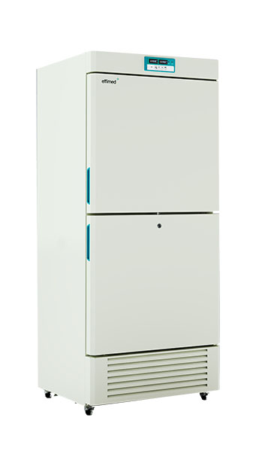**Freezing -25ºC**

Long-term controlled storage down to -25°C ± 0.1°C

Effimed biomedical freezers offer a security deployment in the storage of all kinds of laboratory and research applications. Always with the best use of the and easy operation for precise and uniform storage. Features such as low power consumption, low noise, low heat dissipation and safety towards high/low temperature audible alarm makes this product perfect.

Safety by 8 control points, platinum sensors for greater precision, defrosting system, automatic alarm system, environmentally friendly refrigerant, high efficiency compressor.

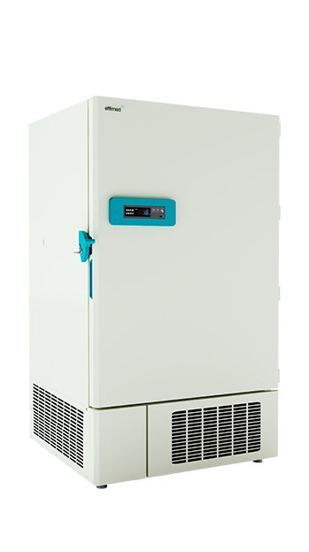

**Ulra Freezing -40ºC**

Long-term controlled storage down to -40°C ± 0.1°C

We cover all sample conservation needs with its wide range of -40º deep freezers, responding to both the most demanding sample custody scenarios with maximum precision and efficiency to the least demanding needs, adapting to all kinds of processes.

Safety through 8 control points with associated alarm, data backup of the last 72 hours in case of system failure, platinum sensors for greater precision, alarm system, environmentally friendly refrigerant, high efficiency compressor.

**Ulra Freezing -40ºC**

Our -86º deep freezers represent a firm commitment to innovation in the most demanding levels of long-term conservation. Specially designed for use in biorepositories, sample storage and all types of sensitive material. Adapted to all kinds of capacities from 770 cryogenic boxes to a portable version

* 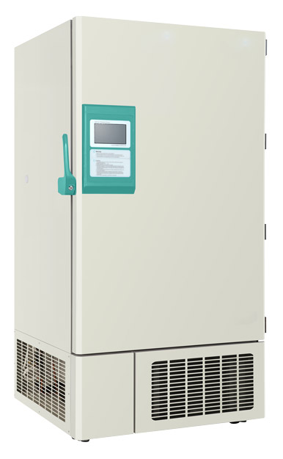Security through 12 control points with associated alarm
* Storage at the indicated temperature with accuracy ±0.1ºC
* Remote communication and reporting of information
* Locking doors with key and keypad with password to prevent unauthorized operations or access.

7-inch touch screen allows you to interact intuitively, youcan modify the set point from -10ºC to -86º, inventorycontrol system, environmentally friendly refrigerant, cooling system "Direct Cooling" (Minimum energy consumption, less acoustic emissions and greater safety).

* **MICROBIOLOGY LABORATORY**

**LABORATORY INCUBATORS**

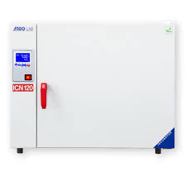Natural and forced convection incubators, with **Safety Class 3.1** (standard DIN 12880) as standard on the equipment marked with the 3.1 icon.

Temperature range from + 5 °C ambient to + 70 / 0.1 ºC, with to establish a program at 130 ° C for thermal sterilization of the chamber. Backlit LCD displays (touch on SUPER series). With low power consumption, they have heating elements on all four walls of the chamber to ensure temperature homogeneity.

Capacities ranging from 16 litres to 200 litres for natural convection models and between 120 and 400 litres for forced convection models.

Include factory calibration certificate.

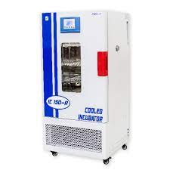**Incubator with cooling (forced air)**

Model with cooling and temperature range 0...60 °C, Models with and without cooling, Safety class 3.1 (standard DIN 12880) as standard on devices marked with the 3.1 icon.

Digital display with indication of the programmed parameters and visual and acoustic alarm, 304 stainless steel chamber easy to clean, with internal light.

Include factory calibration certificate.

**Incubator with agitation**

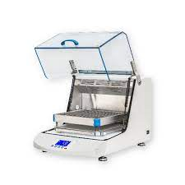Models with and without refrigeration. Large volume, for erlenmeyers up to 2,000 ml. Temperature range +5ºC Tª amb. / +60ºC / 0,1ºC (+4ºC / +60ºC / 0,1ºC in refrigerated models)

They are supplied with universal spring platform and canoptionally incorporate a perforated platform for clip-like supports for erlenmeyers, a non-slip platform or a universal platform with 4 rollers

**AUTOCLAVES**

We have at your disposal Daihan Scientific autoclaves, de top load with sliding door, microprocessor for temperature control up to 132ºC.

Robust equipment with excellent durability. It is supplied with two stainless steel baskets and have wheels to facilitate mobility and had a drain for emptying the chamber.

Features to highlight:

* 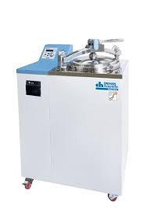Temperature range: Ambient temp. +5°C to 132°C/±0.5°C to 121°C
* Timer and end-of-cycle error alarm and alarm
* Backlit LCD display
* Digital Controller
* Sliding lid with lever and electronic security system.
* 304 stainless steel interior
* Analog pressure gauge pressure gauge
* Available in models of 47, 60, 80 and 100 liters.

Ask for benchtop models for instrument sterilization.

**SAFETY CABINS**

* VERTICAL, HORIZONTAL AND PCR LAMINAR FLOW CABINETS

Manufactured to ensure ISO 5 Class sterility, we have both vertical laminar flow cabinets and horizontal laminar flow cabinets. All of them equipped with HEPA filtration of class H-14 that ensure the reliability and protection of the manipulated product against external contamination and cross-contamination between samples. Total sterility.

Fully equipped, with LED lighting, spill retention tray, UV light depending on model. Desktop or stand mounting.

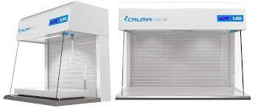

* BIOLOGICAL SAFETY CABINETS

Our microbiological safety cabinets and our Class II A2 cytostatic cabinets, certified by Tüv according to the European Standard EN 12469, as well as the Class III Virus 3 cabinet, have been developed to offer total protection to laboratory personnel and the environment against manipulated pathogenic and cytostatic material and, at the same time, Protect it from external contamination.

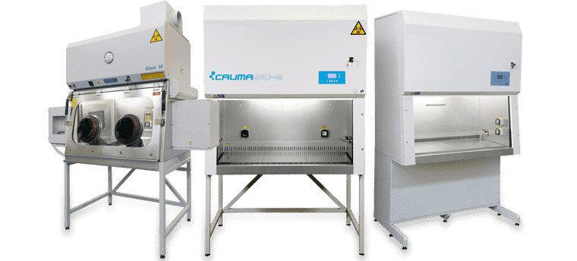

**LIQUID HANDLING**

* MICROPIPETTES CORNING

Corning® Lambda™ EliteTouch™ pipettes have been designed to provide the highest levels of ergonomics, accuracy and precision. The lightweight construction, contoured shape of the handle and 4-digit counter were designed to ensure comfortable pipetting. All pipettes feature smooth plunger movement and extremely low pipetting forces to reduce wrist strain and fatigue (RSI). Colored buttons (included) can help define the user or application for sample safety and reduce the risk of cross-contamination.

* Ergonomic handle design for a perfect fit for both right and left hand
* Convenient one-handed volume adjustment with automatic locking system prevents accidental volume changes during work
* 4-digit counter for accuracy, perfectly positioned for visibility at all times
* Fully autoclavable and UV resistant for sample protection from contamination
* Multi-channel shafts retract individually for perfect tip loading and easier tip ejection
* Easy calibration in the lab helps you quickly adjust your pipette to various types of liquids
* Individually tested and supplied with a quality certificate.

|  |  |
| --- | --- |
| Corning™ Autoclavable Lambda™ EliteTouch™ Pipette Starter Kit: Yes View Products | Fisher Scientific | Corning™ Lambda™ EliteTouch™ 8 multichannel micropipettes, autoclavable 0.5-10 μl View products | Fisher Scientific |

* AUTOMATED SYSTEMS

We have extensive experience with automating workflows when it comes to pipetting samples and reagents using Tecan and similar platforms.

Robotic pipetting platforms automate the pipetting process in the laboratory, offering accuracy, efficiency and safety. These platforms perform precise and repetitive pipetting, improving the accuracy and reproducibility of experiments. In addition, they can handle large volumes of samples simultaneously, increasing laboratory productivity. Their flexibility and customizability make them suitable for various applications in molecular biology and genomics. In short, robotic pipetting platforms are powerful tools that optimize time, resources, and the quality of results in the lab.

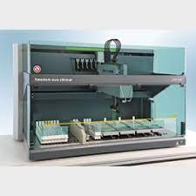

We can design a customized solution according to the needs of the user.

* **ELECTROCHEMISTRY**

Electrochemistry plays a fundamental role both in the clinical field and in the environment. In the clinic, pH is an important measure for assessing the acid-base balance in the human body, which helps diagnose and monitor metabolic, respiratory and kidney diseases. In addition, electrochemistry is used in the detection of biomarkers and analysis of biological samples, which contributes to the research and development of medical treatments. It is also an essential tool for assessing the quality of water, soil and other natural resources.

We have the latest technology for electrochemical measurements of pH, ORP, conductivity and dissolved oxygen, with state-of-the-art instruments, precise, intuitive and easy to use. We have a wide range of probes and sensors that allow us to adapt to the specific needs of each client.

|  |  |
| --- | --- |
| Benchtop pH meter PH 80 PRO. XS. Magnetic stirrer with arm.  Electrode: XS Standard. BNC cable, tempretura probe, buffer solutions pH 7 and pH 4. Datalogger, Datalink software. USB keyboard. Rank  Phmetros XS | XS Cond 80 PRO BASIC - benchtop conductivity meter - Without cell  Conductímetros XS |
| Agitator XS PC 80 PRO – Without electrode and cell – Anamin Group  Multiparamétricos XS | |

SPECTROPHOTOMETRY

We have a line of spectrophotometry equipment designed to meet your analytical needs with precision and reliability. Our equipment offers a wide range of wavelength, high resolution and sensitive detection options, allowing you to make accurate measurements of absorbance, transmittance and concentration of samples.

With an intuitive and easy-to-use interface, our spectrophotometry equipment provides you with a convenient and efficient user experience. In addition, they offer data storage capacity and advanced analysis options, making it easier to manage results and generate reports.

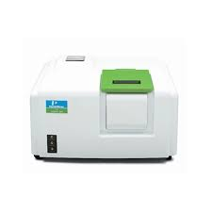We can offer from basic and efficient options for those looking for a simple solution for routine applications, to high-end equipment for those whose demands go beyond, working with reference brands in the market such as Perkin Elmer.

* **LABORATORY CONSUMABLES**

We have a wide range of consumables, with special emphasis on the consumable for molecular biology, microbiology and cell cultures.

In our product line, you will find high-quality tubes, plates, pipettes, pipette tips, flasks and jars made of strong, contaminant-free materials. These products are ideal for sample handling, storage, DNA amplification, polymerase chain reactions (PCR), sequencing, and more.

In addition, we have a range of specific products for cell cultures, such as culture plates, microtiter plates, culture media, reactors and culture bags. These products are designed to provide an optimal, sterile environment for cell growth and study in the laboratory.

Our commitment is to offer high quality and reliable products to meet the demands of your work in molecular biology and cell cultures.

We work with different types of products adapted to all needs, especially highlighting internationally reference products such as:



* **LABORATORY DESIGN**

From MELCAN we have extensive experience in the design and assembly of laboratories both in the private sector and in public institutions in the Canary Islands.

We are proud to offer specialized furniture solutions to meet your needs, focusing on ergonomic and functional laboratory design, ensuring the optimization of space, safety and efficiency in your operations. Our products are designed with high quality materials and meet the highest standards. We are committed to providing you with customized solutions that fit your specific laboratory requirements.

